***Jiuzhou fenye yutu gujin renwu shiji***

**九州分野輿圖古今人物事跡**

Cosmological Map of the Nine Regions [of China], Noting Celebrities and Cultural Remains Past and Present

季名臺選錄刊行。萬曆癸未（十一年，1583）金陵刻本。大幅，一葉，版高131.1釐米，寬116.6釐米。圖高100.6釐米，寬116.6釐米。由兩單張棉紙印刷后拼接而成，背面用連史紙襯裱。上方中間為圖題，右側為地圖總序，左側為圖例説明，均二十八行，行十二字。無比例尺。下方為兩京十三省圖考，羅列屬府州縣司所數目、藩府、錢糧戶口、賦稅，末有牌記“癸未仲秋日南/京季名臺選錄梓行”。現僅見日本天理圖書館《古義堂文庫目錄》著錄。

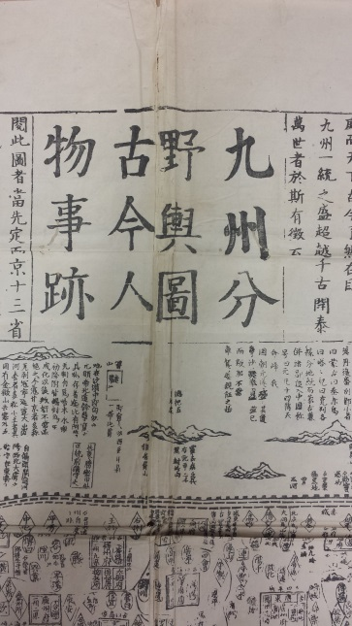季名臺，不詳。所云癸未年，當為萬曆十一年。所錄古今人物事跡，於吉安府吉水縣旁注“解縉、羅洪先（1504-1567）俱吉水人”。其兩京十三省圖考，湖廣條列王府九：楚府武昌治東，遼府荊州城内，岷府武崗治東，襄府襄陽東南，荊府蘄州治西，輝府均州城内，吉府長沙城内，華陽府澧城西，興府德安城内。而萬曆二十九年（1601）所立惠王、桂王均闕。又列戶五十三萬一千六百八十六，口四百八十二萬三千五百九十，與史載萬曆六年戶口數相近。另，河南鈞州已改禹州，萬曆三年（1575）避諱改；汾州猶作屬州，萬曆二十三年（1595）方升為府。崇禎年間設置的府州縣在該地圖中沒有出現。

據季氏，此圖地理方位、四至及道理遠近，均取自《一統志》。其佈局、畫法與萬曆二十一年（1593）梁輈所刻《乾坤萬國全圖古今人物事跡》極爲相似，序言部分亦有詞句相同者。二者顯有淵源。梁氏圖摹自喻時《古今形勝之圖》（1555），並參考羅洪先《廣輿圖》及利瑪竇《坤輿萬國全圖》。惟此季氏所刻，世界地圖部分較梁氏圖為簡略。崇禎十七年（1644）曹君義刊行《天下九邊分野人跡路程全圖》亦屬同一系統。

根據紙張及印痕推斷，雕版為十塊：東部、西部各為五塊聯綴。河流、城池及字跡有錯位和空白，當是雕版完成后聯綴成兩大版，用兩張單幅大紙刷印，然後拼貼成此巨幅。

下方右下角钤“工行”圆印。

DESCRIPTION

A map of Ming China drawn and published by Ji Mingtai in Nanjing in 1583, printed from ten woodblocks on two sheets that have been pasted together to make a single larger sheet measuring 131.1 cm x 116.6 cm. The map portion measures 100.6 cm x 116.6 cm, with two horizontal text panels above and below. In the upper panel, the map title in the center separates the preface and the explanatory note, both printed in the format of 28 columns of 12 characters. The lower panel provides brief introductions to the two metropolitan districts (Beijing and Nanjing) and the thirteen provinces, including the numbers of administrative units at different levels in each province, household and population statistics, corvée and tax quotas, and princely establishments. Only one other copy of this map has been located, in Tenri University in Japan. As that map has not been published, it is yet possible to determine whether they are identical.

No record of Ji Mingtai’s life is known. The colophon in the lower panel declares this map was produced in a *guiwei* year in the sixty-year cycle. We deduce this to be the eleventh year of the Wanli reign (1583) from information on the map. It could not be 1523, because the map names the cartographer and scholar Luo Hongxian (1504-1567). Additionally, Yuzhou (in today’s Henan province) was known as Junzhou until 1575, so this map must postdate 1575. The lower panel notes that Huguang province hosted nine princely establishments; another two were created in 1601, but these do not appear, so the map must predate 1601. More precisely, Fenzhou (in today’s Shanxi), which was a sub-prefecture, as marked on this map, was raised to prefectural status in 1595, which means the map predates 1595.

According to the publisher, the textual descriptions of geographic features and cultural remains were derived from the *Unity Gazetteer of the Great Ming* (*Da Ming yitong zhi*) published in 1461, though this material would have been hopelessly out of date by 1583. Comparing it to the visual design of other Ming maps, this map exhibits technical and textual similarities to a 1593 map published by Liang Zhou, also from Nanjing. Once held in the Philip Robinson Collection, it was auctioned by Sotheby’s in London in 1991 and has disappeared from public view. Design similarities suggest that the UBC map could have been a source for the 1593 map, although the 1593 map shows maritime regions that are not on the UBC map.

**參考文獻 / Reference Matter**

中國測繪科學研究院，中華古地圖珍品選集。哈爾濱：哈爾濱地圖出版社，1998。

李孝聰，歐洲收藏部分中文古地圖敍錄。北京：國際文化出版社公司，1996。

天理図書館，古義堂文庫目録。天理：天理大学出版部，1956。

佐藤文俊，明代王府の研究。研文，1999。

Harley, J. B., and David Woodward, eds. *The History of Cartography*, vol.2, Book 2. Chicago: University of Chicago Press, 1987.