*Liu Wenzheng gong shouzha xingshu ershi ye*

劉文正公手札行書二十頁

Personal Letters from Liu Tongxun in running style, twenty sheets

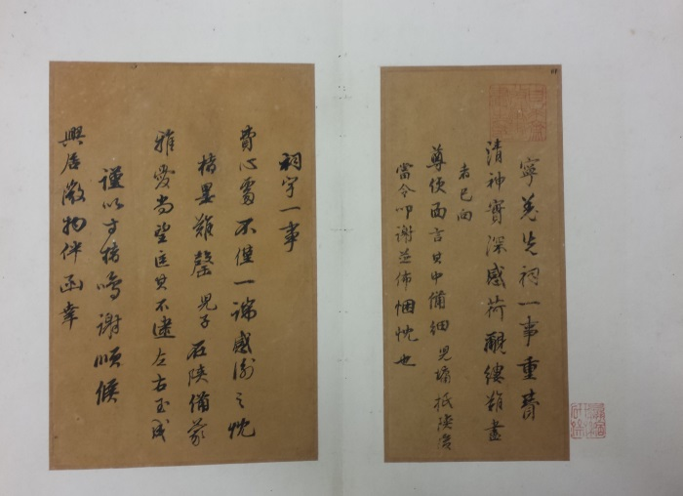

一冊。紙本。經折裝。殘，僅存四頁。高35.1釐米，寬18.5釐米。

前夾板斷裂，後夾板失，並與正文分離。前夾板題簽尚在，云“劉文正公手札行書二十頁/光緒甲午孟夏自求齋主人題檢”。

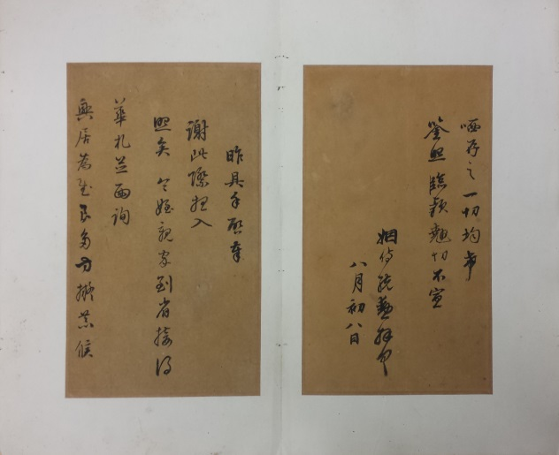劉統勳（1699-1773），字延清，號爾鈍，諡文正。山東諸城人。雍正二年（1724）進士。乾隆元年擢內閣學士。《清史稿》卷三百二有傳。

信中提及兒子劉墉赴陝西，墉乾隆三十七至三十八年（1772-1773）任陝西按察使。此手札當作于此時，不久去世。

鈐“自求齋/所藏書/畫之印”朱文方印，“鏡塘/乙酉後/所得”朱文方印，“嬴縮/研齋” 朱文方印。自求齋主人，待考。

所存四頁手札，計三通。迻錄如下：

寧羌先祠一事，重費清神，實深感荷，覼縷難盡者，已向尊使面言其中備細。兒墉抵陝後，當令叩謝，並佈悃忱也。

祠宇一事，費心處不僅一端。感謝之忱，楮墨難罄。兒子在陝，備蒙雅愛，尚望匡其不逮，左右玉成。謹以寸楮鳴謝，順候興居，微物伴函，幸哂存之。一切均希鋻照。臨款翹切，不宣。姻侍統勛拜書。八月初八日。

昨具手啓奉謝，此際想入照矣。令姪親家到省，接得華札，並面詢興居為感良多，方擬恭候……[下闋]

DESCRIPTION

Calligraphic album of personal letters in running style from Liu Tongxun (1699-1773), originally of twenty sheets in one volume in concertina form, on paper between wooden covers that are missing, 35.1 cm x 18.5 cm.

Liu Tongxun, native of Zhucheng, Shandong, once served the Qianlong emperor as one of his Grand Secretaries.

Only three letters survived on four sheets, in which Liu Tongxun mentioned the appointment of his son Yong (1720-1804) as the Provincial Surveillance Commissioner of Shaanxi in 1772-1773. These three letters were written in 1771-1772, Liu Tongxun’s last years.