[***Shi Chen xiang Kongmiao bei taben*]**

**[史晨饗孔廟碑拓本]**

[The Stele for the Sacrifice to the Confucius Temple by Shi Chen, Rubbing]

一冊。明末拓本。紙本。經折裝。高29.4釐米，寬17.5釐米。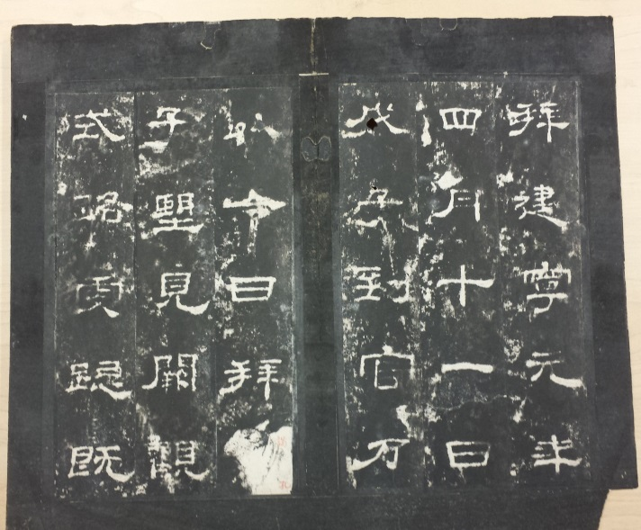

是碑俗稱史晨後碑，刻於建寧元年（168），記述碑主史晨修護孔廟之事。相傳為蔡邕（133-192）所書。隸書十四行，行三十六字。前碑刻於169年，題“魯相史晨祀孔子奏銘”。原在山東曲阜孔廟，1996年移入孔府西倉漢魏碑刻陳列館。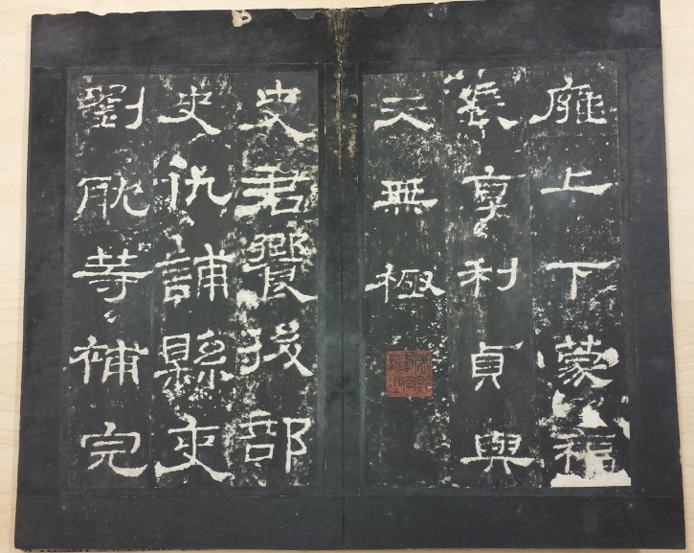

1921年商務印書館影印出版《明初拓史晨前後碑》，實為明末拓本，其前碑十一行“臣輒依社稷出王家穀春秋行禮”中“穀”字之“殳”部中橫已半損，然“秋”字尚完好，當為萬曆以後拓本；十二行“增[異]輒[上]”中“增”字之“日”部中橫已泐。哈佛燕京圖書館藏此後碑拓本兩部，其六行“褒文”與七行“九百”之間石泐連成一片，第八行“上下蒙福”之“蒙”字右側石泐已連及字畫。均屬道光以後拓本。京都大學人文科學研究所所藏同。

此件六行“褒文” 與七行“九百”保存尚好，中間石泐尚未連成一片；“第子合九百七人”中“百”字起筆處未損；第八行“上下蒙福”之“蒙”字右側石泐尚未連及字劃，當屬明末拓本。

該拓本前有散失，闕“相河南史君諱晨字伯時，從越騎校尉”。碑文末唐人題名：“大周天授二年[691]二月廿三日，金台觀主馬元貞，弟子楊景初，郭希元奉於東岳作功德，便謁孔夫子之廟，題石記之。內品官楊君尚，歐陽智琮”，下闋“宣德郎行兗州都督府倉曹參軍事李叔度”。

鈐“吳熙/載字/讓之”白文方印，“頤性/老人”朱文方印，“光風/霽月”朱文方印，“[小]停雲*/*山館”朱文方印，“龐褘”白文方印。為阮元、吳熙載舊藏。阮元（1764-1849），晚號頤性老人，其《山左金石志》卷八著錄此碑。吳熙載（1799-1870），字讓之，工篆刻書法。

DESCRIPTION

Seventeenth-century rubbing from the *Stele for the Sacrifice to the Confucius Temple by Shi Chen*, in one volume in concertina form, on paper, 29.4 cm x 17.5 cm.

The stele was erected in AD 168, traditionally accredited to calligrapher Cai Yong (133-192), as a monument for the sacrifice by Shi Chen, a minister of the Lu State, to Confucius Temple in Qufu, Shandong, where the stele is currently reserved.

This rubbing was made in the seventeenth century. The historical cracks and perforations still appear thin between the characters “*baowen*” 褒文in Column Six and “*jiubai*” 九百in Column Seven and do not damage the character “*meng*” 蒙 in Column Eight; these five characters remain visually complete in form. These physical features are unique in the seventeenth-century rubbings of this inscription.

The copy collected in the Harvard-Yenching Library was made after 1850, as that in the Institute for Research in Humanities, Kyoto University was.

The first page of this rubbing and the last page of the 691 postscript (carved into the original stele) are missing.

This rubbing was owned, successively, by Ruan Yuan (1764-1849), an official and evidential scholar who catalogued this inscription in his bibliography, and Wu Xizai (1799-1870), a seal carver and calligrapher.

**Reference matter 參考文獻**

明初拓史晨前後碑。上海：商務印書館，1921。

仲威，中國碑拓鑒別圖典。北京：文物出版社，2010。

王壯弘，增補校碑隨筆。臺北：華正書局，1985。