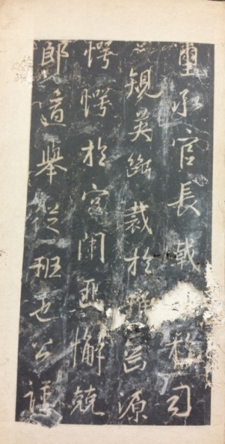*T****ang Daya ji Youjun shu Wu Jiangjun bei***

**唐大雅集右軍書吳將軍碑**

The Stele for General Wu with Calligraphy by Daya of the Tang in Wang Xizhi’s Style, Rubbing

一冊。乾隆拓本。紙本。經折裝。高27.1釐米，寬14.7釐米。殘闕，中有破損。題簽鈐“紹庭/審定”白文方印。首頁鈐“生來情/性不宜官”朱文橢圓印，“紫藤/華館”白文方印。

即“興福寺半截碑”。舊稱“吳文殘碑”。開元九年（721）僧大雅集王羲之行書。明萬曆間（1573-1620）出土於西安南城。出土時僅存下半截，故俗稱“半截碑”，存三十五行，行二十三四五字不等。現存西安碑林博物館。

此件為乾隆拓本。第二十行“窺四序”中“四”字已無，而明本完好。據説初拓本二十七行“及厭塵滓”中“及”原作“乃”，此件作“及”。而此件八行“英斷裁於稚齒”中“斷”字之“斤”部完好；二十五行“瘞將軍於地下”中“軍於”二字完好。

哈佛燕京圖書館藏有三部，八行“斷裁”之“斷”字“斤”部殘泐，二十五行“軍於”二字殘損，為乾隆以後拓本。

DESCRITPION

Rubbing of the *Stele for General Wu* of the Tang dynasty in one volume in concertina form, on paper, 27.1cm x 14.7 cm.

The stele was erected in 721, with the inscription written by the Buddhist monk Daya in Wang Xizhi’s running style. Only half survived and was excavated during the Wanli period (1573-1620) in Xi’an, where it is currently reserved.

This rubbing was made in the Qianlong period (1735-1796). The character *duan* 斷 in Column Eight appears normal with its last stroke undamaged. Three rubbings of this inscription collected in the Harvard-Yenching Library are much later than this copy.

**Reference matter 參考文獻：**

仲威，中國碑拓鑒別圖典。北京：文物出版社，2010。

吳文殘碑。哈佛燕京圖書館藏。

王壯弘，增補校碑隨筆。臺北：華正書局，1985。