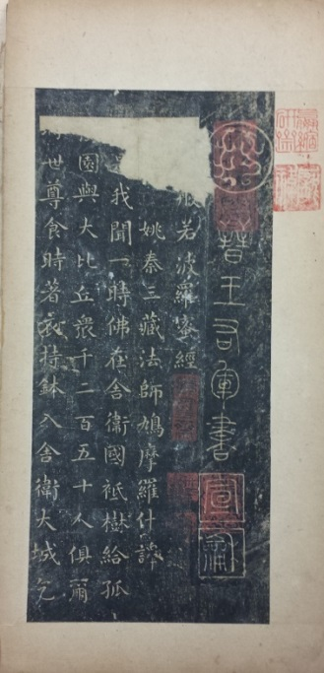[Song shike *Jingang jing* taben]

[宋石刻金剛經拓本]

[Rubbing of the Song Inscription of the *Diamond Sutra*]

一冊。明中葉以前拓本。紙本。經折裝。高28.8釐米，寬14.5釐米。硬木夾板。失題簽。散亂失次。首頁鈐“嬴縮/研齋”朱文方印，“龐/褘”白文方印，“天籟閣”白文長形印，“觀雪齋”白文方印，另有三印不可辨識。末葉鈐“易其/田疇”朱文方印，“程氏/瑤田”朱文方印。

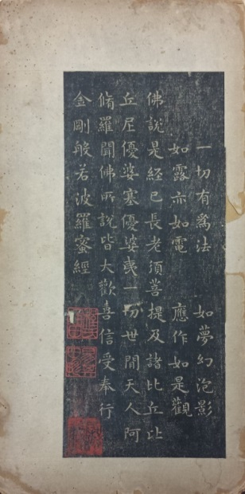首行篆題“晉王右軍書”，刻“宣和”印；末行署 “永和十二年六月旦日山陰王羲之書”，顯係後人摹王羲之（303-361）而託名。程瑤田（1725-1814）、王芑孫（1755-1818）跋有辨別。程瑤田跋云：金剛經，鳩摩羅什所譯。世以爲右軍書，誤矣。足本神味古逸，的是鍾、王家法。刻者當是宋人。紙墨色亦舊，足供清玩。乾隆庚戌[1790]春日，程瑤田跋，時年六十又六。鈐“易田”朱文方印。

王芑孫跋云：宋人仿書有絕精者。予嘗見墨跡黃庭一本於彭尺木家，亦織成黃素，用青絲界道，筆勢腴潤，欲令人不思真跡。此金剛經大抵亦從此種傳本鉤摹入石，故清古之趣溢出行墨，即非真唐人書，亦可寶也。乾隆癸丑[1793]五月王芑孫記。鈐“鐵夫”印。

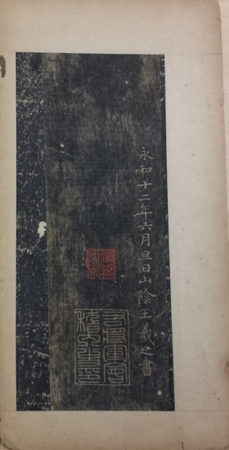王芑孫又云：首行篆題，末行款署，皆他本誤襄。不獨末行楷法與經文不類，紙墨亦不相似耳。惕甫再識。鈐“王芑孫”朱文長形印。

此件加鑲篆題，或意在表明其為宋刻。或為明嘉興項元汴（1525-1590）天籟閣舊物。

程瑤田，字易疇，號葺荷，又號葺翁。安徽歙縣人。《清史列傳》卷六十八有傳。王芑孫，字念豐，號鐵夫，又號惕甫。江蘇長洲人。墓誌銘見秦瀛《小峴山人文集補編》。

DESCRIPTION

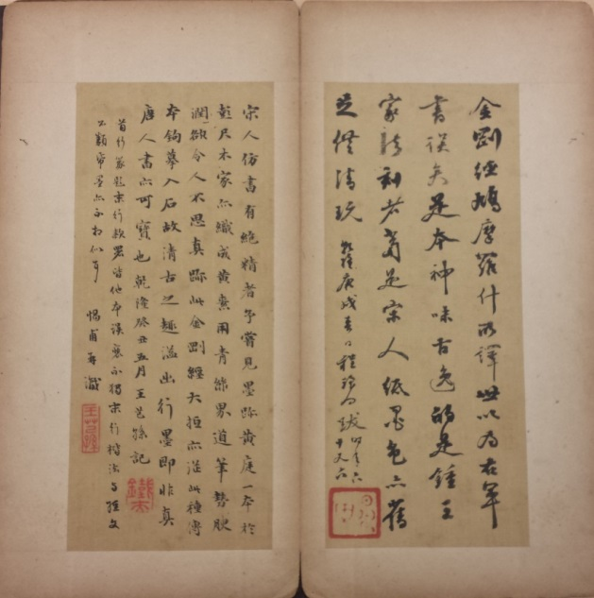Calligraphic album of the rubbing of a Northern Song (960-1127) inscription of the *Diamond Sutra* in one volume in concertina form, on paper between wooden covers, 28.8cm x 14.5 cm.

The inscription, in formal style, of the Diamond Sutra, a Buddhist text translated by Kumārajīva (334–413) from Sanskrit into Chinese, conventionally had been accredited to calligrapher Wang Xizhi (303-361). Yet the surviving rubbing, as two evidential scholars argued in their postscripts to this copy, demonstrates that the inscription was a Northern Song creation in Wang Xizhi’s calligraphic style.

Cheng Yaotian (1725-1814) once owned this rubbing. In his 1790 postscript, he approved its aesthetic value as a Northern Song inscription. Three years later, his friend Wang Qisun (1755-1818) confirmed Cheng’s judgement and found that the columns of title, date and signature were added in mounting the rubbing on paper.

This item possibly was owned by bibliophile Xiang Yuanbian (1525-1590), with one of his special seals stamped above the title. This rubbing could be made in the sixteenth century or earlier.

**Reference matter 參考文獻**

Hummel, *ECCP*, vol. 2, p. 695 for Cheng Yaotian, vol. 2, pp. 620, 658 for Wang Qisun.