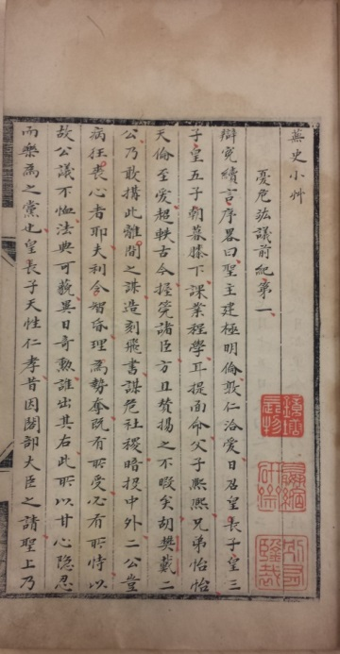*Wu shi xiaocao*

蕪史小艸

A Short Draft of the Miscellaneous History

劉若愚著。康熙四十六年丁亥（1707）張謙宜精抄批本。不分卷。朱筆批點。四冊。黑絲欄。匡高17.9麗米，寬12.2釐米。九行，行二十四字。四周單邊，大黑口，雙黑魚尾相對。鈐“珠雲/仙館藏/書印”朱文方印，“嬴縮/硯齋/藏書”朱文方印，“張印/謙宜”白文方印，“丙戌/進士”朱文方印，“壹門/八登/甲科”朱文方印，“嘿園/眼福”朱文方印，“嬴縮/研齋”朱文方印，“鏡塘/長物”白文方印，“鏡塘/所藏/精品”白文方印，“有味”朱文橢圓印，“張循/宜印”白文方印。

封面題“蕪史”，下鈐“藏書”白文長形印。首“蕪史題詞”，署“康熙四十六年嵗次丁亥四月初七日，膠州進士張謙宜書。”次錄《明史記事本末》“崇禎元年下太監李永貞、劉若愚、李實於獄”條，末云：

聞之羅飯牛曰：劉若愚崇禎十三年赦出，蕪史改爲酌中志，在江寧承恩寺前見此書，未及買。抵淮上，觀紫函鈔本，凡舊稿所缺者，皆在焉。異日購得，方愜予意。故記之。

康熙戊子[1708]四月二十五日，稚松書於竹窓，歸家計二十三日矣。

次劉若愚“蕪史小艸次序”。崇禎七年識語，分是書為二十三節。後補識語，釐辨書中稱謂。

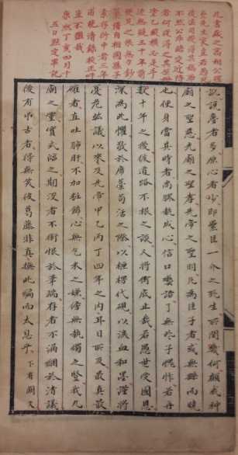書末有“書蕪史後”，署“康熙丁亥[1707]四月朔八日，山東學究題。”

正文末葉有朱筆跋，云：

此書藏之高相公硜參先生家。豈弱愚死後，法司搜得其稿耶？不然，公非結交近侍者，何從得之？其原冊塗乙縱橫，必是手跡無疑。三十年前便見之，恨無力鈔纂。借自相國孫子素，存衍中者三年，甫能清錄校正。吁，豈不難哉？康熙丁亥[1707]四月十五日，點定畢記。

逆賢脅從第十五全闕。

該書即劉若愚《酌中志》，述明萬曆、天啓宮廷掌故。謝國楨《增訂晚明史籍攷》著錄。據張謙宜所述，其本抄自劉氏手稿。因手稿有殘缺，故其抄本亦註明闕處，而所闕者於《酌中志》中可見。中國國家圖書館藏有清内府抄本，鈐“雍正宸賞”印，影印本收入《稀見明史史籍輯存》（北京：綫裝書局，2003）第十冊；兩本差異如何，待考。

全祖望（1705-1755）《鮚埼亭集外編》卷二十九，稱其家舊藏《酌中志略》原稿，為劉氏手寫本，其中塗竄頗多，與近本閒有不同。不知其家藏是否即張氏所據同。

劉若愚（1584-約1642），宦官。《明史》卷三百五有傳。張謙宜，字稚松，一字山農。膠州人。康熙丙戌（四十五年，1706）舉進士，已年逾六旬，不仕。道光《重修膠州志》卷二十八有傳。有《絸齋詩選》二卷，《四庫全書總目提要》卷一百八十四著錄。

匡源（1815-1881），字鶴泉，山東膠州人，別署珠雲仙館。道光二十年（1840）進士。清史稿卷三百八十七有傳。

DESCRIPTION

A fine manuscript scribed in 1707 in four volumes in thread-stitched binding style, on paper with black lines, 17.9cm x 12.2cm, twenty-four characters of nine columns, single edge lines, black folding line, and two folding spots.

This book, also known as *Zhuo zhong zhi*, records the institutions, buildings and events in the Ming court during the Wanli and Tianqi reigns (1572-1627). The eunuch Liu Ruoyu (1584-ca.1642) wrote this book in jail, attempting to defend himself against the accusation of his involvement in the eunuch faction.

Because of its political sensitivity, Liu’s book was just circulated in manuscript form in the early Qing. This manuscript, according to the scribe Zhang Qianyi (1640s-the early 18th century), was made in 1707 after an earlier manuscript that he believed was Liu’s original draft. Zhang witnessed this draft around 1677 but could not transcribe it until his success in the 1706 metropolitan examination, when he was over 60 years old. Zhang read this manuscript carefully and wrote down his comments in red. A few sections in this manuscript are incomplete or missing because, according to Zhang, the draft he followed was so.

A manuscript of the same title is held in National Library of China in Beijing, which bears one seal of the Yongzheng emperor’s (r. 1722-1735) and could be later than this copy.

**Reference matter 參考文獻**

Goodrich, *DMB*, pp. 950-953 for Liu Ruoyu.

Dardess, John W. *Blood and History in China: The Donglin Faction and Its Repression, 1620-1627*. Honolulu: University of Hawai’i Press, 2002.

謝國楨，增訂晚明史籍攷。上海：上海古籍出版社，1981。

全祖望，祖望集彙校集注。朱鑄禹校注。上海：上海古籍出版社，2000。