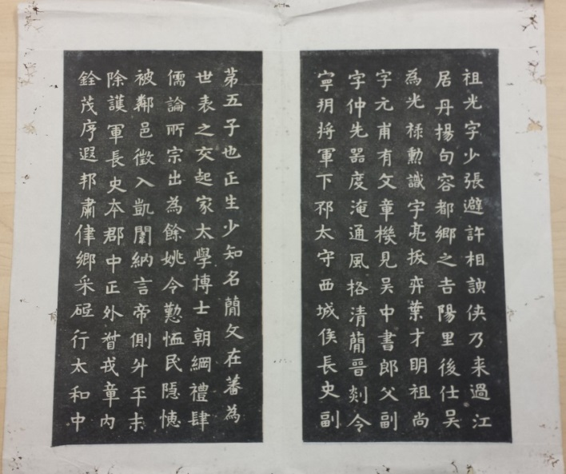[***Xu Zhangshi jiuguan tanbei taben canye*]**

**[許長史舊館壇碑拓本殘葉]**

[A Rubbing of the Stele for Administrator Xu’s Site Altar, Fragments]

僅存兩頁。僞刻拓本。紙本。高33釐米，寬18釐米。起“祖光，字少張”迄“行太和中”。

全稱《上清真人許長史舊館壇碑》。是碑立於梁天監十七年（518），陶弘景（456-536）撰文，孫文韜（六世紀人）書碑。碑文全文收入陶弘景文集及道藏，因保存許謐（305-376）父子重要史料，成爲道教史重要文獻。此碑曾在唐代重立、大歷十三年（778）洗刻，後毀於明嘉靖閒（1522-1567）。清代流傳拓本，朱彜尊（1629-1709）《曝書亭金石文字跋尾》記有爛溪潘氏本。後以顧沅（1799-1851）鈎本流傳較廣（1876），據稱出自范氏天一閣拓本（十六世紀中期以前），收入《石刻史料新編》第三輯第二冊。普林斯頓大學圖書館藏有《大梁上清真人許長史舊館壇碑》拓本(Call# CN1160.D35 1800)。

此殘葉墨色烏黑，字劃清晰。更可疑之處在於，顧氏鉤本可見石泐，此件不見明顯石泐。普林斯頓本有自然石泐，字體偏瘦。比較顧氏鉤本，普林斯頓本標題作“舊館”，鉤本作“舊舘”；“此一行隱居手自書”中“一”字，普林斯頓本完好，鉤本已殘泐；“宇宙之靈也”、“文跡可記”中“也”、“記”之末筆，普林斯頓本端正完好，而鉤本歪斜難以入目，顯係剜改所致。“化育羣生”之“育”字，普林斯頓本完好，而鉤本末筆已泐。普林斯頓本顯然拓自原石，且較鉤本祖本即天一閣本為早。殘葉運筆拘謹。普林斯頓本“寕”，殘葉中該字中間一部闕，與鉤本同。殘葉字體偏肥，與顧氏鈎本極近，雖個別字筆畫有少許差異，但殘葉顯然來自鉤本，而非原石，很有可能拓自鉤本之翻刻本，為十九世紀後期僞作。

DESCRIPTION

Rubbing of the *Stele for Administrator Xu’s Site Altar*, folding paper, only two pages extant, 33 cm x 18 cm.

The original stele was erected in 518, with the text by Daoist master Tao Hongjing (456-536) and calligraphy by his disciple Sun Wentao (fl. the 6th century), narrating another Daoist master Xu Mi’s (305-376) life. The stele was repaired in 778 and completely ruined in the Jiajing period (1522-1567).

In addition to a copy recorded as having been seen in the second half of the seventeenth century but unfortunately lost, a nineteenth-century delineated edition has been published (1876) and widely circulated. Derived from the original rubbing once owned by the Tianyige Library (formed in 1561-1566) but lost too, the delineation allegedly is the only edition close to the original inscription, yet the copy in the East Asian Library of Princeton University (call# CN1160.D35 1800) helps in authenticating the fragments.

Compared with the Princeton edition, the delineation came from a much later rubbing, while the fragments genealogically were much closer to the delineation in terms of writing style. As some strokes in the fragments appear slightly different from those in the delineation, the fragments possibly were from a late nineteenth-century imitation of the delineated edition.