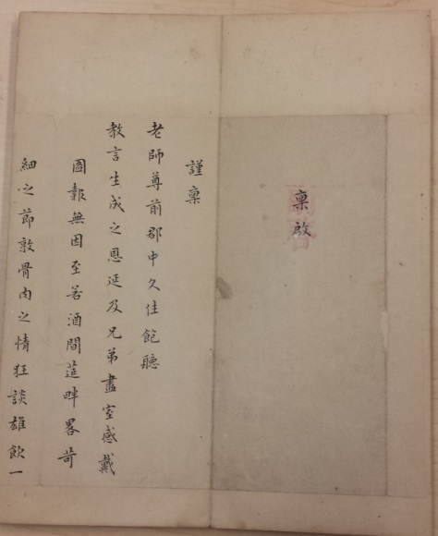*Zh****ao Qiugu xiansheng moji***

**趙秌谷先生墨跡**

(Zhao Zhishen’s Original Hand Scripts [of Two Letters])

一冊。趙執信書，雍正七年八年閒作品。紙本。經折裝，木夾板。半葉高24.3釐米，寬10釐米。鈐“鏡塘/讀過”白文方印，“鏡唐/審定”朱文方印，“嬴縮/研齋”朱文方印。

是件收入趙執信書札二通。第一通信札，當作於雍正六年至七年間（1728-1729）。據年譜，雍正五年七幼女夭亡；是書亦未提八年初所遭家難。鈐“執信”朱文連珠印。第二通作於雍正八年（1730），專為家難事。年譜引“千金歌注后跋”，是年遭家難，至次年方解。此二信札均不見於傳世文集。

趙執信（1662-1744），字仲符，又字伸符，號秋谷。山東益都人。康熙十八年（1679）進士。二十八年（1689），坐國恤中讌飲觀劇，為言者所劾，削籍歸。《清史稿》卷四八四有傳。工吟詠，善書。

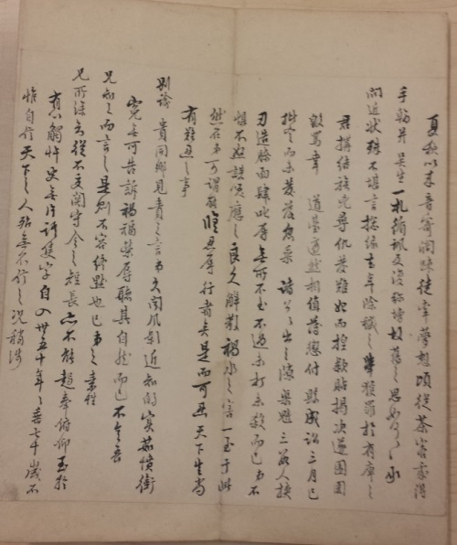

DESCRIPTION

Calligraphic album in one volume in concertina form, on paper between wooden covers, 24.3 cm x 10.0 cm.

Two letters by poet and calligrapher Zhao Zhishen (1662-1744) are contained in this album. The first one in the formal style was written in 1728-1729 mentioning his youngest daughter’s death in 1727, and the second in the running style written in 1730 defending himself against a false accusation of murder. Neither has ever been published.

**Reference matter 參考文獻**

Hummel, *ECCP*, vol.1, p. 71.

李森文，趙執信年譜。濟南：齊魯書社，1988。