Ma Shouzhen 馬守貞 (1548-1604. Attributed)

*Orchids and Bamboo by Ma Xianglan*

(Alternative title: *Orchids, Bamboo, and Rock: Lingzhi, Orchids, Bamboo and Rock*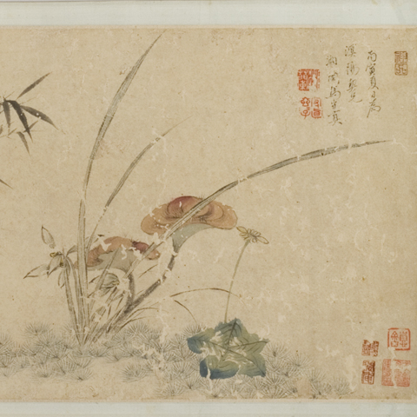)

馬湘蘭蘭竹

*Ma Xianglan lan zhu*

Painting

Dated 1576 (Section 1) & 1566 (Section 2)

Handscroll; ink and color on paper; 31.2 cm x 955 cm (sheet); image: 29.5 cm x 127.4 cm (painting)

The Mactaggart Art Collection. Access # 2004.19.56

Gift of Sandy and Cécile Mactaggart

FRONTISPIECES

Inscription

(1 row in seal script)

*jiu wan zhi lan* 九畹芝蘭

ARTIST’S INSCRIPTIONS & SIGNATURES

Section One

(2 columns in semi-cursive script)

In the spring of the *bing zi* year (1576), your [sworn] sister Shouzhen paints for you, my sworn old brother Baigu (i.e. Wang Zhideng王穉登[1535-1612]).

丙子春日妹守真爲/百榖兄寫

Section Two

(3 columns in semi-cursive script)

In the summer of the *bing yin* year, created for my sworn older brother Mingyang, by Xianglan, Ma Shouzhen.

丙寅夏日爲/溟陽契兄/湘蘭馬守貞

ARTIST’S SEALS

*Xianglan* 湘蘭, square relief (repeated twice)

*Ma shi Yuejiao* 馬氏/月嬌, square intaglio

*Xianglan* 湘蘭, square intaglio

*Shouzhen Xuanxuanzi* 守真/玄玄子, square relief

*Xianglan nüshi* 湘蘭/女史, square intaglio

*Jiu wan zhong ren* 九/畹中/人, square relief

COLOPHONS

Pei Jingfu 裴景福 (1854-1924)

(4 columns in regular script on yellow silk)

In creating this handscroll, [Ma Shouzhen] used her brush with accuracy, power, and excellence. It is superior to those paintings by Ma Quan馬荃 (fl. the 18th century) and Chen Shu陳書 (1660-1736), just because of her graceful genie. What a remarkable lady Xianglan is!

Recently I obtained another piece by Lady Ma. It is a handscroll painting of narcissus, a sketch with ink on paper. It is absolutely remarkable! She is really a bright student of Zhao Mengjian’s 趙孟堅 (1199-1264). Both this piece and the above handscroll are collected in my Zhuangtao Hall (*Zhuangtao ge*).

此卷用筆清勁超逸，尚在馬江香、陳南樓之上，/自是君身有仙骨。湘蘭真奇女子哉。/

頃復得馬卿白描水仙紙本橫幀，精妙絕倫，真子/固入室高足也。同此卷並藏於壯陶閣。

Lu Yiqian 陸以謙 (*juren* 1780), dated 1785

(4 columns in cursive script)

A green brook runs beside her painted house, with water shinning

The Xiang River is entirely represented in the spring.

Sitting beside the window, she smells fragrance

Her heart should be born out of the flower blooming.

Her breathe is sweet and tastes close [to literati’s]

She is magnanimous yet sometimes simple

Who are as heroic as Zhujia and as generous as Ji Bu today?

I do not believe there are ladies like her in a brothel.

On the thirteenth day of the ninth lunar month of the *yi si* year (October 15, 1785), Yiqian records

青溪畫閣水粼粼，寫出湘江一片春。相對小窓/芬可襲，芳心應是此花身。 吹氣如蘭臭/味親，豪情又復露天真。朱家季布今誰/是，不信青樓有此人。乙巳重九後四日以謙題。

[Zhang Yanchang 張燕昌 (1738-1814) (I)][1]

(4 columns in regular script)

[Ma Shouzhen is also good at] painting. [Her works] have raised the price of paper in the cities; jujube trees in mountains were logged [to make printing blocks] without regrets. Under the torsades of the canopy bed, the reader sits up until the late moon peeks in. In front of the jade-mirrored dressing table, the reader recites [her verse] until the morning mist has already descended upon the trees. Who says that only Xue Tao (768-831) of Jinjiang can claim the title of “Collator”? Nor was Du Wei of Jinchang (today’s Suzhou) the only one who distresses the magistrate so![2] After Ma’s death, Wang Zhideng wrote her biography and composed twelve stanzas of four lines. Even today poets who visit her district in Nanjing will write poems for her with regrets.

青箱。既高都市之紙價，遑惜山林之棗林。俾流蘇帳底，披之而夜月窺/人；玉鏡臺前，諷之而朝烟縈樹。奚特錦江薛濤，標書記之目？詎止金/閶杜韋，惱刺史之腸而已哉？湘蘭沒，伯榖爲作儔，賦挽詩十二絕句。至今/詞客過舊院者，皆爲詩吊之。[3]

Dong Bin 董彬, dated 1785

(3 columns in regular script)

With her delicate and graceful mind, how skillfully she paints

Though from a pleasure quarter, she has been esteemed in artistic circles.

What a shame! – Ma Shiying (1591-1646) is also good at painting,

But his pieces wouldn’t be circulated unless his signature was changed into a lady’s.

*In his paintings, Ma Shiying’s signature was later changed into a courtesan Feng Yuying’s, because his conduct was criticized with hatred.*

In the late autumn of the *yi si* year (1785), Dong Bin records.

婀娜芳心點綴工，狹邪猶重萟林中。憐他瑤草/徒工畫，不教流傳改姓馮。馬士英畫，後人惡其行，/改爲妓女馮玉瑛云。/乙巳秋杪董彬題。

[Zhang Yanchang (II)][4]

(13 columns in regular script)

*Selection of Ming Poems* (*Ming shi zong*): Ma Shouzhen, courtesy name Xianglan, also known as Xuan’er and Yuejiao, is a courtesan in Nanjing. She published a collection of her poems.

*Poetic Criticism in the Calm Will House* (*Jingzhi ju shihua*): Xianglan looked average, but she was unrestrained, attractive, and sweet to understand others’ wishes. And with her heroic and generous personality, she often gave money out to young men. When she was in difficulty with an official named Mo, Wang Zhideng of Suzhou as a moderator helped her out. She appreciated his favor and since then had expected to marry him, but Wang declined. In the autumn of the *jia chen* year (1604) in the Wanli reign, Wang would become seventy years old. Xianglan bought a storied boat, with fifteen girls on board, and visited Wang’s Garden of Flying Willow Catkins (*Fei xu yuan*) in which she hosted banquets to celebrate his birthday.[5] Her girls sang and danced every morning and evening during the celebration of one month. She and Wang were really good friends.

Wang prefaced the collection of her poems. Here is an abstract: Moling (today’s Nanjing) is renowned for its beautiful women. In the alleys of the pleasure quarters love is inscribed on peach leaves, willow strands are entangled in sorrow. There are found unruly foibles, and the union of cloud and rain. There lives a beauty of unsurpassed talent and charm. Her family name Ma recalls the priceless stallions on the market of Yan; her given name Xianglan evokes the fragrant grasses gracing the River Xiang. She regards money as dirt – when aiding friends in need she is as generous as Zhu Jia. Yet she considers a promise as weighty as a mountain – in keeping her word she is a female Ji Bu. She wields a writing instrument made of glittering gems; every word from it moves like wind and cloud. She fingers sheets of paper made of jade leaves; every word she utters is [as serene as] moon dew. Tracing the new sounds of “Midnight”, she recreates the old songs of “Garden Blossoms”. Who says that only Xue Tao (768-831) of Jinjiang can claim the title of “Collator”? Nor was Du Wei of Jinchang (today’s Suzhou) the only one who distresses the magistrate so![6] Their stories spread as charming anecdotes in pleasure quarters.

明詩綜：馬守真，字湘蘭，一字元兒，又字月嬌。金陵妓。有集。/靜志居詩話：湘蘭貌本中人，而放誕風流，善伺人意，/性復豪俠，恒揮金以贈少年。感吳人王伯榖解墨/郎之阨，欲委身焉。伯榖不可。萬厯甲辰秋，伯榖秊七/十，湘蘭買樓船，載小鬟十五，造飛絮園，置酒爲/壽，晨夕歌舞，流連者累月，亦勝引也。伯榖序其詩，/大略云：秣陵佳麗之地，青樓狹邪之間，桃葉題情，/柳絲牽恨。胡天胡帝，爲雨爲雲。有美一人，風流絕代。/問姓則千金燕市之駿，託名則九畹湘江之英。輕泉日若/土壤，翠袖朱家；重然諾如邱山，紅妝季布。爾其搦琉/璃之管，字字風雲；擘玉葉之牋，言言月露。翻庭花/之舊曲，按子夜之新聲。奚特錦江薛濤，標書記之/目，金昌杜韋，惱刺史之腸而已哉。曲中傳爲佳話。[7]

Zhang Yanchan 張燕昌 (III), dated 1785

(7 columns in regular script)

In the waterfront pavilion by the Qinhuai River, listening to sweet orioles singing

Enjoying the friend’s voice and loving the beauties of spring

Both bamboo and orchids praise her talent

Yet, how sentimental her brush and ink cannot help being.

*I have in my collection three paintings of orchids and bamboo by Xianglan, one dedicated to her sworn brother Baigu, one for her sworn brother Songzhou, and this third one for her sworn brother Mingyang. Baigu helped her out of her difficulty with a Master Mo. As for Songzhou and Mingyang, I do not know who they are. And regarding the relief seal* Qinhuai shui ge *(lit. waterfront pavilion by the Qinhuai River), I witnessed it once impressed in the corner of a small hanging scroll of orchids and bamboo by Xianglan.*

*In the late autumn of the* yi si *year in the Qianlong reign (1785), after watching maple leaves in my Misty Wave House, I sail to the Laurel Village and moor at the Sweet Flower Bridge, where I randomly examine my scrolls and albums. Zhang Yanchang writes and records.*

秦淮水閣聽嬌鶯，消受春光戀友聲。/虛竹幽蘭誇慧業，翻嫌筆墨太多情。/余所藏湘蘭蘭竹三種，一爲百谷大兄，一松洲兄，此則曰溟陽/契兄。百谷曾爲解墨郎之厄。松洲、溟陽，不知何許人也。/又秦淮水閣朱文印，見湘蘭小立幅蘭竹押角。/乾隆乙巳秋杪，烟波宅看紅葉，泊金粟香花橋/畔，偶檢卷冊。張燕昌題并識。

Wang Wenzhi 王文治 (1730-1802)

(5 columns in regular script)

Lady Ma IV of Jinling is chivalrous

Her painting brush perpetuates her rouge fragrant

With orchids, she remembers her lover’s favors,

Yet standing alone by the river in sunset

*Once I had at home a small hanging scroll of orchids in ink by Ma Shouzhen. It is remarkable without equal. I saw Dong Qichang’s (1555-1636) handwriting of the* Inscription of Mount Yanran *in the collection of a friend of mine, and exchanged [with Ma’s painting] for Dong’s calligraphy. Today, while inspecting this album, I recall that scroll I had, and deeply feel that I cannot forget it. The hermit in the Admonition Studio [Wang] Wenzhi writes and records.*

女俠金陵馬四孃，吮毫猶帶口脂香。紉秋一段離騷/意，獨向湘陰對夕陽。/余家舊藏守真子墨蘭小幅，精妙無匹。因見友人處董/文敏書燕然山銘真跡，遂與易之。今觀此冊，追憶舊/藏，殊覺未能忘情也。 □ [放]下齋居士文治題并記。

Xi Gang 奚岡 (1746-1803)

(5 columns in regular script)

*In her paintings of orchids in ink, Ma Xianglan carried on the tradition that Guan Daosheng (1262-1319), the Lady of Wei, developed. Occasionally, Ma painted plum trees and bamboo, with lots of charming elegance. The three paintings by her in this album represent her delicacy and grace of her wrist and fingers [running brush]. They remind us of the legendary ladies by the Xiang River and are as meaningful as the Chu songs. Therefore I compose a stanza of four lines*:

From Guan Daosheng came her usual beauty and elegance

Every leaf ends fresh as if ink still remains wet

Throughout the paper spring breeze passes with grace

How lovely Orchid by the Xiang River as her given name is[8]

The Owner of the Winter Flower Studio, Xi Gang, records

馬湘墨蘭，深得魏國夫人遺意。間作梅枝竹篠，更/饒風致。是冊三種，幽姿逸態，溢出腕指間，令人有湘潭/灃浦之想，亦無聲之楚騷也。因賦一絕：/清標合共管姬看，葉葉豪端墨未乾。滿帋春風太婀娜，真憐小字喚湘蘭。 冬華盦主奚岡識。

Hu Bicheng 胡璧城 (1868-1925), dated 1919

(3 columns in cursive script)

All remains have become old at the end of the Plank Bridge

A orchid still lives there, reminding of her delicacy

The most sentimental is Wang Zhong (1745-1794),

who exhausted his talents to write of this beauty

In the eight lunar month of the *ji wei* year (1919), Hu Bicheng

紅(橋)板橋頭跡已陳，一枝婀娜想/風神。多情最是汪容甫，費盡清/才弔玉人。己未八月，胡璧城。

COLOPHON WRITERS’ SEALS

Lu Yiqian 陸以謙 (fl. the 18th century)

*Pingyuan Lu shi* 平原/陸氏, square intaglio

*Yiqian zhi yin* 以謙/之印, square relief-intaglio

*Taichong* /太沖, square relief

Zhang Yanchang 張燕昌

*Shigu ting* 石鼓/亭, square relief

*Jinsu shanren* 金粟/山人, rectangular relief

*Wenyu* 文/魚, square relief

*Zhang Yanchang* 張/燕昌, square relief

Dong Bin 董彬

*Dong Bin* 董/彬, square relief

Wang Wenzhi 王文治

*Wenzhi* 文治, rectangular intaglio

Xi Gang 奚岡

*Mengquan waishi* 蒙泉/外史, square intaglio

*Xi Gang zhi yin* 奚岡/之印, square relief-intaglio

Hu Bicheng 胡璧城

Kuigong shuhua 夔公/書畫,

COLLECTORS’ INSCRIPTIONS

Pei Jingfu / Zhu Wanyi 朱婉宜

(2 columns in regular script)

These two remarkable paintings by Mao Shouzhen, both in the Beauteous Class in the Zhuangtao Hall collection. Jie’an

Precious volumes in the fairyland. Zhu Wanyi of Jinchang (today’s Suzhou) collected them into the Zhuangtao Hall.

馬卿雙璧。壯陶閣中艷品。睫庵。

靈霄寶笈。金閶朱婉宜充壯匋閣秘篋收掌。

COLLECTORS’ SEALS

Fang Shishu 方士庶 (1692-1751)

*Fang yin Shishu* 方印/士庶, square intaglio

Pan Yanling 潘延齡 (fl. the 19th century)

*Yanling zhi yin* 延齡/之印, square intaglio

*Jian’an* 健庵, rectangular relief

*Ceng cang Pan Jian’an chu* 曾藏潘/健盦處, tall rectangular relief

*Yanling jizi* 延齡/季子, square relief-intaglio

*Jian’an pingsheng zhen shang* 健菴/平生/真賞, square relief

*Pan shi Jian’an zhencang shu hua yin* 潘氏健/盦珍藏/書畫印, tall rectangular relief

Pan Shicheng 潘仕成 (1804-1873)

*Deyu* 德/畬, square relief

*Hai shan xian guan zhencang shu hua yin* 海山僊/館珍藏/書畫印, square relief

Zhang Xueliang 張學良 (1901–2001)

*Linming Zhang shi zhencang* 臨溟/張氏/珍藏, square intaglio

*Lin zhi zi* 霖/之子, square intaglio

*Yi’an* 毅/盦, square relief

UNIDENTIFIED SEALS

*Fan xia zhuren shu hua zhi yinji* 飯霞主/人書畫/之印記, square relief

*shenpin* 神品, rectangular relief

CATALOGUED

Weidner, *Views from Jade Terrace*, pp. 78-81.

Tsang, *Brilliant Strokes*, pp. 8-11.

Pei Jingfu 裴景福. *Zhuangtao Ge shu hua lu* 壯陶閣書畫錄, 11:36a.

NOTE

A HANDSCROLL painting depicting orchids, bamboo, fungus, and rocks. It was originally two separate handscroll paintings that were remounted together. Both paintings are attributed to the famous courtesan painter and poet Ma Shouzhen (1548-1604), the first dated 1576 and dedicated to her patron and lover Wang Zhideng 王穉登 (1535-1612), and the second dated 1566 and created for a patron whose courtesy title is Mingyang (see below). Both paintings are highly suspicious as the colophons are.

Ma and Wang met each other for the first time in 1572. Their continuing yet unfruitful romance until Ma’s death in 1604 was widely known and praised among literati in their ages and later centuries. Her popularity among leading scholars inspired increasing forgeries of her works on the arts market in the seventeenth and eighteenth centuries. Only a very few paintings and handwritings have recently been confirmed authentic, including eight letters she wrote in 1578-1604 to Wang and an album she created in 1593 for him. The letters are collected in the Shanghai Library and the album appeared at the 2013 Poly Auction in Hong Kong (Lot #1001). The handwritings she signed on these two items clearly were from the same hand.[9]

The inscriptions and signatures on the current handscroll obviously are in styles different from that in the 1593 album and her letters (see *Plates 1 & 2*). Noticeable and illuminating are the characters *chun* 春 (lit. spring), *qixiong* 契兄 (lit. sworn brother), *ma* 馬 (lit. horse; herein her family name), and *Baigu* 百榖 (her lover’s given name). Those on the current handscroll are imitations, skillful but careless. In terms of composition, the second painting features an unusually short end that should have been longer and reserved for the date and signature by the artist who definitely was not Ma Shouzhen. The forger cut the original date and signature away but added an inscription, a signature, and two seals at the beginning. In the added inscription, the patron Mingyang (Cai Maozhao 蔡懋昭 [ca. 1519- ca. 1608]) was much less known. A painting dedicated to a scholar like him would be hard to falsify, which is common in Chinese forgeries. All seals on the two original paintings are forgeries.

The colophons were made to convince prospective purchasers, but the texts betray the forger. All seals attributed to the colophon writers appear inferior to those recorded as authentic. Three colophons attributed to Zhang Yanchang (1738-1814) are obviously from different hands. The first one in his name was a quotation from Qian Qianyi (1582-1664); its first two characters *qingxiang* 青箱 should not precede this paragraph but end a sentence that was cut away. It is an error that an erudite scholar like Zhang should not make. According the one precisely dated 1785, Zhang could have three paintings by Ma, one for Wang Zhideng, one for Songzhou 松洲 (Chai Jing 柴經 [*jinshi* 1517]), and the third for Mingyang 溟陽 (Cai Maozhao). Zhang Yanchang only wrote this third colophon to the Minyang copy that, according to Zhang himself, should bear a relief seal of “*Qinhuai shui ge*” 秦淮水閣 (lit. waterfront pavilion by the Qinhuai River), a seal he witnessed impressed on another piece by Ma. Perhaps this seal was meant to support the authenticity of the Mingyang piece he had, but we cannot find it on the second painting in this current handscroll reportedly once in Zhang’s collection. Actually both Chai Jing and Cai Maozhao were too old to be Ma’s sworn brothers. Chai served the government in Nanjing in 1541-1543.[10] Cai had never worked in Nanjing and he resigned in 1586 from his position in Guizhou, Southwest China, before retiring to his home village in Songjiang (in today’s Shanghai).[11] Therefore, the paintings for Songzhou and Mingyang that Zhang Yanchang held most likely were forgeries. The colophon attributed to Xi Gang was originally written to an album (not a handscroll) that contained three leaves by Ma, although he did not mention anything about their features. The colophon attributed to Wang Wenzhi tells his story of collecting an album by Ma and exchanging with it for an authentic calligraphic piece by Dong Qichang (1555-1636). This colophon was basically adapted from the one originally written to the above mentioned 1593 album. In this authentic colophon dated 1791, Wang Wenzhi writes (in 4 columns in cursive script):

Lady Ma IV of Jinling is chivalrous

Her painting brush perpetuates her rouge fragrant

Without cause, she died with regrets as the Xiang Sisters

Finally, who could understand her broken heart?

*This album had been collected by my son-in-law Di Hu 狄笏 who had never shown it to others. The Moonlight Hermit certainly wanted to have it [and he did], but we exchanged for its return with three famous paintings. Wenzhi records on the third day of the third lunar month of the* xia hai *year* (February 3, 1791).

女俠金陵馬四娘，吮毫猶帶口脂香。無/端傳出瀟湘恨，畢竟何人解斷腸。/此冊爲余女婿狄搢書所藏，珍秘不以示人。蟾輝/居士必欲得之，以名畫三種易歸。文治記。辛亥上巳。

Moreover, Wang Wenzhi wrote one comment on the entire album and three on individual leaves. Perhaps the forger heard about this episode and Wang Wenzhi’s colophon but could not exactly remember Wang’s lines, let alone those comments and some other details.

Before the current handscroll came to Mr. and Mrs. Mactaggart’s collection, according to the collectors’ seals, it once could belong to General Zhang Xueliang (1901-2001). Zhang also owned the 1593 album. He impressed several seals in his pattern on the 1593 album, including that of “Ding yuan zhai” 定遠齋 (not found on the current handscroll). All three seals attributed to him are suspicious in the current handscroll. Before Zhang’s ownership, according to the colophon on a piece of yellow silk, it was in Pei Jingfu’s Zhuang tao Hall (*Zhuangtao ge* 壯陶閣) collection. The handwriting attributed to Pei appears real, but we cannot found any seal of him. The first painting dated 1576 was in Pan Shicheng’s collection before Pan Yanling obtained it. Pan Yanling sold it out together with the second painting dated 1566. Pei Jingfu, as he mentioned, once held three handscroll paintings by Ma. He catalogued the authentic one in detail, while he could consider the other two suspicious as he did not enumerate them as entries. The one dedicated to Wang Zhideng, according to Pei, features the same inscription and signature as those in the current copy, and bears the square relief seal *jiu wan zhong ren* 九畹中人.[12] Although this seal, as we found, was impressed on the painting dedicated to Cai Maozhao that Pei Jingfu did not mention at all, most likely this current handscroll (or the two original paintings in it) once belonged to Pei Jingfu. As for these two fake paintings, they could be made in the 1700s when Ma Shouzhen’s works became popular once again among literati.

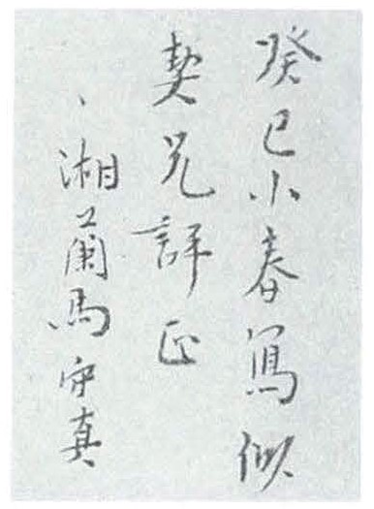 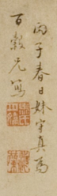 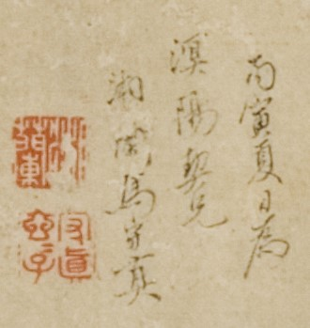

Plate 1: The Authentic Signature (left) by Ma Shouzhe and the fake ones (middle and right) on the current handscroll attributed to her.

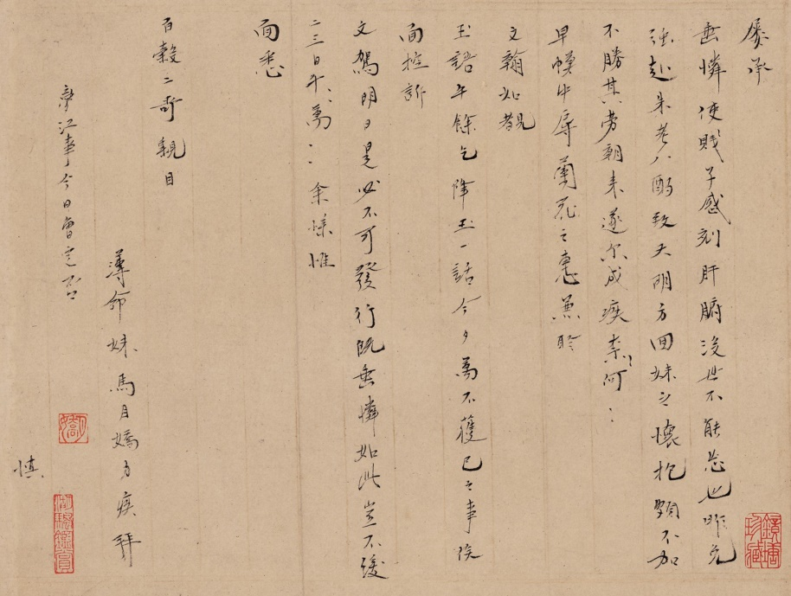

Plate 2: Ma Shouzhen’s letter to Wang Zhideng (undated. The Shanghai Library). Her style of writing Wang Zhideng’s given name Baigu 百榖 is clearly different from the one in the current handscroll.

REFERENCE MATTER

Chang, Kang-i Sun, and Haun Saussy, eds. *Women Writers of Traditional China: An Anthology of Poetry and Criticism*. Stanford, CA: Stanford University Press, 1999.

Chen Jiru 陳繼儒. *[Chongzhen] Songjiang fu zhi* [崇禎]松江府志. Songjiang: n.p., 1630.

Fan Jingzhong 范景中. “Ma Xianglan zhi Wang Baigu shouzha juan shu hou” 馬湘蘭致王百榖手札卷書後. *Lishi wenxian* 歷史文獻 12 (2008): 22–25.

Jiao Hong 焦竑. *Guochao xian zheng lu* 國朝獻徵錄. 1616. XXSK edition.

Li, Wai-yee. “The Late Ming Courtesan: Invention of a Cultural Ideal.” In *Writing Women in Late Imperial China*, edited by Ellen Widmer and Kang-i Sun Chang, 46–73. Stanford, CA: Stanford University Press, 1997.

Pei Jingfu 裴景福. *Zhuangtao Ge shu hua lu 壯陶閣書畫錄*. Shanghai: Zhonghua shuju, 1937.

Qian Qianyi 錢謙益. *Liechao shiji xiaozhuan* 列朝詩集小傳. Shanghai: Shanghai guji chubanshe, 1983.

Shen Shixing 申時行. *Ci xian tang ji* 賜閒堂集. N.p., 1616. SKCM edition.

Weidner, Marsha, ed. *Views from Jade Terrace : Chinese Women Artists, 1300-1912*. Indianapolis, IN: Indianapolis Museum of Art, 1988.

Zhou Xiaoying 周小英. “Ma Xianglan shiji yu huihua xin zheng” 馬湘蘭事跡與繪畫新證. *Xin meishu* 新美術, no. 12 (2013): 3–11.

Zhu Yizun 朱彜尊. *Jingzhi jus shihua* 靜志居詩話. Edited by Huang Juntan 黃君坦. Beijing: Renmin wenxue chubanshe, 1990.

———. *Ming shi zong* 明詩綜. n.p.: Liufeng ge, 1705.

(Lianbin Dai; updated 25 July 25, 2016)

1. There is no signature to this colophon; a seal *Shigu ting* attributed to him is impressed at its end.
2. Translation modified from Chang and Saussy, *Women Writers of Traditional China*, 738.
3. This colophon is a citation from Qian Qianyi, *Liechao shiji xiaozhuan*, 766, which in turn quotes Wang Zhideng's preface to Ma's collection of poems. Noticeable are the textual varieties: the original *zao cai* 棗材 (lit. jujube timber) miswritten into *zao lin* 棗林 (lit. jujube cluster), and *zuo zhuan* 作傳 (lit. to write biography) into meaningless *zuo chou* 作儔, because of their similar forms.
4. There is no signature to this colophon; two seals, *Jinsu shanren* and *Wenyu*, attributed to him are impressed at its end.
5. Actually the celebration took place in the spring of 1604. Ma visited Hangzhou in the summer and died of serious illness in the autumn; see Zhou Xiaoying, “Ma Xianglan Shiji Yu Huihua Xin Zheng,” 3–4.
6. Translation modified from Chang and Saussy, *Women Writers of Traditional China*, 737, 738.
7. Zhu Yizun, *Ming shi zong*, 98:3a–b; see also Zhu Yizun, *Jingzhi ju shihua*, 23.763–764; the meaningless compound *quan ri* 泉日 should be *qian dao* 錢刀 (lit. money, currency).
8. For Wang Zhong's writing of Ma, see Li, “The Late Ming Courtesan: Invention of a Cultural Ideal,” 66–67.
9. Fan Jingzhong, “Ma Xianglan zhi Wang Baigu shouzha juan shu Hou”; Zhou Xiaoying, “Ma Xianglan shiji yu huihua xin zheng.”
10. For Chai Jing's story, see Cai Tong 蔡桐，Chai gong muzhiming 柴公經墓志銘, in Jiao Hong, *Guochao xianzheng lu*, 64:76a–68b.
11. Cai Maozhao was eighty *sui* (seventy-nine years old) in about 1598 and died at nearly ninety *sui* (eighty-nine years old); see Chen Jiru, *[Chongzhen] Songjiang fu zhi*, 40:4a–5b; Shen Shixing, *Ci xian tang ji*, 5:4a.
12. Pei Jingfu, *Zhuangtao ge shu hua lu*, 11:36a–37b.