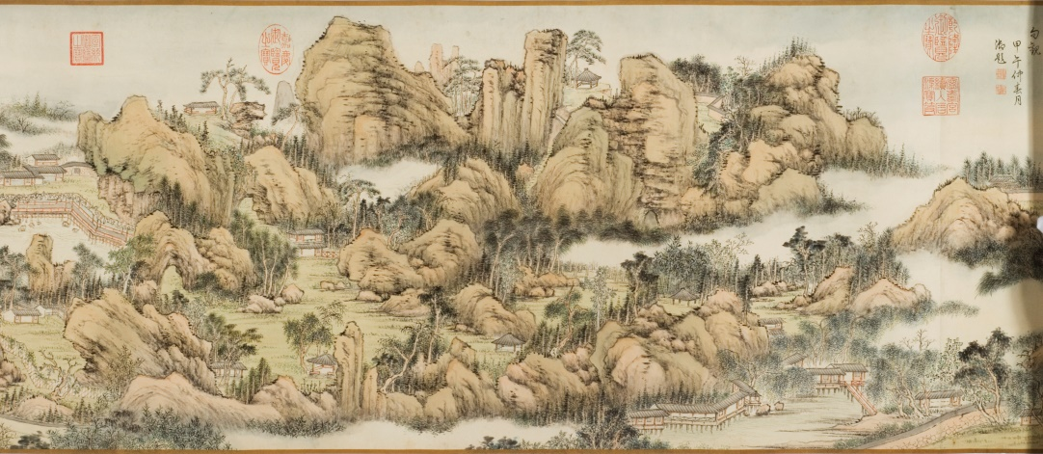Qian Weicheng 錢維城 (1720-1772)

Complete View of the Lion Grove Garden

獅林全景圖

*Shilin quanjing tu*

Painting

1757

Handscroll of a landscape; ink and color on paper; 39.1 cm x 950 cm (sheet); 38.1 cm x 187.3 cm (painting); 6.4 cm x 39.3 cm x 5.6 cm (rolled)

The Mactaggart Art Collection. Access #2004.19.60

Gift of Sandy and Cécile Mactaggart

ARTIST’S COLOPHON & SIGNATURE

(14 columns in regular script)

Proud of his *Painting of the Lion Grove Temple*, Ni Zan praised himself acclaiming that it could not be what Wang Meng (ca. 1308-1385) and his like were able to dream of. Ni’s original handscroll is currently conserved in the court. I, your humble servant, had a fortune to respectfully inspect it while cataloging the court collections. It appears simple, primitive, elegant, accomplished but untrammeled, absolutely free from mere conventionality. It exactly is a self-satisfied piece from this lofty hermit’s brush in his life. In the spring of the *ding chou* year (1757), I accompanied the emperor in his imperial southern tour and halted in Suzhou. I visited the Lion Grove Temple following his majesty’s order. Plants and rocks still remain in the layout that reportedly was designed by Ni Zan himself. The beauty of this garden features the water in its west part and trees and rocks in its east part. In the water section, there are nine grottos that are connected one after another like strung pearls, winding along the pond bank. On the east side of the stone bridge is the land section with clusters of tall pine trees and piles of huge rocks. There are nine grottos in this section too. Among them, some are connected with each other by bridges, some are accessible along upwards steps, some cannot be seen until raising your head, and the others cannot be entered into until bending your body. The trails are narrow and winding like sheep’s intestines. Though tortuous, they lead to the same destination. The entrance to the first grotto is divided into two trails, the left and the right. The left trail ends at the start of the right one, while the right tail ends at the start of the left one. They appear remote and deep like natural ones so that these several acres feel as grandiose as one thousand miles. Ni Zan’s painting, however, just represents one corner of this garden, with his concept of resembling with the unresembling. In spite of my inferior skills, I drew the compete view of this temple and created this painting. I do not dare to imitate Ni Zan but meant to record its real appearance. Your humble servant Qian Weicheng respectfully paints and records.

雲林畫獅子林圖，自詡非王蒙輩所能夢見。此卷現貯/天府。臣於編纂之下，曾得敬觀，簡古秀逸，迥脫凡蹊，洵高/士一生得意筆也。丁丑春，扈從/南巡，駐蹕吳下，奉/命遊獅林寺。林石依然，相傳爲雲林結搆。其園右以水勝，左以樹/石勝。水園之洞凡九，沿池屈曲，纍纍如貫珠。循石橋以東/爲岸園，古松參天，石勢磊砢。爲洞亦九，或懸橋而通，或拾/磴而上，或仰而探，或俯而入。如羊腸九曲，宛轉層折，仍歸/一途。以第一洞左右，爲出入分徑，入左者出右，入右者出左，奧/穾天成，數畝有千里之勢。雲林所繪，特其一角，所謂以不/似爲似者也。臣不揣拙劣，輒規橅全勢，繪爲此圖，非敢學/步倪迂，聊以存廬山真面目耳。/臣錢維城恭畫并敬識

ARTIST’S SEALS

*chen Qian Weicheng* 臣錢/維城, square relief

*jing shi* 敬事, square relief

*chen Qian Weicheng* 臣錢/維城, square intaglio

*bi zhan chunyu* 筆沾/春雨, square relief

INSCRIPTION

The Qianlong Emperor 乾隆 (r. 1735-1796), dated March 1774

(12 columns in cursive script)

Ni Zan’s painting of the Lion Grove is incomplete, covering only one corner

This one supplements it with a complete view drawn with brush

The spring and rocks look as clear as in my memory

Bamboo and pine trees cluster in high and low places

How could Ni Zan predict the Huang family’s ownership?

This current painting can be viewed as the incarnation of the old one

It was funny that several times I tried to write poems and to imitate

How couldn’t I neglect Buddha’s *gatha* of the Four Lines?

In the mid-spring of the *jia wu* year (1774), I the emperor records

一角獅林璧未/完，補成全景運/毫端。爲泉爲石/分明憶，若竹若/松高下攢。倪氏/豈知黃氏占，今/圖又作古圖看。/咲予幾度亦吟/仿，何似金剛四/句觀。[1]/甲午仲春月/御題

INSCRIPTION WRITER’S SEALS

The Qianlong Emperor

*jixia yiqing* 幾暇/怡情, square intaglio

*de jiaqu* 得佳趣, square intaglio

COLLECTORS’ SEALS

The Qianlong Emperor

*Leshou tang jian cang bao* 樂壽堂/鑑藏寶, tall rectangular intaglio

*Shiqu baoji* 石渠/寶笈, rectangular relief

*Shiqu dingjian* 石渠/定鑑, round relief

*Qianlong yulan zhi bao* 乾隆/御覽/之寶, oval relief

*Ningshou gong xu ru Shiqu baoji* 寧壽宮/續入石渠寶笈, square relief

*Qianlong jianshang* 乾隆/鑑賞, round intaglio

*Sanxi tang jing jian xi* 三希堂/精鑑璽, tall rectangular relief

*yi zisun* 宜/子孫, square intaglio

*baoji chong bian* 寶笈/重編, square intaglio

The Jiaqing Emperor (1760-1820; r. 1796-1820)

*Jiaqing yulan zhi bao* 嘉慶/御覽/之寶, oval relief

The Xuantong宣統 Emperor (1906-1967; r. 1908-1912)

*Xuantong yulan zhi bao* 宣統/御覽/之寶, square relief

*Wuyi zhai jing jian xi* 無逸齋/精鑑璽, tall rectangular relief

Liu Zuochou 劉作籌 (1911-1993)

*Liu shi, Zuochou* 劉/氏, 乍/籌, joint square relief

*Xubai zhai Liu shi cang* 虛白齋/劉氏藏, tall rectangular relief

TITLE SLIP

(1 column in regular script)

Complete View of the Lion Grove by Qian Weicheng

錢維城獅林全景圖

*Qian Weicheng Shilin quanjing tu*

CATALOGED

*Shiqu baoji xu bian* 石渠寶笈續編,ch. 60: Ningshou gong cang 寧壽宮藏, Sect 17 (n.p.)

Yang Renkai 楊仁愷，*Guobao chen fu lu* 國寶沉浮錄，p. 382.

Tsang, *Brilliant Strokes*, pp. 24-28.

NOTE

A PAINTING created by court painter Qian Weicheng (1720-1772) for the Qianlong emperor (r. 1735-1796) to represent the Lion Grove Garden in Suzhou. This garden initially was an annex to the Lion Grove Temple that was established in Suzhou in 1342 for Weize Tianru 惟則天如 (1286-1354) with his lay followers’ patronage. This garden, composed of artificial rockeries, grottos, a pond, a winding brook, bridges, and pavilions on a very small property, has been considered a representative Chinese garden and in 2000 became a UNESCO World Heritage Site.[2]

Since its establishment, the Lion Grove Temple had been the subject of several paintings, including those by Zhu Derun 朱德潤 (1294-1365), Ni Zan 倪瓚 (1301-1374), and Xu Ben 徐賁 (d. ca. 1380). Zhu’s creation in 1363 has been lost. Ni Zan reportedly worked in 1373 with Zhao Yuan 趙原 (d. late 14th century) in creating; only a forgery attributed to him that Qian Weicheng and the Qianlong emperor inspected is extant in the Palace Museum in Beijing. Xu Ben created an album of this temple in 1374; his original remains hidden and an imitation is held in the National Palace Museum in Taibei.[3] Although on the requests of Weize’s successors, both works of literati taste by Ni and Xu had been better known for the sceneries in the garden than for the temple itself. In the 1520s or earlier, Wen Zhengming (1470-1559) created a handscroll painting of the garden as the abbot of the temple requested.[4] In the late 1530s, a local powerful family purchased the garden, and since then it had been damaged without appropriate maintenance. Except Wen’s work, a few recorded Ming paintings of the garden simply were imitations of Xu Ben’s album.[5]

The temple was reconstructed in 1589 under the imperial patronage and renamed *Sheng en si* 聖恩寺 (the Imperial Favor Temple). In 1600 the Wanli emperor (r. 1572-1620) bestowed a set of Buddhist *Tripitaka* upon the temple in his mother’s name. Between 1653 and 1676, a library was constructed and then a hall renovated. In 1703, the Kangxi emperor (r. 1661-1722) restored its original name *Shi lin si* (the Lion Grove Temple). It remains unclear whether or not the temple continued to own the garden in the late sixteenth and seventeenth centuries, yet by the 1730s a Huang family had owned it until the late nineteenth century, and since the Huangs’ ownership the garden has become totally independent from the temple. The view in the current painting, therefore, should be the version of the garden renovated by the Huang family.[6]

Qian Weicheng tried to be realistic in representing the garden, as his colophon claims. His water section contains the same physical elements and infrastructures as those in the Suzhou Section in the *Painting of the Qianlong Emperor’s Southern Tour* (see *Plate 1*). Compared with the imitation of Xu Ben’s album, Qian’s version of the garden features both recent physical changes in and some old elements of the 1370s version. While some topographical features remain same, recent buildings and rockeries are visible in Qian’s work (see *Plates 2 & 3*).

While Qian attempted to realistically represent the garden in his eyes, the work attributed to Ni Zan was more impressionist and of more literati taste with simpler brush movements. In terms of composition, both Qian and Ni started their narrations with a simple gate on the left. Fence (together with an enclosing wall in Qian’s painting) invites viewers to concentrate on the garden. Their purposes are different, however. Ni Zan focused on the temple and Buddhist monks inside to shed light on the Chan Buddhist meaning of the garden, while Qian stressed the artificial rockeries and water. In order to convey the grandiosity of those artificial rockeries as he understood, Qian apparently exaggerated their sizes and the garden, with some motifs such as mist, forest and distant sceneries, to the extent that the rockeries appear like mountains and the brook like an endless river. Several Qing artists before and after Qian imitated the painting of the Lion Grove Temple attributed to Ni Zan. Their imitations just conveyed Ni Zan’s view of the temple, while Qian represented the contemporary Lion Grove Garden that he visited with the Qianlong emperor in 1757.

Qian had only one record of creating this painting. In 1757 he composed a poem with the same rhyme to reply the Qianlong emperor. His aesthetic understanding of the Lion Grove Garden in his poem exactly is the same as that in his colophon. The emperor brought the painting attributed to Ni Zan to Suzhou and closely examined it with Qian. Following the emperor’s order, Qian created this complete view of the Lion Grove Garden, integrating the imperial preference and partly following Ni Zan’s style.[7]

Since its creation, this handscroll painting had been conserved in the Forbidden City until November 1922 when Puyi 溥儀 (1906-1967), the former Xuantong emperor (r. 1908-1912), gave it to his brother Pujie 溥傑 (1907-1994) who perhaps sold it on the arts market.[8] It remains unknown when and how Liu Zuochou (1911-1993) obtained it. Since 1922, this piece has been enumerated as missing in Chinese catalogues.

REFERENCE MATTER

Fang Yujin 方裕謹, ed. “Puyi shang Pujie gong zhong guji ji shu hua mulu (I)” 溥儀賞溥傑宮中古籍及書畫目錄 (I). *Lishi dang’an* 歷史檔案, no. 1 (March 1996): 88–96, 12.

Hongli 弘曆. *Yuzhi shi si ji* 御製詩四集. Beijing, n.d. SKQS edition.

Qian Weicheng 錢維城. *Qian Wenmin gong quanji* 錢文敏公全集. Wujin: Mei shou tang 眉壽堂, 1776. XXSK edition.

Sensabaugh, David Ake. “The Lion Grove in Space and Time.” In *Bridges to Heaven: Essays on East Asian Art in Honor of Professor Wen C. Fong*, edited by Jerome Silbergeld, Dora C. Y. Ching, Judith G. Smith, and Alfreda Murck, II:637–52. Princeton, N.J: Princeton University Press, 2011.

Shi Daoxun 釋道恂, and Xu Lifang 徐立方, eds. *Shizi lin ji sheng ji xuji* 師子林紀勝集續集. 1857. SKCM edition.

Wang Shizhen 王世貞. *Yanzhou si bu gao* 弇州四部稿. 1778. SKQS edition.

Xu Bangda 徐邦達. *Gu shu hua wei e kao bian* 古書畫偽訛考辨. 4 vols. Nanjing: Jiangsu guji chubanshe, 1984.

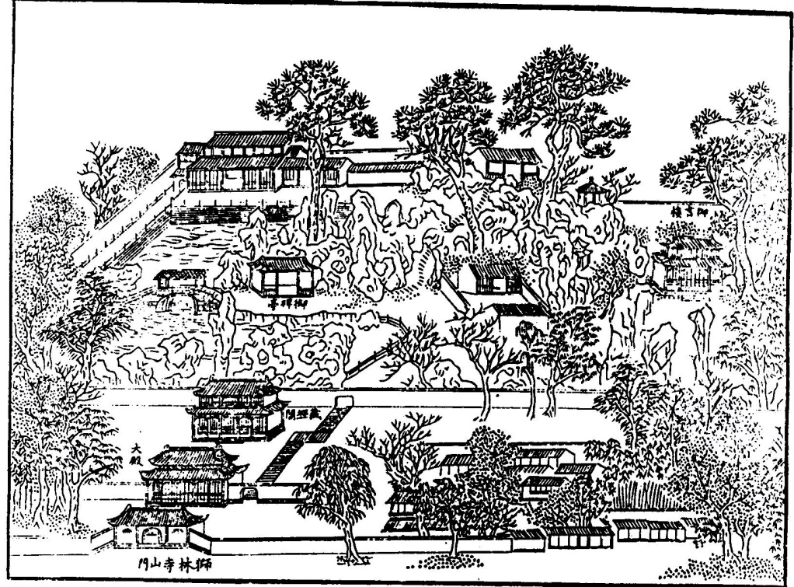

Plate 1: An imitation of the Lion Grove Garden in the *Painting of the Qianlong Emperor’s Southern Tour*

From: Shi Daoxun and Xu Lifang, *Shizi lin ji sheng ji*, xuji.

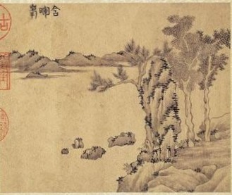

Plate 2: A leaf in an imitation of Xu Ben’s *Album of the Lion Grove* (The National Palace Museum in Taibei. Access # Gu-hua-001123-00002). It represents a part of the water section, with the artificial rockery visible in Qian Weicheng’s work.

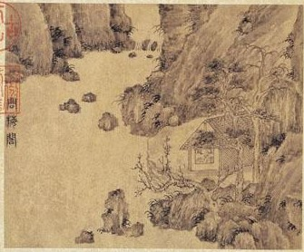

Plate 3: A leaf in an imitation of Xu Ben’s *Album of the Lion Grove* (The National Palace Museum in Taibei. Access # Gu-hua-001123-00009). The topographical elements and layout are still identifiable in Qian Weicheng’s painting.

(Lianbin Dai; updated 25 July 25, 2016)

1. Hongli, “Ti Qian Weicheng Shizi lin tu” 題錢維城獅子林圖, in *Yuzhi shi si ji*, 18:9b–10a.
2. For the history of the Lion Grove and paintings of the garden, see Sensabaugh, “The Lion Grove in Space and Time.”
3. Xu Bangda, *Gu shu hua wei e kao bian*, III:89–92 for Ni Zan, and 101–103 for Xu Ben.
4. Wang Shizhen, “Shu Wen Zhengzhong bu Tianru Shizi lin juan” 書文徵仲補天如獅子林卷, *Yanzhou si bu gao*, 171:16a–17b.
5. Qian Gu 錢榖，“Lin Xu Ben ce” 臨徐賁冊 (1562), in Shi Daoxun and Xu Lifang, *Shizi lin ji sheng ji xuji*, buyi 補遺:4a–5b.
6. For the history of the Lion Grove Temple and Garden, see Shi Daoxun and Xu Lifang, *Shizi lin ji sheng ji xuji*.
7. Qian Weicheng, “Gong he yuzhi you Shizilin yuan yun” 恭和御製遊獅子林元韻, *Ming chun xiao cao* 鳴春小草, 3:19a–b, in *Qian Wenmin gong quanji*.
8. Fang Yujin, “Puyi shang Pujie gong zhong guji ji shu hua mulu (I),” 12.