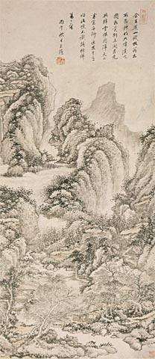Wang Jian 王鑑 (1509-1677)

Painting of Reading among Nine Peaks in the Style of Wang Meng

仿叔明九峰讀書圖

*Fang [Wang] Shuming Jiu Feng dushu tu*

(Alternative title: *Fang Shuming feng mao dushu tu* 仿叔明峰泖讀書圖 [Painting of Reading by the Lakes among Peaks in the Style of Wang Meng]; see Feng Chaoren’s label)

Painting

1666

Hanging scroll; ink and light colour on paper; 239.4 cm x 57.5 cm (scroll sheet); 78 cm x 34.7 cm (painting)

The Mactaggart Art Collection. Access # 2004.19.14.1

Gift of Sandy and Cécile Mactaggart

ARTIST’S INSCRIPTION & SIGNATURE, dated 1666

(8 columns in semi-cursive script)

During my stay in Yushan (today’s Changshu, Jiangsu Province), old gentleman Qian Qianyi (1582-1664) show me [Wang] Shuming’s (i.e. Wang Meng) Painting of Reading in the Nine Peaks to appreciate together. Less than one month after our farewell, this painting was burnt into ash flying into sky in the fire of his library the House of Crimson Clouds (*Jiangyun lou*). Sitting by the window with my time idle, I recollected Wang’s intention and drew this painting. I do not know if I fully imitated his work well. In the autumn of the *bing wu* year, Wang Jian.

余在虞山，錢牧翁出 / 所藏叔明九峰讀書 / 圖相賞。別未閲月，竟 / 與絳雲樓同歸天上。/ 閑窗無聊，返思其意，/作此幀，不識能彷佛 / 萬一否。/ 丙午秋日王鑑

ARTIST’S SEALS

雨新齋, rectangular relief

王鑑 / 之印, square intaglio

INSCRIPTION mounted, dated 1941

(5 columns in cursive script)

Huang Gongwang once lived at the Daoist Temple of Penglai in Wurong (today’s Songjiang, Shanghai), where he draw a handscroll the *Picture of Reading by Lake in Mountain* (*Feng mao dushu tu*). Now I am lucky to inspect Wang Jian’s imitation of [Wang] Shuming’s hanging scroll the *Painting of Reading by Lake in Mountain*. Shuming’s original copy had been conserved in the Qian family of Yushan and was burnt into ash in the fire of the House of Crimson Clouds. It remains unknown where Huang Gongwang’s version is. I have not seen the original pieces by Huang and Wang, but am lucky to witness later pieces in their styles. Their orthodox styles can be imaged on the basis of those later imitations. A friend of mine, who sought refuge from the [Sino-Japanese] War in Shanghai, handed it over to me for safekeeping in my house. I have kept it for a while and completely imitated it once. Now my old friend Zhongying [i.e. Ding Yuanyan] obtained it after it had passed through several owners. He remounted it and asked me for a colophon. This painting reminded me of my old friends. After being excited for several days, I am writing a passage on it to record another artistic encounter. Make sure you will cherish this painting, Zhongying, and it is true that conserving a painting is more important than obtaining it. At the end of the year xin si, Feng Chaoran of Jinling records, warming myself with a brazier beside a cold window.

黃子久嘗寓五茸之蓬萊道院，曾寫峰泖讀書圖卷。今得見王湘碧仿叔明峰泖 / 讀書圖軸。叔明原本藏虞山錢氏，於絳雲樓同遭劫灰。子久本不知流落何所。余不見中郎，猶見虎賁。黃王典型，概可想見焉。此圖係友人避兵來滬，閣置草堂頗久。余曾對臨 / 一過。今展轉爲老友仲英所獲，裝成索題，如晤故人，為之欣然累日，爰志數言，更增一重翰墨緣 / 也。仲英吾兄寶此，重逾求圖也宜。辛巳嵗莫，寒窗擁爐識。晉陵馮超然

INSCRIPTION WRITER’S SEALS

慎得 / 居士, square relief

馮 / 超然, square intaglio

COLLECTORS’ SEALS

Feng Chaoran (1882-1954)

超然 / 心賞, square intaglio

Ding Yuanyan 丁元彥 (b.1888)

(No seal)

TITLE SLIP by Feng Chaoran

王湘碧仿叔明峰泖讀書圖真跡/馮超然題簽

Seal:

*shen de* 慎得, square relief

NOTE

ONE of Wang Jian’s imitations of Wang Meng 王蒙 (1308-1385), who in turn was inspired by Huang Gongwang 黃公望 (1269-1354), in the same theme of reading by lake in mountain. This painting, as a representative piece by Wang Jian, suggests Chinese literati’s ideal of scholarly life and the place of his school in history of art in late imperial China.

Huang Gongwang finished his hand scroll the *Picture of Reading by Lake in Mountain* in his last years, perhaps around 1348 when Wang Meng created his hanging scroll the *Painting of Reading by Lake in Mountain*.[1] Huang’s version, originally entitled *Reading by the Three Lakes among Nine Peaks* (*Jiu feng san mao dushu tu* 九峰三泖讀書圖), was still extant in the seventeenth century.[2] Wang Meng’s painting of the same topic was recorded in at least three versions: (1) the version collected in Qian Qianyi’s 錢謙益 (1582-1664) library that Wang Jian inspected and imitated, (2) a version that Wu Qizhen 吳其貞 (1607-1678+) witnessed and described as a “still fine” but “simple” and “small” piece,[3] and (3) a version that was colored in the style of Zhao Mengfu (1254-1322; Wang Meng’s uncle) as Lu Shihua 陸時化 (1724-1779) described.[4] While both the Wu Qizhen and Lu Shihua versions are questionable due to very limited evidence, the copy that Qian Qianyi held should be authentic and original, even though he did not leave behind any description of this painting.

Qian purchased Wang Meng’s original copy in early 1641 and showed it to his friend Cheng Jiasui程嘉燧 (1565-1643) who joined him in a trip, as Cheng described in a painting and a poem.[5] Since then Wang Jian had inspected this painting for several times in Qian’s library and had several imitations. His extant earliest imitation was made in the summer of 1649, now collected in the Palace Museum in Beijing. In his inscription on this version he claimed that he could inspect anytime Wang Meng’s original that Qian conserved (see *Plate i*). An undated imitation on an album leaf, once held in the Qing court, is collected in National Palace Museum in Taibei (Access # Gu-hua-003184-00009; see *Plate ii*).[6] An imitation in 1667 was recorded, with his inscription on it saying that Wang Meng’s painting had been “lingering over [his] mind for twenty years” and that he imitated it according to his memory when he had leisure time in beautiful days,[7] just as he described in the above transcribed inscription on this 1666 Mactaggart version.[8] Wang Meng was one of the Yuan masters who Wang Jian highly esteemed and technically adhered to.[9]

All the above versions including the Mactaggart one are different from each other in composition and a few techniques. Those distinctions call for rethinking of what “imitation” meant for Wang Jian and his followers. All these versions feature high peaks in the upper part and prosperous trees at the bottom, together with houses scattered among trees. The peaks occupy about two thirds of the space, while houses small with tiny figures reading in. Such a composition, which is typical in Wang Meng’s paintings, represents the physical isolation and mental loftiness of the scholar-hermit’s residence. Wang Jian obviously adopted this composition style in his imitations, but adapted it by integrating different elements and topics with different techniques. The 1649 version in Beijing was created just one year before its source copy was burned in 1650. Compared with the two later versions, it appears simple and contains only a high mountain body, a few straight and high pines and thatched hut where a scholar is reading. Wang Jian depicted the mountain in the method of *jiesuo cun* 解索皴 (lit. strokes like untwisted hemp cords), a method that Weng Meng invented to represent rock reins. In this method, dry brush just runs from up to down and produced dense and slightly curly lines, while wet ink dots closely spread over at the top of mountain to represent green bushes and trees. The 1649 version, therefore, should be a strict imitation of Wang Meng in techniques and possibly in composition. In the Taipei and1666 Mactaggart versions, however, mountains appear massed and ridges are clearly depicted. Rock veins and the mountain body are drawn in the method of *pima cun* 披麻皴 (lit. strokes spreading out to both sides like disheveled hemp filaments), with balanced short lines. Techniques he learned from other Song and Yuan masters than Wang Meng evidently were utilized in these two later imitations. More trees closely spread out and most trunks are twisting. The scholar hermit in the Taibei and 1666 Mactaggart versions seems to have neighbors. They are connected by trails and bridges with each other and with the world outside the painting, while the scholar in the 1649 version is more isolated from others.

Reading in an isolated residence was a common theme in Chinese literati painting. It had been used as an artistic device and intellectual practice to distinguish themselves from others and to manifest their political, social and intellectual stances. In such paintings, the protagonists tend to be depicted as hermits. They could marginalize themselves out of some domains like government service, though dedicate into other domains like literature, calligraphy and painting. This theme repeated more often during dynastic transitions when political loyalists of the fallen reign decided to refuse to serve the new rulers. Both Huang Gongwang and Wang Meng lived in reclusion in most of their lives after their short government services at low rank under the Mongol rule. The seventeenth-century Ming-Qing transition witness more paintings in the theme of reclusion,[10] and Wang Jian obviously represented himself as a hermit loyal to the fallen Ming in this way. As leading writer and official Wang Shizhen’s 王世貞 (1526-1590) great-grandson, Wang Jian had served as the prefect of Lianzhou 廉州 (roughly present-day Qinzhou 欽州 and Baihai 北海 in Guangxi) in 1638-1639. Since his dismissal, he had witnessed the dynastic transition and never reentered officialdom. He imitated Huang Gongwang and Wang Meng to demonstrate his actual lifestyle of reclusion under the alien Manchu rule.

The ownership of this painting prior to Feng Chaoran (1882-1954) remains unknown. In the late 1930s, according to Feng, he had kept it for a couple of years as its owner, one of his friends, entrusted to him. In 1941 Chinese medical practitioner Ding Yuanyan (b. 1888) already obtained it. Ding immigrated to the States later. This Mactaggart copy could be from Ding’s family.

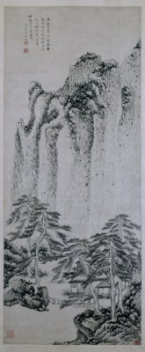

Plate i

Wang Jian, *Fang Shuming Jiufeng dushu tu* 仿叔明九峰讀書圖, 1649

The Palace Museum in Beijing

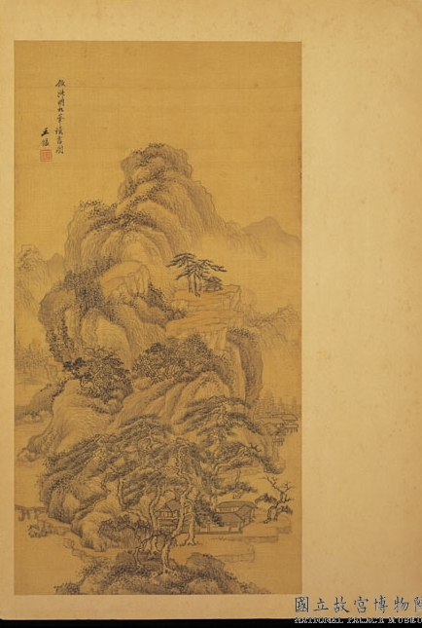

Plate ii

Wang Jian, *Fang Shuming Jiufeng dushu tu* 仿叔明九峰讀書圖, undated

Album leaf, ink and color on silk, 52.5x27.4 cm

(The National Palace Museum, Taibei)

(Lianbin Dai; updated 25 July 25, 2016)

1. Wang Kewen, *Wang Meng*, 173.
2. Cheng Zhengkui conserved Huang's version; see *Shi bai zhai shuhua lu* 十百齋書畫錄, in Lu Fusheng, *Zhongguo shuhua quanshu*, VII:548A; see also Zhang Chou 張丑, *Fashu minghua jianwen biao* 法書名畫見聞表, in Lu Shengfu, IV:121B.
3. Wu Qizhen, *Shu hua ji* 書畫記, see *ibid*., VIII:52B.
4. Lu Shihua, *Wu Yue suo jian shu hua lu* 吳越所見書畫錄, see *ibid*., VIII:1160A.
5. Cheng Jiasui, *Ougeng tang ji*, “Xin si san yue nian si ri...” 辛巳三月廿四日..., 2:21b–22a; Anonymous, *Shibai zhai shuhua lu* 十百齋書畫錄, "Cheng Jiasui shuhua ce" 程嘉燧書畫, in Lu Fusheng, *Zhongguo shuhua quanshu*, VII:556B.
6. Zhang Zhao et al., *Shiqu baoji*, zhu Chonghua gong 貯重華宮, “Wang Jian fanggu yi ce” 王鑑倣古一冊, 4.357.
7. Fang Junze 方濬賾, *Meng yuan shuhua lu* 夢園書畫錄, in Lu Fusheng, *Zhongguo shuhua quanshu*, XII:316B.
8. The Xiling (Hangzhou) auctioned in spring 2011 Wang Jian's 1676 imitation (Lot#1267). No historical record of this version has been found so far.
9. For Wang Meng's biography and art, see Fong, *Beyond Representation*, 455–464.
10. See Sturman and Tai, *The Artful Recluse*.