PROJECTS

[Note: The first two projects are described in other two separate doc files. Please publish them as separate webpages to link to the titles on this page. Xu Zhuoyun’s book cover is also available as a separate file in the folder “BookImages.”]

Currently I am revising my dissertation into a monograph manuscript, entitled *Learning to Be Learned: Neo-Confucian Knowledge Culture in Late Imperial China*.

(Please insert this link to the book title: https://ycar.apps01.yorku.ca/wp-content/uploads/2018/05/YCAR_ARB0029.pdf)

I am also involved in two editorial projects with Professor Timothy Brook.

One is to publish a volume tentatively entitled [*Visualizing China’s Imperial Order: the Material Production of Dynastic Power*](Visualizing%20China's%20Imperial%20Order.docx) based on the lecture series and symposium we organized in 2015 – 2016 at the University of Alberta Museums.

The other is to publish three volumes tentatively entitled [*Ming Statecraft: Chinese Agendas of Political Economy*](Ming%20Statecraft.docx), two volumes of translations from Qiu Jun 丘濬 (1418 – 1495), *The Supplement to the Explication of the Great Learning* (*Daxue yanyi bu* 大學衍義補. 1487), and a third volume of essays on the political philosophy and administrative programs of the mid-Ming dynasty.

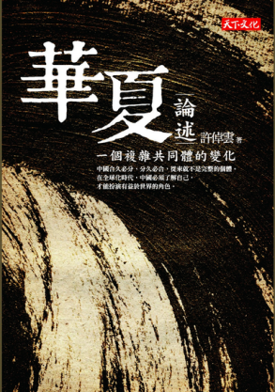Meanwhile, I am translating, with David Luesink (Sacred Heart University), Professor Cho-yun Hsu’s (Xu Zhuoyun 許倬雲) *Huaxia lunshu: yige fuza gongtongti de bianhua* 華夏論述：一個複雜共同體的變化 (Taibei: Tianxia wenhua, 2015) into English. This translation is funded by the Chiang Ching-Kuo Foundation and overseen by Professor David Der-wei Wang (EALC, Harvard University).

(Please insert this link to the book title: https://bookzone.cwgv.com.tw/books/details/BGB393)