PUBLICATIONS

[Note: The images of the book front covers are also available in the folder “Book Images.” Those titles in blue are available in PDF in this same folder.]

## Books

2017. *Cong shuji shi dao yuedu shi: yuedu shi yanjiu lilun yu fangfa* 从书籍史到阅读史：阅读史研究理论与方法 [From history of the book to history of reading: theories and methods for historical studies of reading]. Beijing: Xinxing chubanshe.

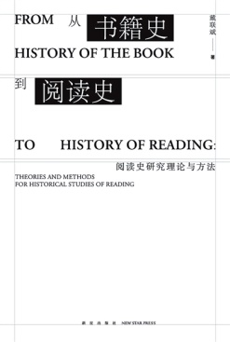

2013. *Buliedian Gelunbiya Daxue Yazhou Tushuguan cang zhongyi guji xuanmu chubian* 不列顛哥倫比亞大學亞洲圖書館藏中醫古籍選目初編 [A Draft of the Annotated Bibliography of Traditional Chinese Medical Literature Collected in the Asian Library of the University of British Columbia]. Vancouver: Asian Library of UBC. (Available online < http://guides.library.ubc.ca/rarechinese/leung >)

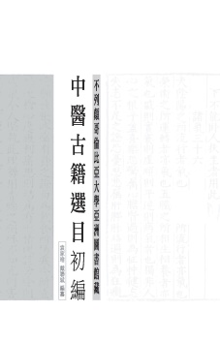

**Book Chapters**

2016. “[From Philology to Philosophy: Zhu Xi (1130 – 1200) as a Reader-Annotator](Dai-From%20Philology%20to%20Philosophy-2016-09-printed.pdf).” In *Canonical Texts and Scholarly Practices: A Global Comparative Approach*, 136-63, eds. Anthony Grafton and Glenn W. Most. Cambridge: Cambridge University Press. 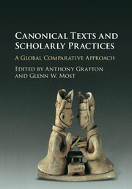

2015. “[Household Publications in the Society of Ming Hangzhou](Dai-Household%20Publications%20in%20Ming%20Hangzhou-TAP-e-edition-2015-12-02.pdf).” In *Imprimer sans profit? Le livre non commercial dans la chine impériale*, 339-414, eds. Michela Bussotti and Jean Pierre Drège. Genève: Librairie Droz.

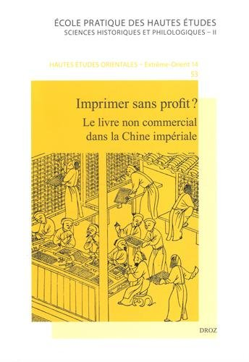

## Journal Articles

2014. “[China’s Bibliographic Tradition and the History of the Book](Dai-China's%20Bibliographic%20Tradition-BH-2014.pdf).” *Book History* 17:1-50.

2008. “[The Economics of the Jiaxing Edition of the Buddhist *Tripitaka*](Dai-Jiaxing%20Tripitaka-2008.pdf).” *T’oung Pao* 94.4-5:306-59.

## Book Reviews

2016. [Review of *Writing, Publishing, and Reading Local Gazetteers in Imperial China, 1100-1700* by Joseph Dennis](Dai-Review%20of%20J%20Dennis-2016-printed.pdf) (Cambridge, MA: The Harvard University Asia Center, distributed by Harvard University Press, 2015). *Ming Studies* (Fall) 74:72-86.

2014. [Review of *The History of the Book in East Asia*, edited by Cynthia Brokaw and Peter Kornicki](Dai-Review%20of%20Brokaw%20and%20Kornicki-LIH-2014.pdf) (The History of the Book in the East Series. Farnham, England: Ashgate, 2013). *Library & Information History* 30.4 (November): 297-99.

2014. [Review of *Home and the World: Editing the “Glorious Ming” in Woodblock-Printed Books of the Sixteenth and Seventeenth Centuries* by Yuming He](Dai-Review%20of%20Yuming%20He-BSOAS-2014.pdf) (Cambridge, MA: The Harvard University Asia Center, distributed by Harvard University Press, 2013). *The* *Bulletin of the School of Oriental and African Studies* 77.2 (June): 415-17.

## Conference Papers

July 19-21, 2016. “Production of Geographical Knowledge and the Manchu Conquest of Central Asia in the Eighteenth Century.” International Symposium *Visualizing China's Imperial Order in Eurasia (1500-1800)* (The University of Alberta Museums, Edmonton, Canada)

June 16-18, 2015. “Importing Citations in Chinese Encyclopedic Historical Writing: Illustrated with Qiu Jun’s Textual Practice in His *Daxue yanyi bu.*” International Conference on *Qiu Jun’s* Daxu yanyi bu (The Hong Kong Polytechnic University, Hong Kong)

May 31-June 1, 2013. “Practical Uses of Historical and Classical Philosophical Texts in Ming Reading Practices.” International Conference on “*Reading, Textual Production, and Literati Culture in Late Imperial China*” (Co-chaired by On-cho Ng and Hung-lam Chu. The Pennsylvania State University, University Park, PA)

May 1-3, 2013. “Translation of Qiu Jun’s *Daxue yanyi bu*, Chapter 94.” Workshop on the *Tradition of Chinese Statecraft: Qiu Jun’s* Daxue yanyi bu (1487) (Concordia University, Montreal, Canada)

April 25-27, 2012. “The Genealogy of the Ming Editions of the Full Text of *Daxue yanyi bu*.” Workshop on the *Tradition of Chinese Statecraft: Qiu Jun’s* Daxue yanyi bu (1487) (University of Washington, Seattle)

May 30-June 1, 2011. “Book Learning and Reading in Statecraft: Zhen Dexiu (1178-1235) in the Ming (1368-1644).” Workshop on *Tradition, “administration du monde” et réforme: le* Daxue yanyi bu *de Qiu Jun (1487) et son impact dans la Chine des Ming et des Qing* (Collège de France, Paris)

June 11-13, 2009. “Household Publication in the Society of Ming Hangzhou: A Statistical and Case Study Based on Bibliographical Reconstruction.” The International Colloquium of *Imprimer sans profit?: Le livre non commercial dans la Chine Impérial*e (EFEO and INHA, Paris)

July 14-17, 2005. “The Economics of the Jiaxing Edition of the Buddhist *Tripitaka*.” The 13th International Conference, Society for the History of Authorship, Reading and Publishing (SHARP) (Halifax, Nova Scotia, Canada)

October 7-10, 2004. “Performance, Nostalgia, and Mixed Loyalties: A Case Study of Literati Spectatorship during the Ming-Qing Transition.” CASA 25th Year Anniversary Conference, Canadian Asian Studies Association (Calgary, Canada)

**Video**

September 21, 2015, launched at EdX (HarvardX, HUM1.3x). “The Book: Print and Manuscript in Asia,” a conversation with Professor Ann Blair (Harvard, History) on Chinese books and printing (about 21 minutes long and taped in Harvard-Yenching Library, Harvard University on June 23, 2014)

<URL: https://www.edx.org/course/book-print-manuscript-western-europe-harvardx-hum1-3x>

**Presentations and Invited Lectures**

June 12, 2014. “Cong xungu dao lixue: Zhu Xi du *Lunyu* ‘Xue er shi xi’zhang” 從訓詁到理學：朱熹讀《論語》“學而時習”章 [From Philology to Philosophy: Zhu Xi’s (1130-1200) Commentary on the *Annelects* 1.1]. Invited public talk in Chinese sponsored by the Harvard Chinese Culture Workshop (Harvard-Yenching Institute, Harvard University)

February 24, 2014. “Textual Collation and Its Guiding Principles in Eighteenth-Century Evidential Scholarship: Illustrated with Lu Wenchao’s (1717 – 1796) Work.” Co-sponsored by the Humanities Center Seminar in Book History and the China Humanities Seminar, Fairbank Center (Barker Center, Harvard University, Cambridge, MA).

Co-hosts: Professors Ann Blair and James Robson (Harvard University)

Discussant: Professor Cynthia Brokaw (Brown University)

Also presented at the AAS Conference in Philadelphia, PA on 30 March, 2014

July-August, 2012. “Lu Wenchao’s (1717 – 1796) Collation of the *Baihu tong.*” Working group on the *Learned Practices of Canonical Texts* (Max Planck Institute for the History of Science [MPIWG], Berlin)

“Learning to Be Learned: Zhu Xi’s Theory of Reading.” Working group on the *Learned Practices of Canonical Texts* (MPIWG, Berlin)

April 7, 2011. “Chinese Bibliographic Tradition in a New Book History.” Invited presentation in the Institute of Asian Research at the University of British Columbia (Vancouver, Canada)