

**Key Design Features and their Implementation**

**CV Showcase Web Page**

**Six Key Design Features and their Implementation**

**Com109 assessment 2**

# [Interactive Web Authoring](javascript:;)

**Author：Liang Yufei 202115020211**

**Author – Your code, Name and Course**

1.use the Drag Me in image_map.html

it’s a jQuery feature

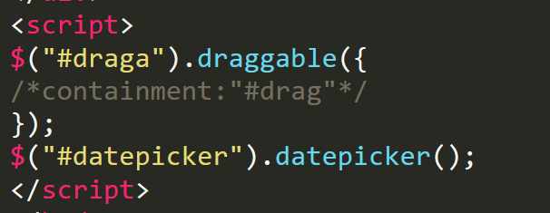

2. GDPR requirement in web_form.html

Requires the use of the GDPR protocol



3.Use the Back key to return to the main page

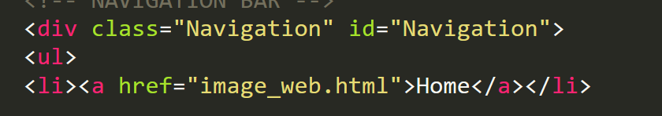

4. Use form validation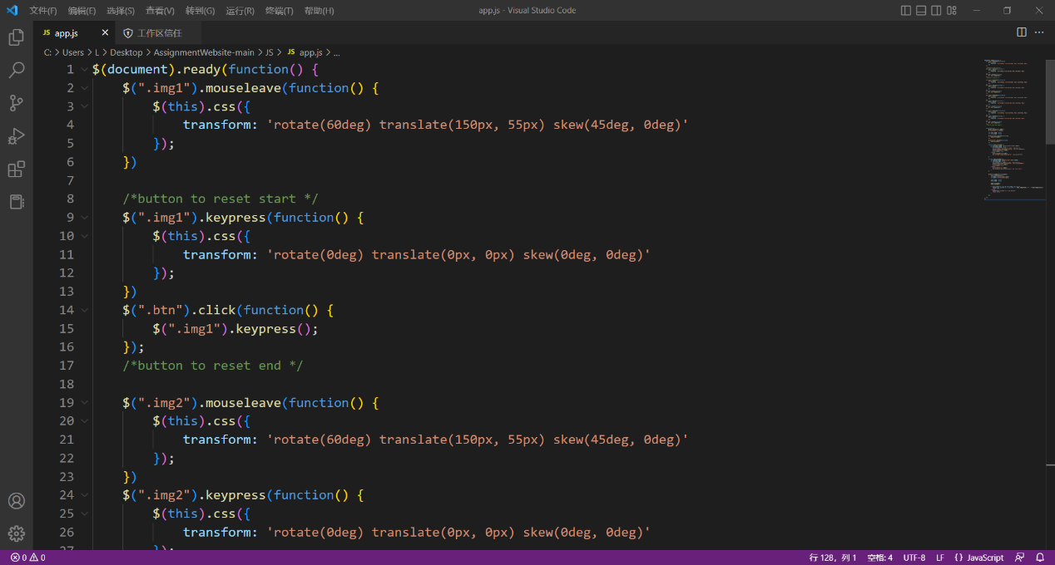

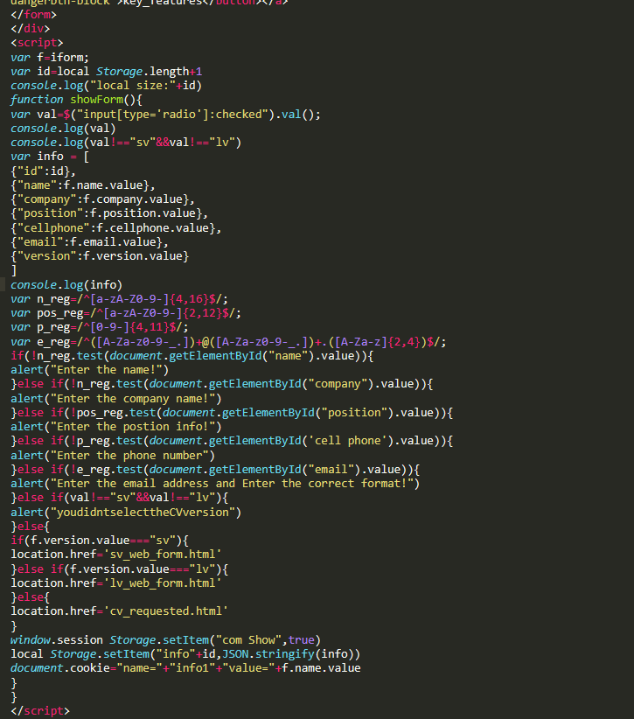

5. Use cookies to cache and load data on the website

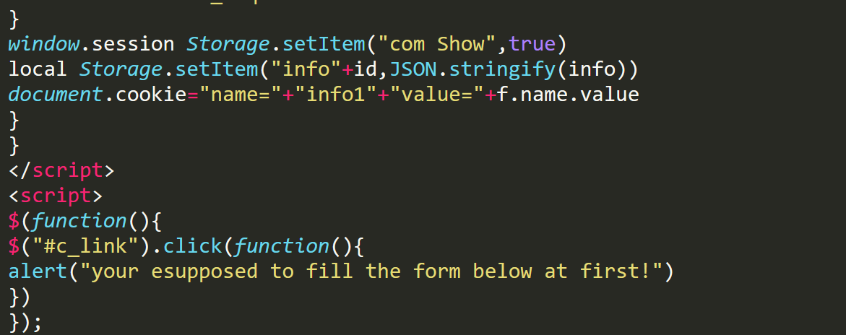

6. Use styles from external CSS

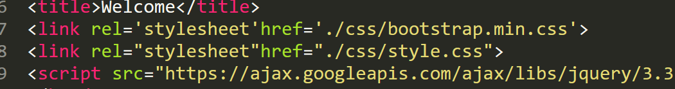

Reference

w3school.com.cn (no date) *Bootstrap 5 教程*. Available at: https://www.w3school.com.cn/bootstrap5/index.asp (Accessed: December 22, 2022).

w3school.com.cn (no date) *JQuery 教程*. Available at: https://www.w3school.com.cn/jquery/index.asp (Accessed: December 22, 2022).

Image_map.html

<!DOCTYPEhtml>

<html lang="en">

<head>

<meta charset="UTF-8">

<meta name="viewport"content="width=device-width,initial-scale=1.0">

<title>Welcome</title>

<link rel='stylesheet'href='./css/bootstrap.min.css'>

<link rel="stylesheet"href="./css/style.css">

<script src="https://ajax.googleapis.com/ajax/libs/jquery/3.3.1/jquery.min.js"></script>

</head>

<style>

body{

background:url(./images/background.jpg)no-repeat!important;

background-size:contain;

background-position:center;

}

.wrapper{

margin-top:8%!important;

}

ul{

padding:0;

background:#FFF;

padding:20px;

text-align:center;

}

li{

list-style:none;

display:inline-block;

margin:0100px;

}

</style>

<body>

<div class="container" >

<div class="wrapper">

<ul>

<li id="drag">

<a href="web_form1.html">

<img src="./images/jiantou.png"alt="ContactionTable" href="./web_form">

<p>web_form.html</p>

<span>DragMe!</span>

</a>

</li>

<li id="drag">

<a href="KeyFeatures.pdf">

<img src="./images/pdf.png"alt="keyFeatures">

<p>KeyFeatures</p>

<span>DragMe!</span>

</a>

</li>

<li id="drag">

<a href="cv_request.html">

<img src="./images/pdf.png"alt="keyFeatures">

<p>CV Request</p>

<span>DragMe!</span>

<li id="drag">

<a href="cv.html">

<img src="./images/lite.png"alt="keyFeatures">

<p>LYF_CVlong</p>

<span>DragMe!</span>

</a>

</li>

</a>

</li>

</ul>

</div>

</div>

<script>

$("#draga").draggable({

/*containment:"#drag"*/

});

$("#datepicker").datepicker();

</script>

</body>

</html>

Web_form.html

<!DOCTYPEhtml>

<htmllang="en">

<head>

<metacharset="UTF-8">

<title>info</title>

<link rel='stylesheet'href='./css/bootstrap.min.css'>

<link rel="stylesheet"href="./css/style.css">

<script src="https://ajax.googleapis.com/ajax/libs/jquery/3.3.1/jquery.min.js"></script></style>

</head>

<body>

<div class="wrapper">

<form name="iform"class="form-signin">

<h2 class="form-signin-heading"">Please input your contact</h2>

<input type="text"class="form-

control"name="name"id="name"placeholder="Name(NeoAnderson)"required="true">

<input

type="text"class="form-

control"name="company"id="company"placeholder="CompanyName(Google)"requir

ed="required">

<input

type="text"class="form-

control"name="position"id="position"placeholder="Position(Engineer)"required="requ

ired">

<input

type="tel"class="form-

control"name="cellphone"id="cellphone"placeholder="Cellphone(15678349348)"requi

red="required">

<input

type="email"class="form-

control"name="email"id="email"placeholder="Email(neoanderson@gmail.com)"requir

ed="required">

<span class="radio"><input type="radio"name="version"value="sv">short versi

on</span>

<span class="radio"><input type="radio"name="version"value="lv">long version</span>

<span class="key"style="color:red;"><input type="radio"name=""value="pri">I

agree to use my cookies under GDPR</span>

<button type="button"class="btnbtn-lgbtn-primarybtn-

block"onclick="showForm()"name="sub_btn">submit</button>

<a class="key"href="key_features.pdf"><button type="button"class="btnbtn-lgbtn-

dangerbtn-block">key_features</button></a>

</form>

</div>

<script>

var f=iform;

var id=local Storage.length+1

console.log("local size:"+id)

function showForm(){

var val=$("input[type='radio']:checked").val();

console.log(val)

console.log(val!=="sv"&&val!=="lv")

var info = [

{"id":id},

{"name":f.name.value},

{"company":f.company.value},

{"position":f.position.value},

{"cellphone":f.cellphone.value},

{"email":f.email.value},

{"version":f.version.value}

]

console.log(info)

var n_reg=/^[a-zA-Z0-9-]{4,16}$/;

var pos_reg=/^[a-zA-Z0-9-]{2,12}$/;

var p_reg=/^[0-9-]{4,11}$/;

var e_reg=/^([A-Za-z0-9-_.])+@([A-Za-z0-9-_.])+.([A-Za-z]{2,4})$/;

if(!n_reg.test(document.getElementById("name").value)){

alert("Enter the name!")

}else if(!n_reg.test(document.getElementById("company").value)){

alert("Enter the company name!")

}else if(!pos_reg.test(document.getElementById("position").value)){

alert("Enter the postion info!")

}else if(!p_reg.test(document.getElementById('cell phone').value)){

alert("Enter the phone number")

}else if(!e_reg.test(document.getElementById("email").value)){

alert("Enter the email address and Enter the correct format!")

}else if(val!=="sv"&&val!=="lv"){

alert("youdidntselecttheCVversion")

}else{

if(f.version.value==="sv"){

location.href='sv_web_form.html'

}else if(f.version.value==="lv"){

location.href='lv_web_form.html'

}else{

location.href='cv_requested.html'

}

window.session Storage.setItem("com Show",true)

local Storage.setItem("info"+id,JSON.stringify(info))

document.cookie="name="+"info1"+"value="+f.name.value

}

}

</script>

<script>

$(function(){

$("#c_link").click(function(){

alert("your esupposed to fill the form below at first!")

})

});

</script>

</body>

</html>

cv.html

<!DOCTYPE html>

<html lang="en">

<meta charset="utf-8">

<meta name="Detail" content="CV Webpage">

<meta name="keytxt" content="HTML, CSS, JAVASCRIPT">

<meta name="author" content="LYF">

<meta name="viewing" content="width-devices-width, initial-scale=1">

<head>

<!-- EXTERNAL CSS SHEET REFERENCED -->

<link rel="stylesheet" type="text/css" href="../CSS/CV Webpage.css">

<!-- EXTERNAL JS REFERENECED -->

<script src="https://ajax.googleapis.com/ajax/libs/jquery/3.3.1/jquery.min.js"></script>

</head>

<!-- BODY CONTENT OF THE WEBPAGE -->

<body>

<style>body{

background:url(./images/background.jpg)no-repeat!important;

background-size:contain;

background-position:center;

}</style>

<!-- NAVIGATION BAR -->

<div class="Navigation" id="Navigation">

<ul>

<li><a href="image_web.html">Home</a></li>

</ul>

</div>

<!-- END OF NAVIGATION BAR -->

<!-- MAIN CONTENT OF THE WEBPAGE -->

<div class="MainContent" id="MainContent">

<div class="content" id="content">

<h1 class="desctxt" id="desctxt"> THANK YOU FOR YOUR IN MY CV. IT CAN BE DOWNLOADED USING THE LINKS BELOW.</h1>

<div class="shortcvbtn" id="shortcvbtn"><a target="blank" class="btntxt" id="btntxt" href="document/LYFShortCV.pdf">SHORT CV VERSION</a></div>

<div class="longcvbtn" id="longcvbtn"><a target="blank" class="btntxt" id="btntxt" href="document/LYFLongCV.pdf">LONG CV VERSION</a></div>

<h1 class="desctxt" id="desctxt">I LOOK FORWARD TO HEARING FROM YOU.<br>YOURS SINCERELY, LYF.</h1>

<br>

<br>

<hr>

<h1 id="copyright" class="copyright"> DEVELOPED BY LYF </h1>

<!-- END OF THE BODY OF THE WEBSITE-->

</body>

</html>

Cs_request

|  |  |
| --- | --- |
|  | <html lang="en"> |
|  | <head> |
|  | <meta charset="UTF-8"> |
|  | <title>CV_requested</title> |
|  | <link rel='stylesheet'href='./css/bootstrap.min.css'> |
|  | <link rel="stylesheet"href="./css/style.css"> |
|  | <script |
|  | src="./js/jquery-3.5.1.min.js"></script> |
|  | </head> |
|  | <body |
|  | > |
|  | <div class="wrapper"> |
|  | <div class="container"> |
|  | <table class="table"id="showtable"> |
|  | <thead> |
|  | <tr> |
|  | <th>name</th> |
|  | <th>position</th> |
|  | <th>company</th> |
|  | <th>cellphone</th> |
|  | <th>email</th> |
|  | </tr> |
|  | </thead> |
|  | <tbody |
|  | > |
|  | <tr><td></td></tr> |
|  | </tbody> |
|  | </table> |
|  | </div> |
|  | </div> |
|  | </body> |
|  | </html> |
|  | <script |
|  | > |
|  | window.onload=function(){ |
|  | var show=window.session Storage.getItem("comShow"); |
|  | console.log(show) |
|  | if(!show){ |
|  | local Storage.clear() |
|  | } |
|  | var name=document.cookie.match("name") |
|  | if(!name){ |
|  | //ifyouareopeninginchormebrowser,mightcantgetthecookie |
|  | //localStorage.clear() |
|  | console.log("without cookie") |
|  | }else{ |
|  | console.log(document.cookie.match("name")); |
|  | console.log(document.cookie.length); |
|  | } |
|  | } |
|  | for(vari=0;i<local Storage.length;i++){ |
|  | var key=local Storage.key(i); |
|  | console.log(JSON.parse(local Storage.getItem("info1"))) |
|  | console.log(local Storage.length) |
|  | var x=document.getElementById("showtable").insertRow(2) |
|  | x.insertCell(0).innerHTML=JSON.parse(local Storage.getItem(key))[5].email |
|  | x.insertCell(0).innerHTML=JSON.parse(local Storage.getItem(key))[4].cellphone |
|  | x.insertCell(0).innerHTML=JSON.parse(local Storage.getItem(key))[3].position |
|  | x.insertCell(0).innerHTML=JSON.parse(local Storage.getItem(key))[2].company |
|  | x.insertCell(0).innerHTML=JSON.parse(local Storage.getItem(key))[1].name |
|  | //console.log(JSON.parse(localStorage.getItem(key))[1].name) |
|  | console.log("---------------------------------"); |
|  | } |
|  | </script> |

Style.css

body{

background:#eee!important;

}

.wrapper{

margin-top:80px;

margin-bottom:80px;

}

.form-signin{

max-width:380px;

padding:15px35px45px;

margin:0auto;

background-color:#fff;

border:1pxsolidrgba(0,0,0,0.1);

}

.form-signin.form-signin-heading{

margin-bottom:30px;

text-align:center;

}

.form-signin.form-control{

margin-top:10px;

position:relative;

font-size:16px;

height:auto;

padding:10px;

-webkit-box-sizing:border-box;

-moz-box-sizing:border-box;

box-sizing:border-box;

}

.form-signinbutton{

margin-top:10px;

}

.form-signin.key{

text-decoration:none;

}

.form-signin.radio{

font-size:16px;

color:#999;

}

.form-signin.form-control:focus{

z-index:2;

}

.form-signininput[type="text"]{

margin-bottom:-1px;

border-bottom-left-radius:0;

border-bottom-right-radius:0;

}

.form-signinselect{

margin-bottom:20px;

border-top-left-radius:0;

border-top-right-radius:0;

}