Project Proposal

Tsz Sum Chau, Joshua Liang, Hon Lam Chung

### **Project Information**

|  |  |
| --- | --- |
| Project | GM |
| Project Time-frame | February 2019 - May 2019 |
| Summary | This project will be a web application that will be a basketball game simulation and predicts the winning probability of competing drafted teams. A user will compete with another user’s drafted team. During the interactive simulation, each player will determine what moves to make (ex: Steph Curry dribble and pass to Thompson at the 3 point line). The application will determine the probability of each move based on actual data from NBA statistics of current NBA players. Each move will affect the team’s averages and scores. Based on the users’ choices, the application’s algorithm will determine which team wins by the highest averages of the teams. |

### **Background and Motivation**

#### **What is the setting and history behind this project?**

Fantasy Basketball has been trending for several years. Players can draft their own team and play against their friends and other players in the same league.

**What is the problem to be addressed?**

When a player drafts his team, he cannot efficiently pick the best option for his line up because he does not know the athlete's performance. Therefore, he has a hard time getting a win from other players because his team is not as good as the others.

**What are some current approaches to this problem?**

Players have to look up the athletes’ stats themselves. Nevertheless, the roaster is always different. Therefore, players have to look up different athletes’ statistic in order to draft the good team.

**Why is this problem worth solving or worth solving better?**

The problem is worth solving because using data analysis NBA players’ performances can be measurable and present in a way user can understand easily. As a result, users can draft their team more effectively.

**How will this product be better than previous approaches?**

Since there are no actual data analysis in Fantasy Basketball, this approach should help dramatically for Fantasy Basketball players in their drafting and thus boosting their winning rate.

**Where is there more info on this problem?**

The following pages provide additional background and motivation:

* <https://www.fantasypros.com/nba/stats/overall.php>
* <https://www.rotowire.com/basketball/stats.php>
* <https://stats.nba.com/fantasycompare/#!?lineupIDs=201939&vsLineupIDs=201142&PlayerNames=Stephen%20Curry&VsPlayerNames=Kevin%20Durant>

### **Goal**

This project will produce a platform for Fantasy Basketball that allows players to quickly find, evaluate using data analysis algorithms, and draft NBA players to a customized teams to allow users compete in real time.

This web application will have the following features:

* Data analysis of drafted teams based on NBA stats
* Individual Player Profiles: When clicking/pressing on the player’s icon, the stats of that player of the past season will be shown
* Interactive mode: A user can compete against another user in a real-time basketball simulation

### **Scope**

|  |  |
| --- | --- |
| In Scope | Out of Scope |
| Building a web application for use in compliance with HTML5 standards | Building a web application that is using past standards |
| Cross Browser Compatibility and Mobile friendly | Working with outdated or unpopular browsers |
| Implementing a text-based interactive simulation | Implementing animation-based interactive mode |
| Data analysis on NBA player stat for the past 2 seasons | Players that have not been played in the last 2 seasons would not be considered |
| Keeping track of which players are in which teams | Tracking all user activity on the site and producing custom reports |

### **Deliverables**

* React Application that users can draft virtual NBA teams from real-life NBA players
* NBA stats analysis of formed teams
* Modern and intuitive User interface/Experience
* Interactive mode where users can start a real-time match, which is a turn-based game for players to select

### **Risks and Rewards**

### **What are the main risks of this project?**

One of the main risks is that our team has little experience in implementing data analysis algorithms. Also, it is a new attempt to use Python as the backend.

##### **What are the main rewards if this project succeeds?**

If we accomplish the elements of our plan, our web application will allow users to test out their strategic skills. If our application generates enough traffic and user counts, advertisements may be in prospects. Beyond that, our team members will gain valuable and practical experience in web development.

# Project Plan

**Summary of Methodology**

**What general development approach will be used?**

* Agile development with SCRUM
* Bi-weekly SCRUM sprints
* Github and Taiga for project coordination control
* Test-Driven Development
* Continuous integration

**How will the project team be organized?**

All project members will be a part of the development team and the change control board. We will rotate SCRUM masters for each sprint. **Joshua Liang** will be the project manager.

**What development and collaboration tools will be used?**

We plan to use the following tools extensively throughout the project:

* Github
* Taiga
* Slack
* Google Drive

**How will changes be controlled?**

* Changes will be tracked by Taiga’s issue tracker system
* Changes will be reviewed and approved by the project manager
* Changes will be logged via Github history logs

**How will this plan be updated?**

This project plan will be updated as needed throughout the project. It will be placed under version control and instructions for accessing it will be on the Github repository. Any change to the plan will cause an automatic notification to be sent to a project mailing list.

**Work Breakdown Structure and Estimates**

|  |  |  |
| --- | --- | --- |
| **Step** | **Description** | **Estimate** |
| 1. | Preparation |  |
| 1.1 | Developer training (learn Python and familiarize ) | 40hrs |
| 2. | Inception |  |
| 2.1. | Requirements gathering | 20 hrs |
| 2.2. | Requirements specification | 20 hrs |
| 2.3. | Requirements validation | 5 hrs |
| 3. | Elaboration |  |
| 3.1. | High-level design | 5 hrs |
| 3.2. | Low-level design (break- down by component) |  |
| 3.2.A. | Object design | 80 hrs |
| 3.2.B | UI design | 10 hrs |
| 3.2.C | Database design | 20 hrs |
| 3.3. | Design review and evaluation | 10hrs |
| 4. | Construction |  |
| 4.1. | System Implementation |  |
| 4.1.A.1. | Player Stats Page | 15 hrs |
| 4.1.A.2 | Interactive Mode | 35 hrs |
| 4.1.A.3 | Drafting Interface | 25hrs |
| 4.1.A.4 | Prediction Algorithm | 45 hrs |
| 4.1.B. | Technical Documentation | 8 hrs |
| 4.1.B.1. | Player Stats Page | 2 hrs |
| 4.1.B.2 | Interactive Mode | 2 hrs |
| 4.1.B.3 | Drafting Interface | 2hrs |
| 4.1.B.4 | Prediction Algorithm | 2hrs |
| 4.1.C. | User Documentation | 8hrs |
| 4.1.C.1. | Player Stats Page | 2hrs |
| 4.1.C.2 | Interactive Mode | 2hrs |
| 4.1.C.3 | Drafting Interface | 2hrs |
| 4.1.C.4 | Prediction Algorithm | 2hrs |
| 4.1.D. | Testing |  |
| 4.1.D.1. | Testing planning | 10hrs |
| 4.1.D.2. | Test code implementation and Execution |  |
| 4.1.D.2.A | Player Stats Page | 5hrs |
| 4.1.D.2.B | Interactive Mode | 5hrs |
| 4.1.D.2.C | Drafting Interface | 5hrs |
| 4.1.D.2.D | Prediction Algorithm | 5hrs |
| 4.2 | Implementation review and evaluation | 5hrs |
| 5. | Reflection |  |
| 5.1 | Final Report | 5hrs |

**Deliverables in this Release**

|  |  |  |
| --- | --- | --- |
| **Deliverable Name** | **Description** | **Delivery Date** |
| Player Stats Page | When pressing on the player’s icon, it will show his stats for the past 3 seasons | 3/15 |
| Interactive mode | This mode allows two users to compete like a real basketball match. It will be turn-based and presented by text. Players can choose their next move with button option | 5/15 |
| Drafting interface | This interface allows users to draft their team at the beginning of the league like Fantasy Basketball. | 4/15 |
| Prediction Algorithm | The algorithm will put all of a player’s stats into a computation and measure the win rate for the user’s team if he picks that player. | 3/1 |

**Schedule for this Release**

|  |  |  |  |  |  |  |  |  |  |  |  |  |
| --- | --- | --- | --- | --- | --- | --- | --- | --- | --- | --- | --- | --- |
| **Task/Week** | **1** | **2** | **3** | **4** | **5** | **6** | **7** | **8** | **9** | **10** | **11** | **12** |
| 1.1 | **40** | **-** | **-** | **-** | **-** | **-** | **-** | **-** | **-** | **-** | **-** | **-** |
| 2 | **-** | **25** | **-** | **-** | **-** | **-** | **-** | **-** | **-** | **-** | **-** | **-** |
| 3 | **-** | **-** | **25** | **-** | **-** | **-** | **-** | **-** | **-** | **-** | **-** | **-** |
| 4.1.A | **-** | **-** | **-** | **40** | **40** | **40** | **-** | **-** | **-** | **-** | **-** | **-** |
| 4.1.B. | **-** | **-** | **-** | **-** | **-** | **-** | **8** | **-** | **-** | **-** | **-** | **-** |
| 4.1.C. | **-** | **-** | **-** | **-** | **-** | **-** | **8** | **-** | **-** | **-** | **-** | **-** |
| 4.1.D. | **-** | **-** | **-** | **-** | **-** | **-** | **-** | **15** | **-** | **-** | **-** | **-** |
| 4.2 | **-** | **-** | **-** | **-** | **-** | **-** | **-** | **-** | **15** | **-** | **-** | **-** |
| 5 | **-** | **-** | **-** | **-** | **-** | **-** | **-** | **-** | **-** | **5** | **-** | **-** |

**Risk Management**

The main risks of this project are:

1. **Technical Difficulties**  
   There are significant technical difficulties in building a web site and web application. This will be a risk because there are some frameworks that we will be utilizing where we have no experience with. We will certainly make some mistakes and suboptimal choices. However, we will address this risk by scoping the project such that we have enough time to train and to review the design and implementation.
2. **Deadlines**  
   The schedule for this project is very short. We will manage this by planning a conservatively scoped functional core and series of functional enhancements that can be individually slipped to later releases if needed. We will be using sprint cycles to complete basic functionalities and improve them in each cycle.
3. **Goals**  
   This is the team’s first time working with data analysis and calculating the prediction algorithm for our application will be very difficult. We will manage this by starting with a low requirement for our algorithm, like predicting which basketball team will win. Then we can move on to making our algorithm predict which player is better and which player will make you win by how much… etc., in each further sprint cycle.

|  |  |  |  |  |  |  |
| --- | --- | --- | --- | --- | --- | --- |
| Name | Description | Likelihood | Impact | Mitigation Strategy | Status | Owner |
| Technical Difficulties | The development team might not be experienced with the frameworks and languages used. | High | Critical | Time will be spent on research and tutorials so that the languages and frameworks become comfortable | Amber | Project Manager |
| Deadlines | Some functional requirements may not be met by specified deadline or the functional requirements won’t meet customer expectation | Medium | Critical | The team will focus on the lowest standard first and then improve it on each sprint cycle | Green | Project Manager |
| Goals | The algorithm may not make accurate predictions | High | Catastrophic | Focus on less things to predict at the start, and make it more advanced a long each sprint cycle | Green | Lead Developer |

**Project Planning Dependencies**

**Does this project conflict or compete for resources with any other project?**

This project does not conflict or compete for resources with any other project.

**Are the same human or machine resources allocated to maintenance of past versions and/or planning of future versions during this release time period?**

Our team will work together on the maintenance of past version and planning of future versions during the release time period. The resource will be our workstation machine.

**Does this project depend on the success of any other project?**

This project is inspired by Fantasy Basketball game, which is already a successful project.

**Does any other project depend on this project?**

So far no projects is dependent on this project.

**Are there any other important dependencies that will affect this project?**

If any of the Fantasy Basketball sites develops a data analysis for players, then we might have to improve our project goal so that we are not just copying their results.

Target Audience and Benefits

**Target Audience**

**What market segment is this product in?**

This product belongs to the game segment in the market.

**What is the target market for this product? Include specific defining characteristics?**

The target market of this product should be NBA fans, especially those who have played Fantasy Basketball before. This game is similar to Fantasy Basketball but the defining feature is that it uses real NBA statistics to calculate the win ratio of each team. In addition, this game will have an interactive mode for users.

**What is the size of the total available market? Cite references for facts.**

According to Statista:

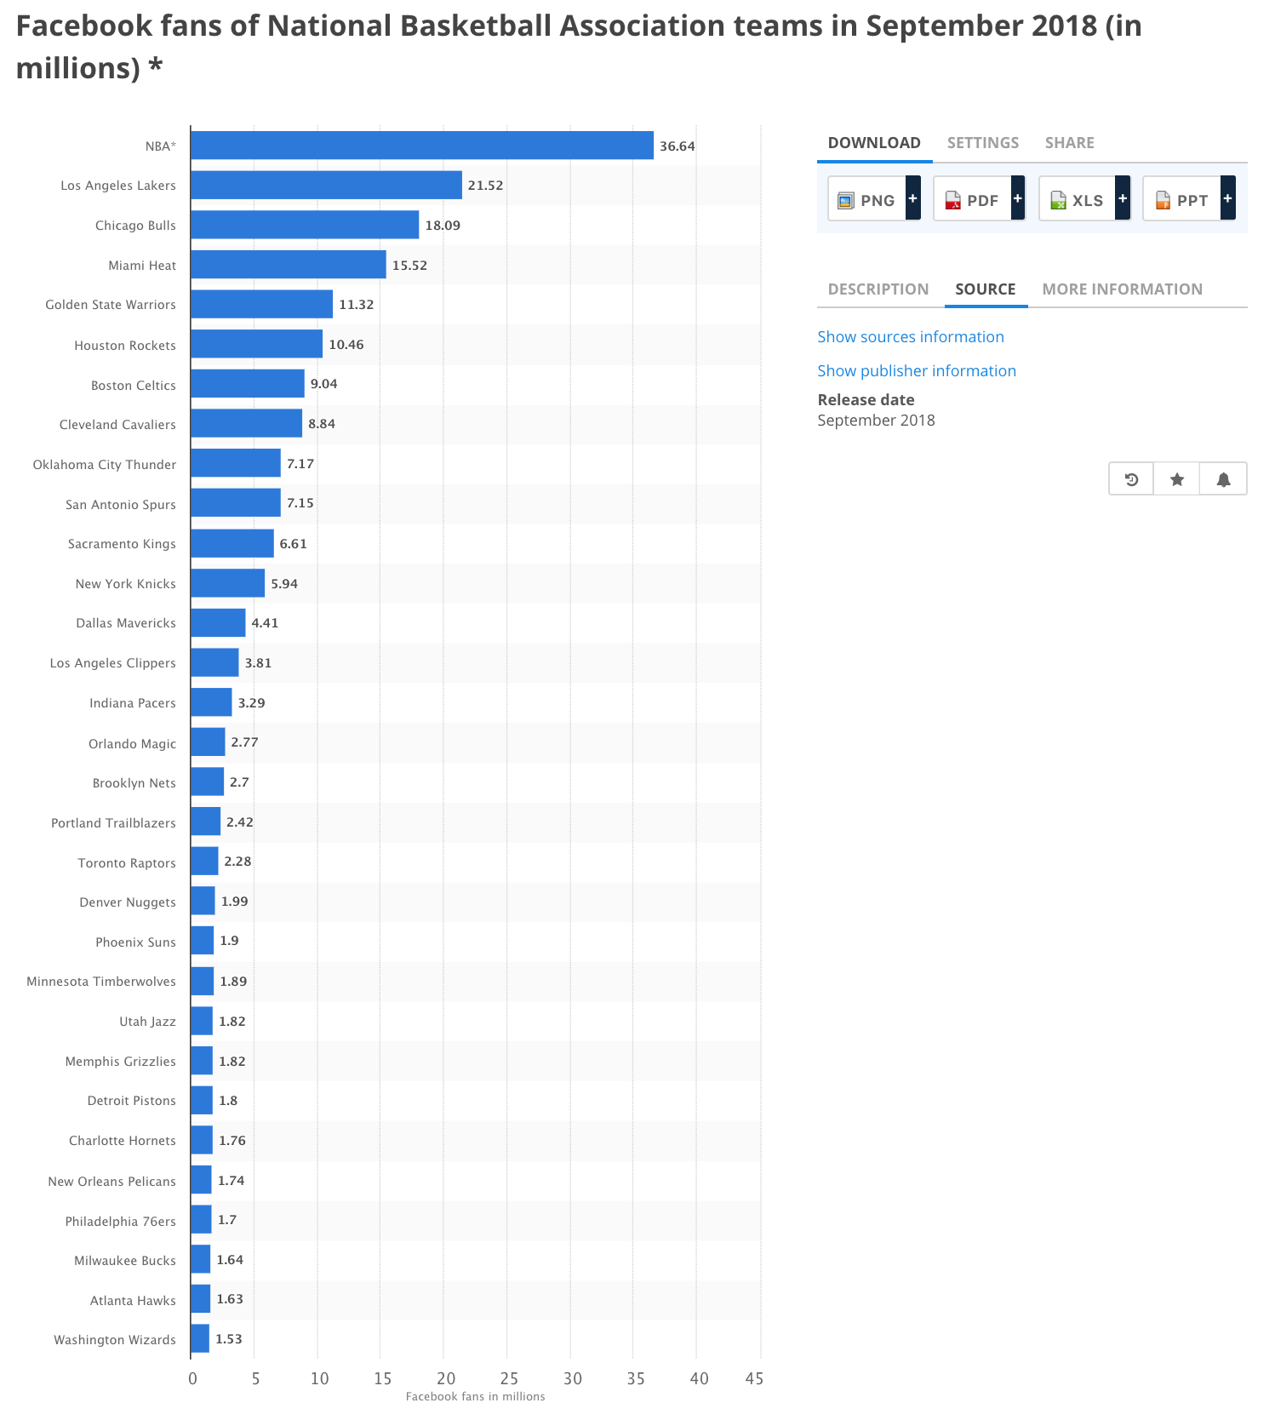

Currently, ESPN, Yahoo, NFL and CBS have the biggest Fantasy Sport sites. The active users in each company, in that order, are 12 millions, 10 millions, 3 millions and about 2 millions. Consequently, about ⅓ Facebook fans played in ESPN Fantasy basketball approximately (Quora). Since there isn’t any research on customer switching to a similar application, we would assume our largest target audience size is 12 millions.

**What are some other customer options or leading products that address the same needs?**

As far as our research, there is not a consistent algorithm that helps Fantasy Basketball player to draft the right players into their team.

**Are there any know customers for this product?**

There are no known customers for this product.

**Benefits to Customers**

* Users take less time to draft NBA players and form a balance team
* Interactive mode to enjoy being a general manager

**Potential Downside**

* Users need less time spending on researching player stats, thus less passion towards the actual league