Example Manuscript Template for a Data Analysis Project
Kexin Cui
The structure below is one possible setup for a manuscript stemming from a data analysis project. It loosely follows the structure of a standard scientific manuscript. Adjust as needed. You don’t need to have exactly these sections, but the content covering those sections should be addressed.
This uses MS Word as output format. See the Quarto documentation for instructions on how to use other formats.
Authors
- First Author$​^{1,2,*}$ (ORCID: 0000-0000-1234-5678)
- Second Author$​^{3,*}$
- Third Author$​^{3,†}$
- Last Author$​^{1,2,∧}$
Author affiliations
- College of Public Health, University of Georgia, Athens, GA, USA.
- Another Affiliation, Athens, GA, USA.
- Yet another Affiliation.
$*$ These authors contributed equally to this work.
$∧$ Corresponding author: some@email.com
$†$ Disclaimer: The opinions expressed in this article are the author’s own and don’t reflect their employer.

1. Summary/Abstract
This project uses human microbiome sequencing data as an example of complex genetics and –omics data. Microbiome data are generated from sequencing technologies and consist of multiple linked components, including microbial feature counts, taxonomic annotations, and sample metadata, which require specialized data structures and tools for analysis. Publicly available 16S rRNA sequencing data from the Human Microbiome Project will be accessed through the Bioconductor ecosystem and explored using SummarizedExperiment and phyloseq objects. The goal of this initial project stage is to assess feasibility by loading the data, performing minimal preprocessing, and conducting exploratory analyses such as se
It is recommended to use a structured abstract with Background/Methods/Results/Discussion sections.

2. Introduction

2.1 General Background Information
Microbiome research aims to characterize microbial communities and understand how they vary across environments or host conditions. Many microbiome studies rely on sequencing technologies such as 16S rRNA amplicon sequencing, which generate high-dimensional count data that are often sparse and noisy. As a result, microbiome data analysis requires specialized workflows and tools that differ from standard analyses of simple rectangular datasets.
These data are commonly categorized as genetics or –omics data. While some –omics datasets can be represented in rectangular form, they typically have many more features than samples and require preprocessing steps such as filtering, normalization, and dimension reduction. The Bioconductor project provides a comprehensive collection of R packages and standardized data structures designed specifically for genetics and –omics data analysis, making it a natural framework for microbiome research.

2.2 Description of data and data source
The data used in this project are 16S rRNA sequencing data from the Human Microbiome Project (HMP), obtained using the HMP16SData Bioconductor package. The unit of observation is an individual microbiome sample. For each sample, the dataset contains a high-dimensional table of microbial feature counts, a taxonomy table assigning features to taxonomic ranks (e.g., phylum and genus), and sample-level metadata describing characteristics such as body site.
This dataset represents a complex data type because it is not a single rectangular data frame. Instead, it consists of multiple linked components that are stored in specialized data structures, such as SummarizedExperiment and phyloseq objects. The number of microbial features greatly exceeds the number of samples, and many features are rare or absent in most samples, motivating the use of filtering and transformation steps prior to modeling.

2.3 Questions/Hypotheses to be addressed
The primary question of this project is whether microbiome community structure differs across sample groups defined by available metadata, such as body site. Outcomes of interest include alpha diversity measures (e.g., Shannon diversity) that summarize within-sample diversity, as well as beta diversity measures that capture differences in community composition between samples. I hypothesize that samples from different body sites will exhibit distinct diversity patterns and will cluster separately in ordination analyses.
To cite other work (important everywhere, but likely happens first in introduction), make sure your references are in the BibTeX file specified in the YAML header above and have the right BibTeX key. Then you can include like this:
Examples of reproducible research projects can for instance be found in (1,2).

3. Methods
Describe your methods. That should describe the data, the cleaning processes, and the analysis approaches. You might want to provide a shorter description here and all the details in the supplement.

3.1 Schematic of workflow
Sometimes you might want to show a schematic diagram/figure that was not created with code (if you can do it with code, do it). Figure 1 is an example of some - completely random/unrelated - schematic that was generated with BioRender. We store those figures in the assets folder.
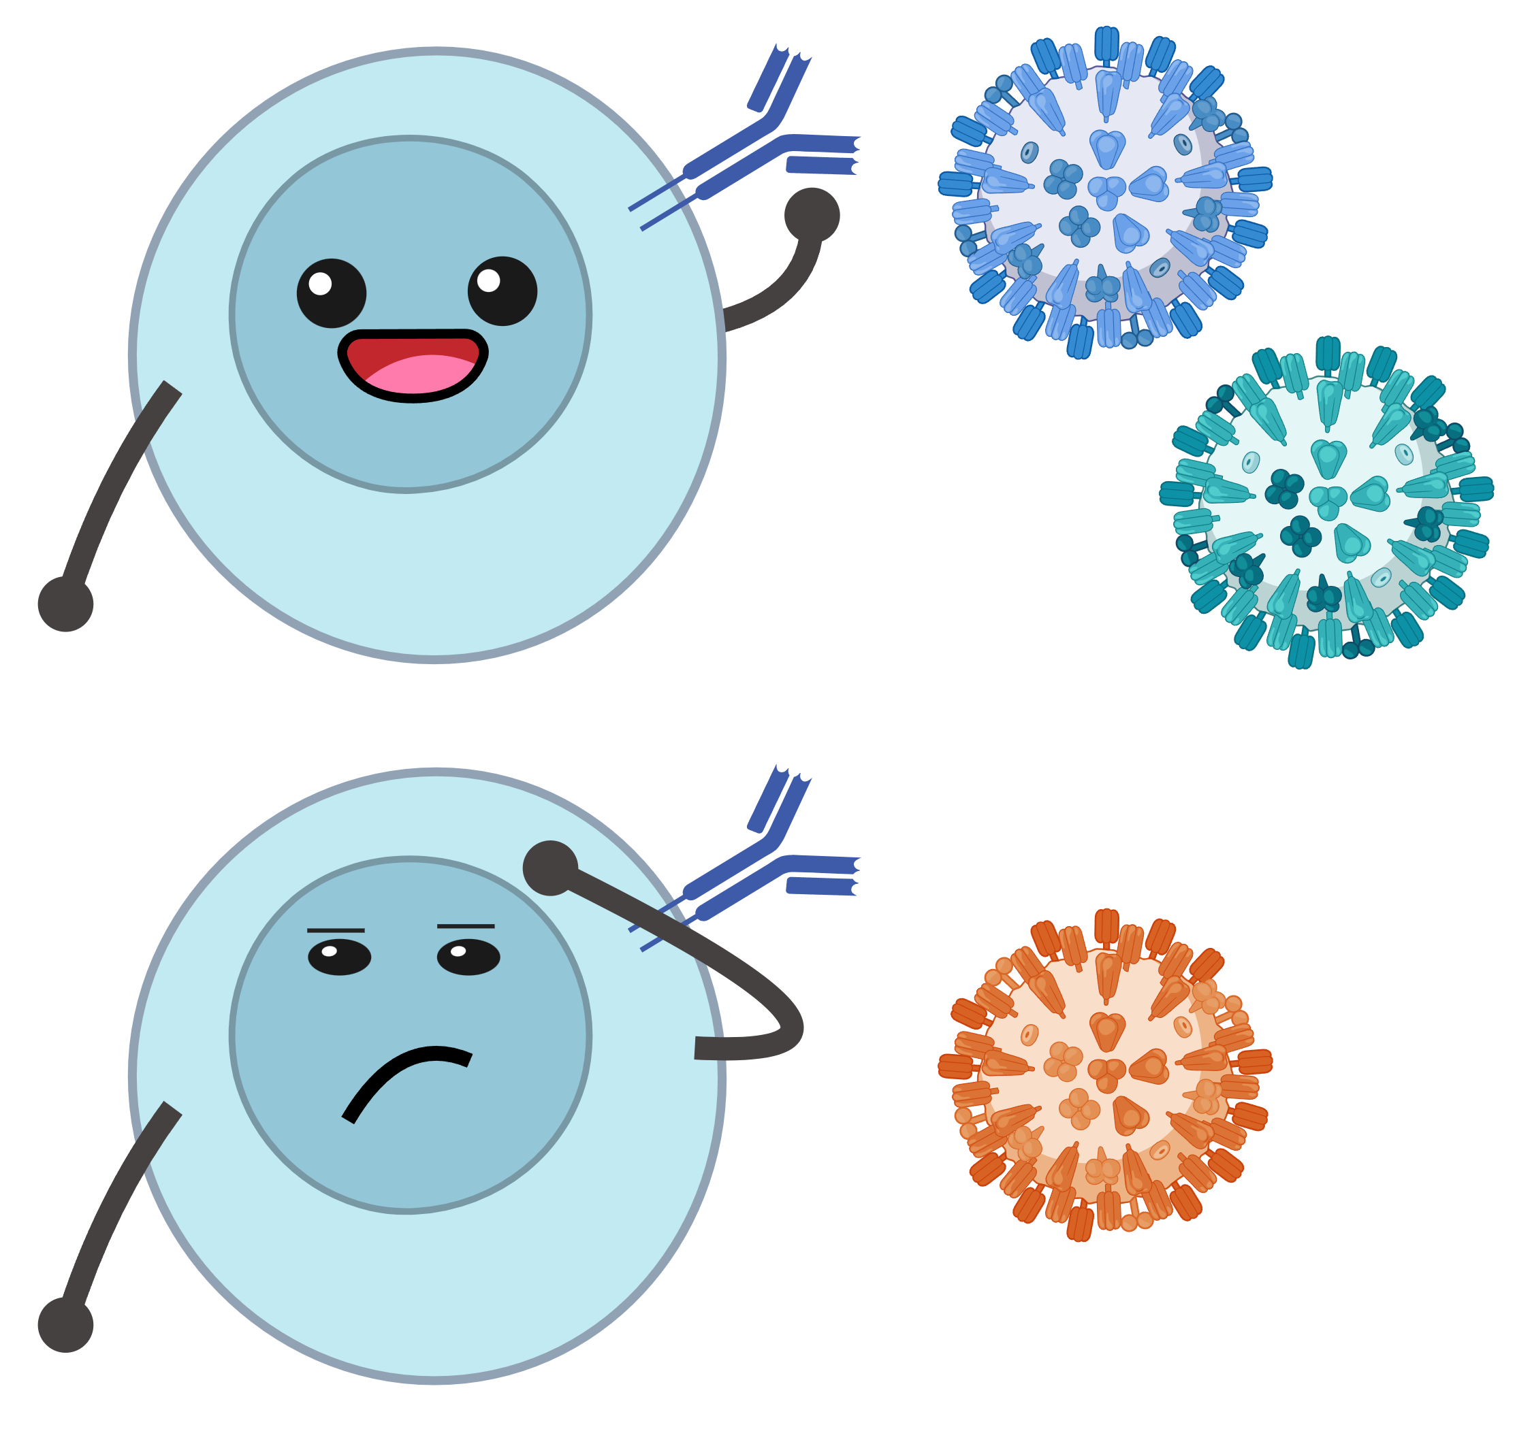
Figure 1: A figure that is manually generated and shows some overview/schematic. This has nothing to do with the data, it’s just a random one from one of our projects I found and placed here.

3.2 Data acquisition
The data were obtained directly from the Human Microbiome Project using the Bioconductor package HMP16SData. The V3–V5 16S rRNA amplicon dataset was imported programmatically in R using the V35() function, which returns the data as a SummarizedExperiment object containing microbial feature counts, taxonomic annotations, and sample metadata. The data were then converted to a phyloseq object to support microbiome-specific data handling and exploratory analysis. Programmatic data access through Bioconductor ensures reproducibility and avoids manual data downloads.
if (!requireNamespace("BiocManager", quietly = TRUE)) {
install.packages("BiocManager")
}
# BiocManager::install("microbiome")
library(tidyverse)
── Attaching core tidyverse packages ──────────────────────── tidyverse 2.0.0 ──
✔ dplyr 1.1.4 ✔ readr 2.1.5
✔ forcats 1.0.1 ✔ stringr 1.5.2
✔ ggplot2 4.0.0 ✔ tibble 3.3.0
✔ lubridate 1.9.4 ✔ tidyr 1.3.1
✔ purrr 1.1.0
── Conflicts ────────────────────────────────────────── tidyverse_conflicts() ──
✖ dplyr::filter() masks stats::filter()
✖ dplyr::lag() masks stats::lag()
ℹ Use the conflicted package (<http://conflicted.r-lib.org/>) to force all conflicts to become errors
library(HMP16SData)
Loading required package: SummarizedExperiment
Loading required package: MatrixGenerics
Loading required package: matrixStats
Attaching package: 'matrixStats'
The following object is masked from 'package:dplyr':
count
Attaching package: 'MatrixGenerics'
The following objects are masked from 'package:matrixStats':
colAlls, colAnyNAs, colAnys, colAvgsPerRowSet, colCollapse,
colCounts, colCummaxs, colCummins, colCumprods, colCumsums,
colDiffs, colIQRDiffs, colIQRs, colLogSumExps, colMadDiffs,
colMads, colMaxs, colMeans2, colMedians, colMins, colOrderStats,
colProds, colQuantiles, colRanges, colRanks, colSdDiffs, colSds,
colSums2, colTabulates, colVarDiffs, colVars, colWeightedMads,
colWeightedMeans, colWeightedMedians, colWeightedSds,
colWeightedVars, rowAlls, rowAnyNAs, rowAnys, rowAvgsPerColSet,
rowCollapse, rowCounts, rowCummaxs, rowCummins, rowCumprods,
rowCumsums, rowDiffs, rowIQRDiffs, rowIQRs, rowLogSumExps,
rowMadDiffs, rowMads, rowMaxs, rowMeans2, rowMedians, rowMins,
rowOrderStats, rowProds, rowQuantiles, rowRanges, rowRanks,
rowSdDiffs, rowSds, rowSums2, rowTabulates, rowVarDiffs, rowVars,
rowWeightedMads, rowWeightedMeans, rowWeightedMedians,
rowWeightedSds, rowWeightedVars
Loading required package: GenomicRanges
Loading required package: stats4
Loading required package: BiocGenerics
Attaching package: 'BiocGenerics'
The following objects are masked from 'package:lubridate':
intersect, setdiff, union
The following objects are masked from 'package:dplyr':
combine, intersect, setdiff, union
The following objects are masked from 'package:stats':
IQR, mad, sd, var, xtabs
The following objects are masked from 'package:base':
anyDuplicated, aperm, append, as.data.frame, basename, cbind,
colnames, dirname, do.call, duplicated, eval, evalq, Filter, Find,
get, grep, grepl, intersect, is.unsorted, lapply, Map, mapply,
match, mget, order, paste, pmax, pmax.int, pmin, pmin.int,
Position, rank, rbind, Reduce, rownames, sapply, setdiff, table,
tapply, union, unique, unsplit, which.max, which.min
Loading required package: S4Vectors
Attaching package: 'S4Vectors'
The following objects are masked from 'package:lubridate':
second, second<-
The following objects are masked from 'package:dplyr':
first, rename
The following object is masked from 'package:tidyr':
expand
The following object is masked from 'package:utils':
findMatches
The following objects are masked from 'package:base':
expand.grid, I, unname
Loading required package: IRanges
Attaching package: 'IRanges'
The following object is masked from 'package:lubridate':
%within%
The following objects are masked from 'package:dplyr':
collapse, desc, slice
The following object is masked from 'package:purrr':
reduce
Loading required package: GenomeInfoDb
Loading required package: Biobase
Welcome to Bioconductor
Vignettes contain introductory material; view with
'browseVignettes()'. To cite Bioconductor, see
'citation("Biobase")', and for packages 'citation("pkgname")'.
Attaching package: 'Biobase'
The following object is masked from 'package:MatrixGenerics':
rowMedians
The following objects are masked from 'package:matrixStats':
anyMissing, rowMedians
library(phyloseq)
Attaching package: 'phyloseq'
The following object is masked from 'package:SummarizedExperiment':
distance
The following object is masked from 'package:Biobase':
sampleNames
The following object is masked from 'package:GenomicRanges':
distance
The following object is masked from 'package:IRanges':
distance
library(vegan)
Loading required package: permute
library(microbiome)
microbiome R package (microbiome.github.com)
Copyright (C) 2011-2022 Leo Lahti,
Sudarshan Shetty et al. <microbiome.github.io>
Attaching package: 'microbiome'
The following object is masked from 'package:vegan':
diversity
The following object is masked from 'package:SummarizedExperiment':
coverage
The following object is masked from 'package:GenomicRanges':
coverage
The following objects are masked from 'package:IRanges':
coverage, transform
The following object is masked from 'package:S4Vectors':
transform
The following object is masked from 'package:ggplot2':
alpha
The following object is masked from 'package:base':
transform
# Load Human Microbiome Project 16S data (V3–V5 region)
se <- V35()
see ?HMP16SData and browseVignettes('HMP16SData') for documentation
loading from cache
ps <- as_phyloseq(se)
# Basic dimensions
nsamples(ps)
[1] 4743
ntaxa(ps)
[1] 45336
# Available sample metadata
sample_variables(ps)
[1] "RSID" "VISITNO" "SEX" "RUN_CENTER"
[5] "HMP_BODY_SITE" "HMP_BODY_SUBSITE" "SRS_SAMPLE_ID"

3.3 Data import and cleaning
After loading the data, several basic data checks and preprocessing steps were performed to prepare the microbiome data for exploratory analysis. Taxonomy and sample metadata were inspected to confirm successful import and consistency. Microbial features with zero total counts were removed, and rare taxa present in only a small number of samples were filtered out to reduce sparsity. Finally, raw count data were transformed to relative abundances to account for differences in sequencing depth across samples. These steps produced a cleaned dataset suitabl
# Inspect taxonomy and metadata
tax_table(ps)[1:5, 1:4]
Taxonomy Table: [5 taxa by 4 taxonomic ranks]:
SUPERKINGDOM PHYLUM CLASS ORDER
OTU_97.15099 "Bacteria" "Firmicutes" "Bacilli" "Lactobacillales"
OTU_97.13686 "Bacteria" "Firmicutes" "Bacilli" "Lactobacillales"
OTU_97.30326 "Bacteria" "Firmicutes" "Bacilli" "Lactobacillales"
OTU_97.26112 "Bacteria" "Firmicutes" "Bacilli" "Lactobacillales"
OTU_97.34719 "Bacteria" "Firmicutes" "Bacilli" "Lactobacillales"
sample_data(ps)[1:5, ]
RSID VISITNO SEX RUN_CENTER HMP_BODY_SITE
700013549 158013734 1 Female BCM Gastrointestinal Tract
700014386 158398106 1 Male BCM,BI Gastrointestinal Tract
700014403 158398106 1 Male BCM,BI Oral
700014409 158398106 1 Male BCM,BI Oral
700014412 158398106 1 Male BCM,BI Oral
HMP_BODY_SUBSITE SRS_SAMPLE_ID
700013549 Stool SRS012191
700014386 Stool <NA>
700014403 Saliva <NA>
700014409 Tongue Dorsum <NA>
700014412 Hard Palate <NA>
# Remove taxa with zero total counts
ps_nz <- prune_taxa(taxa_sums(ps) > 0, ps)
# Filter rare taxa (present in >5 samples)
ps_filt <- filter_taxa(ps_nz, function(x) sum(x > 0) > 5, prune = TRUE)
# Transform counts to relative abundance
ps_rel <- transform_sample_counts(ps_filt, function(x) x / sum(x))
# Compare dimensions before and after filtering
tibble(
stage = c("Original", "Filtered"),
samples = c(nsamples(ps), nsamples(ps_rel)),
taxa = c(ntaxa(ps), ntaxa(ps_rel))
)
# A tibble: 2 × 3
stage samples taxa
<chr> <int> <int>
1 Original 4743 45336
2 Filtered 4743 39214

3.4 Statistical analysis
Explain anything related to your statistical analyses.

4. Results

4.1 Exploratory/Descriptive analysis
Exploratory analyses were used to summarize key characteristics of the microbiome dataset and assess feasibility for later modeling. I first examined sequencing depth across samples to understand variability in read counts. Next, I summarized community composition by visualizing relative abundances of dominant taxonomic groups (phylum level). Finally, I computed alpha diversity (Shannon index) to describe within-sample diversity and compared it across a metadata-defined grouping variable (e.g., body subsite). These descriptive results provide a high-level overview of the data structure and major patterns without performing formal hypothesis testing. ### Sequencing depth distribution
tibble(library_size = sample_sums(ps_filt)) %>%
ggplot(aes(x = library_size)) +
geom_histogram(bins = 30) +
labs(x = "Sequencing depth (reads per sample)",
y = "Number of samples")
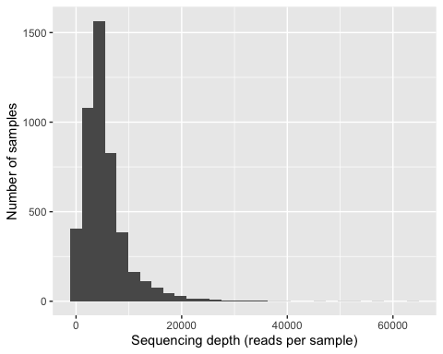

4.1.1 Dominant taxa composition (top phyla)
# Extract relative abundance matrix
otu <- as(otu_table(ps_rel), "matrix")
if (taxa_are_rows(ps_rel)) otu <- t(otu)
# Get phylum labels
tax <- as(tax_table(ps_rel), "matrix")
phylum <- tax[, "PHYLUM"]
phylum[is.na(phylum) | phylum == ""] <- "UNASSIGNED"
# Collapse features to phylum level
otu_phylum <- rowsum(t(otu), group = phylum)
otu_phylum <- t(otu_phylum)
# Plot top 10 phyla
df <- as_tibble(otu_phylum, rownames = "SampleID") |>
pivot_longer(-SampleID, names_to = "PHYLUM", values_to = "RelAbund")
top10 <- df |>
group_by(PHYLUM) |>
summarize(total = sum(RelAbund), .groups = "drop") |>
slice_max(total, n = 10) |>
pull(PHYLUM)
df |>
filter(PHYLUM %in% top10) |>
ggplot(aes(SampleID, RelAbund, fill = PHYLUM)) +
geom_col() +
theme(axis.text.x = element_blank(), axis.ticks.x = element_blank()) +
labs(x = "Samples", y = "Relative abundance")
Warning: Removed 21 rows containing missing values or values outside the scale range
(`geom_col()`).
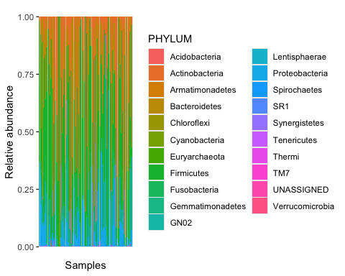
Relative abundances of dominant bacterial phyla varied substantially across samples, indicating heterogeneous community composition typical of human microbiome data.

4.1.2 Alpha diversity (Shannon) + boxplot by group
alpha <- estimate_richness(ps_filt, measures = "Shannon") %>%
rownames_to_column("SampleID")
meta <- as(sample_data(ps_filt), "data.frame") %>%
rownames_to_column("SampleID")
df_alpha <- left_join(alpha, meta, by = "SampleID")
GROUP_VAR <- "HMP_BODY_SUBSITE" # change if needed
df_alpha %>%
ggplot(aes(x = .data[[GROUP_VAR]], y = Shannon)) +
geom_boxplot() +
labs(x = GROUP_VAR, y = "Shannon diversity") +
theme(axis.text.x = element_text(angle = 45, hjust = 1))
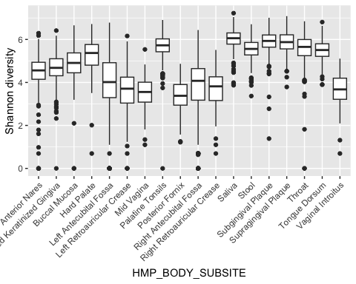
Table 1 shows a summary of the data.
Note the loading of the data providing a relative path using the ../../ notation. (Two dots means a folder up). You never want to specify an absolute path like C:\ahandel\myproject\results\ because if you share this with someone, it won’t work for them since they don’t have that path. You can also use the here R package to create paths. See examples of that below. I generally recommend the here package.
Table 1: Data summary table.
skim_type | skim_variable | n_missing | complete_rate | factor.ordered | factor.n_unique | factor.top_counts | numeric.mean | numeric.sd | numeric.p0 | numeric.p25 | numeric.p50 | numeric.p75 | numeric.p100 | numeric.hist
factor | Gender | 0 | 1 | FALSE | 3 | M: 4, F: 3, O: 2 | NA | NA | NA | NA | NA | NA | NA | NA
numeric | Height | 0 | 1 | NA | NA | NA | 165.66667 | 15.97655 | 133 | 156 | 166 | 178 | 183 | ▂▁▃▃▇
numeric | Weight | 0 | 1 | NA | NA | NA | 70.11111 | 21.24526 | 45 | 55 | 70 | 80 | 110 | ▇▂▃▂▂

4.2 Basic statistical analysis
To get some further insight into your data, if reasonable you could compute simple statistics (e.g. simple models with 1 predictor) to look for associations between your outcome(s) and each individual predictor variable. Though note that unless you pre-specified the outcome and main exposure, any “p<0.05 means statistical significance” interpretation is not valid.
Figure 2 shows a scatterplot figure produced by one of the R scripts.
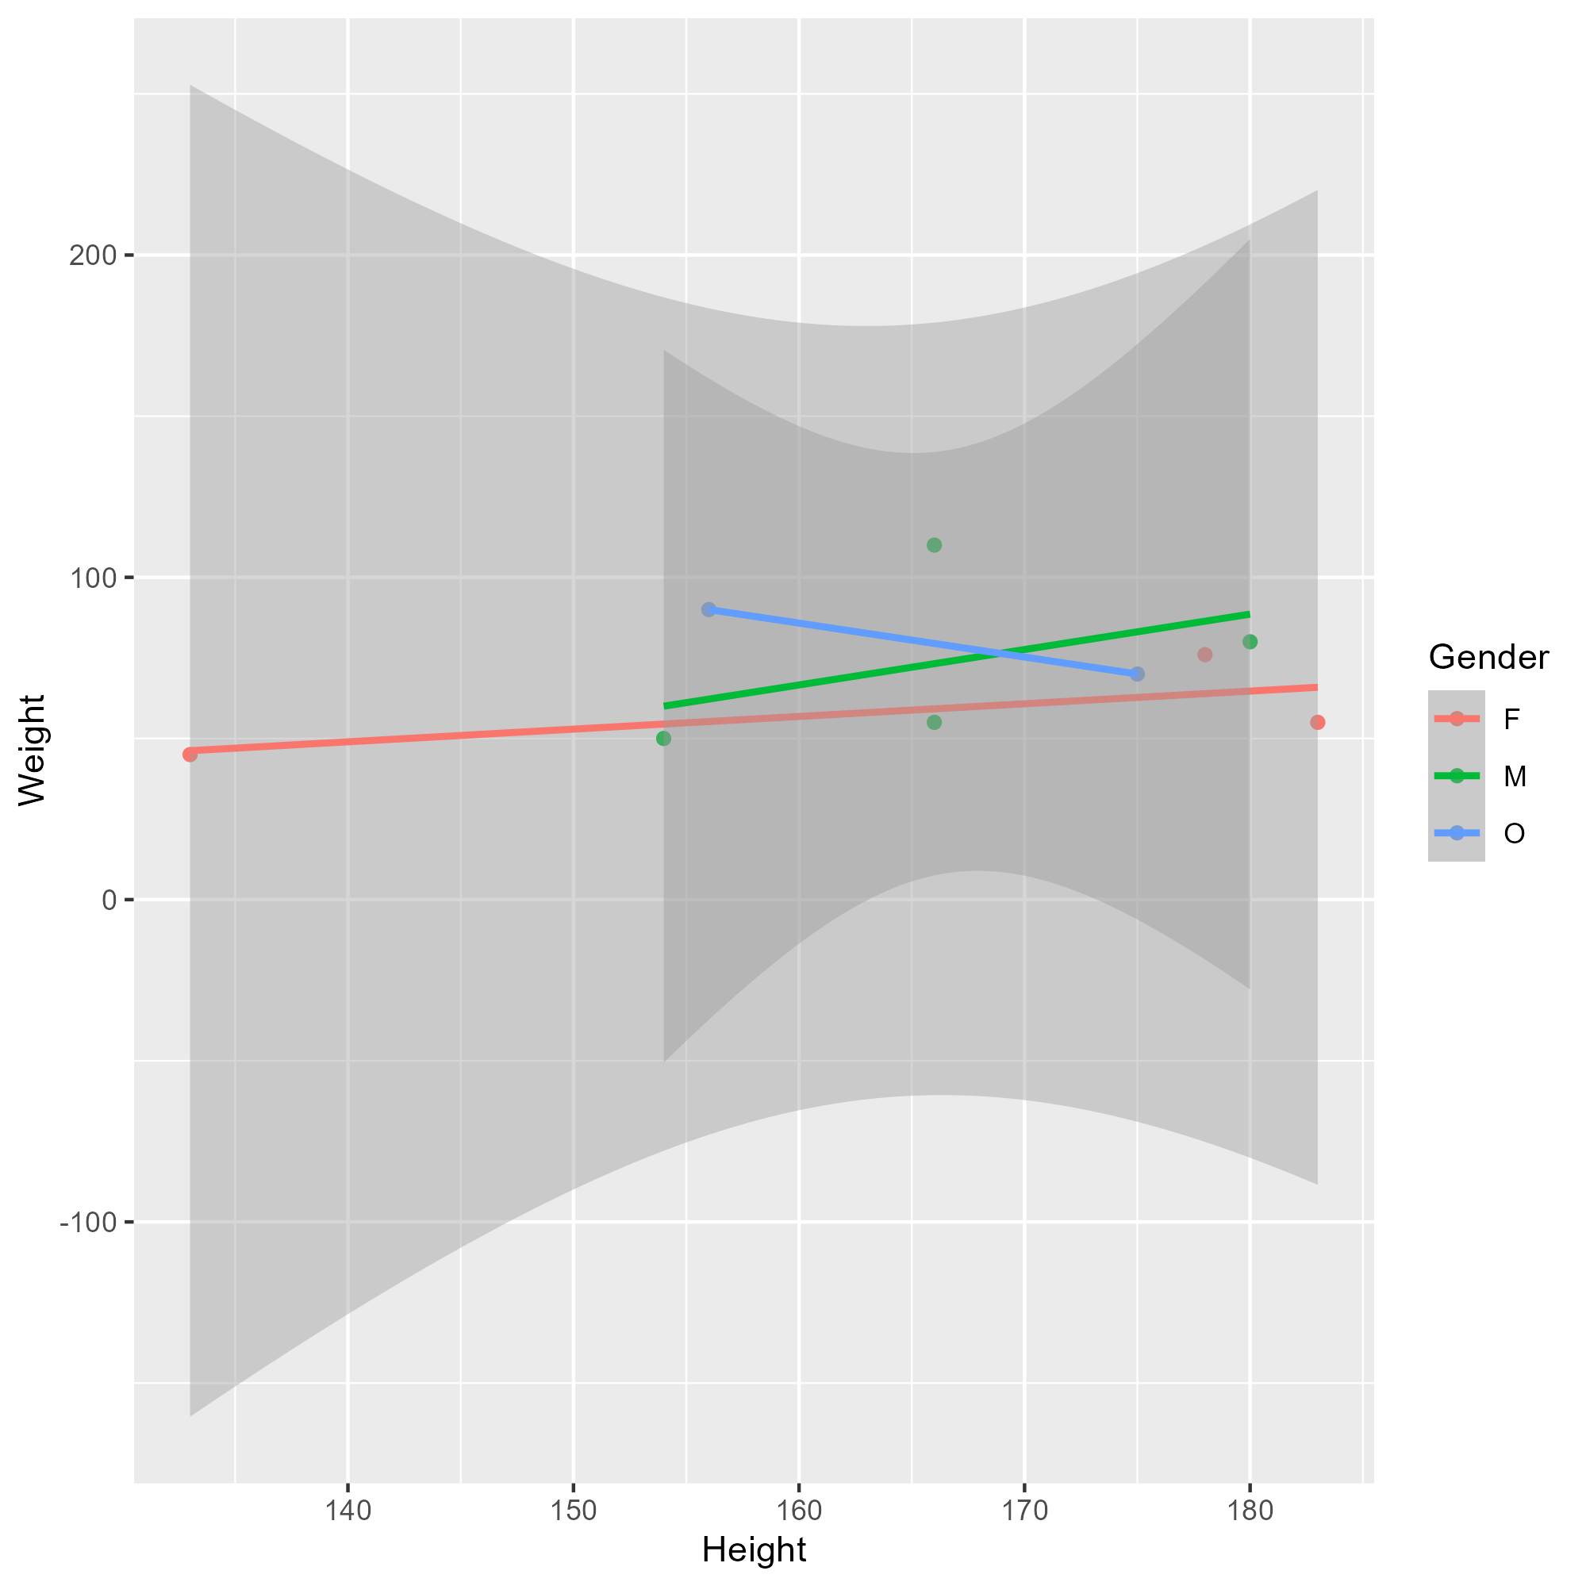
Figure 2: Height and weight stratified by gender.

4.3 Full analysis
Use one or several suitable statistical/machine learning methods to analyze your data and to produce meaningful figures, tables, etc. This might again be code that is best placed in one or several separate R scripts that need to be well documented. You want the code to produce figures and data ready for display as tables, and save those. Then you load them here.
Example Table 2 shows a summary of a linear model fit.
Table 2: Linear model fit table.
term | estimate | std.error | statistic | p.value
(Intercept) | 149.2726967 | 23.3823360 | 6.3839942 | 0.0013962
Weight | 0.2623972 | 0.3512436 | 0.7470519 | 0.4886517
GenderM | -2.1244913 | 15.5488953 | -0.1366329 | 0.8966520
GenderO | -4.7644739 | 19.0114155 | -0.2506112 | 0.8120871

5. Discussion

5.1 Summary and Interpretation
Summarize what you did, what you found and what it means.

5.2 Strengths and Limitations
Discuss what you perceive as strengths and limitations of your analysis.

5.3 Conclusions
What are the main take-home messages?
Include citations in your Qmd file using BibTeX, the list of references will automatically be placed at the end
This paper (3) discusses types of analyses.
These papers (1,2) are good examples of papers published using a fully reproducible setup similar to the one shown in this template.
Note that this cited reference will show up at the end of the document, the reference formatting is determined by the CSL file specified in the YAML header. Many more style files for almost any journal are available. You also specify the location of your BibTeX reference file in the YAML. You can call your reference file anything you like.

6. References
1. McKay B, Ebell M, Billings WZ, et al. Associations Between Relative Viral Load at Diagnosis and Influenza A Symptoms and Recovery. Open forum infectious diseases. 2020;7(11):ofaa494.
2. McKay B, Ebell M, Dale AP, et al. Virulence-mediated infectiousness and activity trade-offs and their impact on transmission potential of influenza patients. Proceedings. Biological sciences. 2020;287(1927):20200496.
3. Leek JT, Peng RD. Statistics. What is the question? Science (New York, N.Y.). 2015;347(6228):1314–1315.

