A description of your modifications to the program. You may include snippets of source code if required.
- Each work process sends the calculation results of the previous task to the management process while requesting the allocation of the next task to the management process. The worker process packages its process number, index of completed columns, and calculation result data and sends them to the management process as a request at one time.
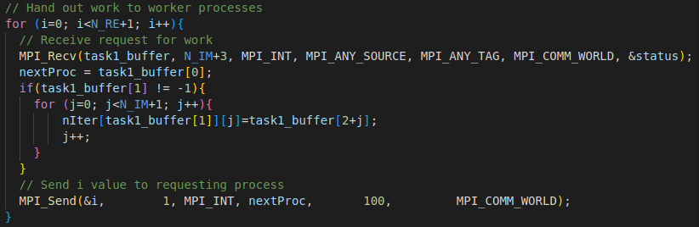
- When the management process receives a task request from a work process, Isolate the last calculated result of the worker process from the request, it saves the calculation results of the previous task sent by the work process.
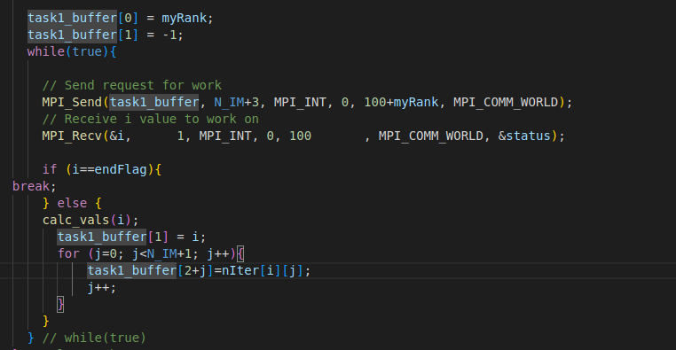

A paragraph describing and assessing your results. You should say whether your modi-fications have improved the parallel performance of the program and quantify the sizeof any improvement.
在相同进程数下，修改后的版本V2比原始版本V1有着更高的加速比。随着进程数的增加，V2加速比与V1加速比的差越来越大，这说明修改确实提升了程序的并行性能。
从程序代码角度分析，原始版本V1是在所有工作进程将所有任务计算完毕后，将结果汇总，每一个工作进程都将整个数组（自己计算的部分+自己没有计算的部分）使用MPI_Reduce求和，这使得会传递很多没有计算的数据，并且随着进程数的增多，每一个工作进程的计算量减少，但是每一个进程都传递同样大小的数组，这使得通信的工作量越来越大，有效的数据传输占比越来越小。修改后的版本V2是在每一个工作进程计算完一列后，将该列的值发送给管理进程进行存储，无论进程数的多少，总的数据传输都是固定的.
因此V2的效率肯定会高于V1，并且随着进程数的增多优势越明显。
With the same number of processes, the modified version V2 has a higher acceleration ratio than the original version V1. As the number of processes increases, the difference between the V2 acceleration ratio and the V1 acceleration ratio becomes larger, indicating that the modifications have indeed improved the parallel performance of the program.
From the perspective of program code, the original version V1 summarized the results after all work processes had calculated all tasks, and each work process used MPI_ Reduce for the entire array (the part calculated by itself+the part not calculated by itself) summation, which makes it possible to transfer a lot of data that has not been calculated. As the number of processes increases, the calculation amount of each working process decreases. However, each process passes an array of the same size, which increases the communication workload of communication and reduces the proportion of effective data transmission. The modified version of V2 is to send the value of a column to the management process for storage after each worker process has calculated it. Regardless of the number of processes, the total data transmission is fixed.
so the efficiency of V2 will definitely be higher than that of V1, and the advantages will become more apparent as the number of processes increases.

