
2025-2026学年第一学期
Academic year and semester: 2025-2026-1

《机器学习与社会计算》
实验报告

院 （系）： 信息与控制工程学院
专业班级： 计算机2203
学生姓名： 梁桐
学 号： 2209060322
指导教师： 吕长春
日 期： 2025.11.19

目录
任务1：安装软件NetLogo，基于Segregation模型分析不同参数（两个参数）变化下谢林模型的演化规律（C1-社交网络的结构中）： 2
1.1 安装NetLogo 2
1.2 固定density参数实验 3
1.3 固定simila-wanted参数实验 8
1.4 实验结果统计 10
1.5 实验结果分析 10
任务2：基于模型库中network—virus on a network分析不同参数（7个参数）下对传播的影响规律（C3-传播与影响）。 12
2.1 测试initial-outbreak-size参数 12
2.2 测试number-of-nodes参数 14
2.3 测试average-node-degree参数 16
2.4 测试virus-spread-chance参数 17
2.5 测试virus-check-frequency参数 19
2.6 测试recovery-chance参数 20
2.7 测试gain-resistance-chance参数 21
2.8 实验结果表格 22
2.9 实验结果分析 28

任务1：安装软件NetLogo，基于Segregation模型分析不同参数（两个参数）变化下谢林模型的演化规律（C1-社交网络的结构中）：

安装NetLogo
打开官网安装自己对应版本的NetLogo

安装完成


1.2 固定density参数实验
打开NetLogp 7.0.2，File → Models Library

Social Science → Segregation.nlogo





初始状态，simila-wanted = 20%、density = 95%
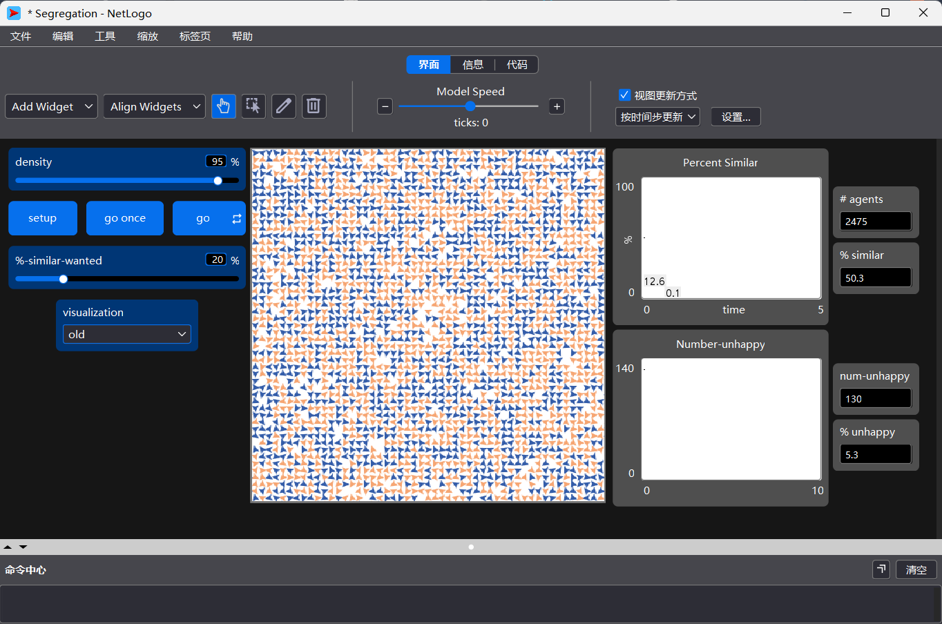
最终状态,simila-wanted = 20%、density = 95%
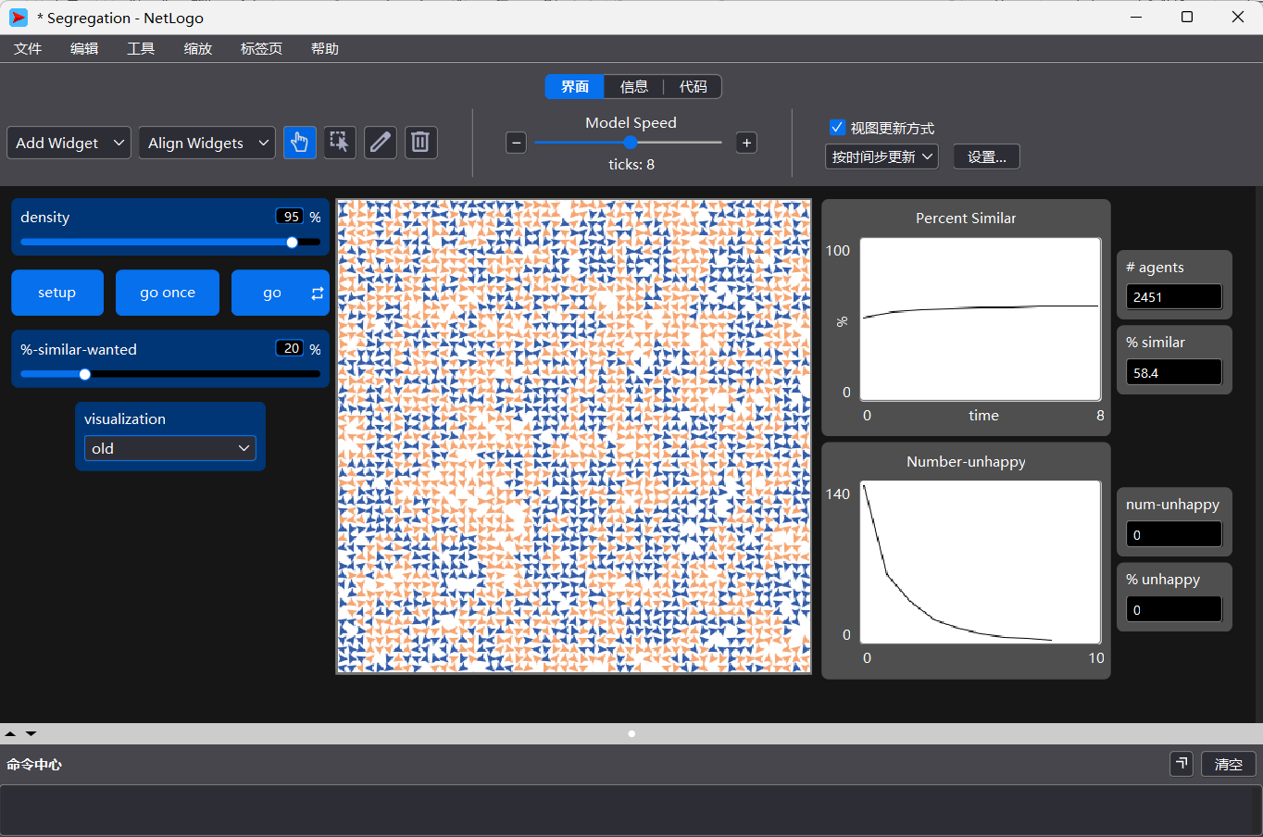

simila-wanted = 30%、density = 95%
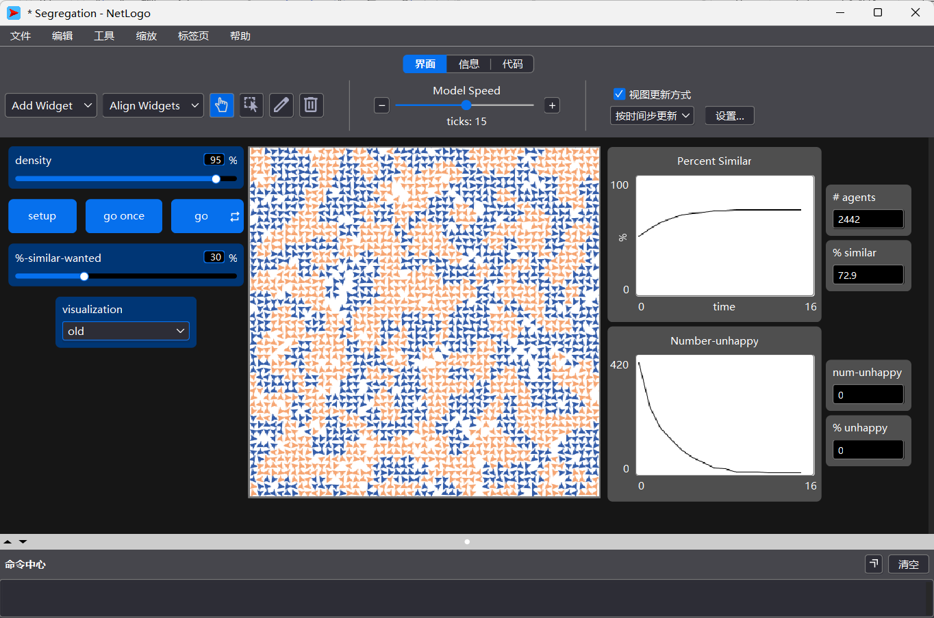

simila-wanted = 40%、density = 95%

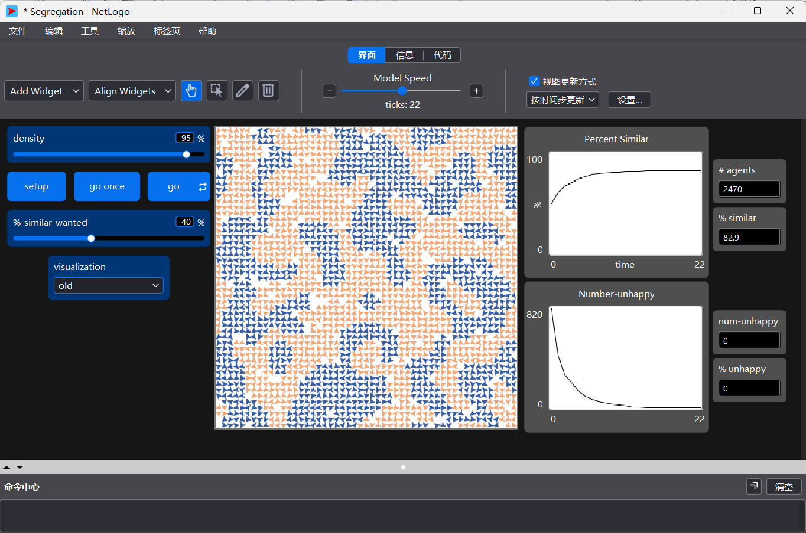

simila-wanted = 50%、density = 95%
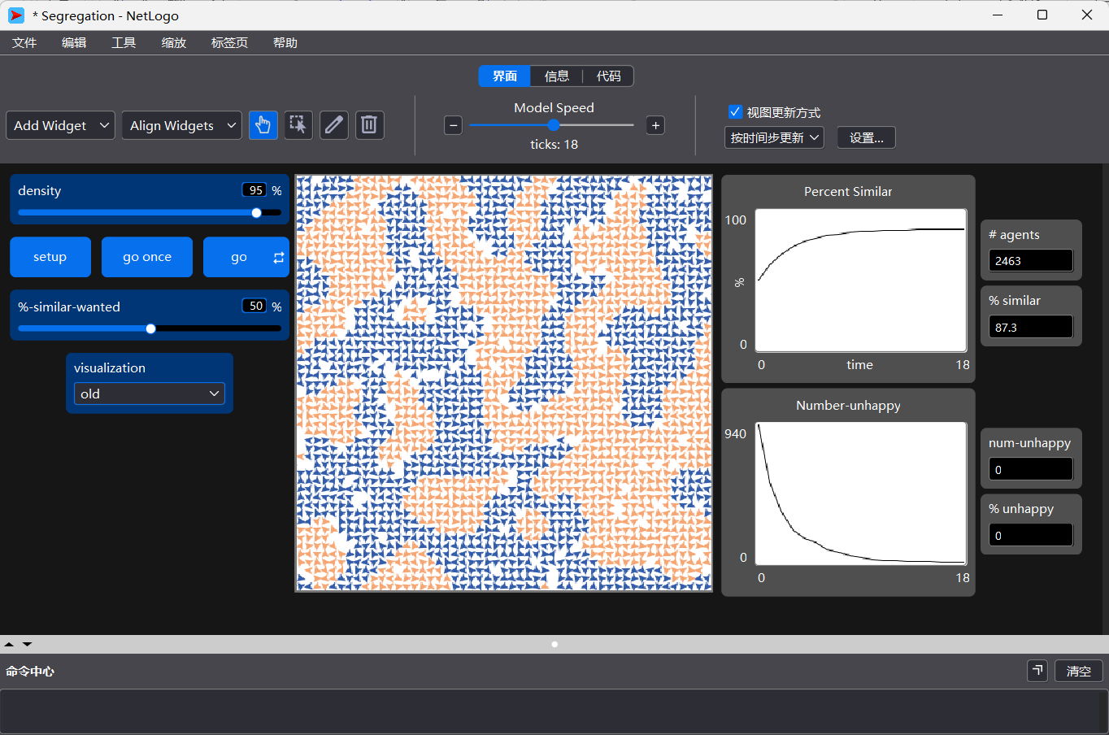

simila-wanted = 80%、density = 95%,模型一直不稳定
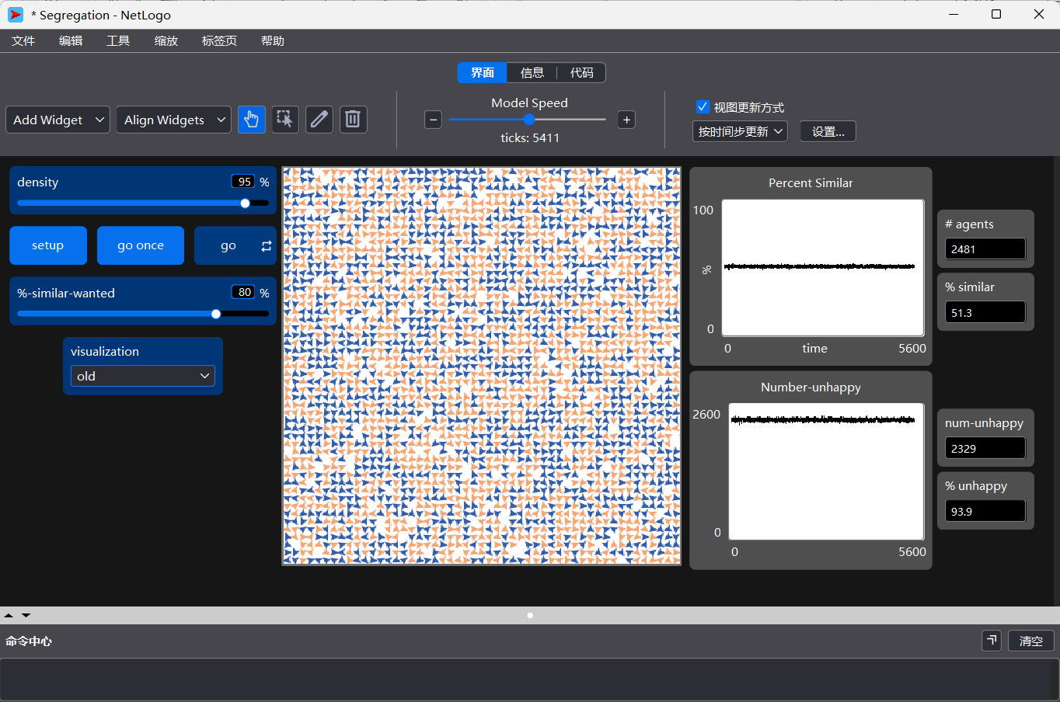

1.3 固定simila-wanted参数实验
simila-wanted = 50%、density = 80%
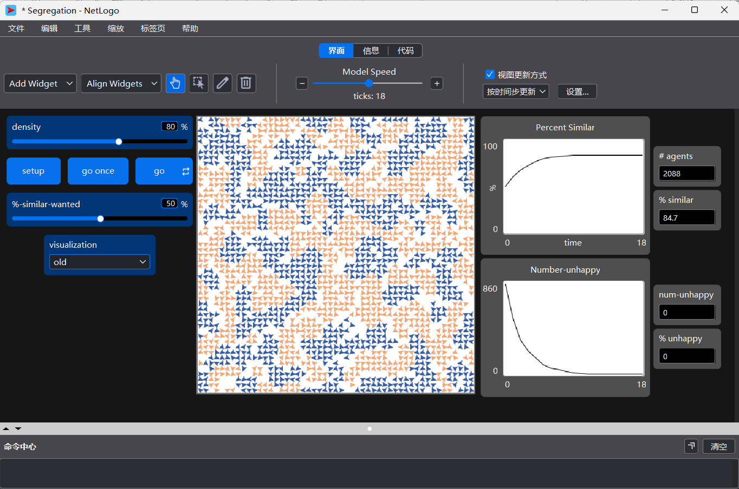

simila-wanted = 50%、density = 60%

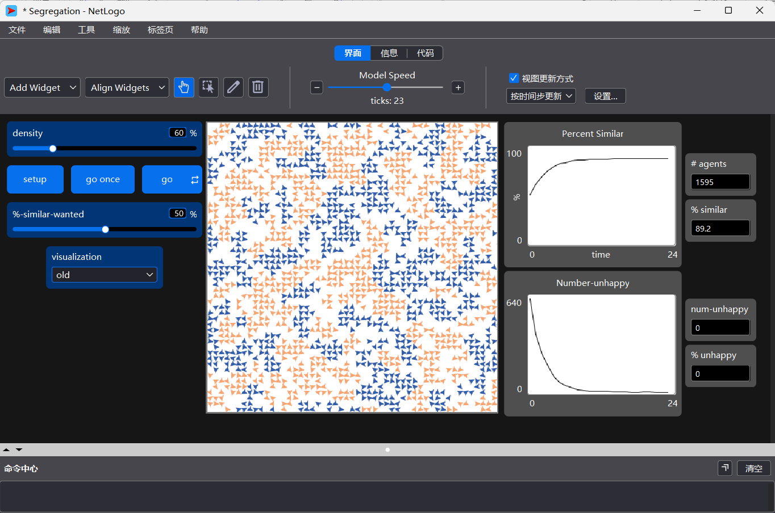

simila-wanted = 50%、density = 50%
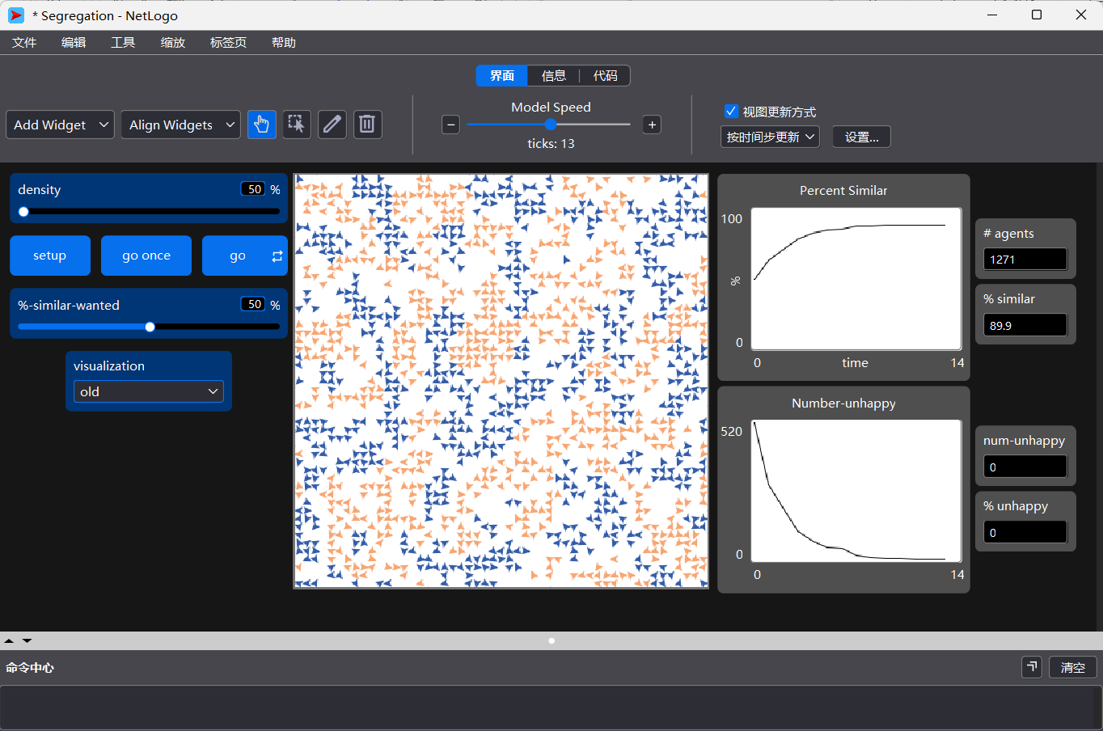

1.4 实验结果统计

实验序号 | 参数 1：%-similar-wanted（%） | 参数 2：density（%） | 实验结果 1：最终 % similar（%） | 实验结果 2：达到稳定的 ticks（步数）
1 | 20 | 95 | 58.4 | 8
2 | 30 | 95 | 72.9 | 15
3 | 40 | 95 | 82.9 | 22
4 | 50 | 95 | 87.3 | 18
5 | 80 | 95 | 不稳定 | 不稳定
6 | 50 | 80 | 84.7 | 18
7 | 50 | 60 | 89.2 | 23
8 | 50 | 50 | 89.9 | 13

1.5 实验结果分析
本实验基于 NetLogo 的 Segregation（谢林分离）模型，通过改变模型中两个关键参数——%-similar-wanted（邻居同类容忍度）与 density（人口密度），观察个体在微观规则下所形成的宏观聚集与隔离现象。实验数据显示，小小的容忍度变化与人口密度调整会产生显著的群体空间分化效应。

1. %-similar-wanted 对分离程度的影响

在保持人口密度为 95% 的情况下：
实验序号 | 参数 1：%-similar-wanted（%） | 参数 2：density（%） | 实验结果 1：最终 % similar（%） | 实验结果 2：达到稳定的 ticks（步数）
1 | 20 | 95 | 58.4 | 8
2 | 30 | 95 | 72.9 | 15
3 | 40 | 95 | 82.9 | 22
4 | 50 | 95 | 87.3 | 18
5 | 80 | 95 | 不稳定 | 不稳定

可以观察到：

当容忍度仅为 20% 时，个体对邻居的要求极低，系统快速达到稳定（仅 8 ticks），但整体只形成较弱的聚集现象（最终相似度约 58.4%）。

随着容忍度上升至 40%–50%，个体开始追求更高比例的同类邻居，导致频繁迁移，系统达到稳定需要更多步数（15~22 ticks），最终产生明显的隔离格局。

表明：容忍度越高，整体分离程度越强，系统越难收敛。

值得注意的是，当容忍度提高至 80%（实验 5），模型无法收敛至稳定状态，代理不断移动却始终无法满足过高的邻域要求，系统呈现长期不稳定。这体现了谢林模型的经典结论：

过度的同质性偏好会导致系统不可达成稳定状态，甚至引发社会结构性撕裂。

2. density 对分离现象的影响
实验序号 | 参数 1：%-similar-wanted（%） | 参数 2：density（%） | 实验结果 1：最终 % similar（%） | 实验结果 2：达到稳定的 ticks（步数）
6 | 50 | 80 | 84.7 | 18
7 | 50 | 60 | 89.2 | 23
8 | 50 | 50 | 89.9 | 13

在保持容忍度 50% 的情况下：

密度较高时（80%~95%），由于空位较少，个体迁移空间受限，系统需要更多步数才能形成局部均衡。

当密度降低至 50%~60% 时，可移动空间增大，个体更容易找到符合偏好的邻居环境，因此最终相似度略高且收敛更快（13 ticks）。

这说明：
适度的空间冗余有助于社会结构快速分化；人口越拥挤，迁移难度越大，分离过程越缓慢。

3. 综合结论
通过上述实验可得：
微小的偏好会导致宏观隔离：即使个体并非完全排斥异类，仅追求 40% 的“类似邻居”，最终也会演化出高度隔离的群体结构。
容忍度是系统隔离程度的主控参数：从 20% 到 50%，分离现象呈现阶跃式增强；到 80% 时系统失稳。
人口密度影响系统的演化速度和可达性：过高密度阻碍迁移并延缓收敛，而一定的空余空间会加速群体结构的重组。
这些规律与谢林模型的理论一致，体现了局部行为偏好能够自发演化出全局性的社会隔离模式，是典型的复杂系统涌现现象。

任务2：基于模型库中network—virus on a network分析不同参数（7个参数）下对传播的影响规律（C3-传播与影响）。

2.1 测试initial-outbreak-size参数
首先选择模型


本打算每个参数设3个值，应该运行3^7=2187次，由于电脑性能限制，改为运行3*7=21次。
使用Experiment工具完成实验,测试initial-outbreak-size参数
["initial-outbreak-size" 1 3 10]
["number-of-nodes" 150]
["average-node-degree" 6]
["virus-spread-chance" 2.5]
["virus-check-frequency" 1]
["recovery-chance" 5]
["gain-resistance-chance" 5]
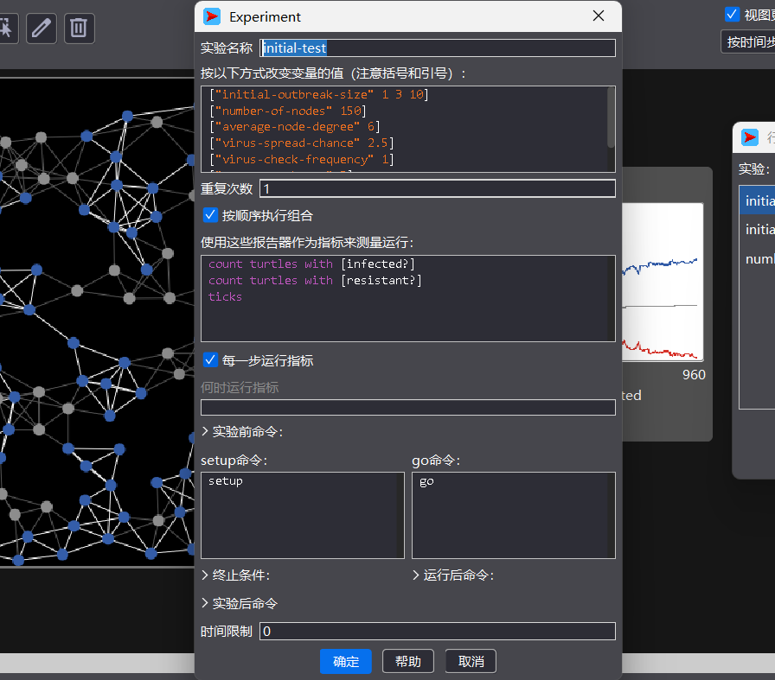
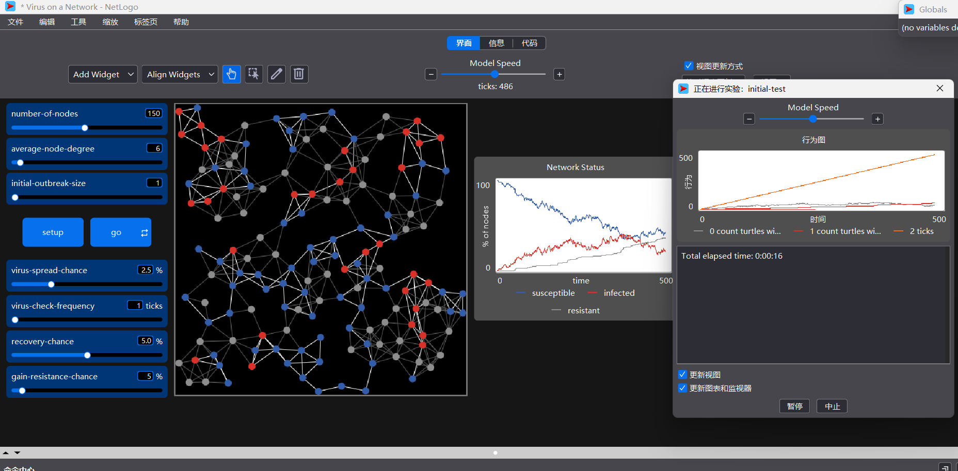
测试结果如下：
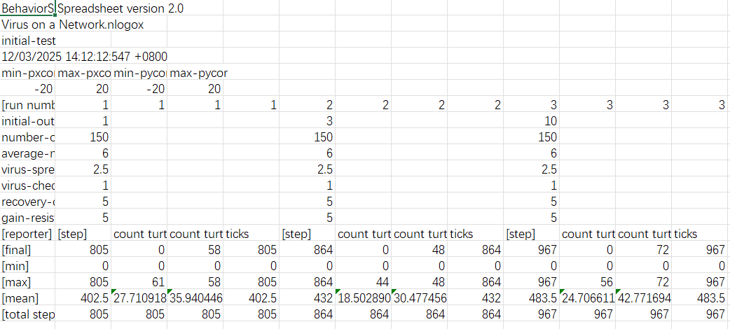

2.2 测试number-of-nodes参数
["initial-outbreak-size" 3]
["number-of-nodes" 100 150 200]
["average-node-degree" 6]
["virus-spread-chance" 2.5]
["virus-check-frequency" 1]
["recovery-chance" 5]
["gain-resistance-chance" 5]
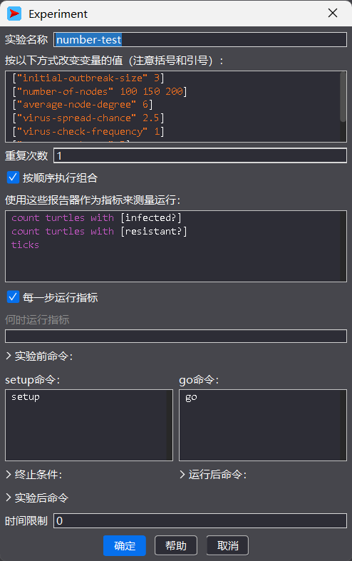
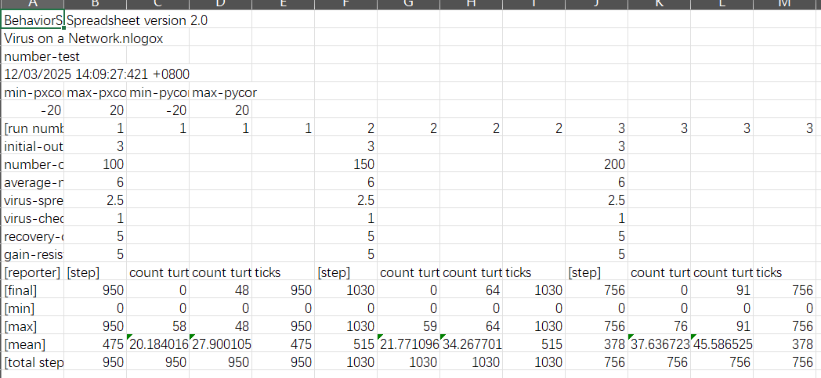

2.3 测试average-node-degree参数
["initial-outbreak-size" 3]
["number-of-nodes" 150]
["average-node-degree" 3 6 9]
["virus-spread-chance" 2.5]
["virus-check-frequency" 1]
["recovery-chance" 5]
["gain-resistance-chance" 5]
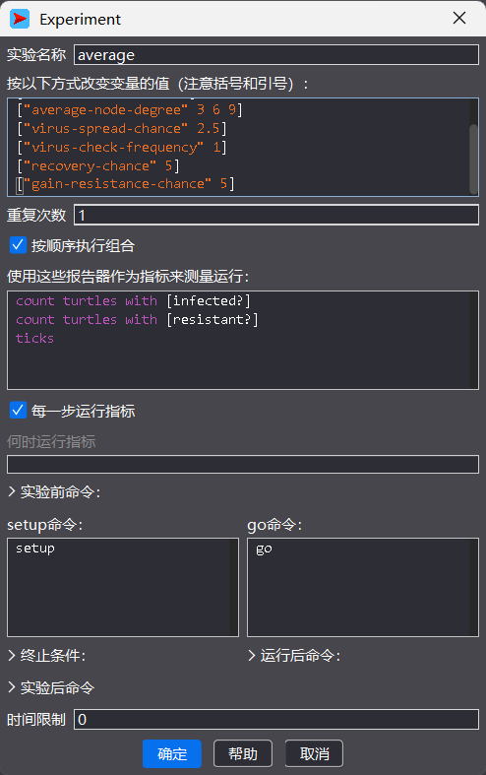
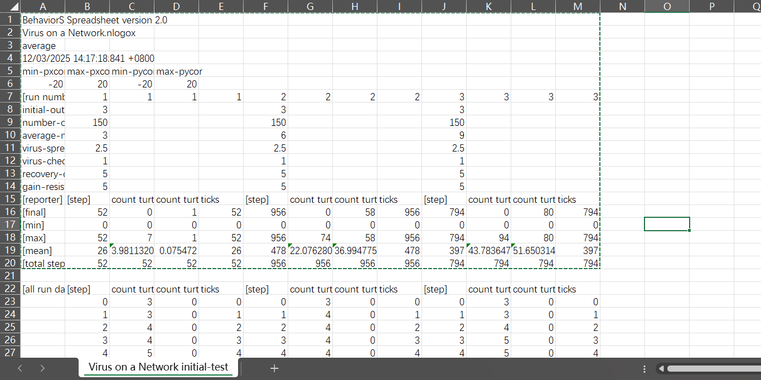

2.4 测试virus-spread-chance参数
["initial-outbreak-size" 3]
["number-of-nodes" 150]
["average-node-degree" 6]
["virus-spread-chance" 2.5 5 7.5]
["virus-check-frequency" 1]
["recovery-chance" 5]
["gain-resistance-chance" 5]
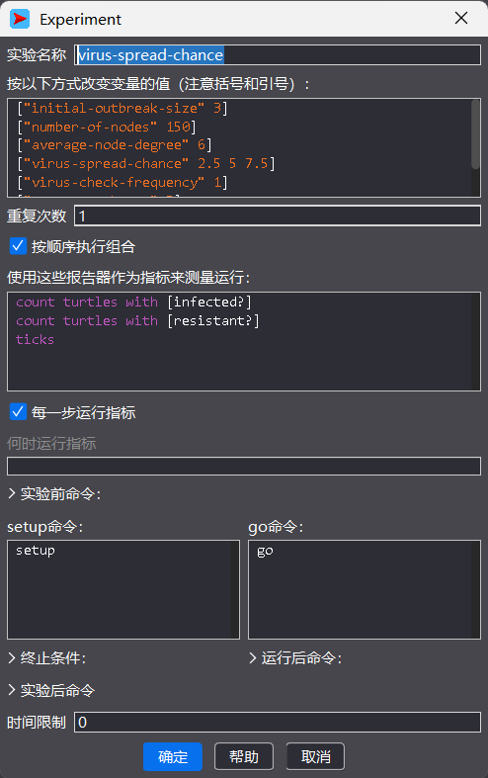
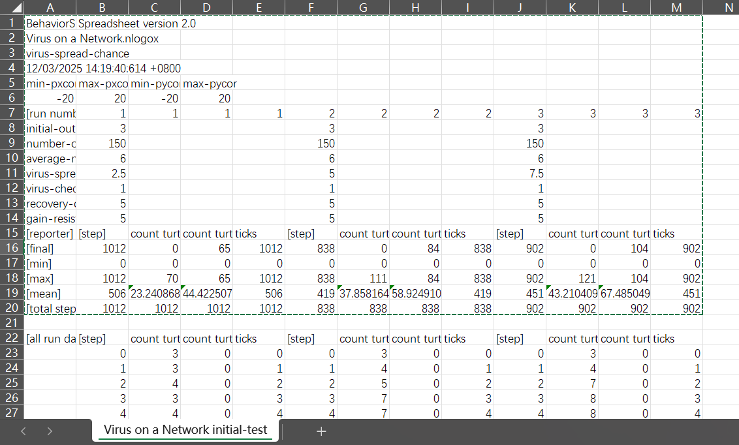

2.5 测试virus-check-frequency参数
["initial-outbreak-size" 3]
["number-of-nodes" 150]
["average-node-degree" 6]
["virus-spread-chance" 2.5]
["virus-check-frequency" 1 3 5]
["recovery-chance" 5]
["gain-resistance-chance" 5]
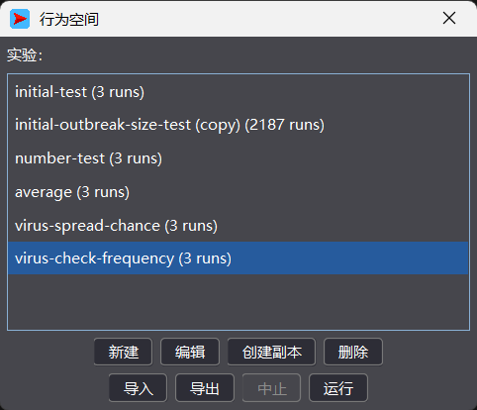
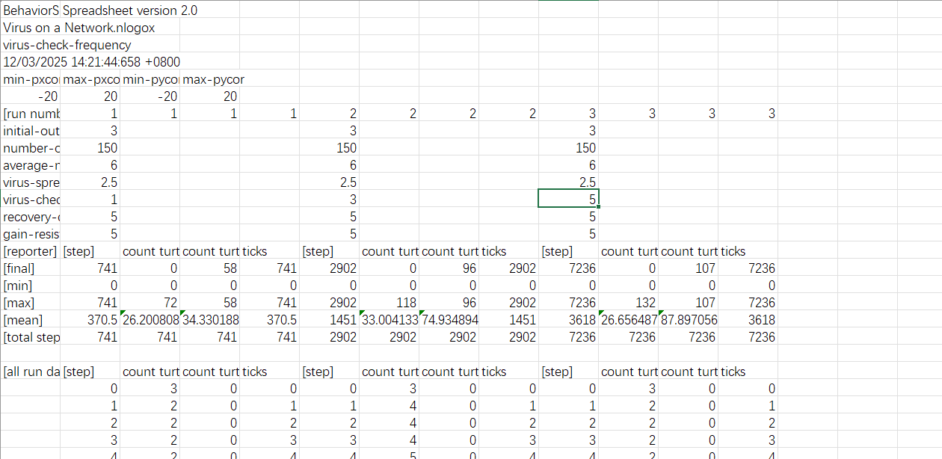

2.6 测试recovery-chance参数
["initial-outbreak-size" 3]
["number-of-nodes" 150]
["average-node-degree" 6]
["virus-spread-chance" 2.5]
["virus-check-frequency" 1]
["recovery-chance" 2.5 5 7.5]
["gain-resistance-chance" 5]
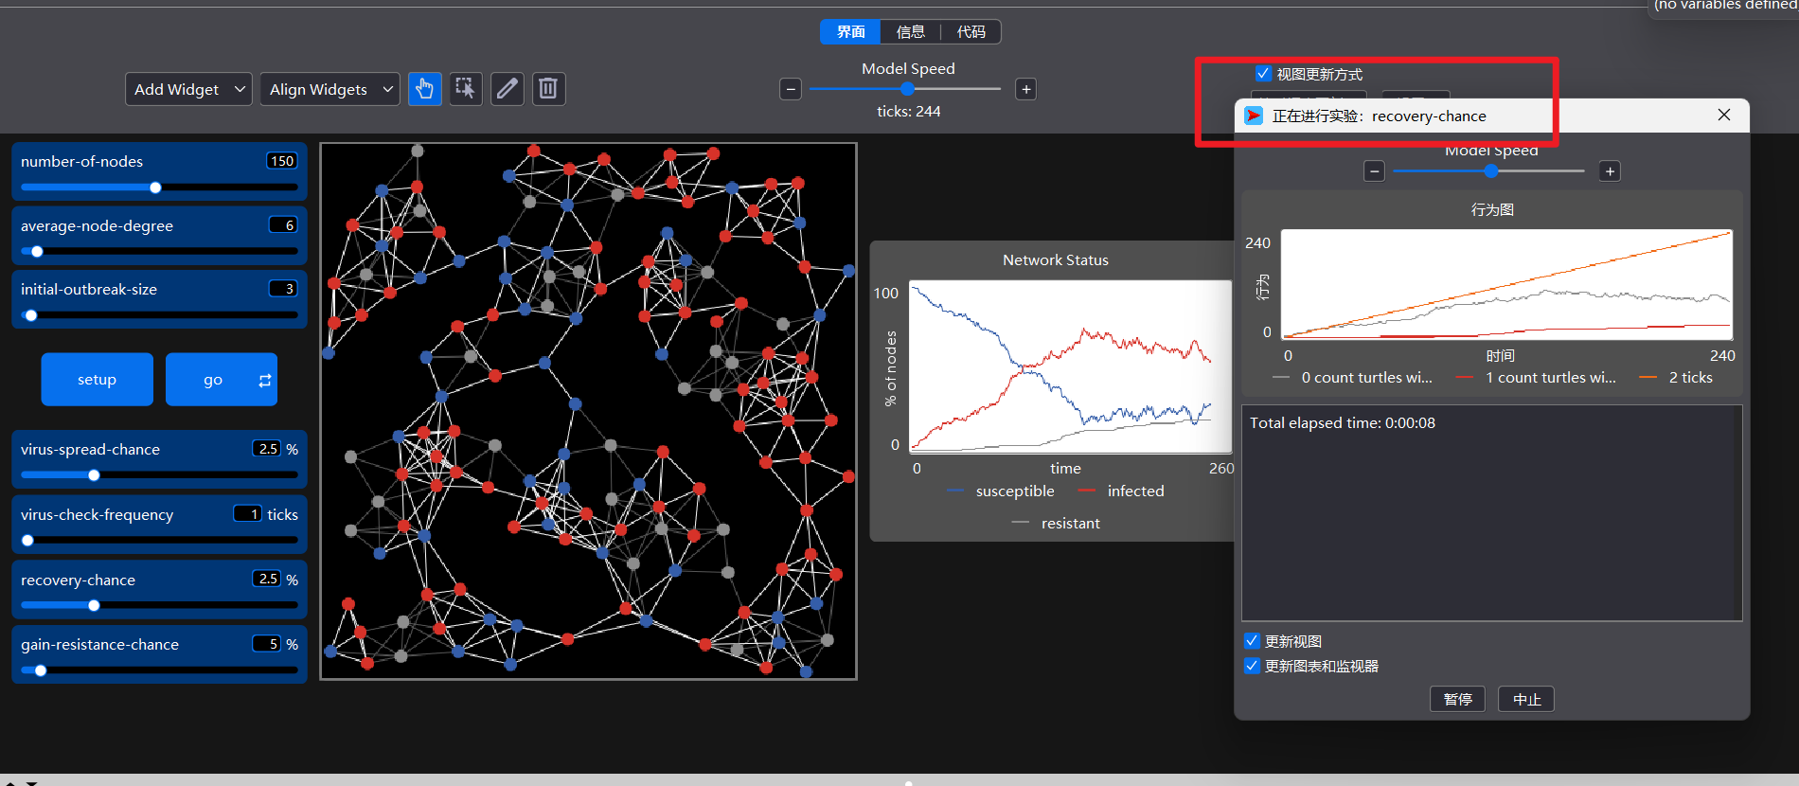
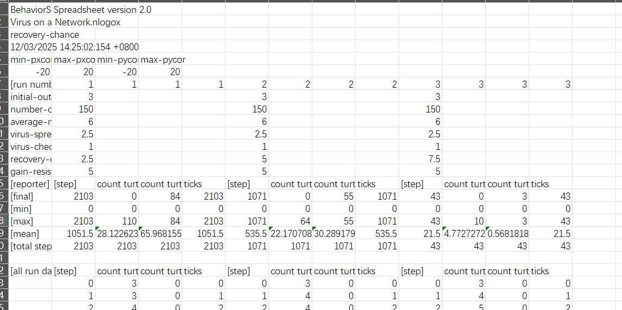

2.7 测试gain-resistance-chance参数
["initial-outbreak-size" 3]
["number-of-nodes" 150]
["average-node-degree" 6]
["virus-spread-chance" 2.5]
["virus-check-frequency" 1]
["recovery-chance" 5]
["gain-resistance-chance" 5 10 15]
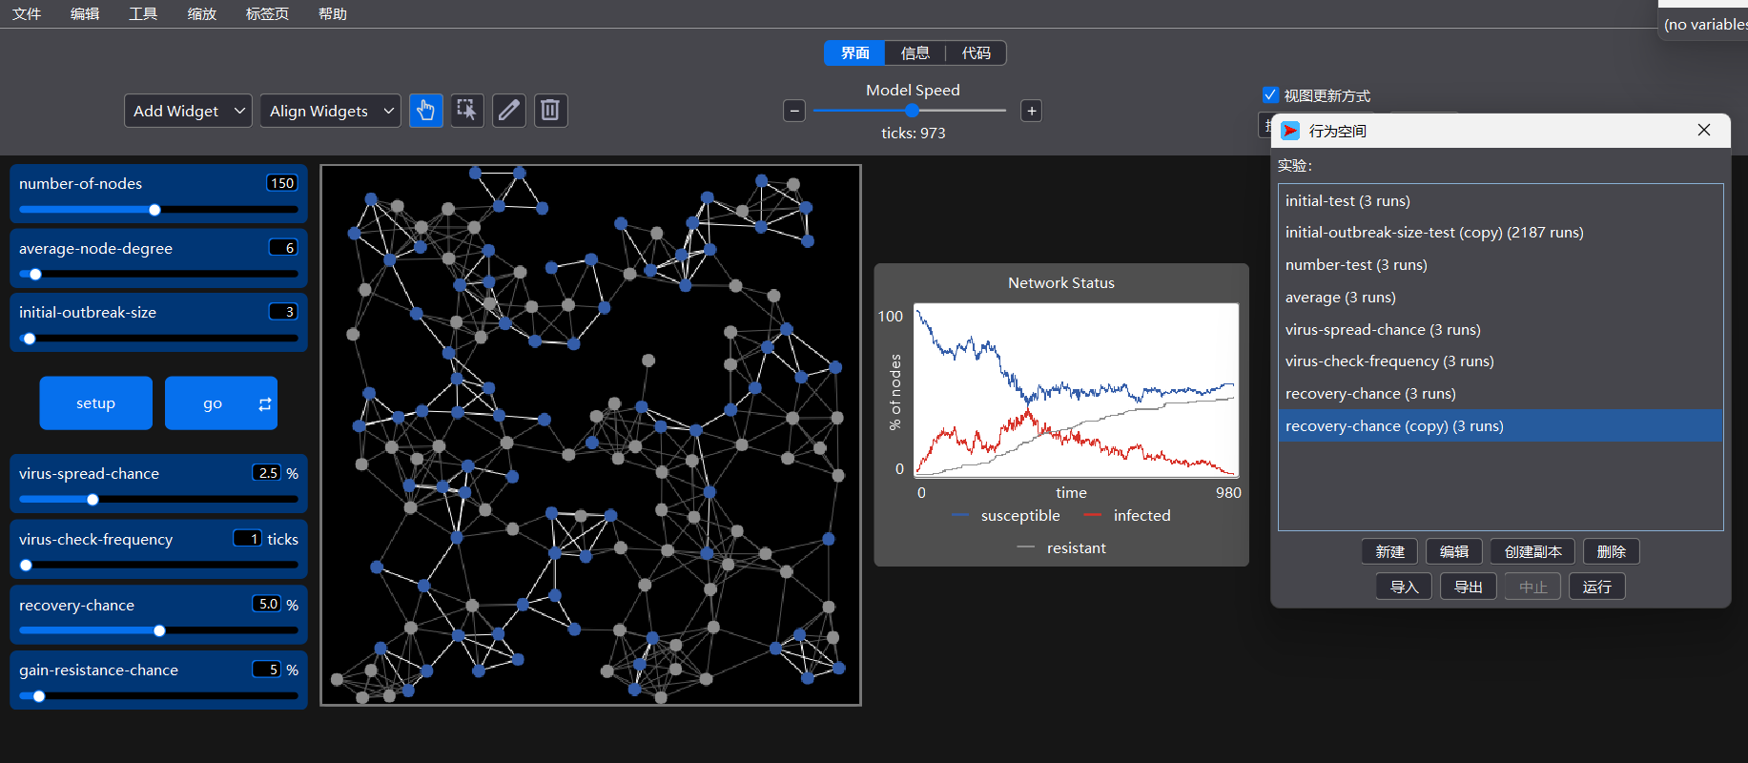
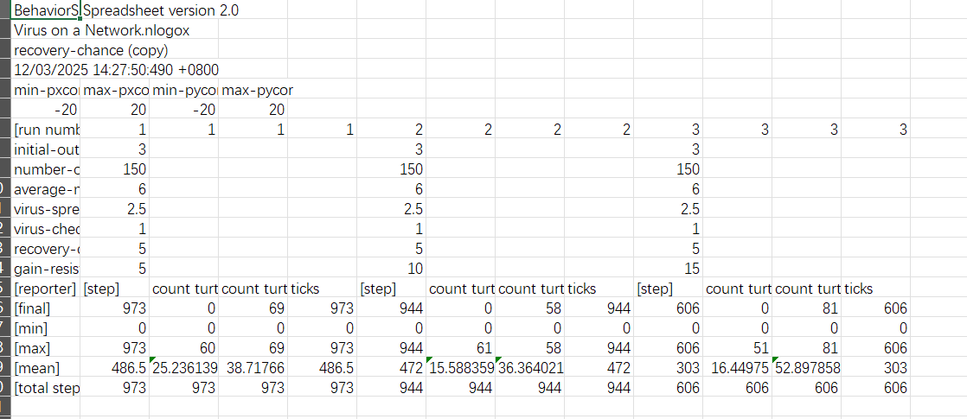

2.8 实验结果表格
BehaviorSpace results (NetLogo 7.0.2) | Spreadsheet version 2.0
Virus on a Network.nlogox
number-test
12/03/2025 14:09:27:421 +0800
min-pxcor | max-pxcor | min-pycor | max-pycor
-20 | 20 | -20 | 20
[run number] | 1 | 1 | 1 | 1 | 2 | 2 | 2 | 2 | 3 | 3 | 3 | 3
initial-outbreak-size | 3 |  |  |  | 3 |  |  |  | 3
number-of-nodes | 100 |  |  |  | 150 |  |  |  | 200
average-node-degree | 6 |  |  |  | 6 |  |  |  | 6
virus-spread-chance | 2.5 |  |  |  | 2.5 |  |  |  | 2.5
virus-check-frequency | 1 |  |  |  | 1 |  |  |  | 1
recovery-chance | 5 |  |  |  | 5 |  |  |  | 5
gain-resistance-chance | 5 |  |  |  | 5 |  |  |  | 5
[reporter] | [step] | count turtles with [infected?] | count turtles with [resistant?] | ticks | [step] | count turtles with [infected?] | count turtles with [resistant?] | ticks | [step] | count turtles with [infected?] | count turtles with [resistant?] | ticks
[final] | 950 | 0 | 48 | 950 | 1030 | 0 | 64 | 1030 | 756 | 0 | 91 | 756
[min] | 0 | 0 | 0 | 0 | 0 | 0 | 0 | 0 | 0 | 0 | 0 | 0
[max] | 950 | 58 | 48 | 950 | 1030 | 59 | 64 | 1030 | 756 | 76 | 91 | 756
[mean] | 475 | 20.184016824395375 | 27.900105152471085 | 475 | 515 | 21.77109602327837 | 34.267701260911736 | 515 | 378 | 37.63672391017173 | 45.58652575957728 | 378
[total steps] | 950 | 950 | 950 | 950 | 1030 | 1030 | 1030 | 1030 | 756 | 756 | 756 | 756
BehaviorSpace results (NetLogo 7.0.2) | Spreadsheet version 2.0
Virus on a Network.nlogox
initial-test
12/03/2025 14:12:12:547 +0800
min-pxcor | max-pxcor | min-pycor | max-pycor
-20 | 20 | -20 | 20
[run number] | 1 | 1 | 1 | 1 | 2 | 2 | 2 | 2 | 3 | 3 | 3 | 3
initial-outbreak-size | 1 |  |  |  | 3 |  |  |  | 10
number-of-nodes | 150 |  |  |  | 150 |  |  |  | 150
average-node-degree | 6 |  |  |  | 6 |  |  |  | 6
virus-spread-chance | 2.5 |  |  |  | 2.5 |  |  |  | 2.5
virus-check-frequency | 1 |  |  |  | 1 |  |  |  | 1
recovery-chance | 5 |  |  |  | 5 |  |  |  | 5
gain-resistance-chance | 5 |  |  |  | 5 |  |  |  | 5
[reporter] | [step] | count turtles with [infected?] | count turtles with [resistant?] | ticks | [step] | count turtles with [infected?] | count turtles with [resistant?] | ticks | [step] | count turtles with [infected?] | count turtles with [resistant?] | ticks
[final] | 805 | 0 | 58 | 805 | 864 | 0 | 48 | 864 | 967 | 0 | 72 | 967
[min] | 0 | 0 | 0 | 0 | 0 | 0 | 0 | 0 | 0 | 0 | 0 | 0
[max] | 805 | 61 | 58 | 805 | 864 | 44 | 48 | 864 | 967 | 56 | 72 | 967
[mean] | 402.5 | 27.710918114143922 | 35.940446650124066 | 402.5 | 432 | 18.502890173410403 | 30.477456647398842 | 432 | 483.5 | 24.706611570247933 | 42.771694214876035 | 483.5
[total steps] | 805 | 805 | 805 | 805 | 864 | 864 | 864 | 864 | 967 | 967 | 967 | 967
BehaviorSpace results (NetLogo 7.0.2) | Spreadsheet version 2.0
Virus on a Network.nlogox
average
12/03/2025 14:17:18:841 +0800
min-pxcor | max-pxcor | min-pycor | max-pycor
-20 | 20 | -20 | 20
[run number] | 1 | 1 | 1 | 1 | 2 | 2 | 2 | 2 | 3 | 3 | 3 | 3
initial-outbreak-size | 3 |  |  |  | 3 |  |  |  | 3
number-of-nodes | 150 |  |  |  | 150 |  |  |  | 150
average-node-degree | 3 |  |  |  | 6 |  |  |  | 9
virus-spread-chance | 2.5 |  |  |  | 2.5 |  |  |  | 2.5
virus-check-frequency | 1 |  |  |  | 1 |  |  |  | 1
recovery-chance | 5 |  |  |  | 5 |  |  |  | 5
gain-resistance-chance | 5 |  |  |  | 5 |  |  |  | 5
[reporter] | [step] | count turtles with [infected?] | count turtles with [resistant?] | ticks | [step] | count turtles with [infected?] | count turtles with [resistant?] | ticks | [step] | count turtles with [infected?] | count turtles with [resistant?] | ticks
[final] | 52 | 0 | 1 | 52 | 956 | 0 | 58 | 956 | 794 | 0 | 80 | 794
[min] | 0 | 0 | 0 | 0 | 0 | 0 | 0 | 0 | 0 | 0 | 0 | 0
[max] | 52 | 7 | 1 | 52 | 956 | 74 | 58 | 956 | 794 | 94 | 80 | 794
[mean] | 26 | 3.981132075471698 | 0.075472 | 26 | 478 | 22.076280041797283 | 36.994775339602924 | 478 | 397 | 43.78364779874214 | 51.650314465408805 | 397
[total steps] | 52 | 52 | 52 | 52 | 956 | 956 | 956 | 956 | 794 | 794 | 794 | 794
BehaviorSpace results (NetLogo 7.0.2) | Spreadsheet version 2.0
Virus on a Network.nlogox
virus-spread-chance
12/03/2025 14:19:40:614 +0800
min-pxcor | max-pxcor | min-pycor | max-pycor
-20 | 20 | -20 | 20
[run number] | 1 | 1 | 1 | 1 | 2 | 2 | 2 | 2 | 3 | 3 | 3 | 3
initial-outbreak-size | 3 |  |  |  | 3 |  |  |  | 3
number-of-nodes | 150 |  |  |  | 150 |  |  |  | 150
average-node-degree | 6 |  |  |  | 6 |  |  |  | 6
virus-spread-chance | 2.5 |  |  |  | 5 |  |  |  | 7.5
virus-check-frequency | 1 |  |  |  | 1 |  |  |  | 1
recovery-chance | 5 |  |  |  | 5 |  |  |  | 5
gain-resistance-chance | 5 |  |  |  | 5 |  |  |  | 5
[reporter] | [step] | count turtles with [infected?] | count turtles with [resistant?] | ticks | [step] | count turtles with [infected?] | count turtles with [resistant?] | ticks | [step] | count turtles with [infected?] | count turtles with [resistant?] | ticks
[final] | 1012 | 0 | 65 | 1012 | 838 | 0 | 84 | 838 | 902 | 0 | 104 | 902
[min] | 0 | 0 | 0 | 0 | 0 | 0 | 0 | 0 | 0 | 0 | 0 | 0
[max] | 1012 | 70 | 65 | 1012 | 838 | 111 | 84 | 838 | 902 | 121 | 104 | 902
[mean] | 506 | 23.24086870681145 | 44.42250740375123 | 506 | 419 | 37.85816448152563 | 58.92491060786651 | 419 | 451 | 43.21040974529347 | 67.48504983388705 | 451
[total steps] | 1012 | 1012 | 1012 | 1012 | 838 | 838 | 838 | 838 | 902 | 902 | 902 | 902
BehaviorSpace results (NetLogo 7.0.2) | Spreadsheet version 2.0
Virus on a Network.nlogox
virus-check-frequency
12/03/2025 14:21:44:658 +0800
min-pxcor | max-pxcor | min-pycor | max-pycor
-20 | 20 | -20 | 20
[run number] | 1 | 1 | 1 | 1 | 2 | 2 | 2 | 2 | 3 | 3 | 3 | 3
initial-outbreak-size | 3 |  |  |  | 3 |  |  |  | 3
number-of-nodes | 150 |  |  |  | 150 |  |  |  | 150
average-node-degree | 6 |  |  |  | 6 |  |  |  | 6
virus-spread-chance | 2.5 |  |  |  | 2.5 |  |  |  | 2.5
virus-check-frequency | 1 |  |  |  | 3 |  |  |  | 5
recovery-chance | 5 |  |  |  | 5 |  |  |  | 5
gain-resistance-chance | 5 |  |  |  | 5 |  |  |  | 5
[reporter] | [step] | count turtles with [infected?] | count turtles with [resistant?] | ticks | [step] | count turtles with [infected?] | count turtles with [resistant?] | ticks | [step] | count turtles with [infected?] | count turtles with [resistant?] | ticks
[final] | 741 | 0 | 58 | 741 | 2902 | 0 | 96 | 2902 | 7236 | 0 | 107 | 7236
[min] | 0 | 0 | 0 | 0 | 0 | 0 | 0 | 0 | 0 | 0 | 0 | 0
[max] | 741 | 72 | 58 | 741 | 2902 | 118 | 96 | 2902 | 7236 | 132 | 107 | 7236
[mean] | 370.5 | 26.200808625336926 | 34.33018867924528 | 370.5 | 1451 | 33.00413365483982 | 74.93489493627283 | 1451 | 3618 | 26.656487494818293 | 87.89705679148818 | 3618
[total steps] | 741 | 741 | 741 | 741 | 2902 | 2902 | 2902 | 2902 | 7236 | 7236 | 7236 | 7236
BehaviorSpace results (NetLogo 7.0.2) | Spreadsheet version 2.0
Virus on a Network.nlogox
recovery-chance
12/03/2025 14:25:02:154 +0800
min-pxcor | max-pxcor | min-pycor | max-pycor
-20 | 20 | -20 | 20
[run number] | 1 | 1 | 1 | 1 | 2 | 2 | 2 | 2 | 3 | 3 | 3 | 3
initial-outbreak-size | 3 |  |  |  | 3 |  |  |  | 3
number-of-nodes | 150 |  |  |  | 150 |  |  |  | 150
average-node-degree | 6 |  |  |  | 6 |  |  |  | 6
virus-spread-chance | 2.5 |  |  |  | 2.5 |  |  |  | 2.5
virus-check-frequency | 1 |  |  |  | 1 |  |  |  | 1
recovery-chance | 2.5 |  |  |  | 5 |  |  |  | 7.5
gain-resistance-chance | 5 |  |  |  | 5 |  |  |  | 5
[reporter] | [step] | count turtles with [infected?] | count turtles with [resistant?] | ticks | [step] | count turtles with [infected?] | count turtles with [resistant?] | ticks | [step] | count turtles with [infected?] | count turtles with [resistant?] | ticks
[final] | 2103 | 0 | 84 | 2103 | 1071 | 0 | 55 | 1071 | 43 | 0 | 3 | 43
[min] | 0 | 0 | 0 | 0 | 0 | 0 | 0 | 0 | 0 | 0 | 0 | 0
[max] | 2103 | 110 | 84 | 2103 | 1071 | 64 | 55 | 1071 | 43 | 10 | 3 | 43
[mean] | 1051.5 | 28.122623574144487 | 65.96815589353612 | 1051.5 | 535.5 | 22.17070895522388 | 30.28917910447761 | 535.5 | 21.5 | 4.7727272727272725 | 0.5681818181818182 | 21.5
[total steps] | 2103 | 2103 | 2103 | 2103 | 1071 | 1071 | 1071 | 1071 | 43 | 43 | 43 | 43
BehaviorSpace results (NetLogo 7.0.2) | Spreadsheet version 2.0
Virus on a Network.nlogox
recovery-chance (copy)
12/03/2025 14:27:50:490 +0800
min-pxcor | max-pxcor | min-pycor | max-pycor
-20 | 20 | -20 | 20
[run number] | 1 | 1 | 1 | 1 | 2 | 2 | 2 | 2 | 3 | 3 | 3 | 3
initial-outbreak-size | 3 |  |  |  | 3 |  |  |  | 3
number-of-nodes | 150 |  |  |  | 150 |  |  |  | 150
average-node-degree | 6 |  |  |  | 6 |  |  |  | 6
virus-spread-chance | 2.5 |  |  |  | 2.5 |  |  |  | 2.5
virus-check-frequency | 1 |  |  |  | 1 |  |  |  | 1
recovery-chance | 5 |  |  |  | 5 |  |  |  | 5
gain-resistance-chance | 5 |  |  |  | 10 |  |  |  | 15
[reporter] | [step] | count turtles with [infected?] | count turtles with [resistant?] | ticks | [step] | count turtles with [infected?] | count turtles with [resistant?] | ticks | [step] | count turtles with [infected?] | count turtles with [resistant?] | ticks
[final] | 973 | 0 | 69 | 973 | 944 | 0 | 58 | 944 | 606 | 0 | 81 | 606
[min] | 0 | 0 | 0 | 0 | 0 | 0 | 0 | 0 | 0 | 0 | 0 | 0
[max] | 973 | 60 | 69 | 973 | 944 | 61 | 58 | 944 | 606 | 51 | 81 | 606
[mean] | 486.5 | 25.236139630390145 | 38.71766 | 486.5 | 472 | 15.588359788359789 | 36.36402116402117 | 472 | 303 | 16.44975 | 52.897858319604616 | 303
[total steps] | 973 | 973 | 973 | 973 | 944 | 944 | 944 | 944 | 606 | 606 | 606 | 606

2.9 实验结果分析
本次实验核心目的为分析七个关键参数对病毒网络传播的三大影响维度，即传播规模（最大感染峰值）、持续时间（最终 ticks）及群体免疫水平（最终抵抗力节点数），具体影响规律如下：
一、加速传播和扩大规模的参数（促使疫情爆发）
该组参数数值越高，病毒传播速度越快、覆盖范围越广，最大感染峰值也随之提升。
初始爆发规模（initial-outbreak-size）：数值越大，疫情爆发越迅速。较高的初始感染人数能帮助病毒在网络中快速建立传播立足点，加快感染峰值的到来，其对最终总抵抗力节点数的影响相对有限。
节点数量（number-of-nodes）：数值越大，疫情规模上限越高。随着网络总节点数增加，最大感染峰值会显著上升，最终获得抵抗力的节点绝对数量也同步增加，即病毒影响的总个体规模扩大。
平均节点连接度（average-node-degree）：数值越大，传播效率越高、疫情越猛烈。节点连接的邻居数量越多，病毒传播路径越密集，不仅会显著提高最大感染峰值，还会因病毒快速席卷整个网络而缩短疫情持续时间。
病毒传播几率（virus-spread-chance）：数值越大，感染峰值越高、传播速度越快。这是直接影响病毒传播力的核心参数，较高的传播几率意味着每次接触导致感染的可能性更大，推动疫情快速爆发；当该数值低于某一临界值时，病毒难以形成大规模流行。
二、抑制传播和控制疫情的参数（促使疫情平息）
该组参数数值越高，越能有效抑制感染峰值、缩短疫情持续时间，推动网络快速恢复。
病毒检查频率（virus-check-frequency）：数值越高，疫情控制效果越显著。节点越频繁地检查自身感染状态并触发恢复 / 抵抗机制，其保持传染性的时间就越短，进而降低最大感染峰值，同时缩短疫情持续时间。
恢复几率（recovery-chance）：数值越高，感染峰值越低。节点从感染状态中恢复的速度越快，传染源数量会快速减少，不仅能显著降低最大感染峰值，还能缩短疫情持续时间（注：本模型中 “恢复” 不代表永久免疫）。
获得抵抗力几率（gain-resistance-chance）：数值越高，群体免疫形成越快，疫情平息越迅速。这是控制病毒传播、实现群体免疫的关键参数，高抵抗力几率能让节点更快转变为永久免疫状态，切断传播链，既显著降低感染峰值，又能提高最终抵抗力节点数。

病毒在网络中的传播过程，本质是网络结构（节点数、连接度）与病毒 / 个体行为（传播几率、检查频率、恢复与抵抗几率）相互作用、相互博弈的结果：
最大感染峰值主要由病毒传播几率和平均节点连接度驱动，同时受节点数量的上限约束；
传播持续时间主要取决于传播效率与抵抗 / 恢复速度的平衡；
提高获得抵抗力几率是快速终结疫情、建立长期群体保护的最有效手段。

