103062331 Archi_Project1_Report

1. Project Description
   1. Program Flow Chart

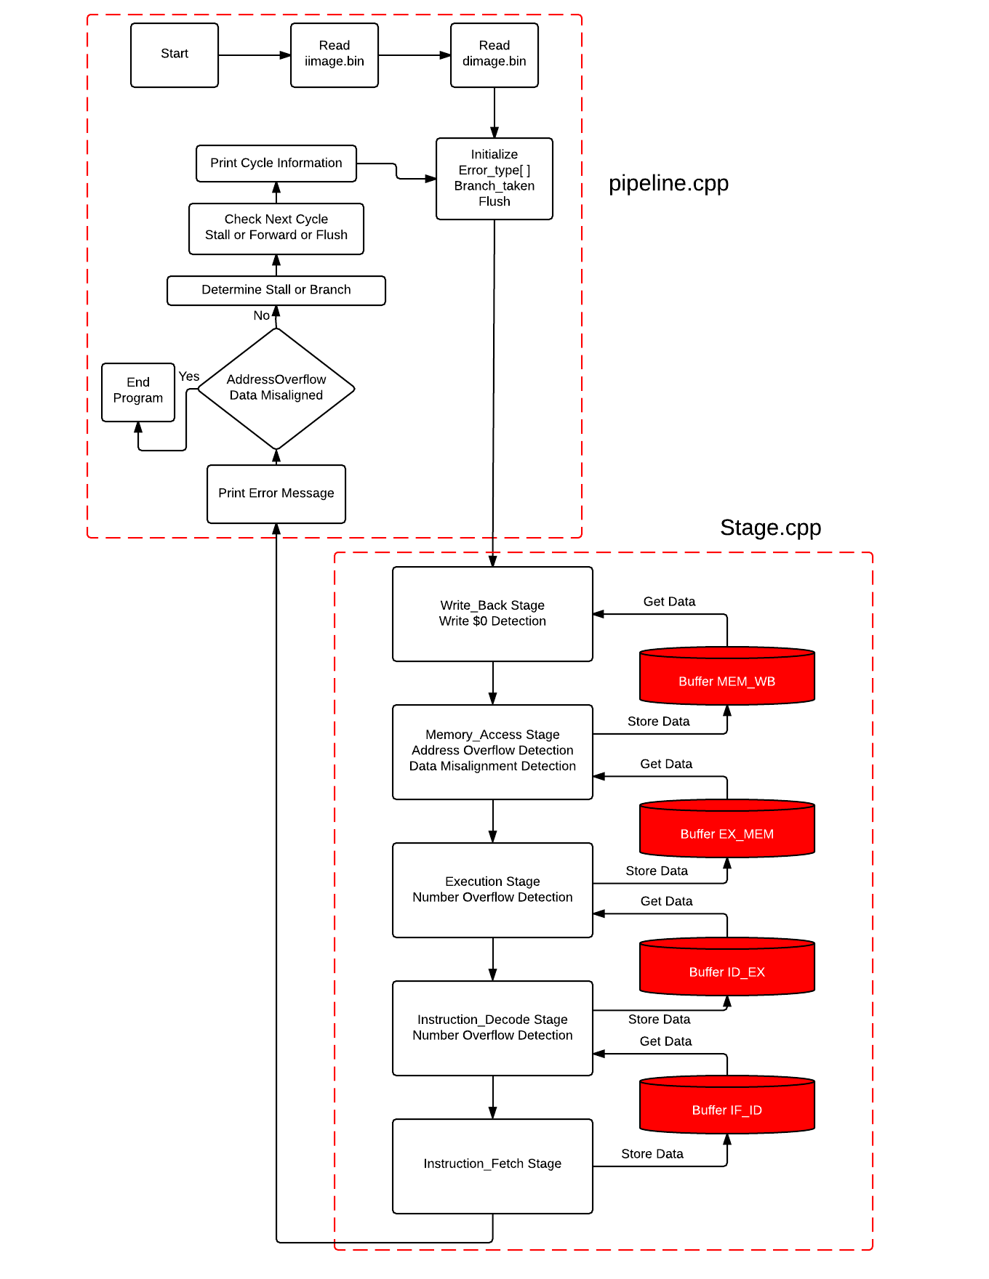

* 1. Detailed Description

1. Classes Define

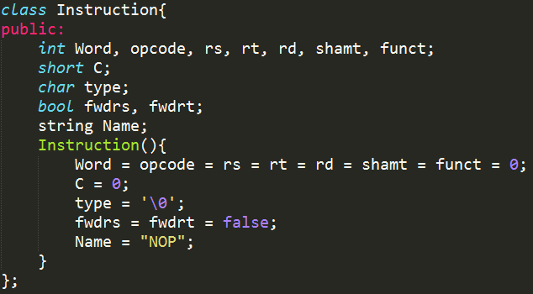

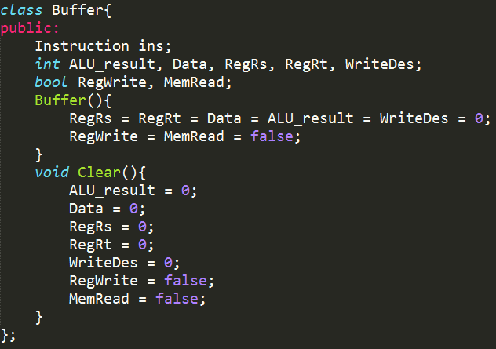

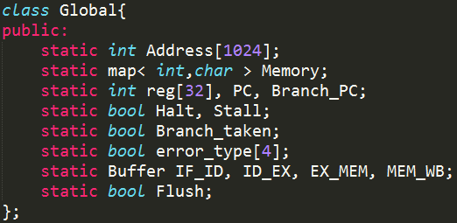

Memory (Store Data), reg[32] for 32 registers

PC for Program Counter, Branch_PC for PC to be branched

Halt for ending the program, Stall for whether to stall

Branch_taken for whether to branch.

error_type[4] for four types of errors.

1. Read iimage.bin

Int Word (Store Instruction). Use get() to get a char each time

Word = (Word << 8) | (unsigned char) ch ; (Four times to get a 32-bit)

Store Program Counter into PC

Store Word into (map<int, int> Address), which is easier to access.

1. Read dimage.bin

The same as (2.)

Store Stack Pointer into reg[29] ($sp)

Store Data into (map<int, char> Memory), which is easier to access.

1. Write_Back Stage

Take instruction from MEM_WB buffer.

Write data back to register.

1. Memory_Access Stage

Take instruction from EX_MEM buffer.

Access the memory to get data and store data

Store data and instruction into MEM_WB beffer.

1. Execution Stage

Take instruction from ID_EX buffer.

Use ALU to do calculation.

Store data and instruction into EX_MEM beffer.

1. Instruction_Decode Stage

Take instruction from IF_ID buffer.

Decode the instruction.

Store data and instruction into ID_EX beffer.

1. Instruction_Fetch Stage

Fetch instruction from Address[PC]

Store data and instruction into IF_ID beffer.

1. Print Error Messages

Use for loop to check error_type[0 to 3], if error occurs, output the error messages.

1. Check Halt

If Halt is true, end the program.

Else check next cycle’s stage whether to Stall or Forward or Flush

Output the register and PC status at this cycle, and continue.

1. Close File

Close snapshot.rpt and error_dump.rpt.

1. Test case Design

2-1) Detail Description of Test case

Basically, my test case will test every function except bgtz.

And test Write $0, Number Overflow, Address overflow, Data Misalignment

I’ll show it as a graph step by step.

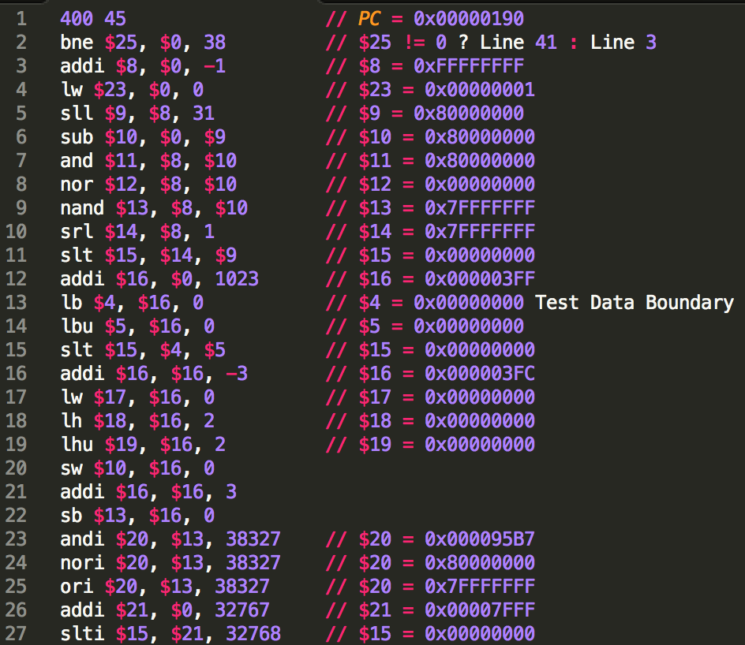

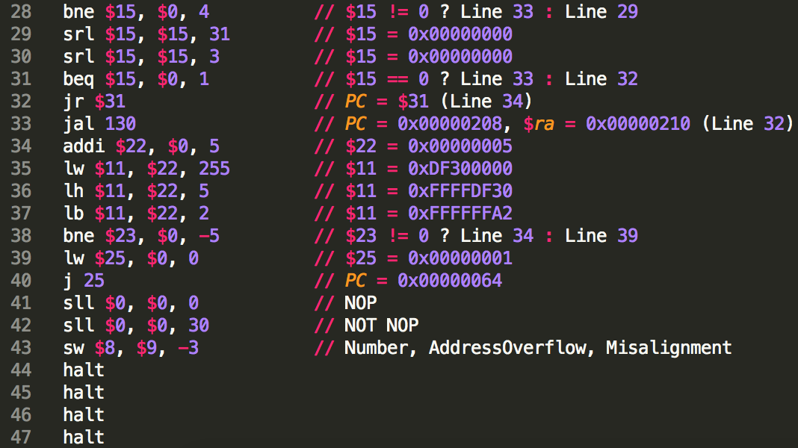

About dimage.bin :

I randomly generate the data inside it (1024 Bytes)

I just modify some specific position which I will use in the test case.