**Overall test result for switch**

Lianghao Yuan

yuanlianghao@gmail.com

Functional coverage result:

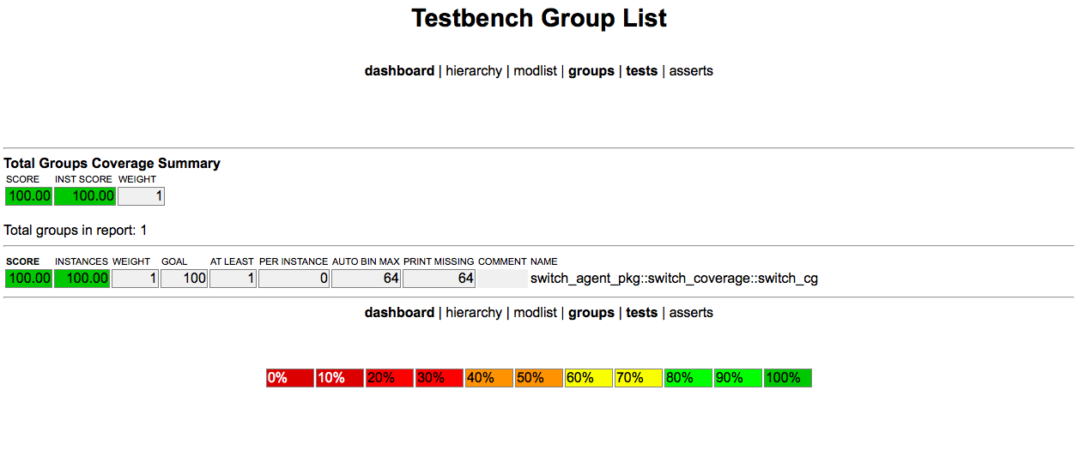

All the functions in the test plan have been covered and no error generated. We are sure that this switch is functionally correct.

Line coverage result:

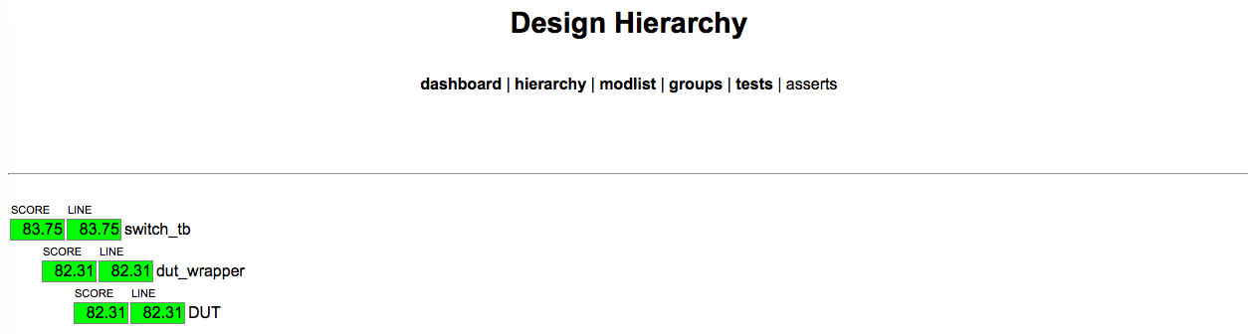

Some lines have never been covered. Since the RTL code we have is “encoded”, we cannot figure out the reason for that.