**酒店信息：**

参会者自行预定房间，在11月15日前预定可享受如下协议价。若遇预定问题，请联系：柴老师（电话：15936237963），张老师（电话：15137105588）

酒店1：中州皇冠假日酒店（会场酒店），高级大床房：500元、单早，高级双人间：550元、双早，地址：金水路115号。预定电话：15736938381/19939135185（祝女士）

酒店2：中州假日酒店（会场旁酒店），高级大床房：400元、单早；高级双人间：430元、双早。地址：金水路115号。预定电话：15736938381/19939135185（祝女士）

酒店3：中州智选假日酒店（会场旁酒店），高级大床房：340元、单早或双早；高级双人间：340元、单早或双早。地址：金水路115号。预定电话：15736938381/19939135185（祝女士）

**Accommodation information**

Suggestions: To enjoy the following agreement prices, it is recommended to book your rooms before Nov. 15. If you have any reservation questions, please contact Mr. Chai (Tel: 15936237963) and Mrs. Zhang (Tel: 15137105588).

Hotel 1: Crowne Plaza* Zhengzhou (Conference hotel), Superior Single Room (1BF), 500 RMB, Superior Double Room (2BF), 550 RMB, Address: No.115 Jinshui Road. Reservation Telephone: 15736938381/19939135185 (Mrs. Zhu)

Hotel 2: Holiday Inn in Henan (Near the conference hotel), Superior Single Room (1BF), 400 RMB, Superior Double Room (2BF), 430 RMB, Address: No.115 Jinshui Road. Reservation Telephone: 15736938381/19939135185 (Mrs. Zhu)

Hotel 3: Holiday Inn Express Zhengzhou Zhongzhou (Near the conference hotel), Standard Single Room (1or2BF), 340 RMB, Standard double Room (1or2BF), 340 RMB, Address: No.115 Jinshui Road. Reservation Telephone: 15736938381/19939135185 (Mrs. Zhu)

**交通信息：**

**新郑国际机场——中州皇冠假日酒店**：

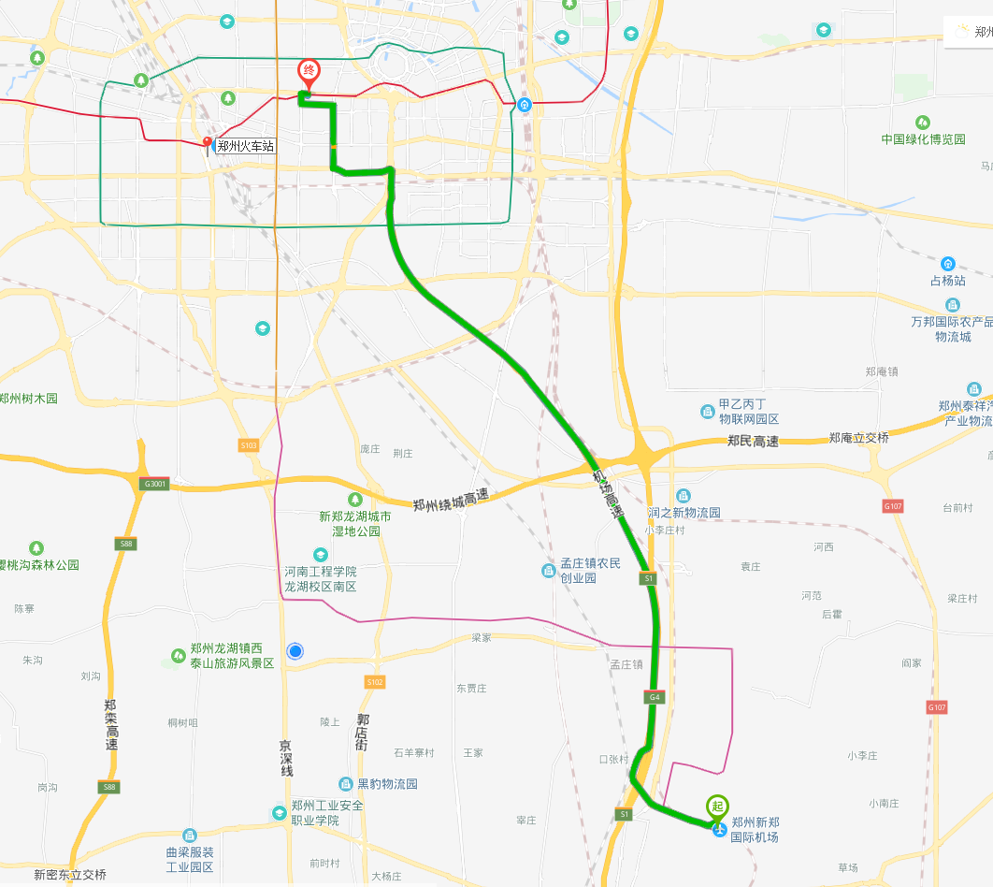

**方案1（约47.6公里）：乘坐城郊线到南四环站，换乘地铁2号线到紫荆山站，换乘1号线到燕庄站C出口出站，沿金水路向西步行880米，即到酒店（金水路南侧）。**

**方案2（约35.8公里）：乘坐机场巴士4线，到民航大酒店下车，沿金水路向西步行580米，即到酒店（金水路南侧）。**

**方案3（约37.2公里）**：**打出租车约80元。**

**郑州东站（高铁站）——中州皇冠假日酒店**：

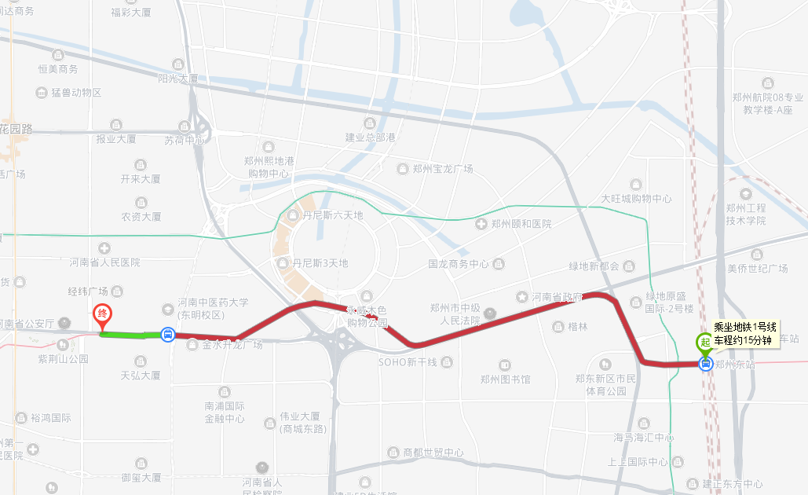

**方案1（约8.6公里）：乘坐地铁1号线到燕庄站（约15分钟），C出口出站，沿金水路向西步行880米，即到酒店（金水路南侧）。**

**方案2（约11公里）**：**打出租车约22元。**

**郑州火车站——中州皇冠假日酒店**：

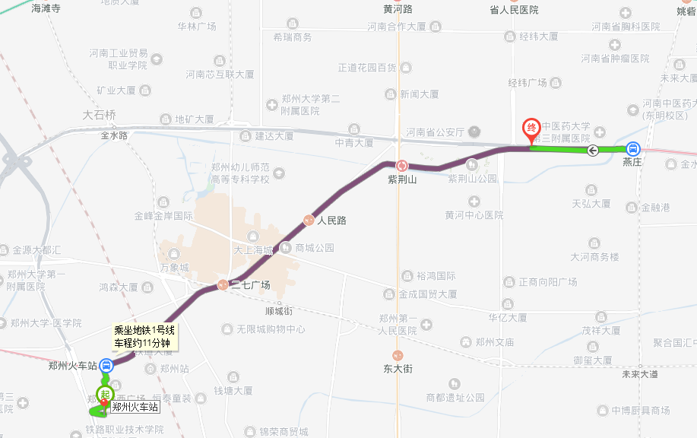

**方案3（约4.3公里）**：**从火车站东广场出**，**在火车站（北港湾）公交站处，乘坐26路公交到国际饭店站下车，酒店即在对面。**

**方案1（约6.2公里）：从火车站西广场出，乘坐地铁1号线到燕庄站，C出口出站，沿金水路向西步行880米即到酒店（金水路南侧）。**

**方案2（约7公里）**：**打出租车约16元。**

**Transportation：**

**ZhengZhou Xinzheng International Airport——Crowne Plaza* Zhengzhou**：



**Route 1 (47.6km): Airport (Subway Chengjiao Line)→Nansihuan** **Station (transfer Subway Line 2) →Zijingshan Station（transfer Subway Line 1）→Yanzhuang Station (Exit C）, walk east along Jinshui Road for 880 meters (south side of the street)**

**Route 2 (35.8km): Airport (airport bus Line 4)→Civil Aviation Hotel, walk west along Jinshui Road for 580 meters (south side of the street)**

**Route 3 (37.2km): Taxi (80 RMB)**

**Zhengzhou East Railway Station（High-Speed Railway Station）——Crowne Plaza* Zhengzhou：**



**Route 1 (8.6km): Zhengzhou East Railway Station (Subway Line 1)→Yanzhuang Station (Eixt C）, walk east along Jinshui Road for 880 meters (south side of the street)**

**Route 2 (11 km): Taxi (22 RMB)**

**Zhengzhou Railway Station——Crowne Plaza* Zhengzhou：**



**Route 2 (4.3km): Zhengzhou Railway Station (NO.26 bus)→Guojifandian Station (across the street)**

**Route 1 (6.2km): Zhengzhou Railway Station (Subway Line 1)→Yanzhuang Station（Exit C）, walk east along Jinshui Road for 880 meters (south side of the street)**

**Route 3 (7km): Taxi (16 RMB)**