BUDT 703 Fall 2021 Homework #1 – Data and Entity-Relationship (ER) Model

Due by 11:59pm, Monday, September 20th, 2021

**Note**: Insert your final ER diagram downloaded from the Lucidchart into this document.

This file name must be renamed to **HW1_YourLastName_YourFirstName.docx** for submission.

Share your model file with your TAs on the Lucidchart.

Repeat steps below for the **Terps Enterprise, Inc.** design.

1. Describe the ER schema:
   1. A list of entities, attributes, and primary keys.
   2. A list of relationships (unary, binary, ternary, etc.) and attributes.
   3. Participation and cardinality constraints from business rules.
2. Represent the ER schema in an ER diagram:
   1. Use Lucidchart as demonstrated in class to draw ER diagram.
   2. Note that some business rules will not be captured in the model.

# Example: Publisher

Ms. Contract would like you to design a conceptual model for her organization using the entity-relationship model. She represents authors and publishing companies and helps them draw up contracts. The business rules include:

* Each book is described by a unique ISBN, year of publication, sales price, and number of pages.
* Each author is described by a unique name (consists of first and last name) and phone number.
* Each book is written by at least one author. Because there can possibly be multiple authors for a book, this relationship is described by an attribute role; values are primary-author, editor, etc.
* Ms. Contract maintains author information even if they have not written any book as yet.
* Each publishing company is identified by a unique name, and one or two phone numbers.
* Each book must be under-review by at least one publishing company, and this relationship is described by an expiration date.
* There are several editors who work for each publisher, but each editor only works for one publisher.
* Editors are not independent of publishers; therefore, each editor is identified by a combination of name and the publisher’s name.
* Each editor should provide a phone number.
* Number of editors should be available.
* For each book that is finally completed and published by a publisher, there is a single author who signs a contract for that book with a contract date. *– Note: This is a ternary relationship.*

# Example Answers:

# ER Schema:

## Entities, Attributes and Primary Keys

Book (**bokISBN**, bokPubYear, bokPrice, bokPages)

Author (**autName**, -autFirstName, -autLastName, autPhone)

Publisher (**pubName**, pubPhone [1..2])

Editor (**edtName**, edtPhone, =countEditors)

## Relationships, Attributes, Degrees, Participating Entities and Constraints

Write (role): binary relationship

1 Book to 1 or more Authors

1 Author to 0 or more Books

Review (expDate): binary relationship

1 Book to 1 or more Publishers

1 Publisher to 0 or more Books *– Note: Inferred so no limitation.*

Work: binary relationship

1 Publisher to 1 or more Editors

1 Editor to 1 Publisher

Sign (conDate): ternary relationship

1 Book and 1 Publisher to 1 Author

1 Author and 1 Book to 0 or 1 Publisher *– Note: Inferred by best judgment.*

1 Author and 1 Publisher to 0 or more Books *– Note: Inferred so no limitation.*

# ER Diagram:

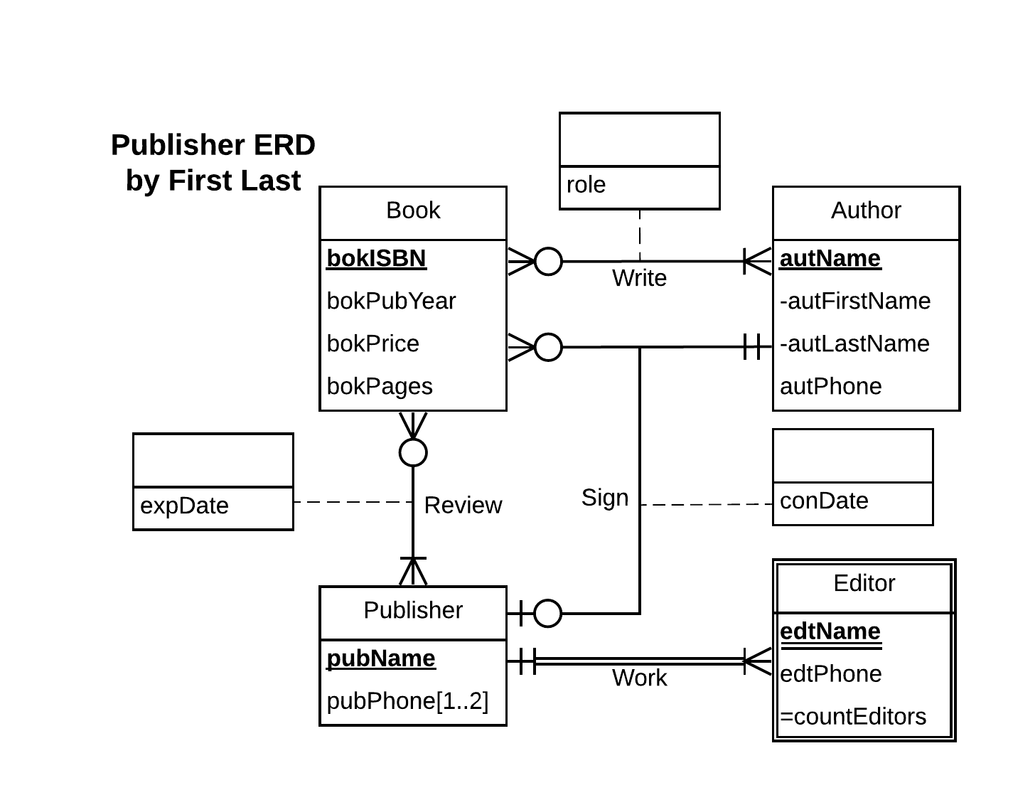

# Terps Enterprise, Inc.

Terps Enterprise, Inc., is a consultant firm with approximately 300 employees. A database is required to keep track of all employees, their dependents, projects worked on, and departments assigned to. Every employee has a unique Social Security Number (SSN) and is required to store the full name (in three fields – first name, middle name initial, and last name), date of birth (DOB), gender, address (in four fields – street, city, state, and zip code), salary, supervisor's SSN if any, department assigned to, and total number of hours that she or he worked on (during the most recent week). There are three departments (Headquarters, Administration, and Research), each with a unique identifier, name, manager (who is an employee), the manager's starting date, and location(s). Each department, except the Headquarter (at single location), may have up to three locations. Many employees can work on a project, and an employee can work on many projects (e.g., Capital Refinery, Metro Transportation, and so on). Number of hours that an employee works on a project should be recorded weekly. A project is organized by a department, and is distinguished by a unique project identifier. We must store the project name and location. An employee may carry dependents, whose names, DOB, genders, and relationships to the corresponding employee should be recorded.

# Answers: (Note: ER model should not include any FK. Your model should not include any entity or relationship other than what were described in the above paragraph. State any assumption that you believe you have to make on cardinalities in order to develop a complete model.)

# ER Schema:

## Entities, Attributes and Primary Keys

Employee (**eeSSN**, eeFullName, –eeFirstName, -eeMiddleNameInitial, -eeLastName, eeDateOfBirth, eeGender, eeAddress, -eeStreet, -eeCity, -eeState, -eeZipCode), eeRecentWeeklyWorkHour, eeSalary)

Department (**depIdentifier**, depName)

-SingleLocationDepartment (Location[1])

-MultipleLocationDepartment (Location[1..3])

Project (pjIdentifier, pjName, pjLocation)

Dependent (**dependentName**, dependentDateOfBirth, dependentGender, dependentRelationship)

## Relationships, Attributes, Degrees, Participating Entities and Constraints

Assign: binary relationship

1 Employee to 1 Department

1 Department to 1 or more Employee *– Note: department cannot be empty.*

WorkOn (eeWeeklyWorkHour): binary relationship

1 Employee to 0 or more Project *– Note: employee may not have current project.*

1 project to 1 or more employee *– Note: project must be worked by employee(s).*

Manage (mngrStartingDate): binary relationship

1 Employee to 0 or more Department *– Note: employee may not have department.*

1 Department to 1 Employee

Organize: binary relationship

1 Project to 1 Department

1 Department to 0 or more Project *– Note: department may not have current project.*

Carry: binary relationship

1 Dependent to 1 Employee

1 Employee to 0 or more Dependent

Supervise: unary relationship

1 Employee to 0 or 1 Employee *– Note: Assume employee can only supervised by 1 supervisor.*

1 Employee to 0 or more Employee *– Note: 1employee, if is supervisor, can supervise many.*

# ER Diagram:

