BUDT730 – Individual Assignment 1

UID: 117509922

Question: Gender versus Opinion

In this case, we want to add either gender’s percentage to 100%, so the crosstab looks like this:

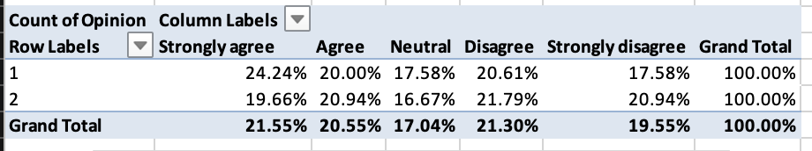

Then we can get the associated column chart:

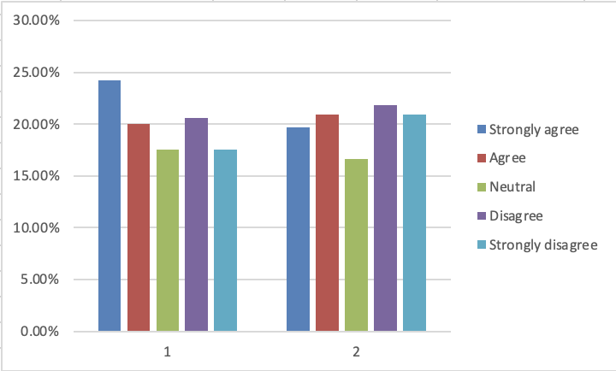

Also, I created the chart below, which shows the proportions of opinions in each gender more clearly: 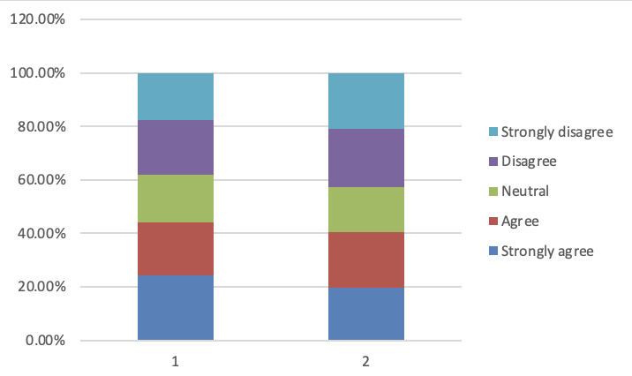

I rearranged the order of opinions, from strongly agree to strongly disagree. After that, it’ easy to notice that different genders do have different tendency of opinions: gender 1 tend to agree with the government environmental policy, with higher proportion in strongly agree, while gender 2 shows less proportion to agree, but more to disagree and strongly disagree.

Question: Age versus Opinion

Similarly in this case, we divide samples into 3 age groups, add age’s percentage to 100%, and get the crosstab, looks like this:

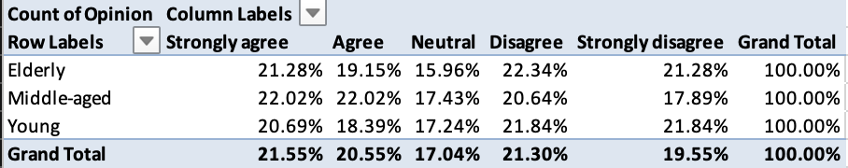

Then we can get the associated column chart:

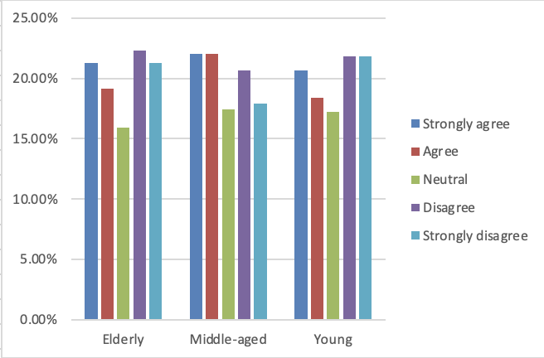

Also, I created the chart below:

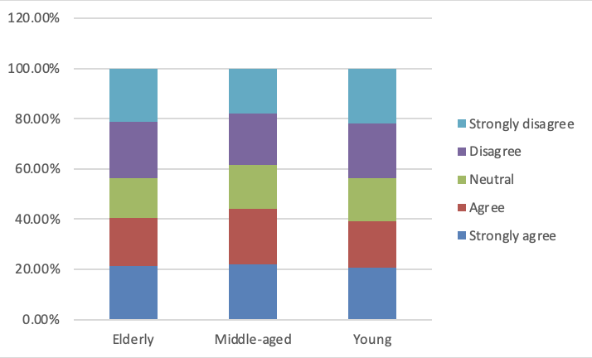

Then we’re able to notice that different age groups have different tendency of opinions: middle-aged people in our survey were much more likely to agree with the government environmental policy, as this group has the highest proportions in agree and strongly agree, with the lowest proportions in disagree and strongly disagree. But elderly and young show the similar proportion of opinion, their thoughts look similar.