**Question 1 (25 points)**

The following data contains the monthly number of airlines tickets sold by a travel agency for four years.

|  |
| --- |
| Month |
| January |
| February |
| March |
| April |
| May |
| June |
| July |
| August |
| September |
| October |
| November |
| December |
| January |
| February |
| March |
| April |
| May |
| June |
| July |
| August |
| September |
| October |
| November |
| December |
| January |
| February |
| March |
| April |
| May |
| June |
| July |
| August |
| September |
| October |
| November |
| December |
| January |
| February |
| March |
| April |
| May |
| June |
| July |
| August |
| September |
| October |
| November |
| December |

Our goal is to build a regression model to predict the demand for the following 12 months.

a) (2 pts) Does a linear trend appear to fit these data well? Explain why or why not. Reference any tables/figures that you need to make your point.

*Solution*:

Linear trend appear to fit these data well because the trend goes up approximately linear, as the time series plot shows:

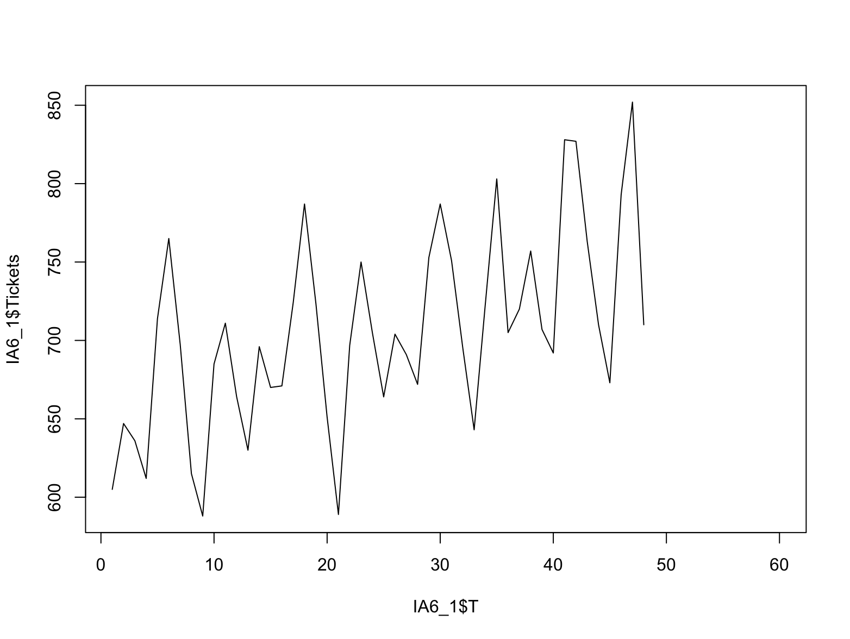

Also from residual plot, we cannot see any non-linear pattern:

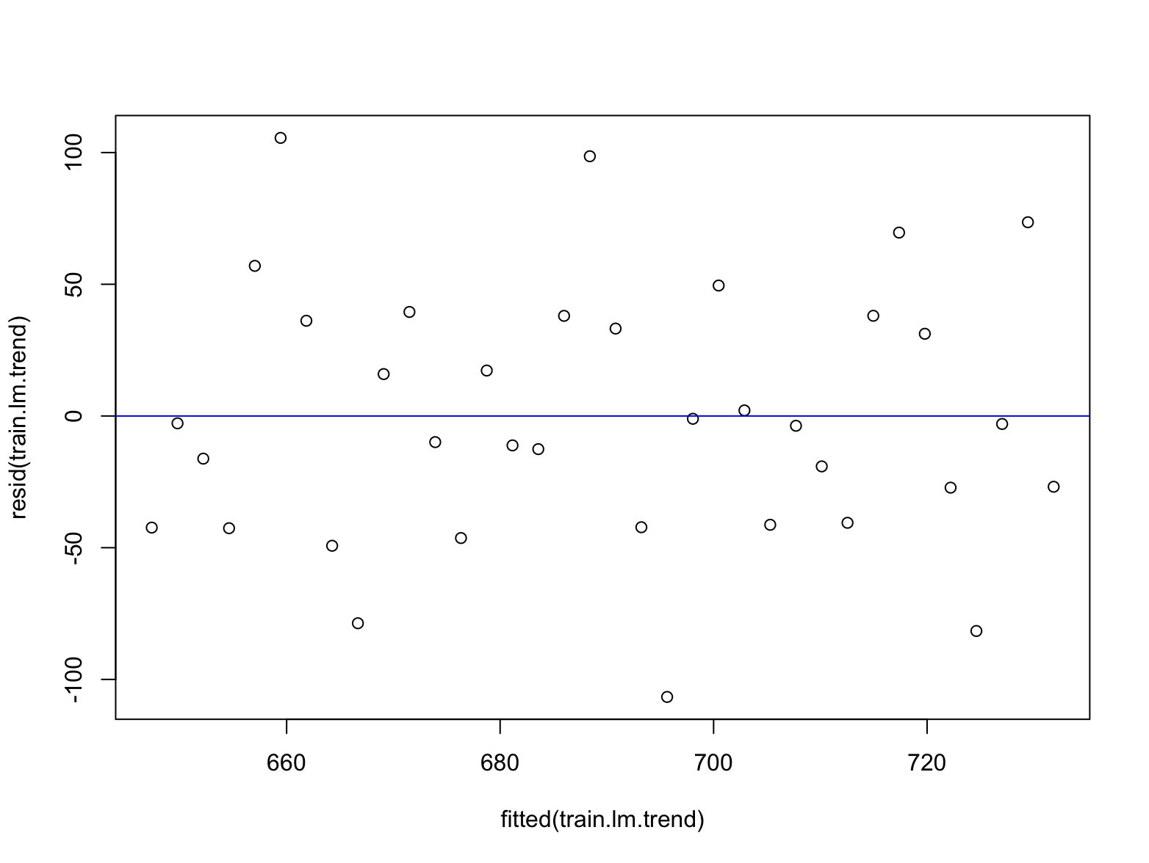

Thus, we say linear trend appear to fit these data well and use it for modeling.

b) (5+2+2 = 9 pts) Build a linear trend model or nonlinear trend regression model (depending on your answer in part a). Do not add a seasonality factor to this model. To validate your model, use the last 12 months as a validation data set.

1. Copy and paste your R code and display the regression output.

* *Solution*:
* FIrst, import the data from excel and split data for training and testing.
* # attach data for question 1  
  attach(IA6_1)  
    
  # time series plot  
  plot(IA6_1$T, IA6_1$Tickets, type="l")  
    
  # split data  
  ndata = length(IA6_1$T)  
  nTrain <- ndata - 24   
  train <- IA6_1[1:nTrain, ]  
  test <- IA6_1[nTrain+1:12, ]  
  # print(test)  
  fore <- IA6_1[nTrain+13:24, ]  
  # print(fore)
* Then, build the linear trend model as:
* # trend model  
  train.lm.trend <- lm(Tickets~T, data = train)  
  summary(train.lm.trend)  
  observed <- test$Tickets  
  predicted <- predict(train.lm.trend, test)  
  # forecast for the 5 year  
  forecasted <- predict(train.lm.trend, fore)  
  print(forecasted)  
    
  # plot data and forecasts  
  plot(IA6_1$T, IA6_1$Tickets, type = "l")  
  # plot fitted value in the training period  
  lines(train.lm.trend$fitted, lwd=2)  
  lines(c(nTrain+1:12), predicted, lwd=2, col="blue")  
  lines(c(nTrain+13:24), forecasted, lwd=2, col="green")
* The model goes like this:
* 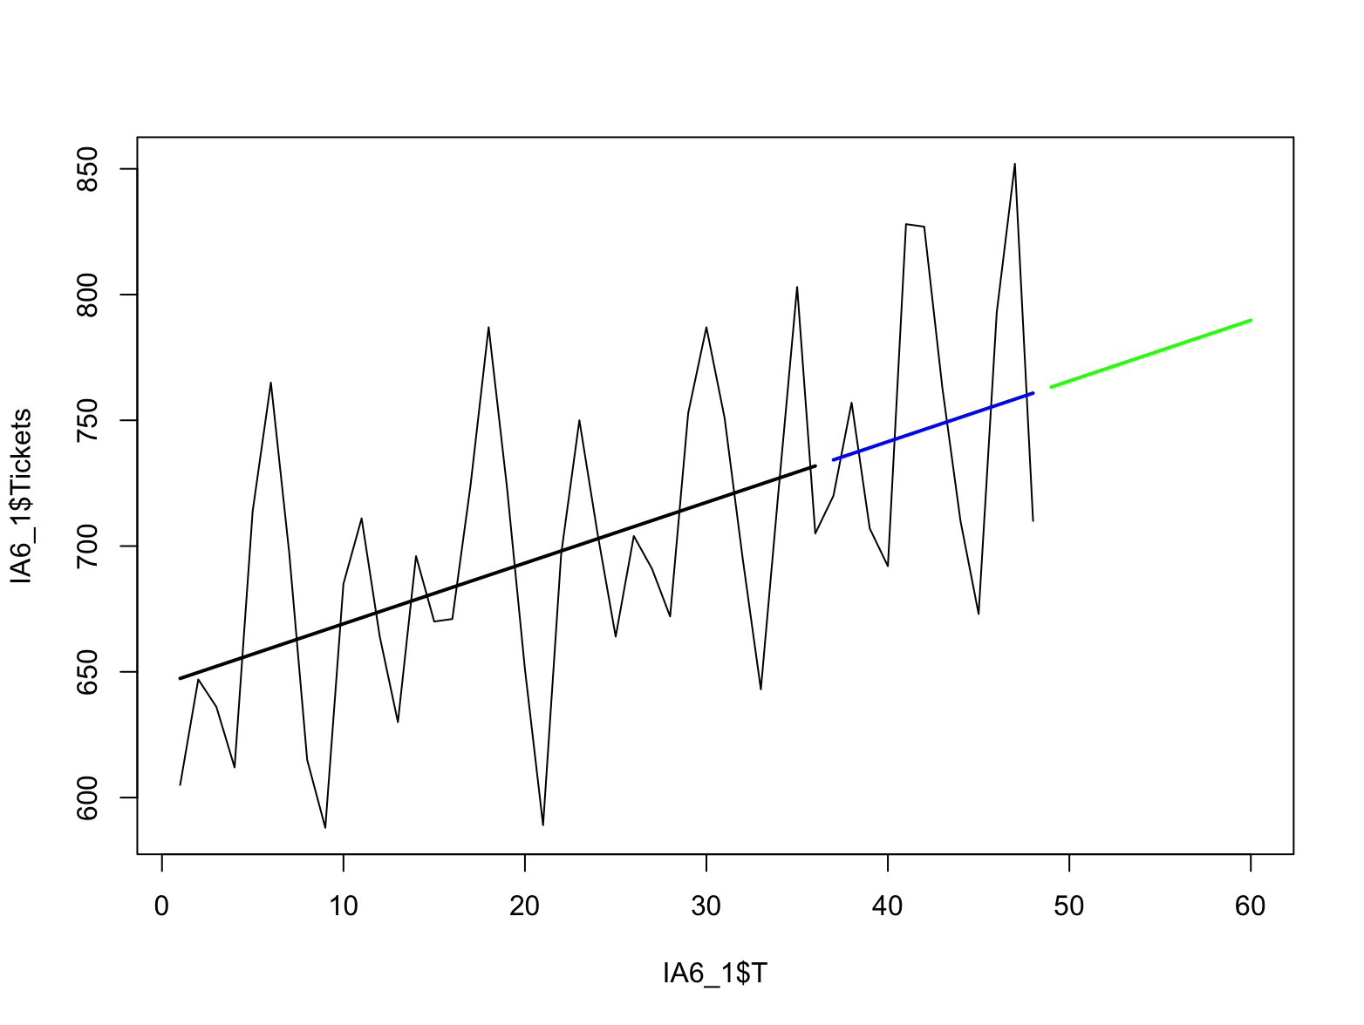

1. What are the RMSE and MAPE of the trend model based on the validation data? Discuss the overall performance of you model.

* *Solution*:
* Compute the RMSE and MAPE as:
* # compute rmse and mape  
  rmse.lm.trend <- rmse(observed, predicted)  
  mape.lm.trend <- mape(observed, predicted)*100  
  print(c(rmse.lm.trend,mape.lm.trend))  
  [1] 56.84390 6.55971
* RMSE=56.84390 and MAPE=6.55971%.
* Also, Adjusted R-squared: 0.1866. Considering these factors, my model’s overall performance is not bad, because MAPE is within the tolerance and the model catch the trend. But it’s not good enough, since it R-squared is too small, and it cannot fit in the original curve, without a seasonality factor.

1. Fill in the table with your predictions for the following 12 months.

# forecast for the 5 year  
forecasted <- predict(train.lm.trend, fore)  
print(forecasted)

|  |
| --- |
| Month |
| January |
| February |
| March |
| April |
| May |
| June |
| July |
| August |
| September |
| October |
| November |
| December |

c) (2 pts) Is there evidence of some seasonal pattern in the sales data? If so, characterize the seasonal pattern (monthly, quarterly, or yearly).

*Solution*:

There is strong evidence of **monthly** seasonal patterns in the sales data, as the time series plot shows:



d) (5+2+2= 9 pts) Build a regression model with trend and seasonality. To validate your model, use the last 12 months as a validation data set.

1. Copy and paste your R code and display the regression output.

* *Solution*:
* Build the regression model with trend and seasonality as:
* # trend model  
  train_monthly.lm.trend <- lm(Tickets~T+factor(Month), data = train)  
  summary(train_monthly.lm.trend)  
  observed <- test$Tickets  
  predicted <- predict(train_monthly.lm.trend, test)  
  # forecast for the 5 year  
  forecasted_monthly <- predict(train_monthly.lm.trend, fore)  
  print(forecasted_monthly)  
    
  # plot data and forecasts  
  plot(IA6_1$T, IA6_1$Tickets, type = "l")  
  # plot fitted value in the training period  
  lines(train_monthly.lm.trend$fitted, lwd=2)  
  lines(c(nTrain+1:12), predicted, lwd=2, col="blue")  
  lines(c(nTrain+13:24), forecasted_monthly, lwd=2, col="green")
* The model goes like:
* 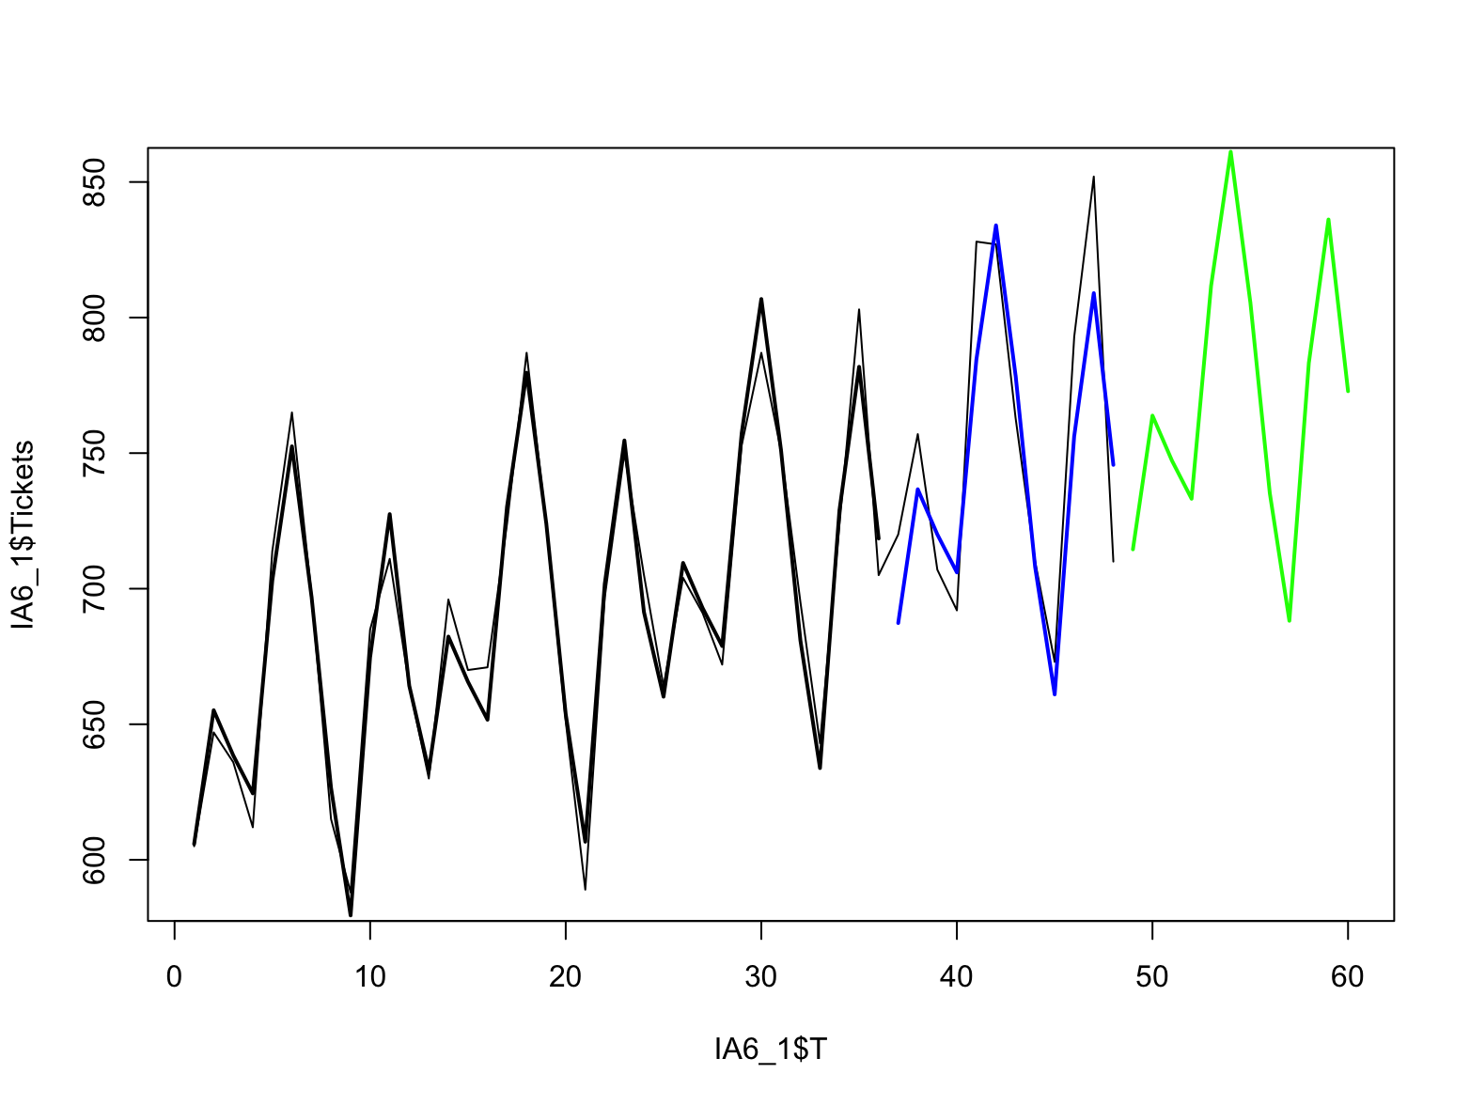

1. What are the RMSE and MAPE of the trend model based on the validation data? Discuss the overall performance of you model.

* *Solution*:
* Compute the RMSE and MAPE as:
* # compute rmse and mape  
  rmse_monthly.lm.trend <- rmse(observed, predicted)  
  mape_monthly.lm.trend <- mape(observed, predicted)*100  
  print(c(rmse_monthly.lm.trend, mape_monthly.lm.trend))  
  [1] 26.819355 2.998095
* RMSE=26.819355 and MAPE=2.998095%.
* Also, Adjusted R-squared: 0.9468. Considering these factors, my model’s overall performance is very great, because MAPE is ideally small and R-squared is close to 1. The fitted values go so close to the original that even shows some over-fitted patterns, and the predict is close to the test data.

1. Fill in the table with your predictions for the following 12 months.

# forecast for the 5 year  
forecasted_monthly <- predict(train_monthly.lm.trend, fore)  
print(forecasted_monthly)

|  |
| --- |
| Month |
| January |
| February |
| March |
| April |
| May |
| June |
| July |
| August |
| September |
| October |
| November |
| December |

e) (3 pts) Between the two models (part b and part d), which model will you use? Explain your answer.

*Solution*:

I choose the regression model with linear trend and seasonality in **d)**, as the graph shows clearly monthly patterns, and also the **d)** model gives a better performance, comparing the other, because of it’s small MAPE, RMSE, higher R-squared, and closer prediction.

**Question 2 (25 points)**

The following data contains the annual revenue of a convenient store in thousand dollars.

|  |
| --- |
| Year |
| 1990 |
| 1991 |
| 1992 |
| 1993 |
| 1994 |
| 1995 |
| 1996 |
| 1997 |
| 1998 |
| 1999 |
| 2000 |
| 2001 |
| 2002 |
| 2003 |
| 2004 |
| 2005 |
| 2006 |
| 2007 |
| 2008 |
| 2009 |
| 2010 |
| 2011 |
| 2012 |

Our goal is to predict the revenue for the following 4 years.

Model A:

a) (2 pts) Which exponential smoothing method would be the best (select one)?

1. Simple Exponential smoothing
2. Double (Holt’s) exponential smoothing
3. Triple (Holt-Winter’s) exponential smoothing

*Solution*:

I choose Double (Holt’s) exponential smoothing, because the plot shows a trend, but the seasonality is mixed with 2 years and 3 years:

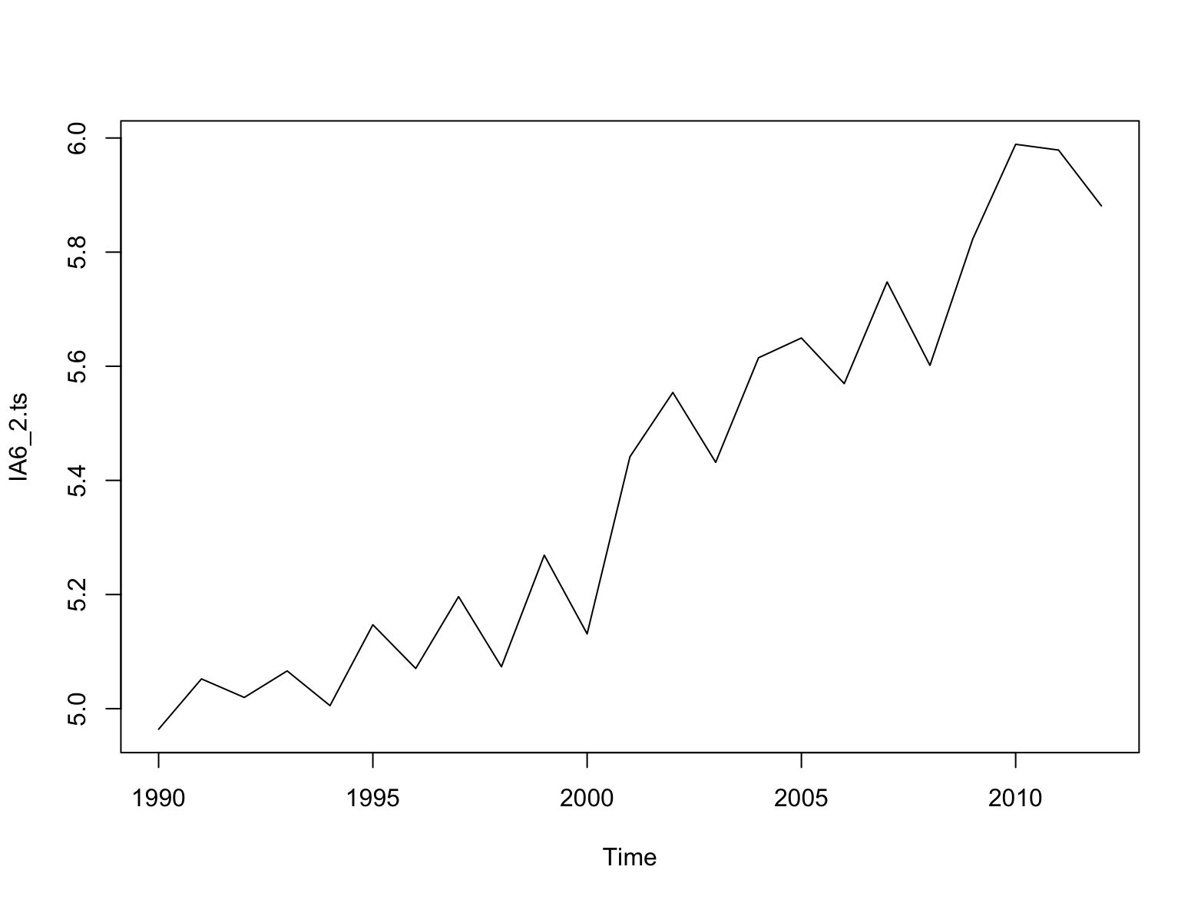

Actually, for method 1 and 3, I’ve also tried: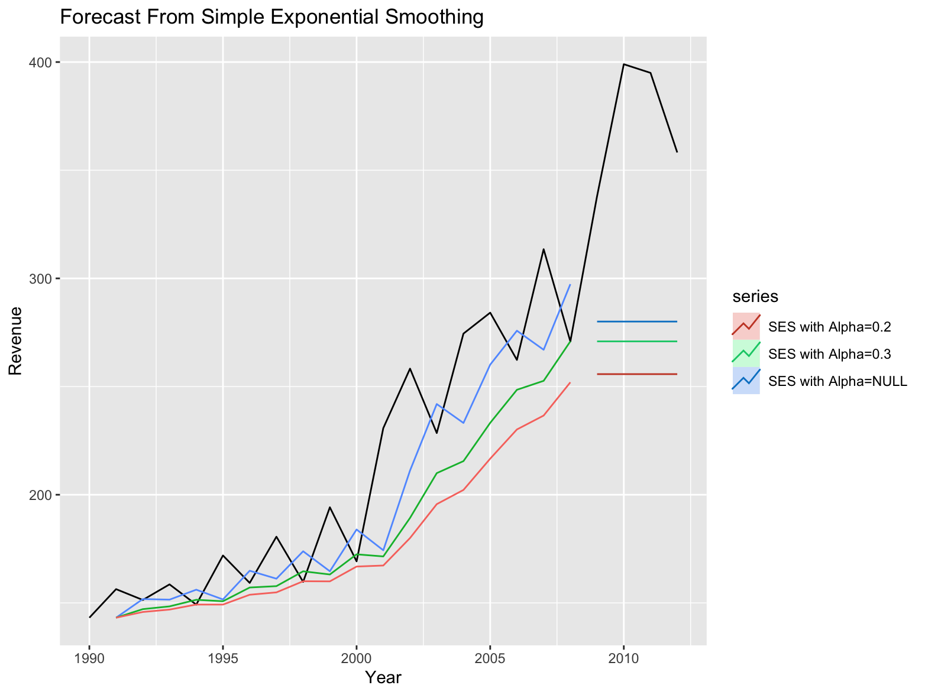

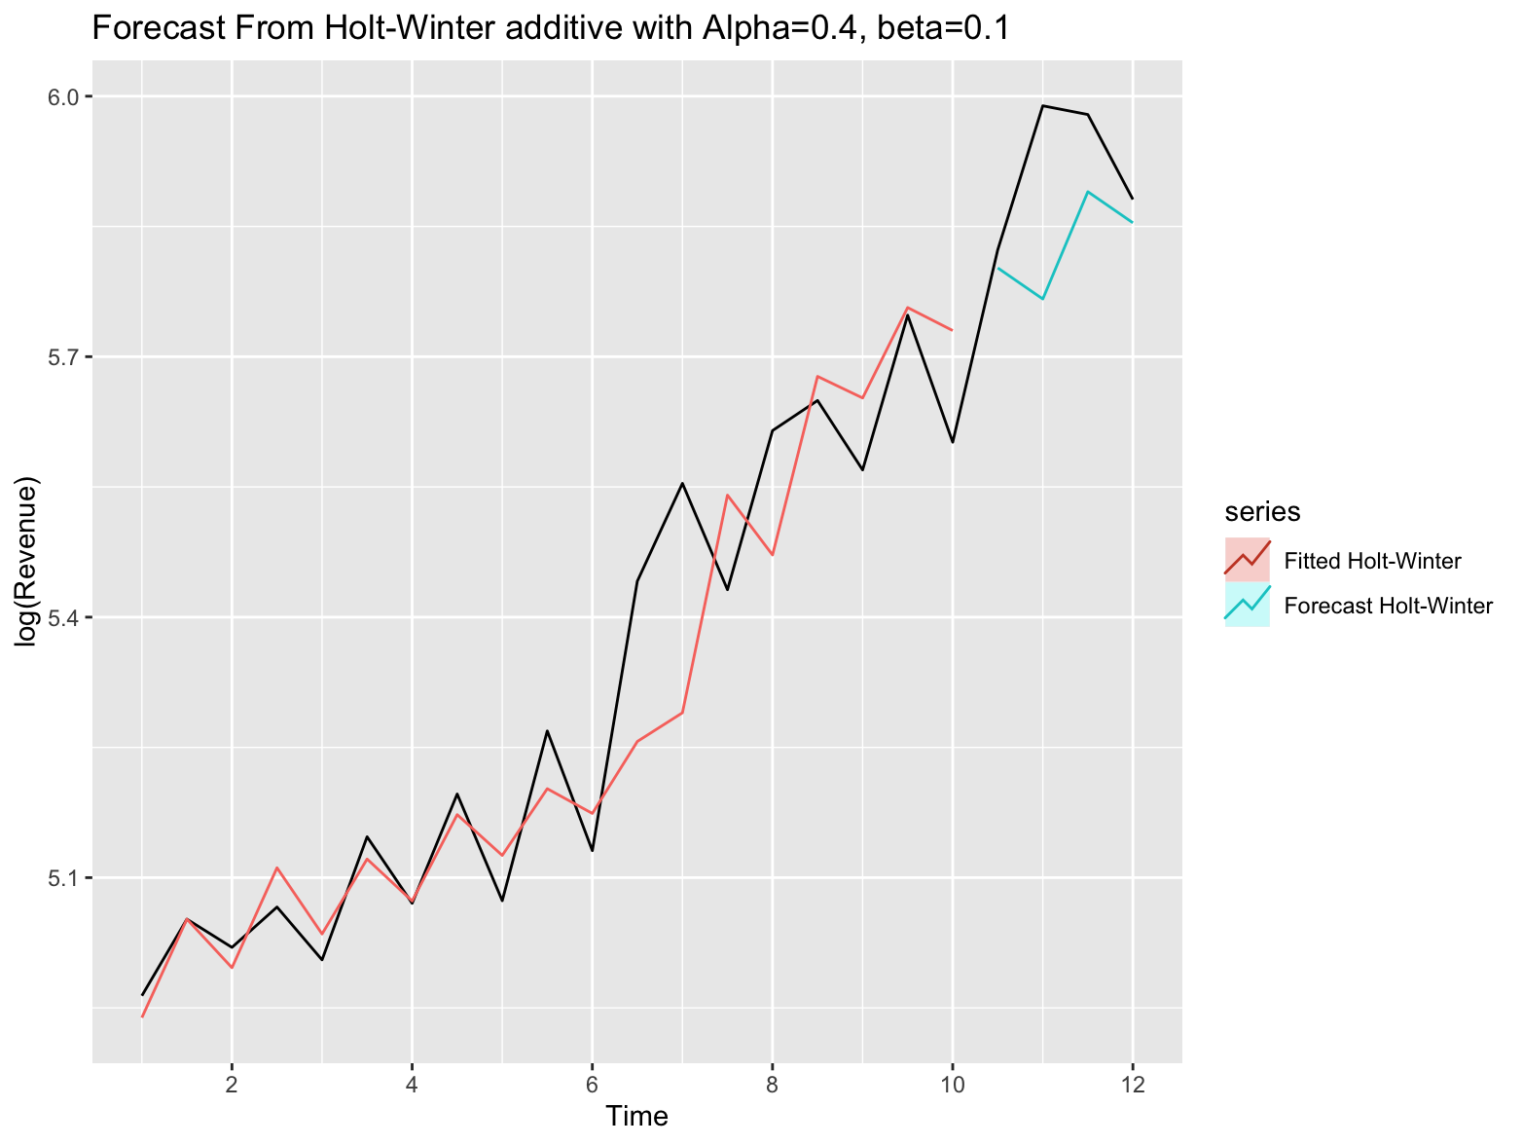

See R file for details.

b) (5+2+2=9 pts) Build an appropriate exponential smoothing model (depending on your answer in part a). To validate your model, use the last 4 years as a validation data set.

* 1. Copy and paste your R code and display the regression output.
  + *Solution*:
  + Import data and split:
  + # attach data for question 2  
    attach(IA6_2)  
      
    #store the data in a time series object  
    IA6_2.ts <- ts(IA6_2$Revenue,start = 1990)  
    #IA6_2.ts <- log(IA6_2.ts) # add this for model B  
    #create a time series plot  
    plot(IA6_2.ts)  
    hist(Revenue, breaks = 20)  
    hist(log(Revenue), breaks = 20) # add this for model B  
    # ndata = length(IA6_2$Revenue)  
    # print(ndata)  
      
    # split data  
    train.ts <- window(IA6_2.ts, start=1990, end=2008)  
    # print(train.ts)  
    test.ts<-window(IA6_2.ts, start=2009)  
    # print(test.ts)
  + Try SES to decide Alpha:
  + # SES  
    # alpha=NULL  
    train.simple <- HoltWinters(train.ts, alpha = NULL, beta = FALSE, gamma = FALSE)  
    simple.pred <- forecast(train.simple, h = 4, level = 0)  
    summary(simple.pred)  
      
    # alpha=0.3  
    train1.simple <- HoltWinters(train.ts, alpha = 0.3, beta = FALSE, gamma = FALSE)  
    simple1.pred <- forecast(train1.simple, h = 4, level = 0)  
    summary(simple1.pred)  
      
    # alpha=0.2  
    train2.simple <- HoltWinters(train.ts, alpha = 0.2, beta = FALSE, gamma = FALSE)  
    simple2.pred <- forecast(train2.simple, h = 4, level = 0)  
    summary(simple2.pred)  
      
    # autoplot to compare  
    autoplot(IA6_2.ts) +  
     autolayer(simple.pred$fitted, series="SES with Alpha=NULL") +  
     autolayer(simple.pred, series="SES with Alpha=NULL")+  
     autolayer(simple1.pred$fitted, series="SES with Alpha=0.3") +  
     autolayer(simple1.pred, series="SES with Alpha=0.3")+  
     autolayer(simple2.pred$fitted, series="SES with Alpha=0.2") +  
     autolayer(simple2.pred, series="SES with Alpha=0.2")+  
     xlab("Year")+ylab("Revenue")+  
     ggtitle("Forecast From Simple Exponential Smoothing")
  + 
  + For the best performance, choose Alpha = **0.3**.
  + Then build Holt’s as:
  + # Holt, alpha=0.3  
    # beta=NULL  
    train.Holt <- HoltWinters(train.ts, alpha = 0.3, beta = NULL, gamma = FALSE)  
    Holt.pred <- forecast(train.Holt, h = 4, level = 0)  
    summary(Holt.pred)  
      
    # beta=0.3  
    train1.Holt <- HoltWinters(train.ts, alpha = 0.3, beta = 0.3, gamma = FALSE)  
    Holt1.pred <- forecast(train1.Holt, h = 4, level = 0)  
    summary(Holt1.pred)  
      
    # beta=0.5  
    train2.Holt <- HoltWinters(train.ts, alpha = 0.3, beta = 0.5, gamma = FALSE)  
    Holt2.pred <- forecast(train2.Holt, h = 4, level = 0)  
    summary(Holt2.pred)  
      
    # autoplot to compare  
    autoplot(IA6_2.ts) +  
     autolayer(Holt.pred$fitted, series="Holt with Beta=NULL") +  
     autolayer(Holt.pred, series="Holt with Beta=NULL")+  
     autolayer(Holt1.pred$fitted, series="Holt with Beta=0.3") +  
     autolayer(Holt1.pred, series="Holt with Beta=0.3")+  
     autolayer(Holt2.pred$fitted, series="Holt with Beta=0.5") +  
     autolayer(Holt2.pred, series="Holt with Beta=0.5")+  
     xlab("Year")+ylab("Revenue")+  
     ggtitle("Forecast From Holt, Alpha=0.3")
  + 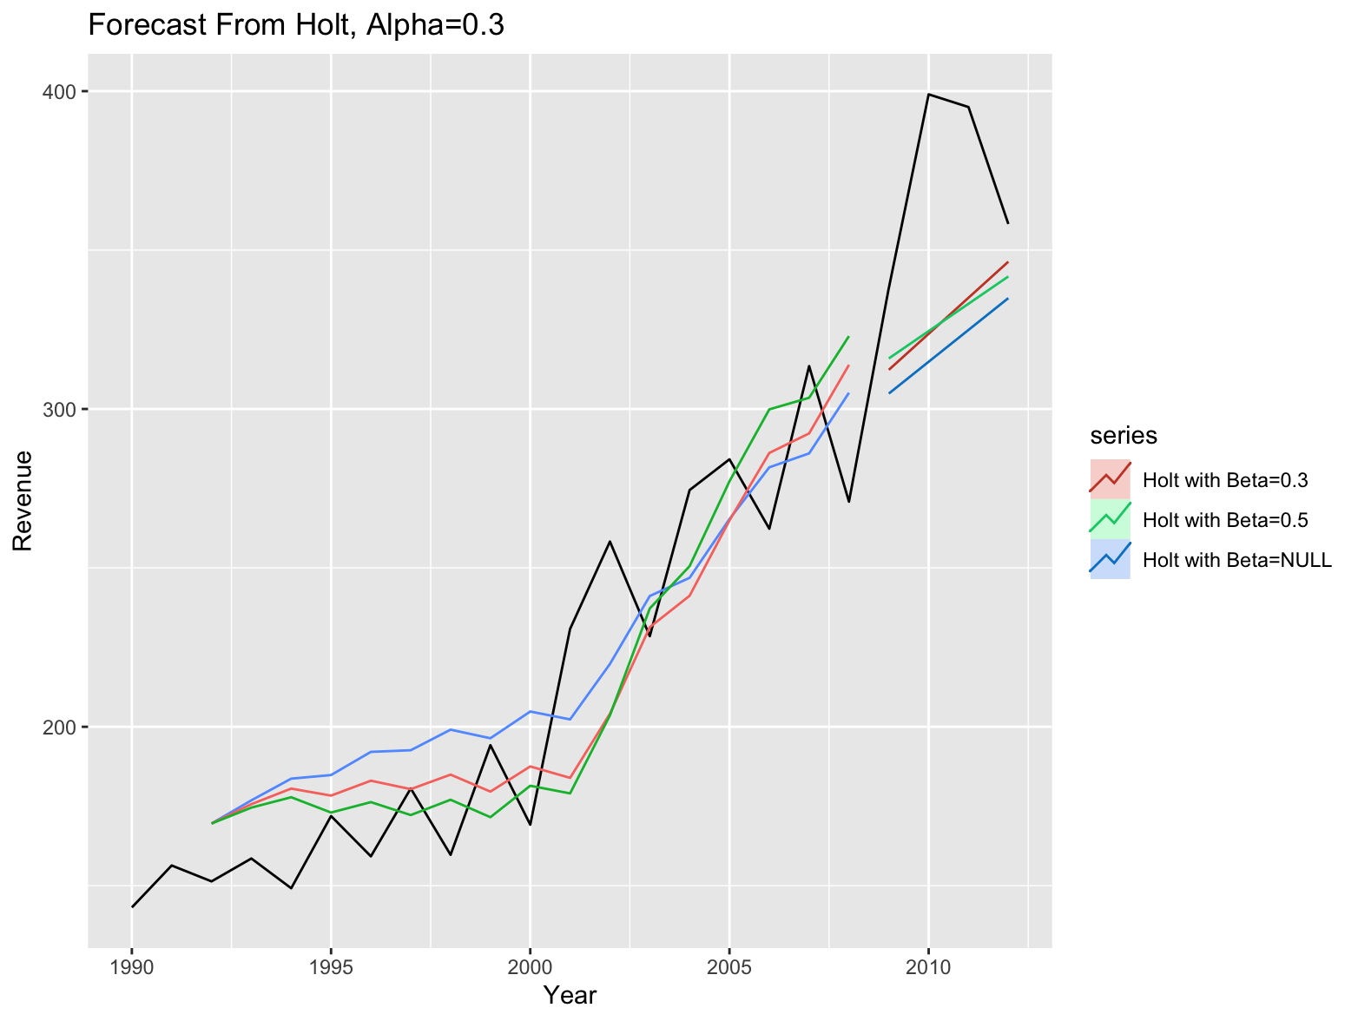
  + For the best performance, choose Beta = **0.1**.
  + # choose beta=0.3 and plot  
    autoplot(IA6_2.ts) +  
     autolayer(Holt1.pred$fitted, series="Fitted Holt") +  
     autolayer(Holt1.pred, series="Forecast Holt")+  
     xlab("Year")+ylab("Revenue")+  
     ggtitle("Forecast From Holt with Alpha=0.3, beta=0.3")
  + 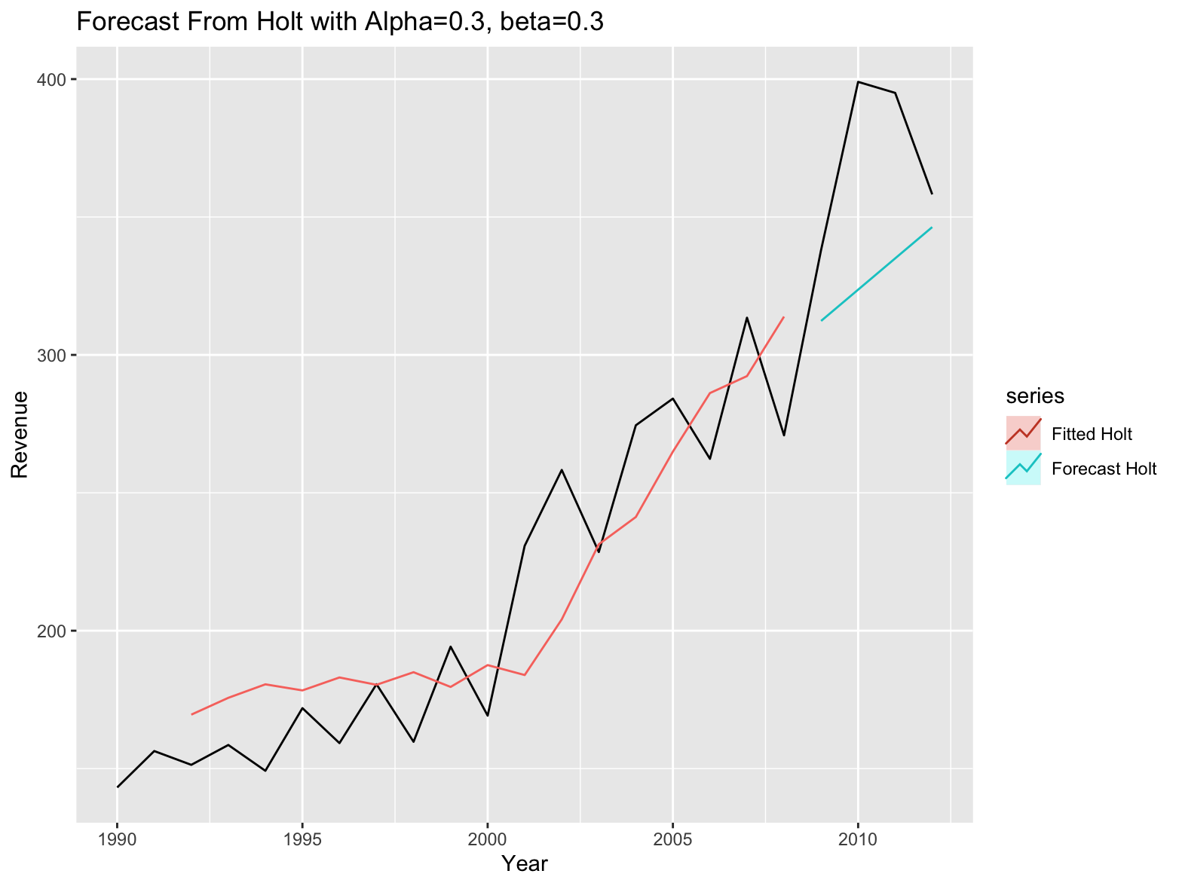
  1. What are the RMSE and MAPE of the trend model based on the validation data? Discuss the overall performance of you model.
  + *Solution*:
  + Compute the RMSE and MAPE as:
  + # compute rmse and mape  
    print(c(rmse(test.ts,Holt1.pred$mean),mape(test.ts,Holt1.pred$mean)))  
    [1] 50.1977504 0.1124855
  + RMSE=50.1977504 and MAPE=0.1124855.
  + My model’s overall performance is quite great here, because the MAPE is relatively high, meaning that the predict isn’t accurate enough, also the predict is not close to the test. This model, however, is already an optimal option without over-fitting or under-fitting, and the problem is due to the small size of data and mixed seasonality.
  1. Fill in the table with your predictions for the following 4 years.

# forcast  
train1.holtfore <- forecast(train1.Holt, h = 8, level = 0)  
summary(train1.holtfore)

|  |
| --- |
| Year |
| 2013 |
| 2014 |
| 2015 |
| 2016 |

Model B:

Now, take the logarithmic transformation of the revenue (log(Revenue)).

a) (2 pts) Which exponential smoothing method would be the best (select one)?

1. Simple Exponential smoothing
2. Double (Holt’s) exponential smoothing
3. Triple (Holt-Winter’s) exponential smoothing

*Solution*:

I choose Double (Holt’s) exponential smoothing, because the plot shows a trend, but the seasonality is mixed with 2 years and 3 years, **same as a)**

b) (5+2+2=9 pts) Build an appropriate exponential smoothing model (depending on your answer in part a). To validate your model, use the last 4 years as a validation data set.

* 1. Copy and paste your R code and display the regression output.
  + *Solution*:
  + Import data and split:
  + # attach data for question 2  
    attach(IA6_2)  
      
    # store the data in a time series object  
    IA6_2.ts <- ts(IA6_2$Revenue,start = 1990)  
    IA6_2.ts <- log(IA6_2.ts) # add this for model B  
    # create a time series plot  
    plot(IA6_2.ts)  
    hist(Revenue, breaks = 20)  
    hist(log(Revenue), breaks = 20) # add this for model B  
    # ndata = length(IA6_2$Revenue)  
    # print(ndata)  
      
    # split data  
    train.ts <- window(IA6_2.ts, start=1990, end=2008)  
    # print(train.ts)  
    test.ts<-window(IA6_2.ts, start=2009)  
    # print(test.ts)
  + Try SES to decide Alpha:
  + # SES  
    # alpha=NULL  
    train.simple <- HoltWinters(train.ts, alpha = NULL, beta = FALSE, gamma = FALSE)  
    simple.pred <- forecast(train.simple, h = 4, level = 0)  
    summary(simple.pred)  
      
    # alpha=0.3  
    train1.simple <- HoltWinters(train.ts, alpha = 0.3, beta = FALSE, gamma = FALSE)  
    simple1.pred <- forecast(train1.simple, h = 4, level = 0)  
    summary(simple1.pred)  
      
    # alpha=0.2  
    train2.simple <- HoltWinters(train.ts, alpha = 0.2, beta = FALSE, gamma = FALSE)  
    simple2.pred <- forecast(train2.simple, h = 4, level = 0)  
    summary(simple2.pred)  
      
    # autoplot to compare  
    autoplot(IA6_2.ts) +  
     autolayer(simple.pred$fitted, series="SES with Alpha=NULL") +  
     autolayer(simple.pred, series="SES with Alpha=NULL")+  
     autolayer(simple1.pred$fitted, series="SES with Alpha=0.3") +  
     autolayer(simple1.pred, series="SES with Alpha=0.3")+  
     autolayer(simple2.pred$fitted, series="SES with Alpha=0.2") +  
     autolayer(simple2.pred, series="SES with Alpha=0.2")+  
     xlab("Year")+ylab("log(Revenue)")+  
     ggtitle("Forecast From Simple Exponential Smoothing")
  + 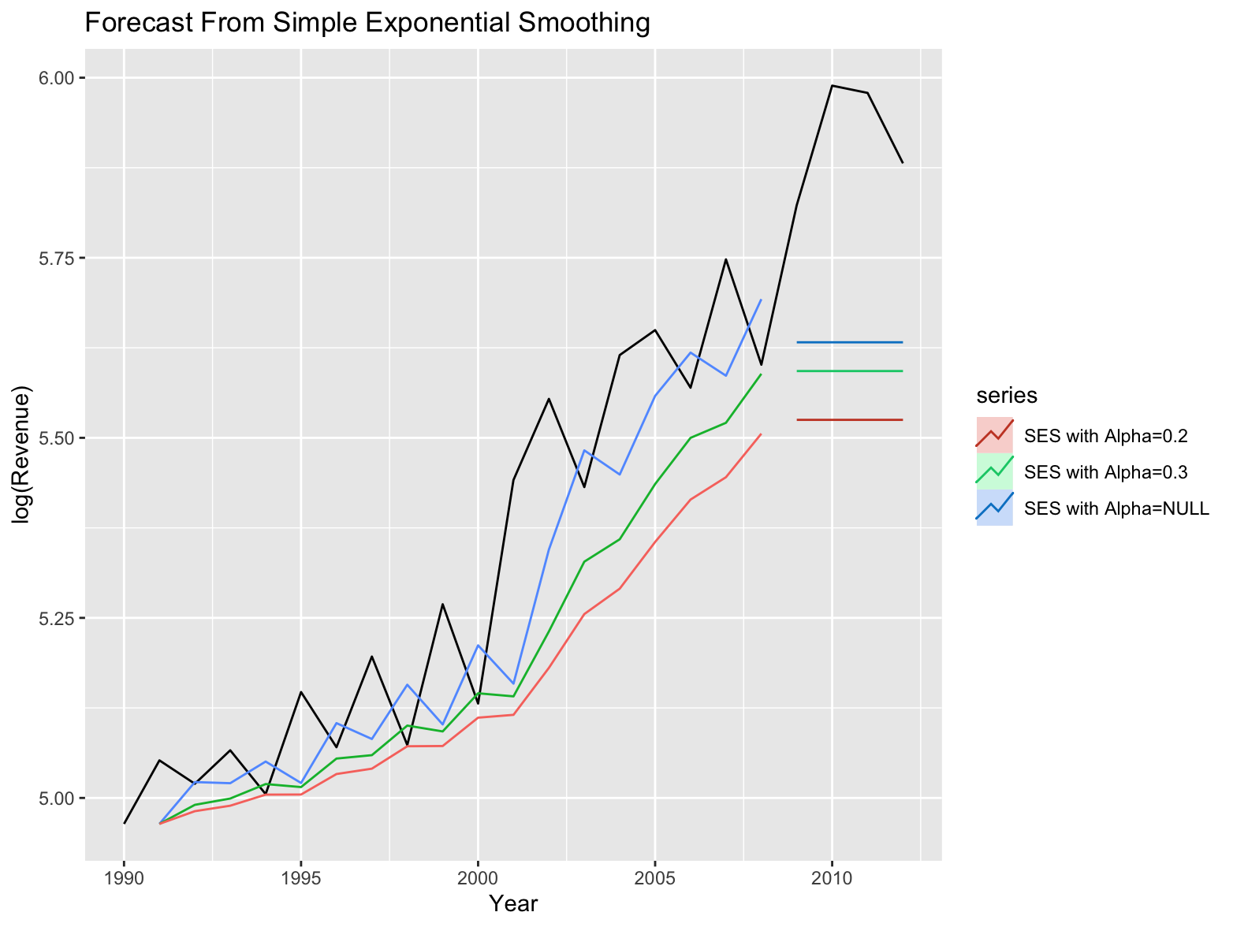
  + For the best performance, choose Alpha = **0.3**.
  + Then build Holt’s as:
  + # Holt, alpha=0.3  
    # beta=NULL  
    train.Holt <- HoltWinters(train.ts, alpha = 0.3, beta = NULL, gamma = FALSE)  
    Holt.pred <- forecast(train.Holt, h = 4, level = 0)  
    summary(Holt.pred)  
      
    # beta=0.3  
    train1.Holt <- HoltWinters(train.ts, alpha = 0.3, beta = 0.3, gamma = FALSE)  
    Holt1.pred <- forecast(train1.Holt, h = 4, level = 0)  
    summary(Holt1.pred)  
      
    # beta=0.5  
    train2.Holt <- HoltWinters(train.ts, alpha = 0.3, beta = 0.5, gamma = FALSE)  
    Holt2.pred <- forecast(train2.Holt, h = 4, level = 0)  
    summary(Holt2.pred)  
      
    # autoplot to compare  
    autoplot(IA6_2.ts) +  
     autolayer(Holt.pred$fitted, series="Holt with Beta=NULL") +  
     autolayer(Holt.pred, series="Holt with Beta=NULL")+  
     autolayer(Holt1.pred$fitted, series="Holt with Beta=0.3") +  
     autolayer(Holt1.pred, series="Holt with Beta=0.3")+  
     autolayer(Holt2.pred$fitted, series="Holt with Beta=0.5") +  
     autolayer(Holt2.pred, series="Holt with Beta=0.5")+  
     xlab("Year")+ylab("log(Revenue)")+  
     ggtitle("Forecast From Holt, Alpha=0.3")
  + 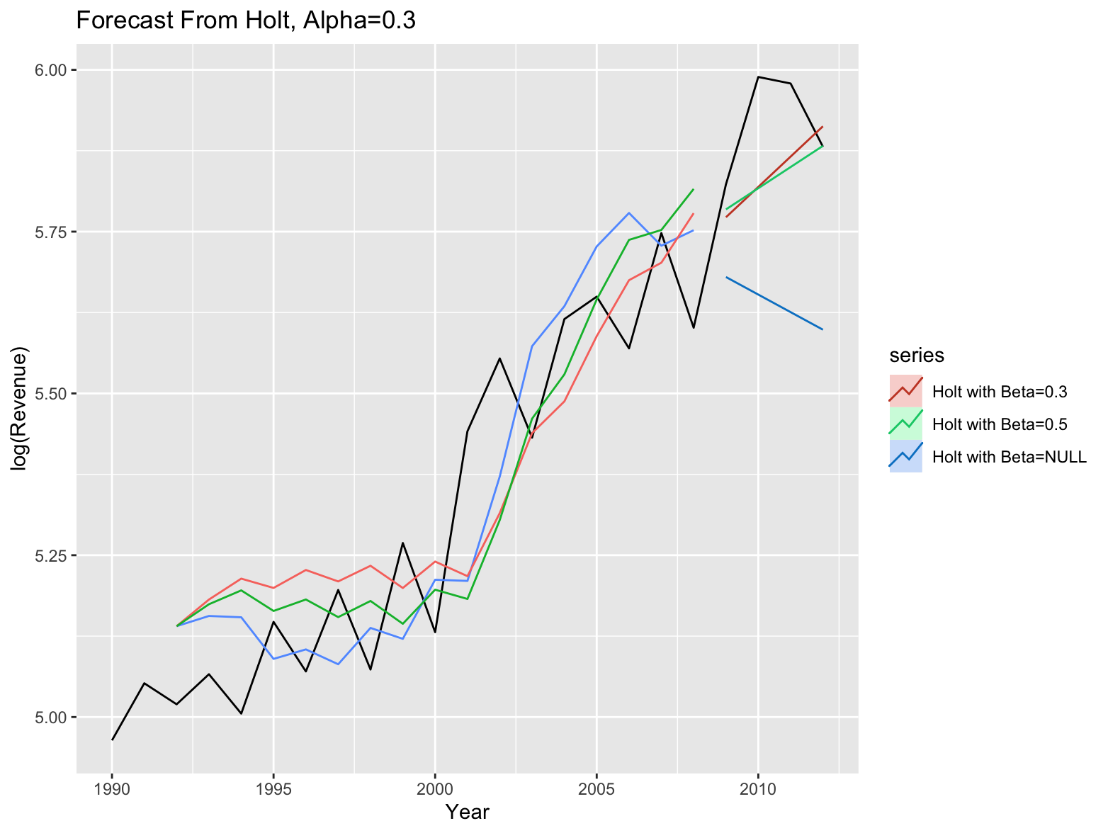
  + For the best performance, choose Beta = **0.1**.
  + # choose beta=0.3 and plot  
    autoplot(IA6_2.ts) +  
     autolayer(Holt1.pred$fitted, series="Fitted Holt") +  
     autolayer(Holt1.pred, series="Forecast Holt")+  
     xlab("Year")+ylab("log(Revenue)")+  
     ggtitle("Forecast From Holt with Alpha=0.3, beta=0.3")
  + 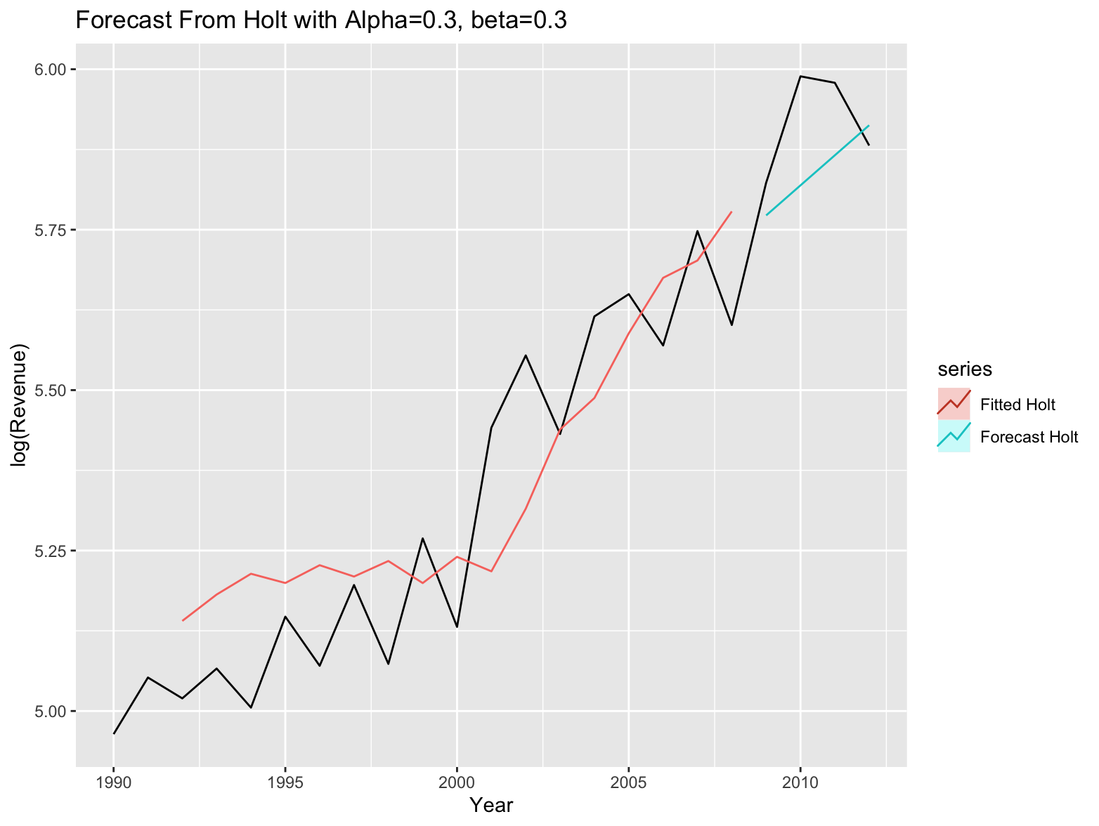
  1. What are the RMSE and MAPE of the trend model based on the validation data? Discuss the overall performance of you model.
  + *Solution*:
  + Compute the RMSE and MAPE as:
  + # compute rmse and mape  
    print(c(rmse(test.ts,Holt1.pred$mean),mape(test.ts,Holt1.pred$mean)))  
    [1] 0.10633263 0.01534862
  + RMSE=0.10633263 and MAPE=0.01534862.
  + Similarly to a)’s reason, my model’s overall performance is still not quite great here, because predict isn’t accurate enough. Here the RMSE and MAPE is quite small, because log function lower it down.
  1. Fill in the table with your predictions for the following 4 years.

|  |
| --- |
| Year |
| 2013 |
| 2014 |
| 2015 |
| 2016 |

c) (3 pts) Between Model A and Model B, which model will you use? Explain your answer.

*Solution*:

I choose Model B. From the histogram, we see the original data is right-skewed:

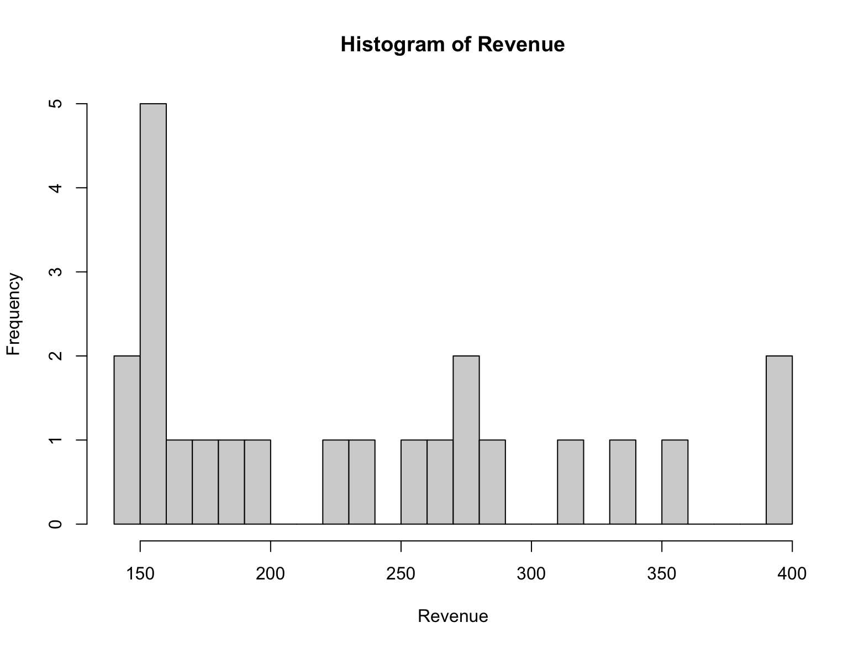

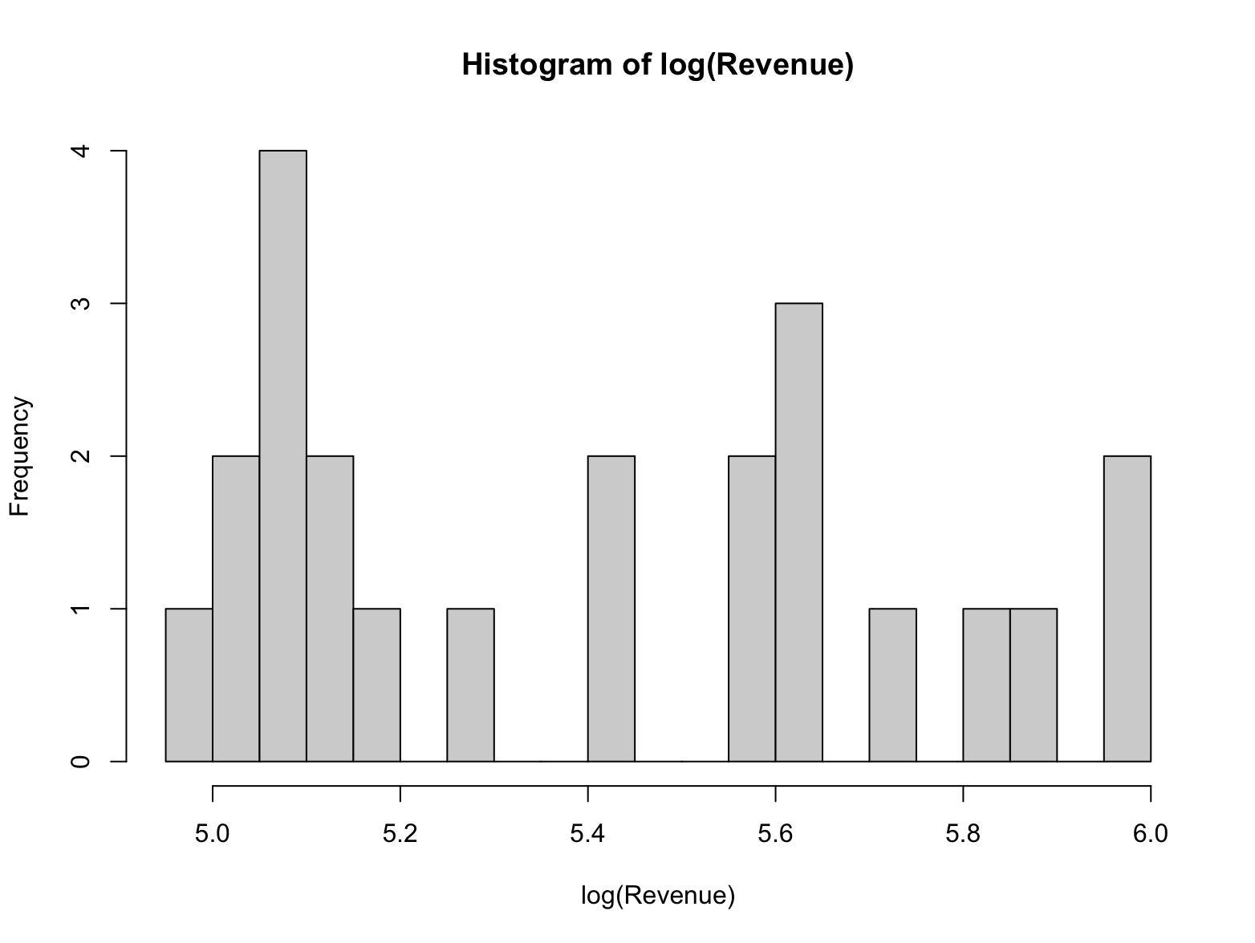

The distribution become better after log, and the result is more accurate. But again, both of the model is not good, we need more data to draw strong predictions, **Model B** is just a better choice.