BUDT732 – Individual Assignment 1

**Question 2.2:**

Decision variables:



The description says that Pizza Man offers plain, meat, vegetable, and supreme pizzas, so our decision variables should be the number of each type to make (marked as P-type for plain, M-type for meat, V-type for vegetable, and S-type for supreme), in order to maximize revenue from sales.

The objective function:

$$Total Revenue= \sum_{t=P, M,V,S}{p_{t}n_{t}}$$

$$where p represents unit price, n represents numbers$$

Shows in excel as:

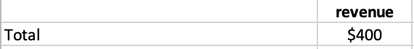

The constraints are the total amounts of the ingredients, that are: sauce, cheese, dough, meat, vegetable (used<=supplied). For example, the dough:

$$u_{d}≤200$$

$$where u_{d} represents the number of dough used,200 is the amount of dough that we have$$

Shows in excel as:

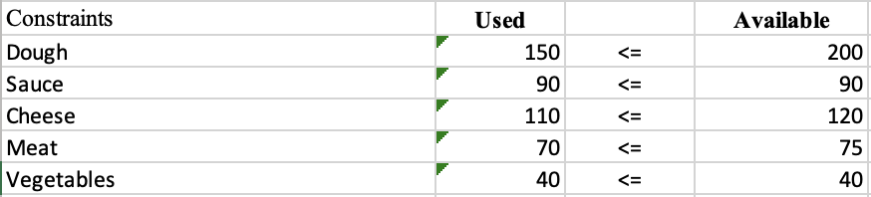

1. We’d make 10 meat and 20 supreme.
2. The maximum sales revenue is 400$
3. Sauce and vegetable are all economically scarce that reach their supply limitations.