BUDT732 – Individual Assignment 1

**Question 2.2:**

Decision variables:

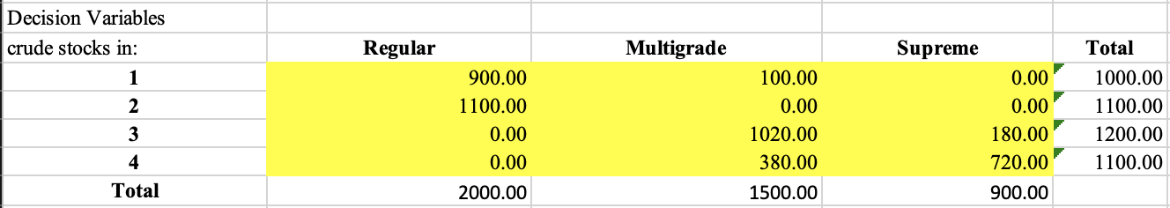

The description says that there are three kinds of oil products: regular, multigrade, and

supreme. Each brand of oil is composed of one or more of four crude stocks: 1-4. Therefore, the decision variables should be each kind of crude stocks used in each kind of oil products (marked as $u_{o,c}$, where o represents the type of oil and c the type of crude stocks

The objective function:

$$Total Revenue= \sum_{o=R,M,S}{p_{o}n_{o}}-\sum_{c=1,2,3,4}{p_{c}n_{c}}$$

$$where \sum_{o=R,M,S}{p_{o}n_{o}} represents selling price from oil products,$$

$$\sum_{c=1,2,3,4}{p_{c}n_{c}} represents cost from crude stocks.$$

Shows in excel as:

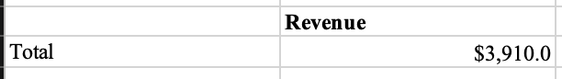

The constraints are:

(1) Each brand of oil must meet a minimum standard for a lubrication index. For example, the Regular oil:

$$\frac{\sum_{c=1,2,3,4}{l_{c}n_{c}}}{\sum_{c=1,2,3,4}{n_{c}}}≥25$$

$$where l_{c} represents lubrication index of crude stocks,n_{c} the number of crude stocks,$$

$$so that \frac{\sum_{c=1,2,3,4}{l_{c}n_{c}}}{\sum_{c=1,2,3,4}{n_{c}}} is the average of the mixture, also the final lubrication index.$$

But the above is non-linear, so we simply it to be linear as:

$$\sum_{c=1,2,3,4}{{(l}_{c}-25)n_{c}}≥0$$

Shows in excel as:

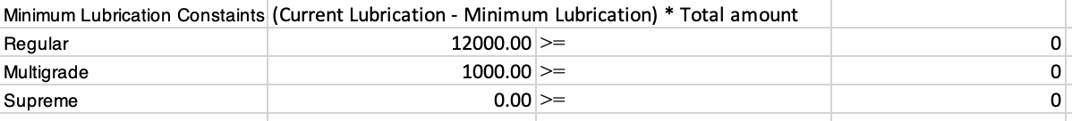

(2) Daily Supply of each kind of crude stocks, show in excel as:

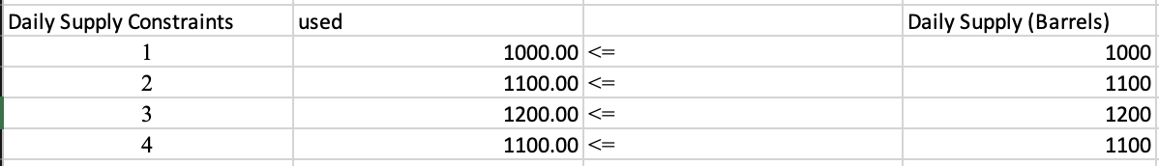

Question a:

In this question, there’s an extra constraint that the productions of oil shouldn’t be more than the Daily Demand, show in excel as:

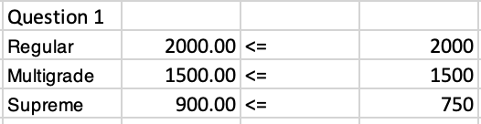

Thus, the optimal profit is 3964.2.

Question b:

In this question, there’s an extra constraint that the productions of oil should equal to the Daily Demand, show in excel as:

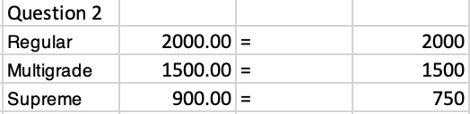

Thus, the optimal profit is 3760.

Question c:

In this question, there’s an extra constraint that the productions of oil shouldn’t be less than the Daily Demand, show in excel as:

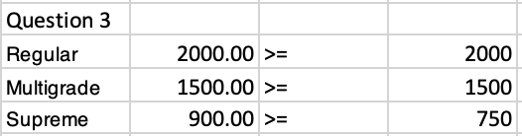

Thus, the optimal profit is 3910.

Note:

In my excel program, I used the same table in all questions, and only change the constraints. You may not find problem a and b’s optimal situations. But the report of each questions are attached, you can check it.