**IA 10: Simulation**

**Instructions:** Review the data file and answer the questions. Your answers should be submitted in the form of a Word document. The Word document should include ALL your answers including any charts, tables, or graphs required. Answer questions with complete sentences and using appropriate units and notation. You need to submit the Excel files that supports your work (but they will not be graded, and answers will not be searched within the file; make sure to include everything in your Word document.)

This is an individual assignment. No sharing of answers or work is allowed. Students can discuss and brainstorm models; however, all work submitted must be individually authored by each student.

**PROBLEMS:**

**Question 1: (25 points)**

A Flexible Savings Account (FSA) plan allows you to put money into an account at the beginning of the calendar year that can be used for medical expenses. This amount is not subject to federal tax as you pay medical expenses during the year, you are reimbursed by the administrator of the FSA until the money is exhausted. From that point on, you must pay your medical expenses out of your own pocket. On the other hand, if you put more money into your FSA than the medical expenses you incur, this extra money is lost to you. The goal of this study is to identify the optimal amount of FSA contribution to maximize the expected salary after tax and medical expenses.

Your annual salary is $70,000 and your federal income tax rate is 30%. Assume that you put **$2,000** into your FSA at the beginning of the year and that medical expenses in a year are normally distributed with mean $2,000 and a standard deviation of $500.

A static model is given in the *IA10_Q1_FSA_template.xlsx*. Note that the output is the amount of money left to you after i) putting money into the FSA, ii) paying tax, iii) paying out of pocket medical expenditure. Make sure you understand all the calculations in the model.

1. Determine the input variables of this problem:
   * What is(are) the input random variable(s)?
   * What is(are) the decision variable(s)?

Solution:

**Random** Variable:

* Medical expenses in a year, which are normally distributed with mean $2,000 and a standard deviation of $500.

**Decision** Variable:

* Amount of salary that is put into the FSA.

1. Add the simulation functionality to the template to output the salary after tax and health care costs (add randomness to any random variables and designate the appropriate outputs). Run the simulation with 1000 replications. **Copy and paste the graph of the distribution of salary after tax and health care costs.** Explain the shape of the distribution. Particularly, can you explain the spike on the right and the smooth distribution on the left?

Solution:

Since I’ve already built the **RiskSimTable**, which is more convenient actually, I use the result from **RiskSimTable here:**

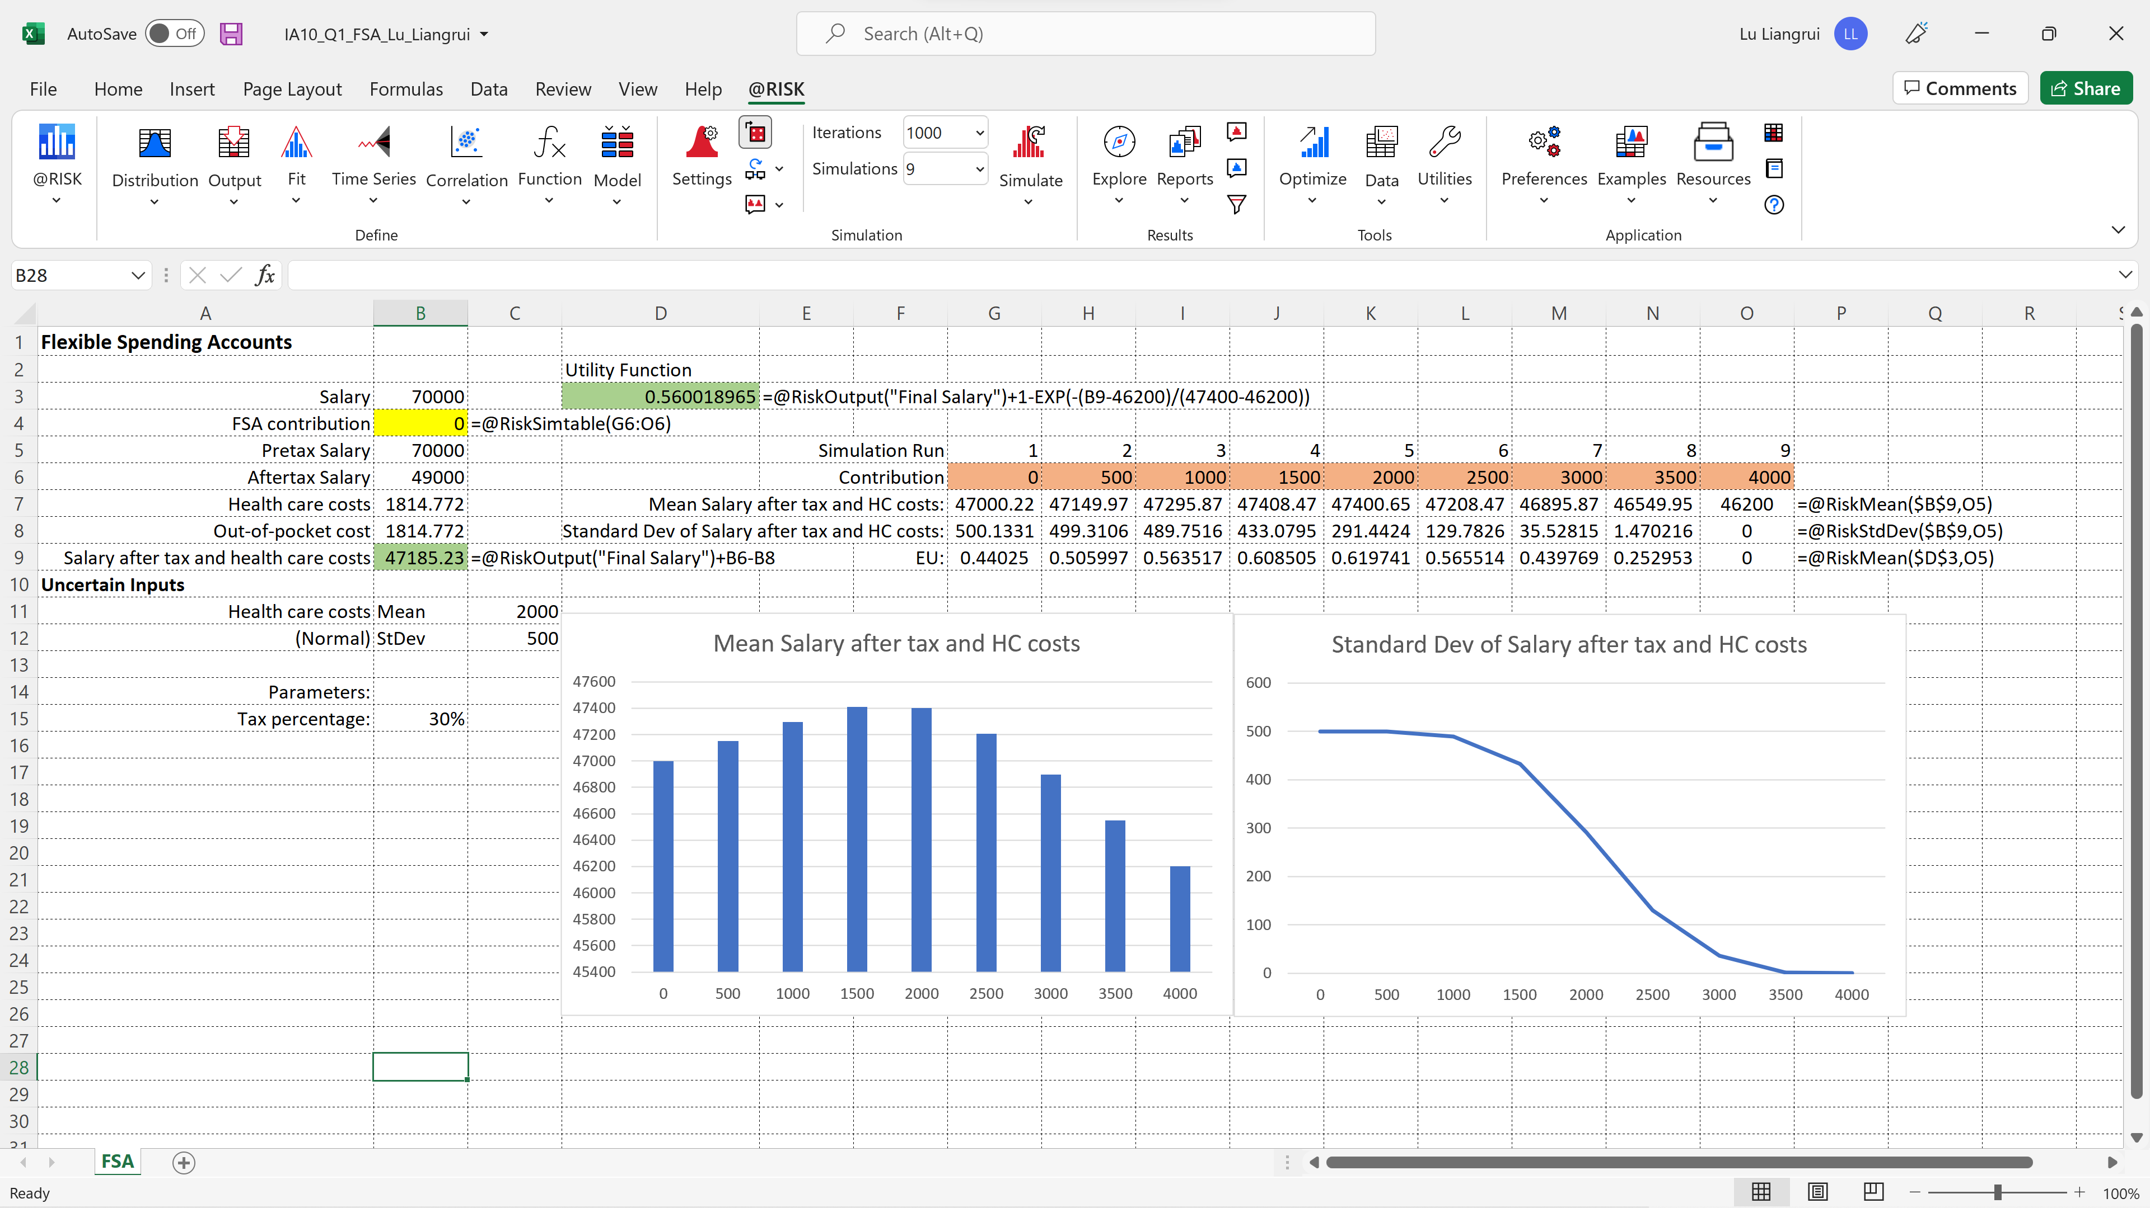

Here I get the Distribution plot as FSV=2000 (Simu 5) is:

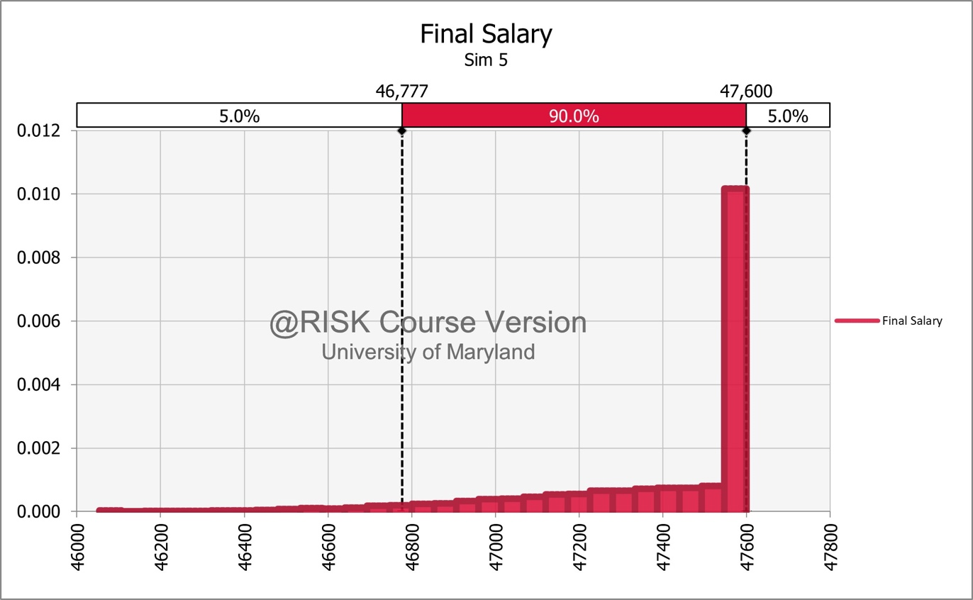

From the distribution graph, we can see that the net salary a smooth growth on the left and a spike on the right. Here we need to consider the actual distribution of medical cost, in order to understand this distribution pattern:

* Medical expenses in a year are normally distributed with mean $2,000 and a standard deviation of $500. Considering that FSA plan cannot be refunded, half of the situations, which have medical expenses smaller than $2000, are all in the spike.
* Considering to the shape of a normal distribution, there are also lots of situations, which have medical expenses greater than but close to $2000, like smaller than $2050, those are also in the spike.
* For the smooth distribution on the left, they are situations on the right tail on the normal distributions, having medical expenses largely greater than $2000, and their shape is just like the shape of the tail in normal distribution.

1. Now use RiskSimTable to experiment with the amount of money put in the FSA. Set the range of the amount of FSA contribution to [$0, $4000]. The sections shaded in yellow are intended to assist you organize the information. Also, add RiskSimTable function to the model and update the number of simulations.

**Copy and paste your table**. Based on the simulation results, answer the following questions.

* 1. If you are risk-neutral, how much would you contribute to your FSA? Explain your answer.
  2. If you are risk-averse, how much would you contribute to your FSA? Explain your answer.

Solution:

1. If we are risk-neutral, we only care about EMV, that is the mean of the salary after all expenses. From the plot, we see that Simu 4, with FSV=1500, has the best EMV, so we’d contribute **1500** to FSA.
2. If we are risk-averse, things become different as we also want to avoid the high risk. Here we define the utility function as:
   * Set a baseline of salary to exclude, here we choose 46200, which is the lowest amount all trials.
   * Set risk tolerance, here we choose 47400, which is approximately the optimal EMV.
   * Set the utility function as:

* Comparing the EU, Simu 5, with FSV=2000, has the best performance, so we’d contribute **2000** to FSA.

**Question 2: (25 points)**

The Greatyear Tire Company has developed a new tire and wants to jump start the marketing of this tire. Based on their testing of the product, it has mean lifetime of 36,500 miles and a standard deviation of 5,000 miles. They also determined that the lifetime follows a normal distribution with those parameters quite well.

The marketing department decided on the following plan for promotion of the product: they are so sure that the product will wear well that they will promise to pay a rebate for any tire that needs replacement at a threshold. They are considering 5 thresholds: 28,000, 29,000, 30,000, 31,000 and 32,000 miles, respectively. They will pay the purchaser back $1 for each full 100 miles the tire is below this threshold. (For example, if the threshold is 29,000, and the tire is replaced at 27,430 miles, the below threshold mileage is 1,570 miles (= 29,000-27,430). Then, the below threshold mileage is divided by 100 (that yields 15.7), so the number of FULL 100s below is 15. This person would be paid $15 for that tire.)

1. Determine the input variables of this problem:
   * What is(are) the input random variable(s)?
   * What is(are) the decision variable(s)?

Solution:

**Random** Variable:

* Actual lifetime for each product, which is normally distributed with the mean of 36,500 miles and the standard deviation of 5,000 miles

**Decision** Variable:

* Threshold for rebate payments.

1. Set up a simulation model in @Risk for each of the 5 different thresholds. Use 1000 replications for each alternative threshold. Also, show the Mean, Standard Deviation, Max rebate, and the probability that a rebate will exceed $5.

**Copy and paste your table**. Discuss the results briefly (2-3 lines).

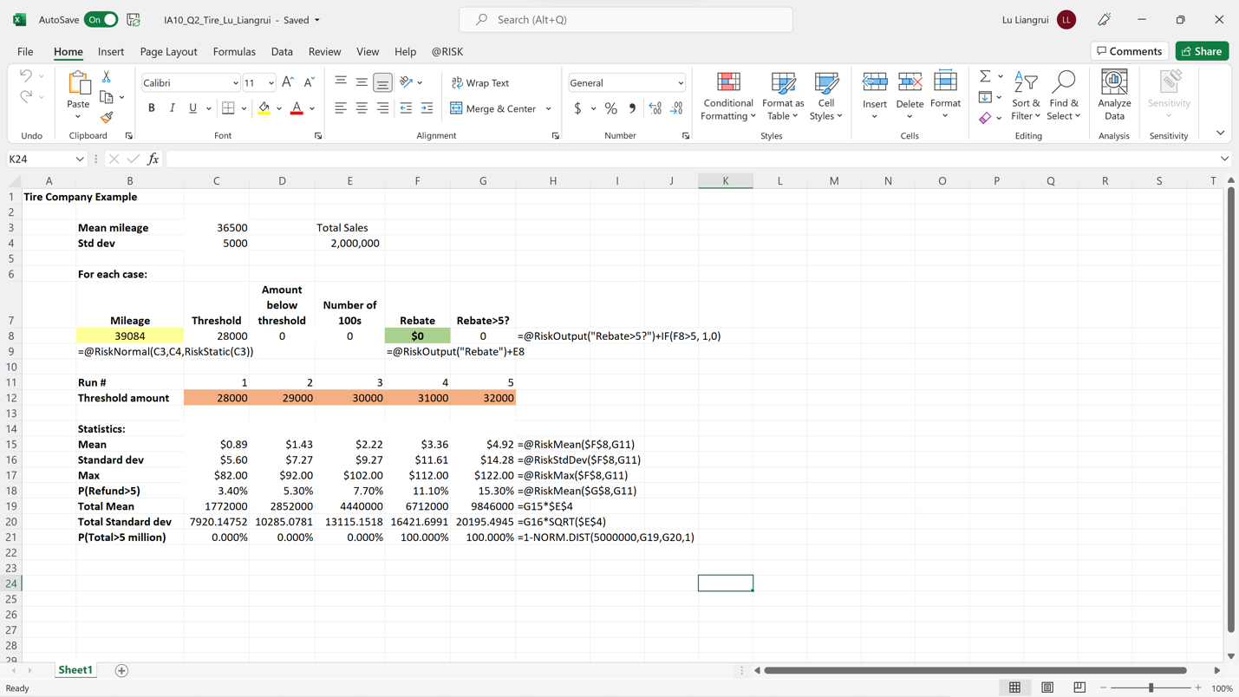

Solution:

* Cutting down the threshold would definitely lower down the EMV and also StdDev.
* The worst situations in all 5 runs are actually the same, since lower down 1000 in threshold would lower $10 in rebate, under the worst case
* We are going to find a balance, a relatively low threshold with acceptable EMV and StdDev.  
    
  HINTS:
  + Use the spreadsheet titled *IA10_Q2_Tire_templatet.xlsx* as a starting point for this analysis.
  + The sections shaded in yellow are intended to assist you organize the information.
  + Add the simulation functionality to the template to output the rebate per tire (add randomness to any random variables and designate the appropriate outputs).
  + To round the number FULL 100s down to the nearest integer, use ‘INT’ function in Excel.
  + Use RiskSimTable to compute the summary statistics for all five thresholds simultaneously.

Management expects that the promotion will run for the initial 3 months after release and that sales will be approximately 2 million tires in that period. However, they do not want to invest more than $5 million in the rebate program.

1. Based on the simulation results, compute the mean total cost for each alternative threshold assuming that sales will be 2 million tires.



Solution:

The results are actually shown in Total Mean and Total Standard Dev rows.

* 32000: 9.846 million
* 31000: 6.712 million
* 30000: 4.440 million
* 29000: 2.852 million
* 28000: 1.772 million

1. Based on the results in part (c), what threshold level would you recommend that Greatyear use so that they will have strong sales but not exceed the $5 million limit in rebate cost. Explain your answer. At that level, what percent of tires will see a greater than $5 rebate?

Solution:

I recommend to set the threshold level at **30000**, with the probably of rebate total cost >5 million as almost 0. And at that level, we have 7.70% percent to see tires have greater than $5 rebate.