BUDT-732 Individual Assignment 2

UID: 117509922

Make or Buy:

From the description, I model Acme Alarms’ decision problem as:

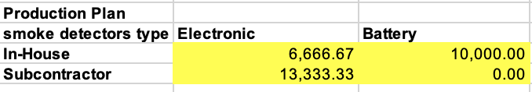

And we need to allocate the resource for both in-house production and additional units from a subcontractor.

The conditions are interpreted as:

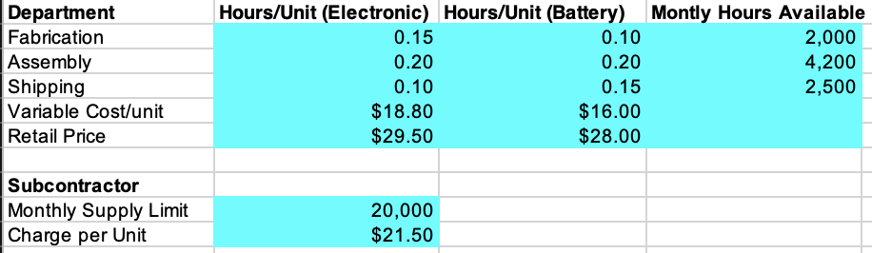

We want to maximize the total revenue, but the constraints for productivity of departments’ monthly available hours, subcontractor’s available unit, and total demands come as:

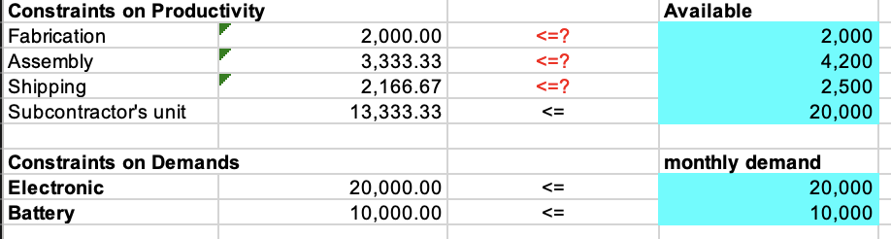

Using the Solver as: 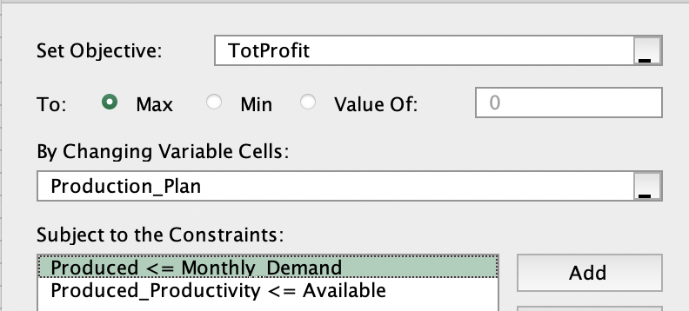

And the sensitivity report is:

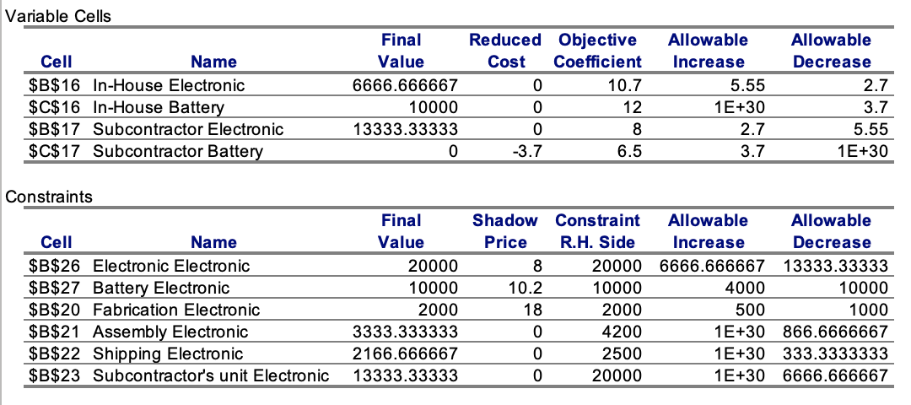

Questions 4.4:

1. Allocations for the in-house capacity and the subcontractor are as:

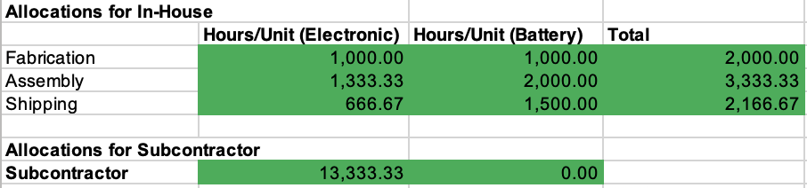

The maximum profit is **298000**, and the manufacturer should produce **6667 ($\frac{20000}{3})$** electronic detectors and **10000** battery-operated detectors, then buy **13333 ($\frac{40000}{3})$** electronic detectors from subcontractor, in order to maximize the profit.

1. I investigate the solution for Shipping capacities between 1200 and 2400 hours, through SolverTable as:

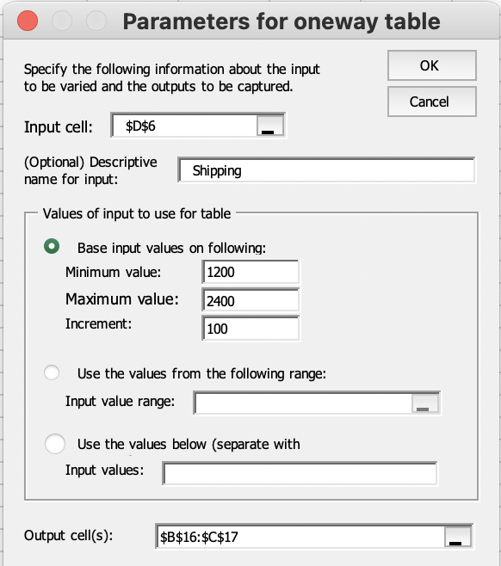

And get the table in Sheet “Shipping”. The graph for the optimal quantities changes over this range are listed here for all four decision variables:

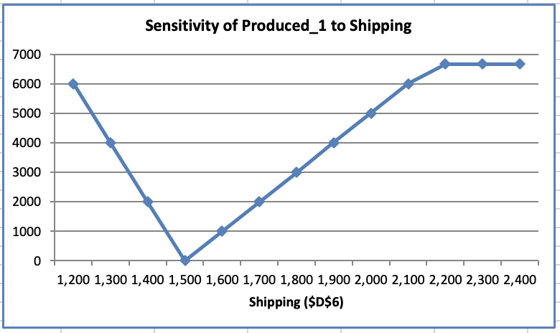 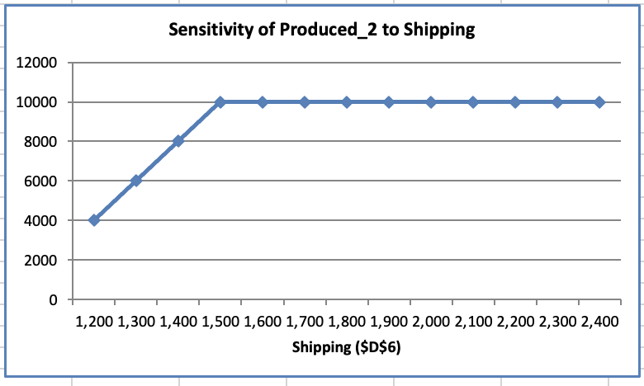 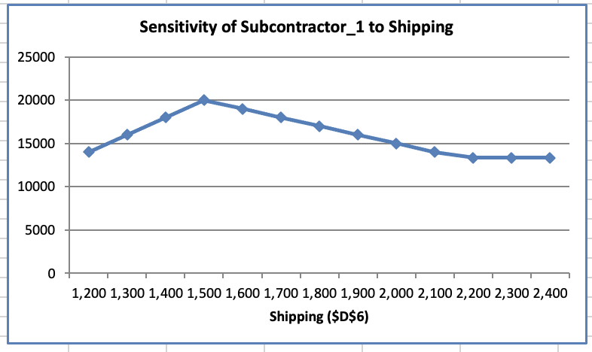 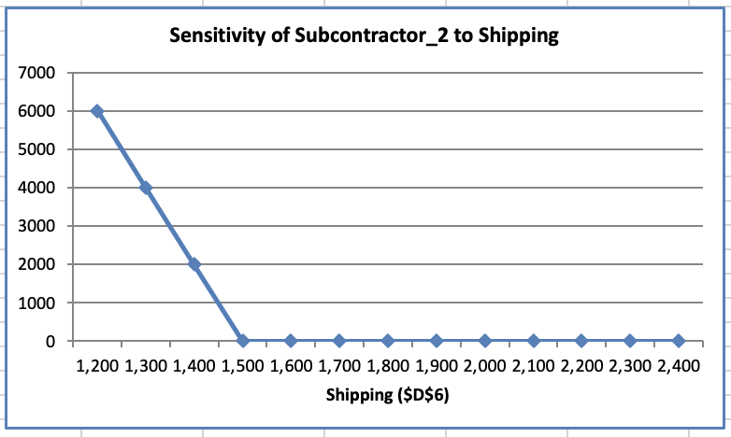

Questions 4.5:

1. The pattern is to produce the batteries in-house, to its demand 10000, and then produce electronic with the remaining in-house capacity. Then, obtaining additional electronic units from the subcontractor with the remaining demand of electronic units. But if the in-house productivity for battery is lower than 10000, the pattern switch as we produce batteries and electronic to totally demand as 10000, but allocate resource to produce batteries as much as possible. Then, allocating the total 20000 units that the subcontractor provide to meet the demand of both battery (10000) and electronic (20000).
2. After increasing the fabrication capacity by 10%, Acme Alarms can in-house produce more on electronic and reduce their demand from subcontractor. Now the fabrication capacity becomes 2200 monthly available hours, and follow the pattern above, we in-house produce **10000 batteries then 8000 electronic**, consuming 3600 assembly and 2300 shipping (under the available hours), and then obtain **12000 electronic** from subcontractor. The optimal profit increase as: $（8000-\frac{20000}{3}）×（21.5-18.8）=3600，$ and the new is **301600.**
3. Using the SolveTable, I get the one-way-table for fabrication as in Sheet “Fabrication”:

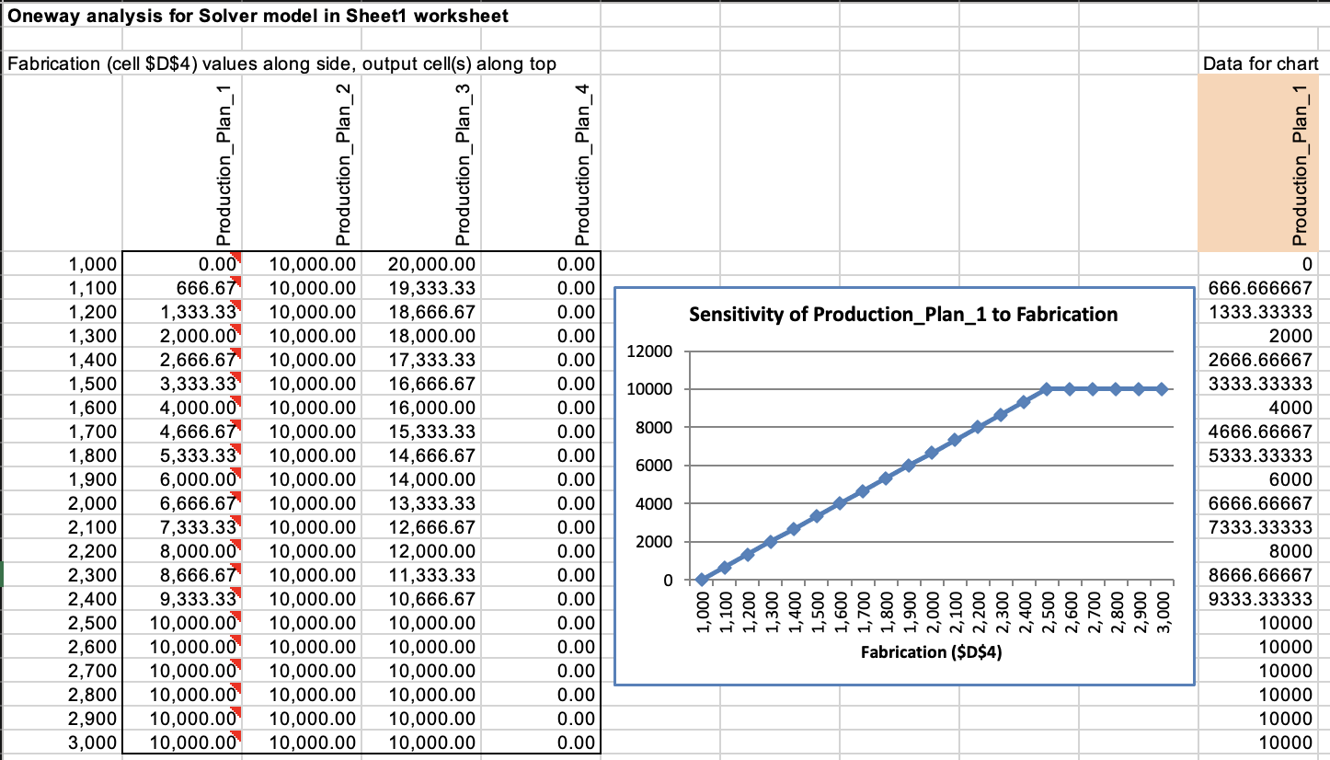

Thus, for changes among **decreasing 1000 to increasing 500** in fabrication capacity, the pattern in (b) persist.

Also, through sensitivity report we can find the answer for (b) and (c):

