BUDT-732 Individual Assignment 2

UID: 117509922

YesterTech:

From the description, I model YesterTech’s problem as:

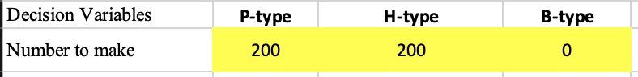

Where P represents PDAs, B for wireless handsets, and B for blackberrys.

The conditions are interpreted as:

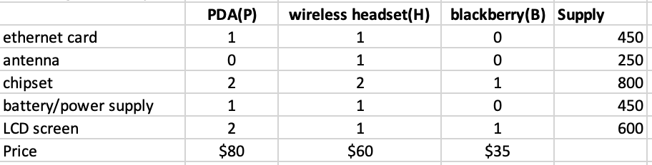

We want to maximize the total revenue, but the constraints come as:

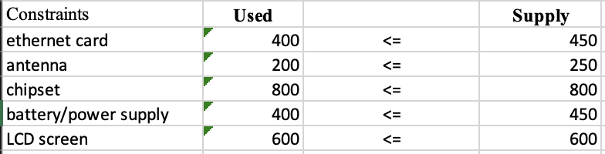

Using the Solver as: 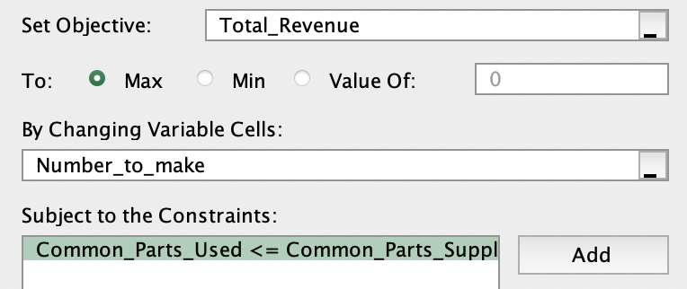

And the sensitivity report is:

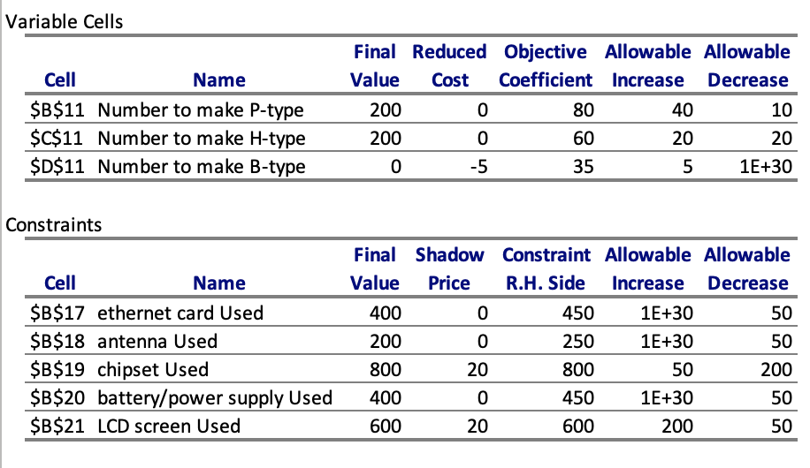

Questions:

1. Solution doesn’t change, because the final value of ethernet card used is 400, lower than 425.
2. It’s not profitable to produce Blackberrys. To make it profitable to produce Blackberrys, profit margin should be increased to **40,** as the current objective coefficient is 35 and the reduced cost is -5, meaning that we pay 5 to per unit in order to produce Blackberrys when its price is 35.
3. For handsets, the objective coefficient is 60 and allowable increase and decrease are both 20, so the plan doesn’t need to change when the objective coefficient is in [40, 80]. 70 is in [40, 80], so the production plan of YesterTech ***doesn’t change***. But the profit do increase as the profit margin on handsets increased 10 per unit, so the new profit is: $28000+200×10=30000$.
4. Similarly, when the chipset’s supply is in the range of [800-200, 800+50] = [600, 850], we can simply calculate the new profit using the chipset’s shadow price: 20/unit, and get the profit as: $28000+(750-800)×20=27000$
5. The cost for an extra LCD screen is exactly equal to LCD screens’ shadow price. Under this situation, the total revenue won’t change, whether YesterTech go ahead or not. Thus, they need to consider other factors to make the decisions. The total revenue will still keep the same if they choose to purchase, but at **most 200** LCD screens.