BUDT732 – Individual Assignment 3

**Question 3.2:**

Decision variables:

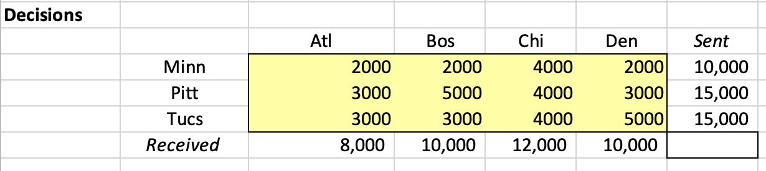

This question is an extension to previous example 3.1, discussed in class. The decision variables, as in previous question, are shipping amounts in each route, connecting each plant and distributor.

The objective function, the same as example, is:

$$Total Cost= \sum_{p=M,P,T;d=A,B,C,D}{c_{p,d}s_{p,d}}$$

$$where c represents unit cost, s represents shipping amounts,$$

$$and \left(p,d\right) combined to represent route from p\left(plant\right) to d(distributor)$$

Shows in excel as:

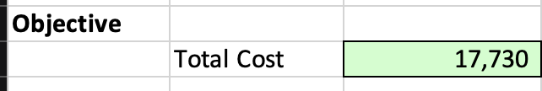

The extended question also has the previous constraints:

1. Each plant’s supply cannot over than its capacity.
2. Each distributor’s received shouldn’t over than its demand.
3. Decision variables non-negative, as always.

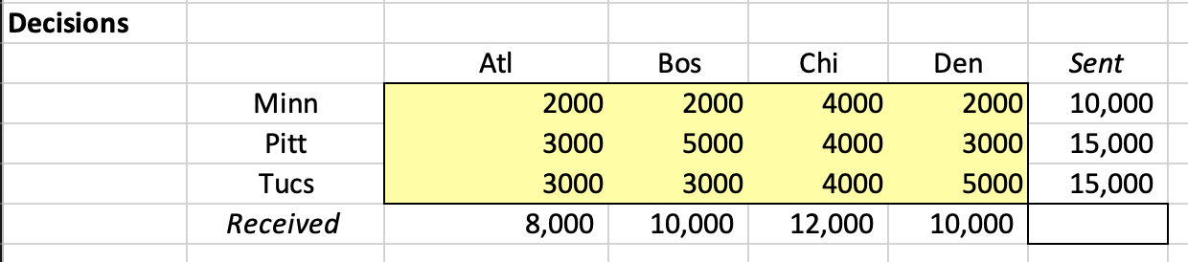

Also, in this question, the shipment volume on any route out of a plant must be at least 20% of the total volume leaving that plant.

$$s_{p}-20\%*\sum_{p;d=A,B,C,D}{s_{p,d}}≥0$$

$$where p represents any plants$$

Shows in excel as:

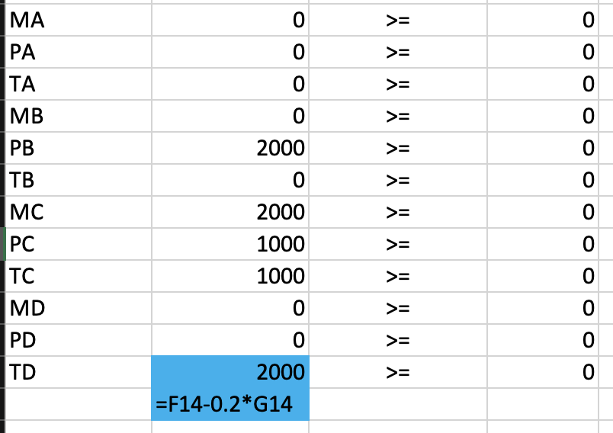

I actually started from yield loss question (I discussed with you several times, and found out bugs, you may remember). And it’s left for possible further use.

And solver result is:

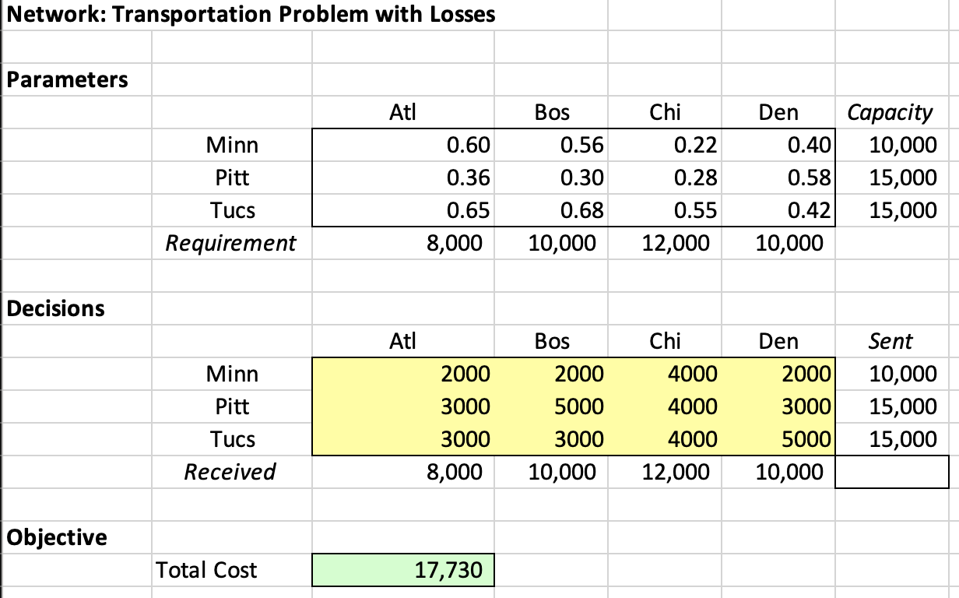

The previous solution for example 3.1 is:

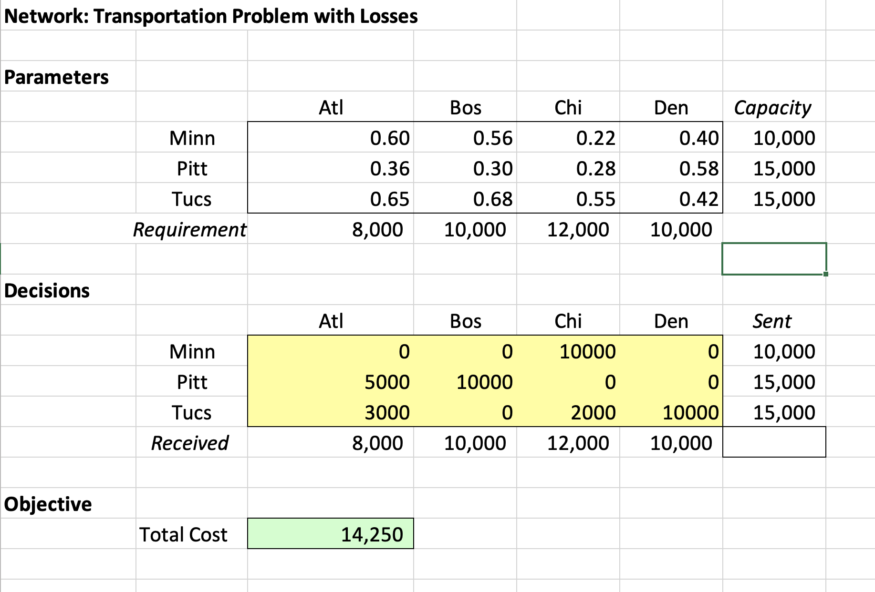

1. Increase = 17730-14250 = 3480$
2. Alter quantities = $\sum_{p=M,P,T;d=A,B,C,D}{s_{p,d}}-\sum_{p=M,P,T;d=A,B,C,D}{Min\left({old}_{p,d},{new}_{p,d}\right)} =$ 10000+15000+15000-(0+0+4000+0)-(3000+5000+0+0)-(3000+0+2000+5000) =

40000-4000-8000-10000=18000