BUDT732 – Individual Assignment 3

**Question 3.2:**

Decision variables:

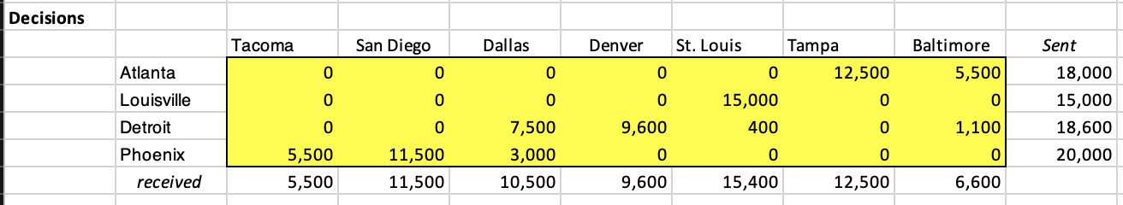

The decision variables are security lock’s amount allocated to wholesale distributor through each route, connecting each plant and wholesale distributor.

The objective function, the same as example, is:

$$Total Cost= \sum_{p=A,L,D,P;d=Tac,San,Dal,Den,St,Tam,B}{{(c}_{p,d}+C_{p})s_{p,d}}$$

$$where c represents unit shipping cost, s represents shipping amounts, C production cost,$$

$$and \left(p,d\right) combined to represent route from p\left(plant\right) to d(distributor)$$

Shows in excel as:

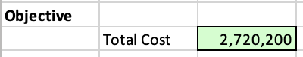

Constraints:

1. Each plant’s supply cannot over than its capacity.
2. Each distributor’s received shouldn’t over than its demand.
3. Decision variables non-negative, as always.

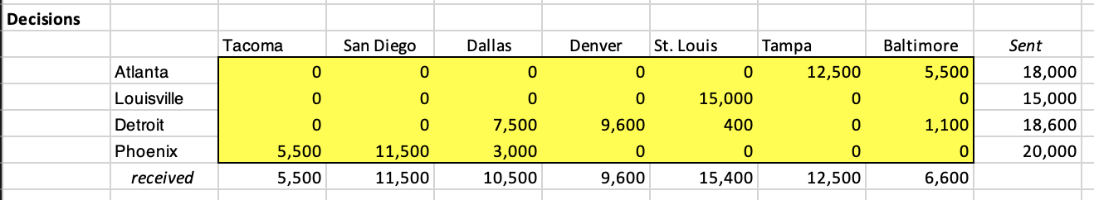

And solver result is:

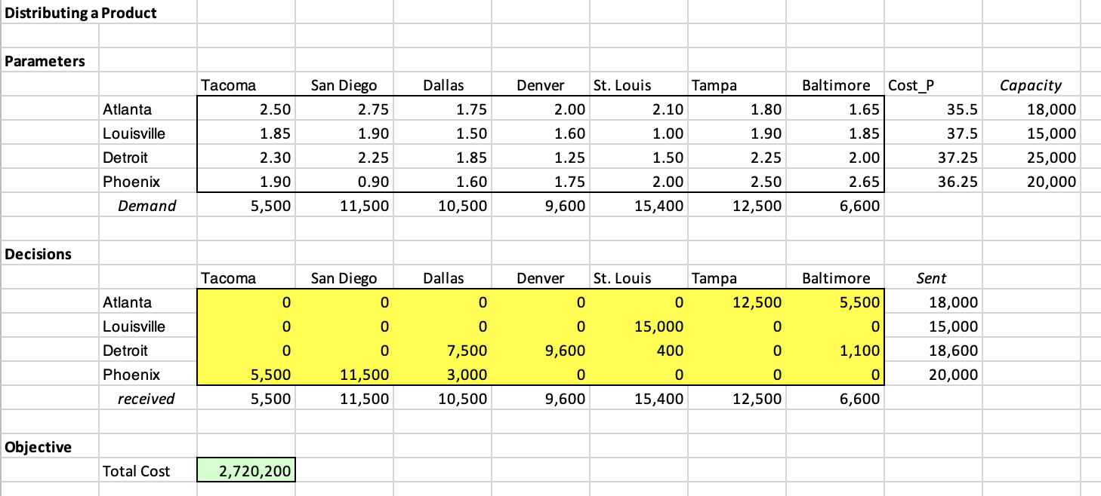

1. See above.

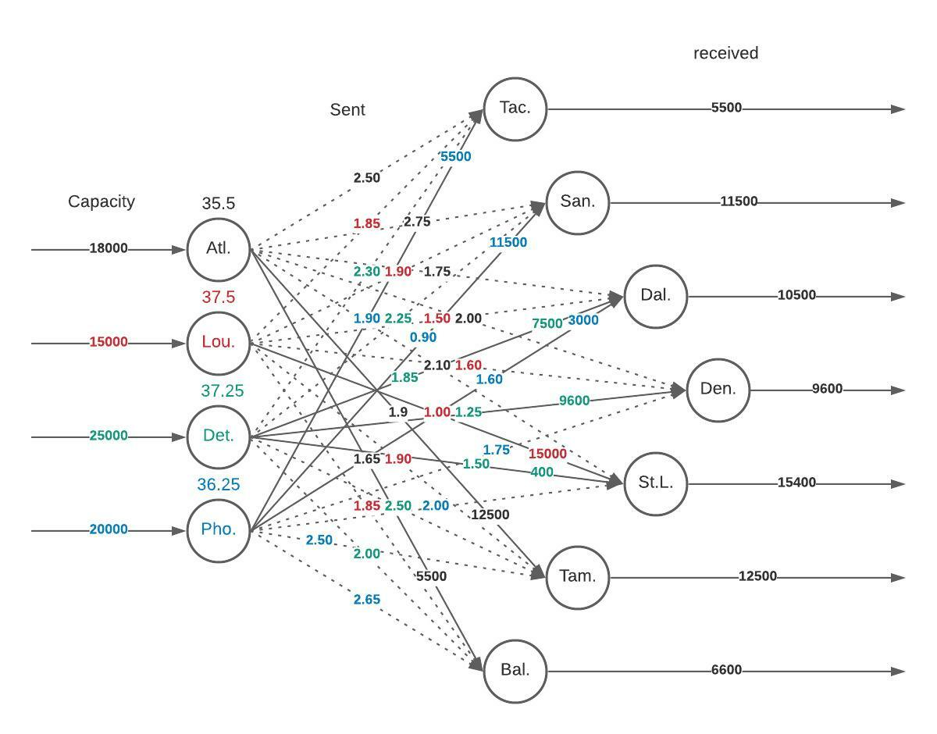

In order to distinguish, I use color to represent plants, dots to non-used routes and lines to used routes with shipping quantities marked.

1. The optimal distribution plan would remain the same in both situations, though the total cost goes up. Here is the reason:

Start from objective function:

$$Total Cost= \sum_{p=A,L,D,P;d=Tac,San,Dal,Den,St,Tam,B}{{(c}_{p,d}+C_{p})s_{p,d}}$$

$$Total Cost= \sum_{p=A,L,D,P;d=Tac,San,Dal,Den,St,Tam,B}{{(c}_{p,d}+C_{p})s_{p,d} (c_{p,d}=0)}$$

$$= \sum_{p=A,L,D,P;d=Tac,San,Dal,Den,St,Tam,B}{C_{p}s_{p,d}}=C_{p} \sum{s}$$

As total shipping amounts always equal to total demands, given the unit cost increase at each plant, the total cost increase a constant amount, regardless of the distribution plan. Thus, the optimal distribution plan would remain the same.