**BUDT 732: Decision Analytics**

Individual Assignment 4: Network Models

**Instructions:**

* Carefully read all the problems. Let me know if you have any questions.
* Complete the problems within this document and submit your answers in Canvas.
* Please type your answers in red font.

Please note that you need to submit the spreadsheet models for full credit. The Excel file must include the problem spreadsheet model and Excel Solver Reports. One Excel file per problem.

**Problems:**

Chapter 3 Problem 3.5 (Re-positioning Supply), Problem 3.7 (Distributing Oil), and Problem 3.8 (Cash Planning). **Refer to the other file in the assignment on canvas for the full pictures of the problems in the textbook.**

Type your answers below.

Problem 3.5 (Re-positioning Supply)

LP Model: Formulate a linear programming problem for the problem. Provide the algebraic formulation of the model. Clearly identify the decision variables, the objective function and constraints. Do not solve.

Decision variables:

In this re-positioning supply problem, all of the 8 outlets can be both start point and destination, so the decision variables should be the number of cars re-positioning from one outlet to another, marked as .

Note:

Re-positioning from one outlet to itself is not meaningful. But if we define its cost to be greater than 0, in the optimal solution the number of self-re-positioning is always 0, as it can be avoided with no effect to the result, and then I keep it to make the table complete.

The objective function:

The constraints are:

1. After re-positioning, cars distribution in outlets should meet the specific “target” percentage policy.

2. Shipping amount non-negative.

a. Given the distribution of cars, find a schedule for minimizing the total distance traveled during the overnight redistribution of the cars.

Answer:

Optimal schedule: Ship 3 from outlet 2 to outlet 3; ship 1 from outlet 2 to outlet 6; ship 12 from outlet 4 to outlet 6; ship 12 from outlet 5 to outlet 3; ship 5 from outlet 7 to outlet 1; ship 11 from outlet 8 to outlet 1; remaining cars do not need to redistribution, and remain in previous outlets.

With minimum cost as: 160

b. Show the network diagram corresponding to the solution in **(a)**. That is, label each of the arcs in the solution and verify that the flows are consistent with the given information. (**Note:** Please DO NOT turn in any jpg files. If you write the answer out by hand, make sure you paste a picture of the answer below)

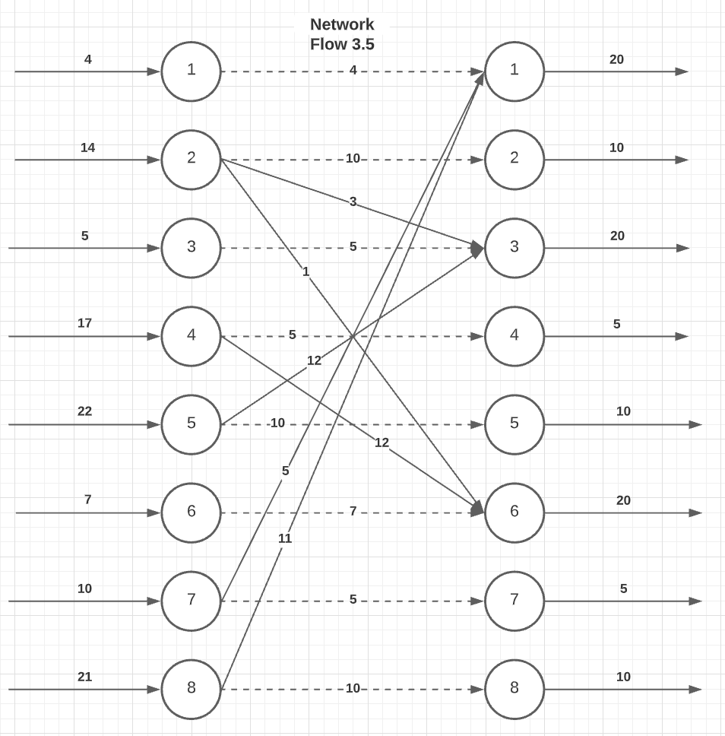Excel ScreenshotsL Paste below a screenshot of your spreadsheet model and Excel Solver Reports. You must also include the Excel file for full credit (10 points off if not attached). Use formatting (labels, colors, borders) to enhance the readability of your models.

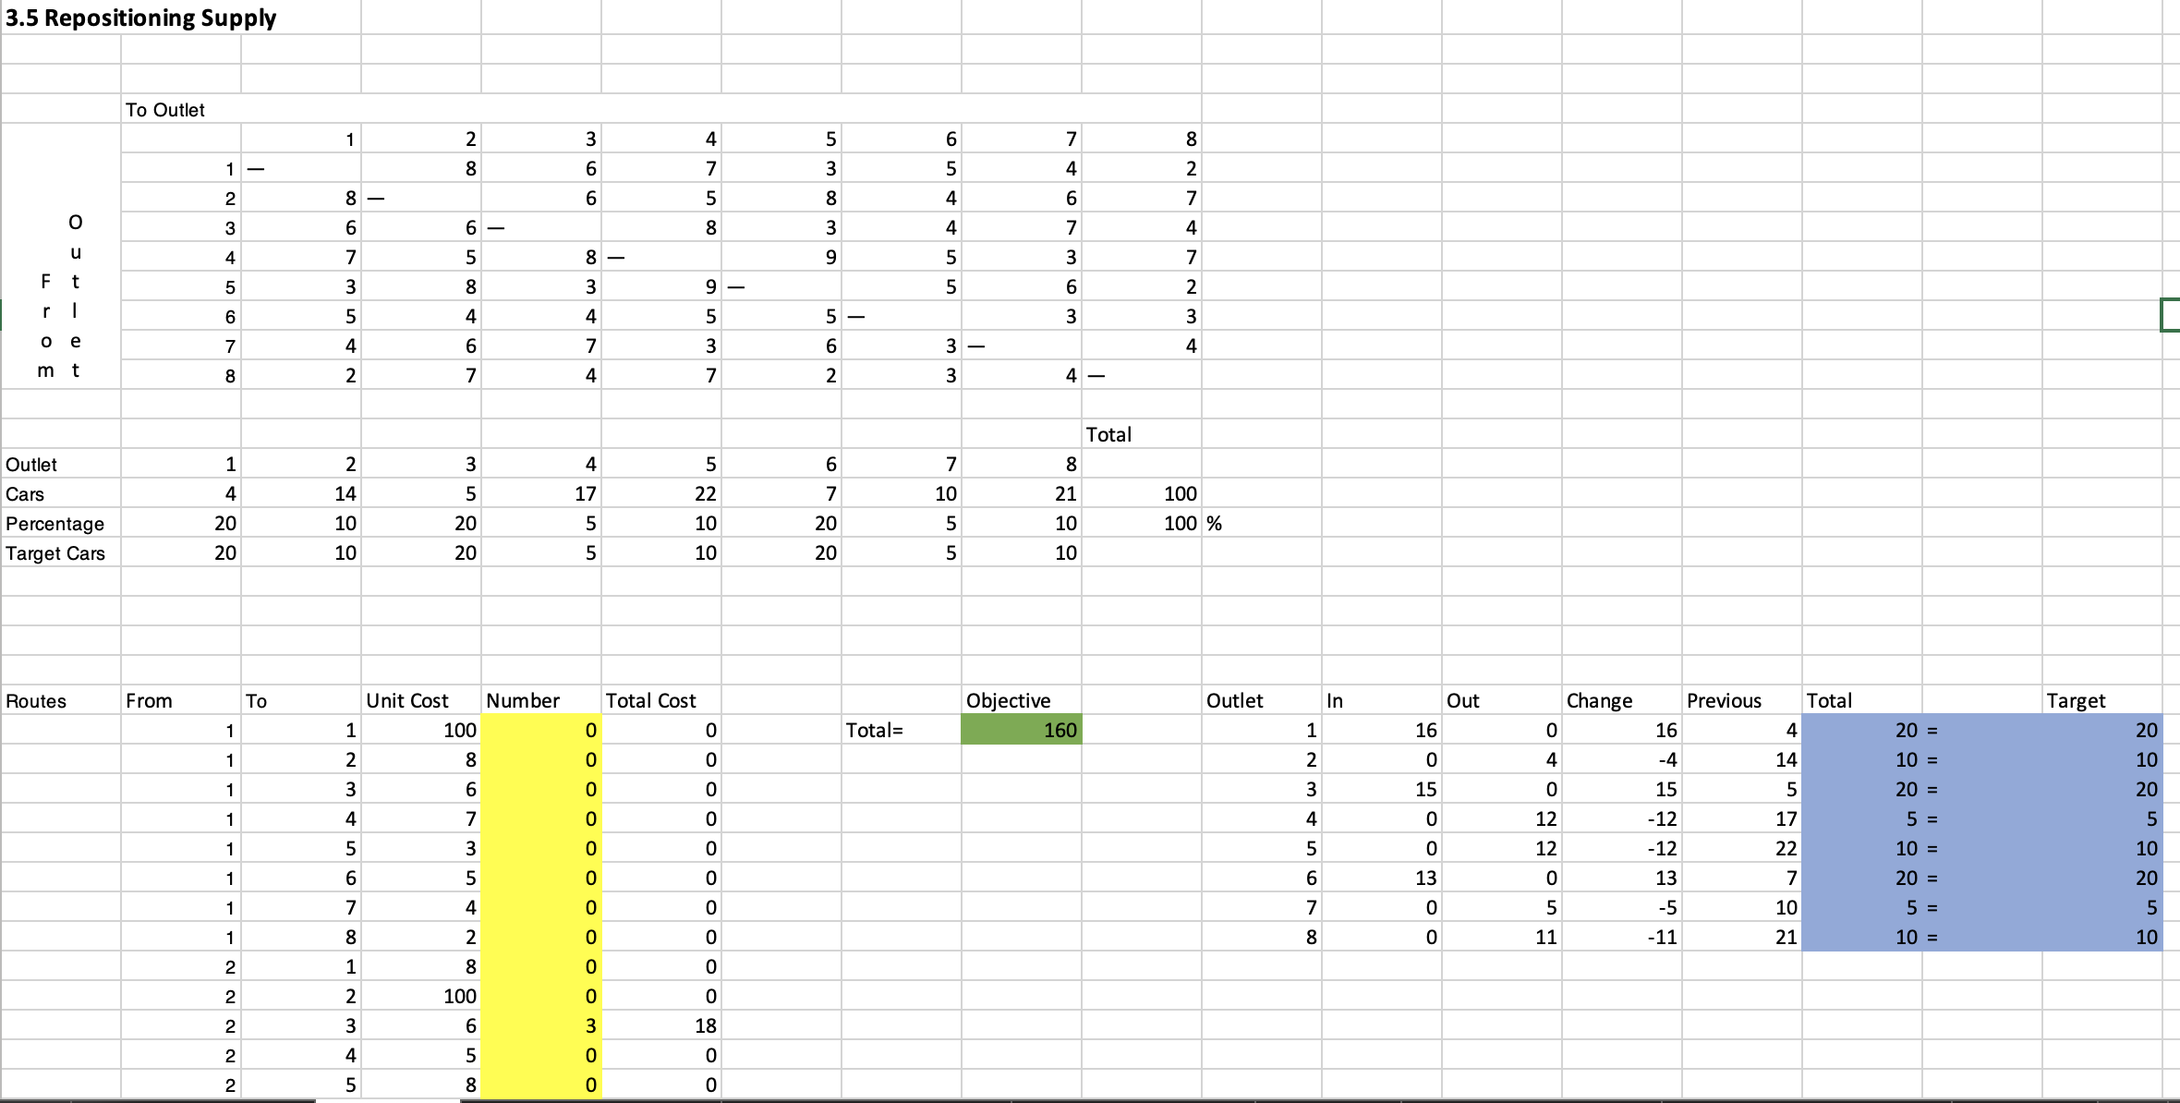

Above is excel for question 3.5. Decision variables are colored in yellow, constraints in blue and objective function in green.

Answer report is here:

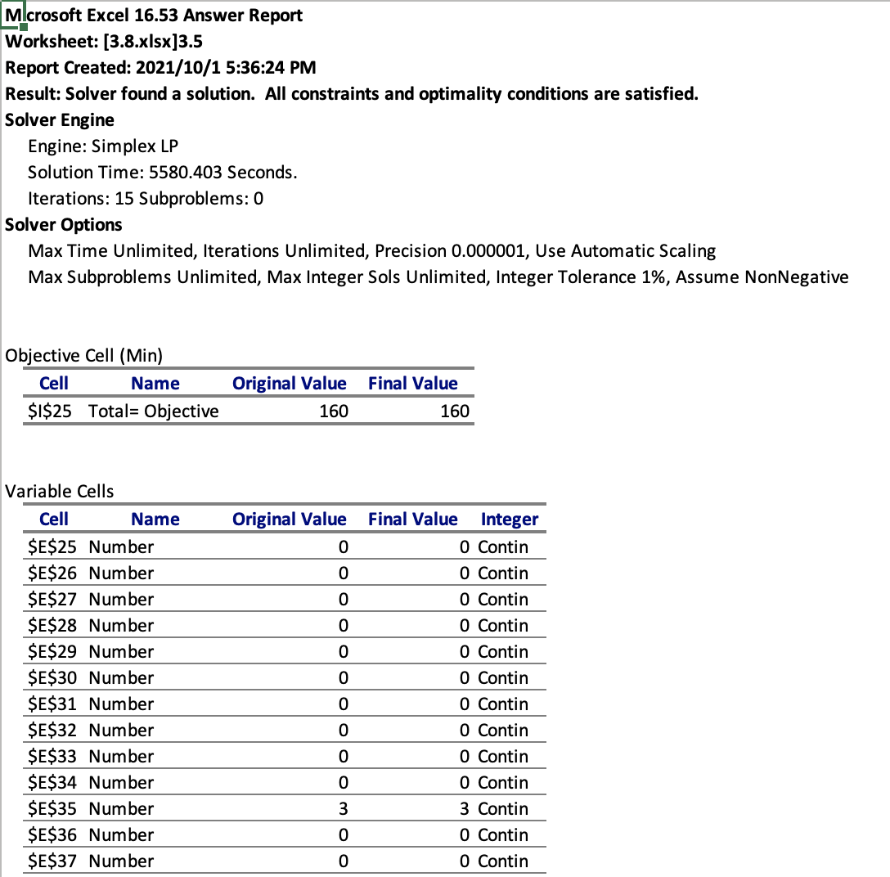

It’s just part of it, because the number of decision variables is large. You can see details in the excel file.

Problem 3.7 (Distributing Oil)

LP Model: Formulate a linear programming problem for the problem. Provide the algebraic formulation of the model. Clearly identify the decision variables, the objective function and constraints. Do not solve.

The distributing oil problem is a standard transshipment problem. Actually, I started from the Goodwin example. To simplify the representation, I mark well 1, 2, 3 as *1, 2, 3,* pump A, B, C as *A, B, C,* and refineries 1-5 as *4-8, and u*se *w* for Wells, *w ∈ {1, 2, 3},* and *p* for Pumps, *r* for Refineries correspondingly.

Decision variables:

The decision variables basically have two parts: oil flows from wells to pumps, marked as , and then oil flows from pumps to refineries, marked as .

The objective function:

The constraints are:

1. Flow in and flow out in each pump should be the same, colored in blue in excel.
2. Flow out from each well cannot be more than its capacity.
3. Flow in of each refinery should meet its demand.
4. Decision variables non-negative.

a. What is the minimum cost of providing oil to the refineries? Which wells are used to capacity in the optimal schedule?

Answer:

The minimum cost of providing oil to the refineries is 1,963.82, under the situation that well 1 and 3 are used to capacity.

b. Show the network diagram corresponding to the solution in **(a)**. That is, label each of the arcs in the solution and verify that the flows are consistent with the given information. (**Note:** Please DO NOT turn in any jpg files. If you write the answer out by hand, make sure you paste a picture of the answer below)

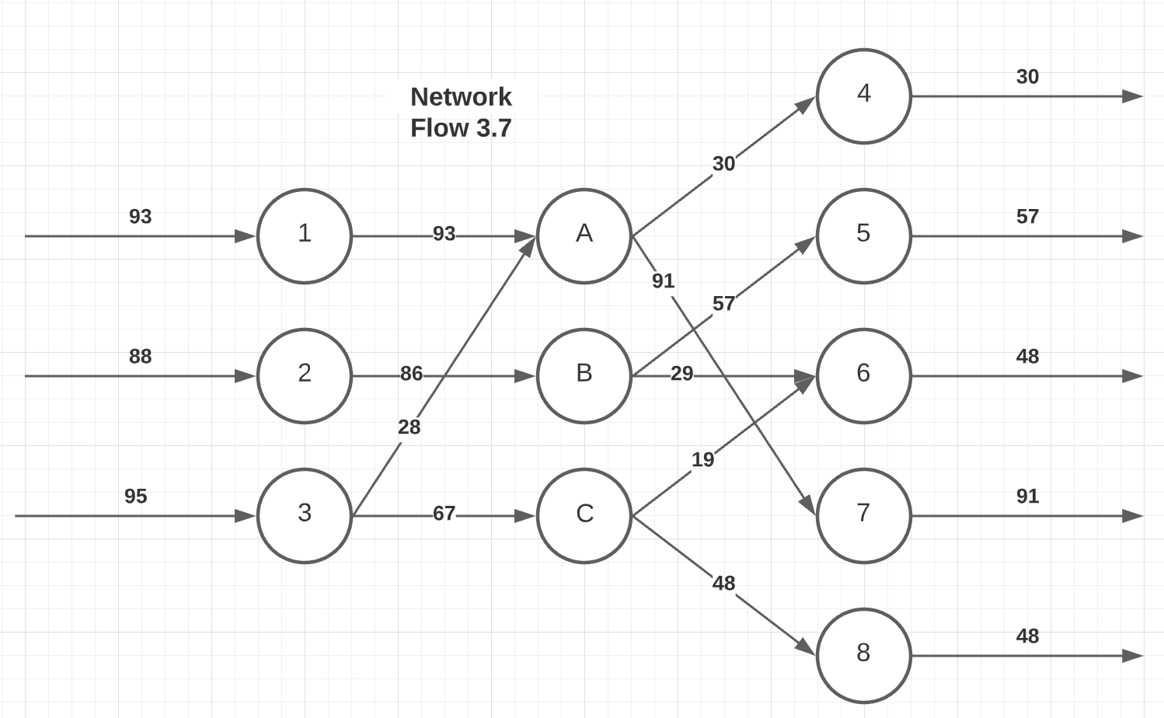 Excel Screenshot: Paste below a screenshot of your spreadsheet model and Excel Solver Reports. You must also include the Excel file for full credit (10 points off if not attached). Use formatting (labels, colors, borders) to enhance the readability of your models.

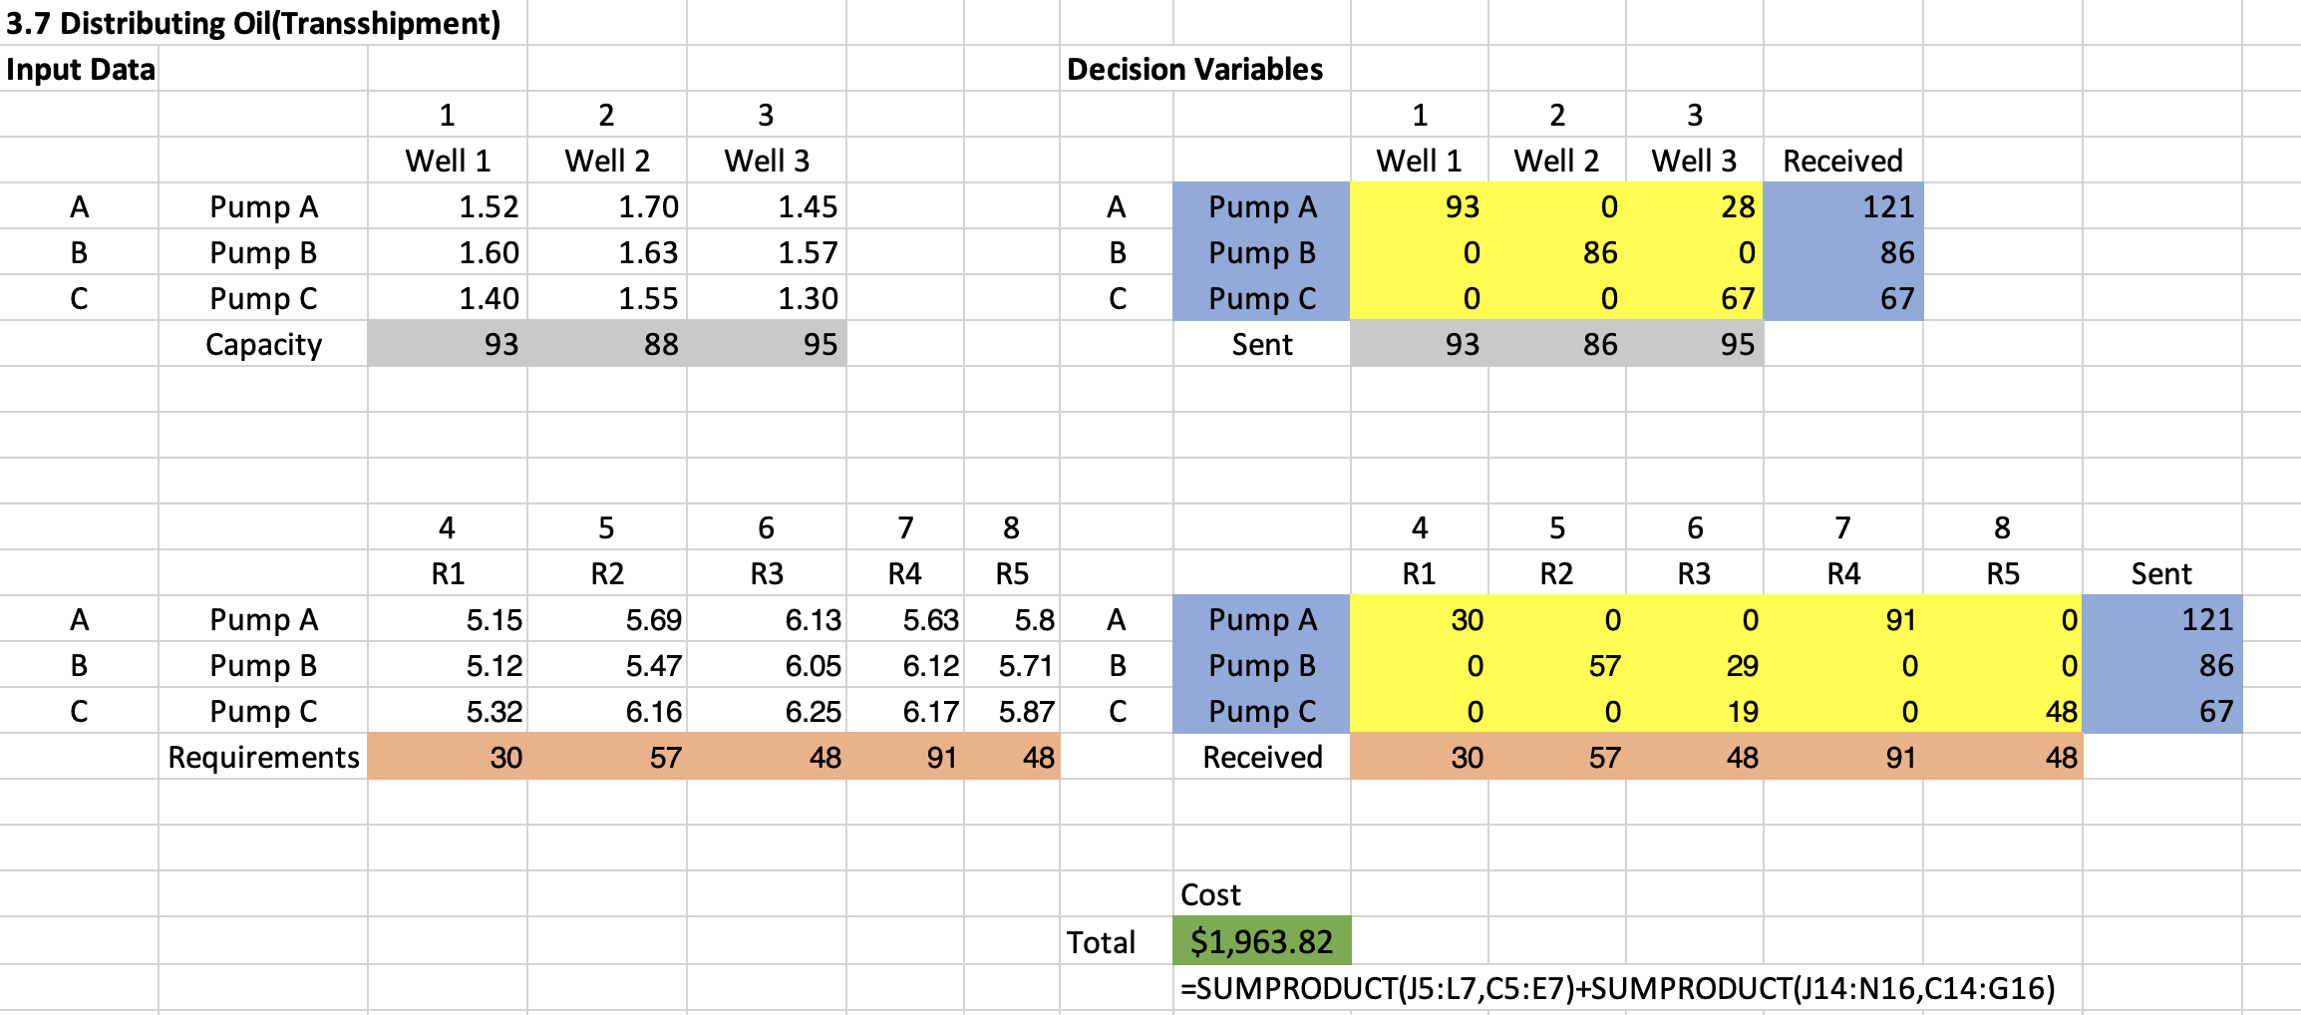

Specific meaning of colors is mentioned above. And the answer report is here:

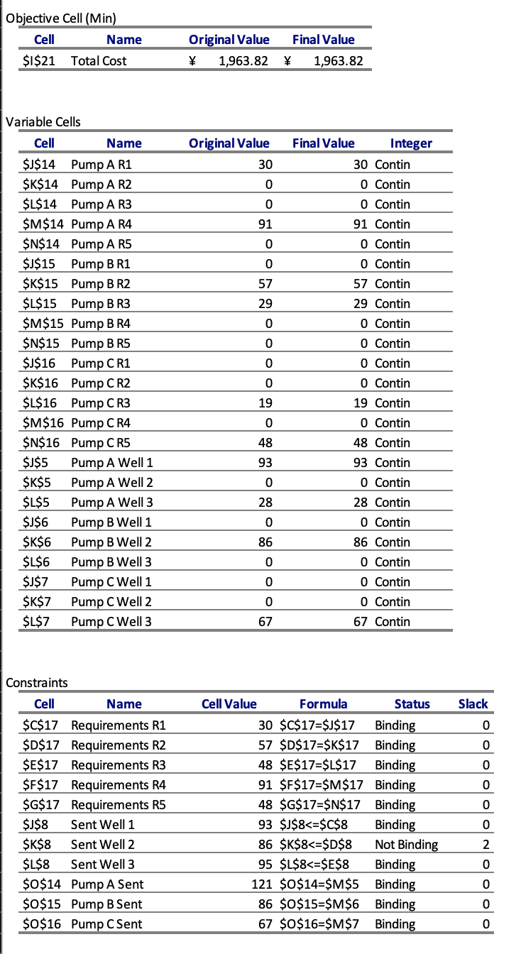

Problem 3.8 (Cash Planning)

LP Model: Formulate a linear programming problem for the problem. Provide the algebraic formulation of the model. Clearly identify the decision variables, the objective function and constraints. Do not solve.

In this cash planning problem, the most important thing is to figure out when will each cash flow takes into effect. Hint from Prof. actually provides a good vision and standard.

Decision variables:

The decision variables basically have three parts: the long-term loan amount in Jan., the short-term loan amount in each month, and investment amount in each month.

The objective function:

The objective function is the total amount of money in hand on May 1st. To be more specific, it includes cash flow in April, cash in hand in the start of April, minus extra expense like payment of loan and loan interest.

The constraints are:

1. Total amount of money remain should be non-negative.
2. Long-term loan in Jan. cannot be more than 400k$.
3. Short-term loan in each month cannot be more than 300k$.
4. Decision variables non-negative.

a. What is the maximum amount that can be returned to investors? What is the optimal amount of money to borrow from each of the potential loan sources?

Answer:

The maximum amount that can be returned to investors is 133.44k$. To get it, we loan 400k$ from long-term loan in Jan.; put 250$ of the loaned cash into investment, then take it back and loan 202.25$ from short-term loan in Feb.; in March we loan 208.68k$ from short-term loan; in April we loan 115.18k$ from short-term loan.

b. Show the network diagram corresponding to the solution in **(a)**. That is, label each of the arcs in the solution and verify that the flows are consistent with the given information. (**Note:** Please DO NOT turn in any jpg files. If you write the answer out by hand, make sure you paste a picture of the answer below)

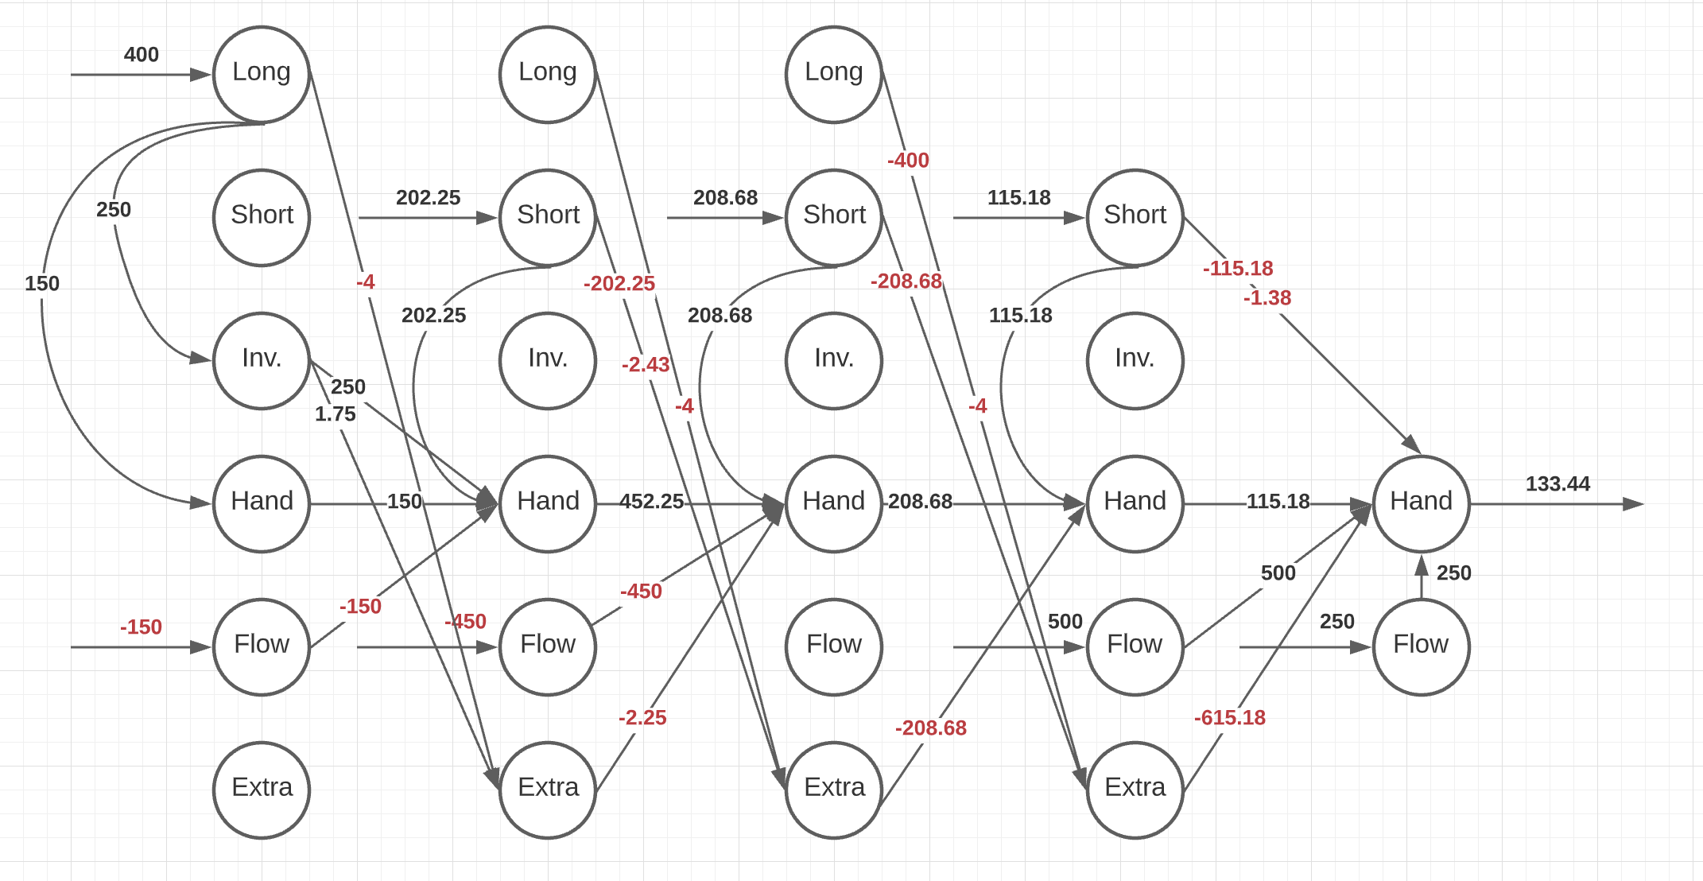 c. Explain the cost of funds for each month in the planning period. That is, if there were a $1000 change in the cash flows for any month, what would be the dollar change in the amount returned to investors?

Basically, from the graph and optimized table, we see that we first come to long-term loan, and then use monthly short-term loan to cover cash deficit. April 1st is the payment day of long-term loan, and if we still in deficit and need short-term loan, we’d always consider full use of long-term loan at the beginning. Therefore, if the change of total cash flow is under 115.18 by the first four months, the basic strategy: loan 400k$ long-term loan, put surplus to investment and use short-term to cover shortage doesn’t change.

Specifically, increase one unit (1000$) cash flow in Jan. brings 1.04 unit more, while decrease cost 1.05 unit more. In Feb. it’s 1.03 and 1.04. In March it’s 1.01 and 1.02. In April it’s 1 for all.

Excel Screenshots: Paste below a screenshot of your spreadsheet model and Excel Solver Reports. You must also include the Excel file for full credit (10 points off if not attached). Use formatting (labels, colors, borders) to enhance the readability of your models.

