**BUDT 732: Decision Analytics**

Individual Assignment 5: Introduction to Integer Optimization

**Instructions:**

* Carefully read all the problems. Let me know if you have any questions.
* Complete the problems within this document and submit your answers in Canvas.
* Please type your answers in red font.

Please note that you need to submit the spreadsheet models for full credit. The Excel file must include the problem spreadsheet model and Excel Solver Reports. One Excel file per problem.

Label your files in this format:

For Word: 732IA#_Word_LastName_FirstName.doc/docx

For Excel: 732IA#_Excel_LastName_FirstName.xlsx

**Problems:**

Chapter 6 Problem 6.5 (Choosing R&D Projects), Problem 6.7 (Reservation Scheduling). **Refer to the other file in the assignment on canvas for the full pictures of the problems in the textbook.**

Type your answers below.

Problem 6.5 (Choosing R&D Projects)

LP Model: Formulate a linear programming problem for the problem. Provide the algebraic formulation of the model. Clearly identify the decision variables, the objective function and constraints. It is acceptable to use short notation and/or brief statements to represent the formulation of the problem. Do not solve.

Decision variables:

In this Choosing R&D Projects problem, for the 8 projects available, we need to decide which to choose, marked as $x_{i}, i[1, 8]$, and use $x_{i}=1$ to represent project *I* is selected, $x_{i}=0$ otherwise.

The objective function:

$$Total Cost= \sum_{i}{x_{i}p_{i}}$$

$$where p_{i} represents profit of project i, in \left(\$000\right), and i[1, 8]$$

The constraints are:

1. Expense, as Total Expense = $\sum_{i}{x_{i}e_{i}}$, cannot be over than the budget ($300000)
2. Scientists Required, as Total Scientists = $\sum_{i}{x_{i}s_{i}}$, cannot be over than the number of available scientists (40)
3. Decision variables binary (0 or 1) and non-negative.

a. What is the maximum profit, and which projects should be selected?

Answer:

Optimal Selection: Project 2& 5& 6

With Maximum Profit as: 199 ($000)

b. Suppose that projects 2 and 5 are mutually exclusive. That is, TEC should not undertake both. As a result, what is the revised project portfolio and the revised maximum profit?

Answer:

Under the current situation, there’s an extra constraint as:

$x_{2}+x_{5}≤1$

Thus, the new Optimal Selection: Project 1& 2& 3& 7

With Maximum Profit as: 195 ($000)

c. In addition, suppose that projects 5-8 involve consumer products and that management decides to undertake at least two of those. As a result, what is the revised project portfolio and the revised maximum profit?

Answer:

Under the current situation, there’s an extra constraint as:

$x_{5}+x_{6}+x_{7}+x_{8}≥2$

Thus, the new Optimal Selection: Project 2& 6& 7

With Maximum Profit as: 191 ($000)

Excel ScreenshotsL Paste below a screenshot of your spreadsheet model and Excel Solver Reports. You must also include the Excel file for full credit (10 points off if not attached). Use formatting (labels, colors, borders) to enhance the readability of your models.

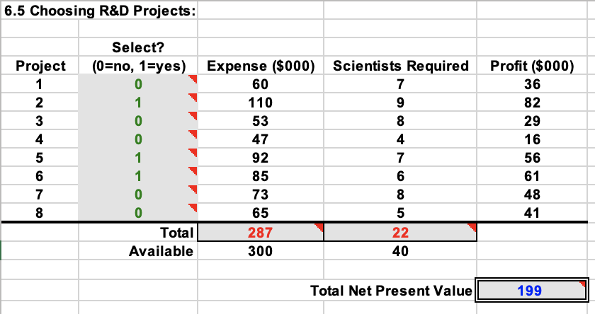

Question(a)

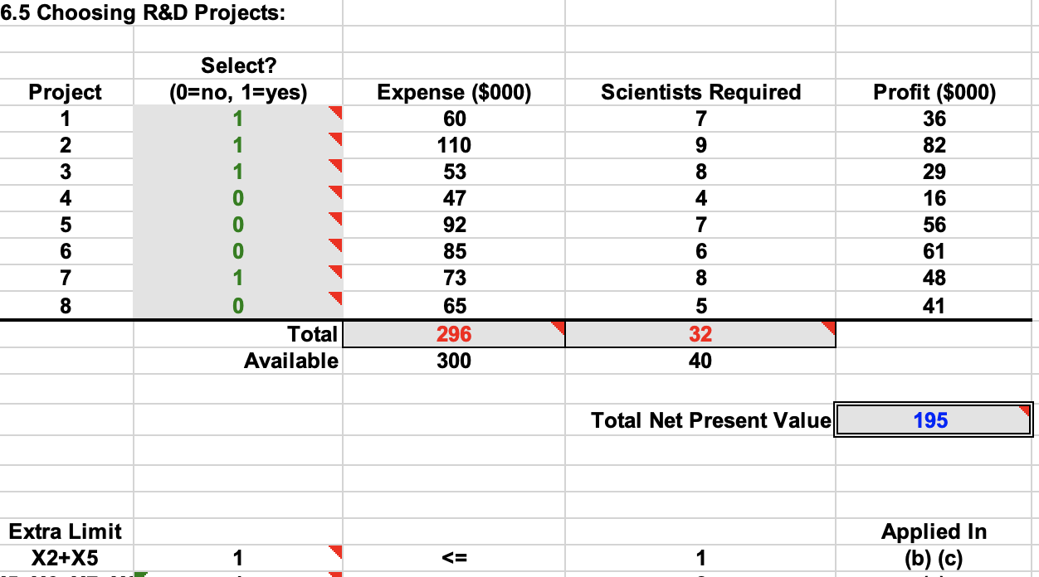

Question(b)

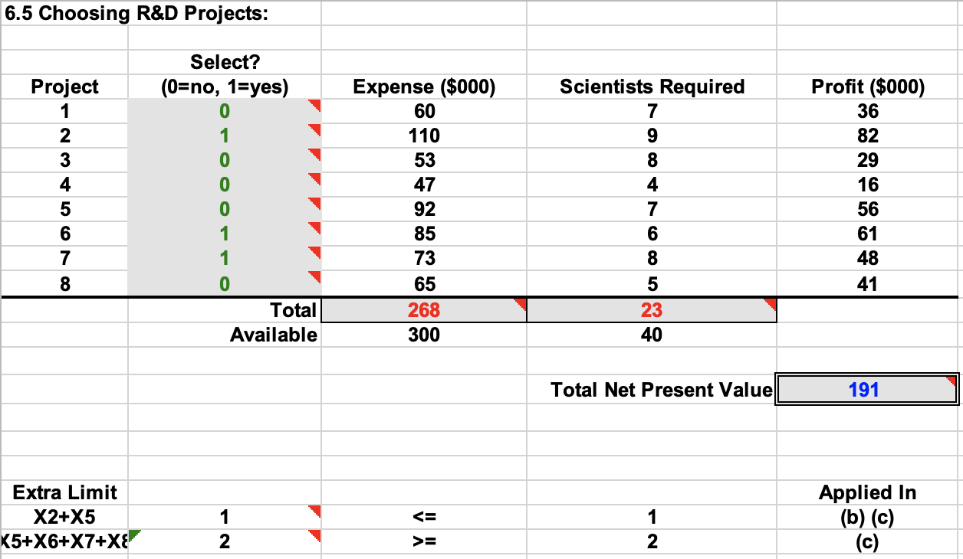

Question(c)

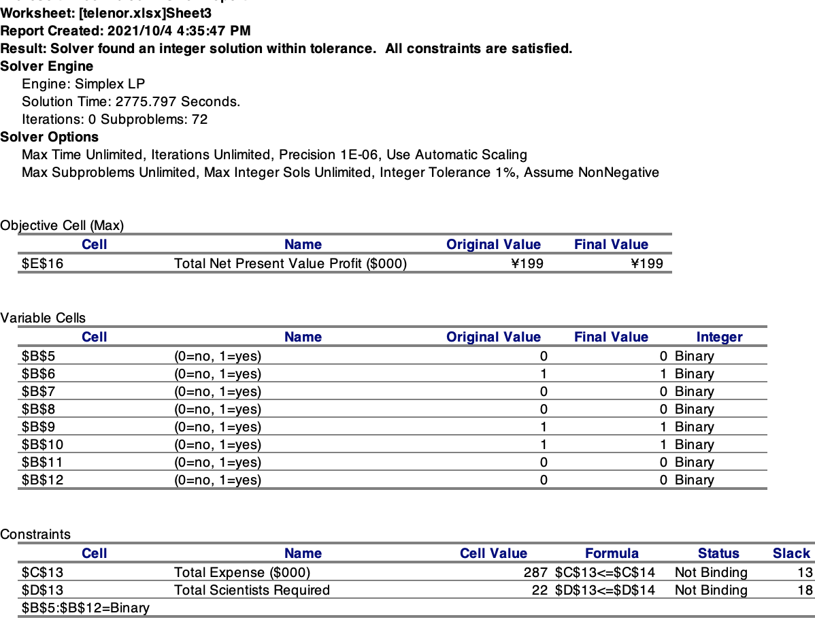

Solver Answer Reports for (a), it reports multi-selection error and thus I cannot export other answer report. I don’t know what happened, sorry for that. But for (b) and (c), the reports are actually similar.

Problem 6.7 (Reservation Scheduling)

LP Model: Formulate a linear programming problem for the problem. Provide the algebraic formulation of the model. Clearly identify the decision variables, the objective function and constraints. It is acceptable to use short notation and/or brief statements to represent the formulation of the problem. Do not solve.

Decision variables:

In this Reservation Scheduling problem, what we need to decide is the allocation of the total available 10 SUVs. Specifically, for the SUVs allocate for each of 6 contracts, we mark them as $x_{i}, i[1, 6]$.

* Contract 1: FSSM
* Contract 2: FS
* Contract 3: FSS
* Contract 4: SS
* Contract 5: SSM
* Contract 6: Sunday

The objective function:

$$Total Revenue= \sum_{i}{x_{i}r_{i}}$$

$$where r_{i} represents rental cost for contract i, i[1, 6]$$

The constraints are:

1. For all the weekend days, FR& SA& SU& MO, Total Serviced D= $\sum_{i}{x_{i}s_{i,d}} (s_{i,d}=1$ to represent contract *i* need to use SUV on day *d*, $s_{i,d}=0$ otherwise), cannot be over than the number of available SUVs (10)
2. Each contract selected times cannot over than its customer demand.
3. Decision variables integer and non-negative.

a. What is the maximum revenue that can be generated from the list of orders?

Answer:

Maximum Revenue: 1019.40

b. In the optimal solution of **(a)**, what percentage of customer demand is satisfied?

Answer:

Customer Percentage: 63.158%

c. In the optimal solution of **(a)**, what percentage of dollar demand is satisfied?

Answer:

Dollar Percentage: 65.808%

d. Answer the set of three questions above for fleet sizes of 11-16

Answer:

This question can actually be manually solved: since there’s no available Sunday-only demand to come together with Saturday-only one, we can only serve one more demand, given one more capacity, and select the one with the largest revenue, we can get the answer.

Under the view of solver table, the change can be viewed as:

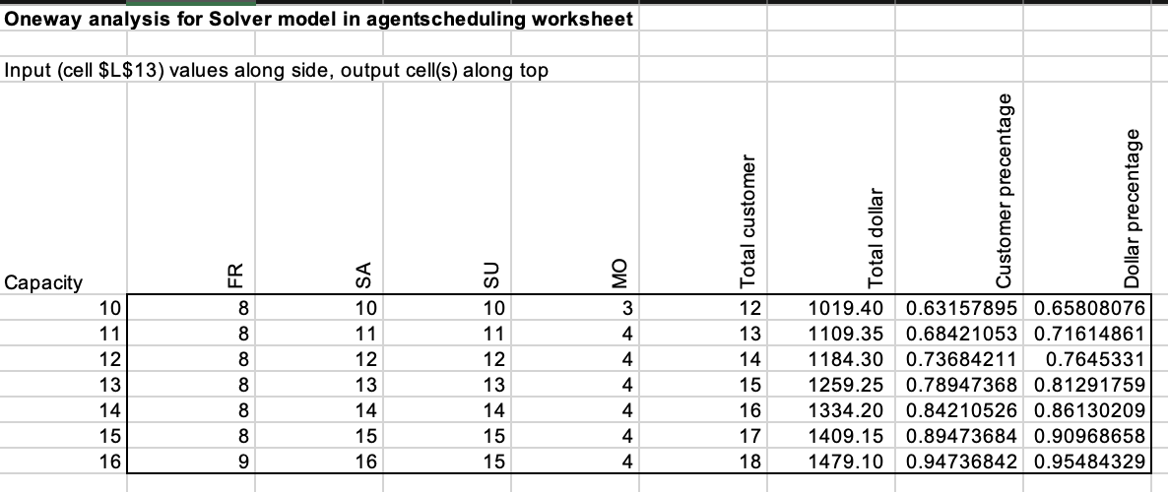

Excel Screenshot: Paste below a screenshot of your spreadsheet model and Excel Solver Reports. You must also include the Excel file for full credit (10 points off if not attached). Use formatting (labels, colors, borders) to enhance the readability of your models.

