**BUDT 732: Decision Analytics**

Individual Assignment 6: Commercial software

**Question 3.1** (introduced in class)**:**

Data implementation in CPLEX:

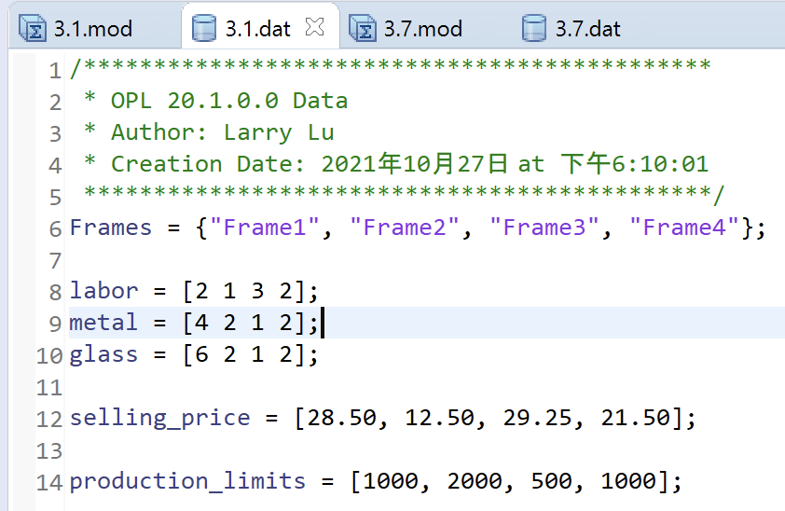

Modeling:

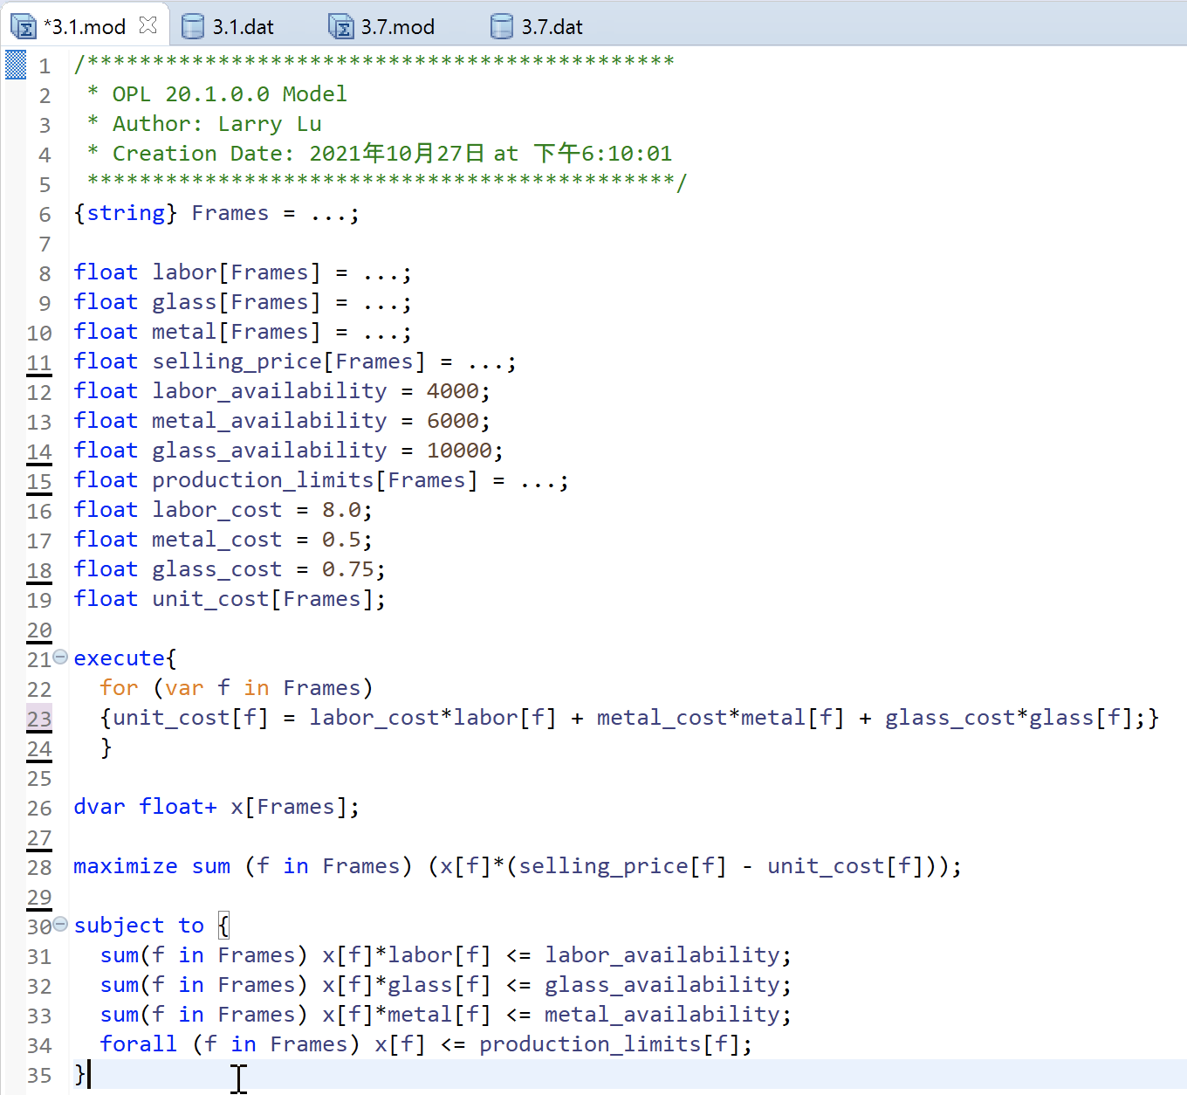

Optimal Solution:

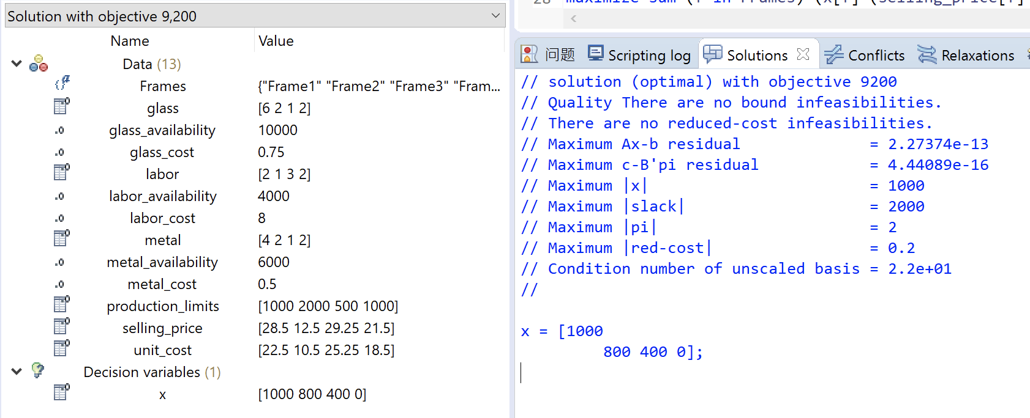

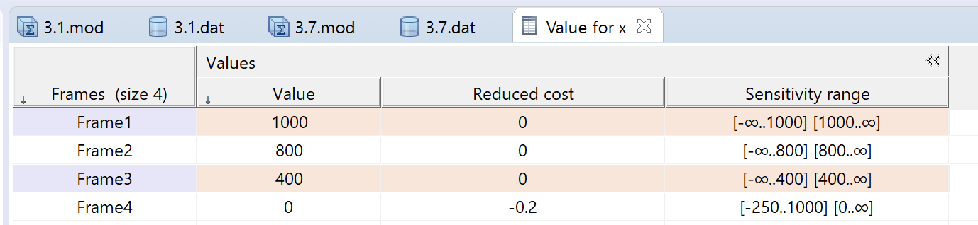

From the result table, we can see that CPLEX outputs the optimal solution as 9200, along with the optimal situation as Frames = [1000 800 400 0] for all the 4 frames.

**Question 3.7:**

In the selective question I select **Question 3.7** from Baker, not only because it’s one of our previous IA, but also, it’s a transshipment problem, involving two-dimensional attributes, and it’s a good practice.

Here I copied and pasted question modeling from IA4, since there’s no need to introduce it one more time. Rather, I focused on the implementation through OPL-CPLEX:

The distributing oil problem is a standard transshipment problem. Actually, I started from the Goodwin example. To simplify the representation, I mark well 1, 2, 3 as *1, 2, 3,* pump A, B, C as *A, B, C,* and refineries 1-5 as *4-8, and u*se *w* for Wells, *w ∈ {1, 2, 3},* and *p* for Pumps, *r* for Refineries correspondingly.

**Decision variables**:

The decision variables basically have two parts: oil flows from wells to pumps, marked as , and then oil flows from pumps to refineries, marked as .

The **objective** **function**:

The **constraints** are:

1. Flow in and flow out in each pump should be the same, colored in blue in excel.
2. Flow out from each well cannot be more than its capacity.
3. Flow in of each refinery should meet its demand.
4. Decision variables non-negative.

Here is the network flow, reflecting the optimal solution from Excel:

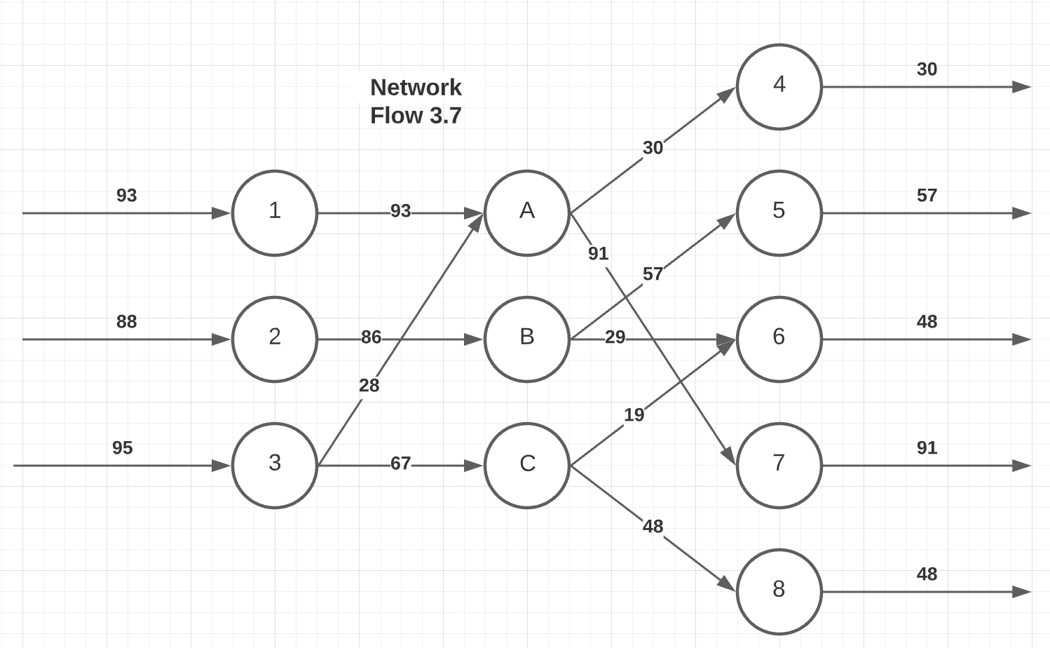

Data implementation in Cplex:

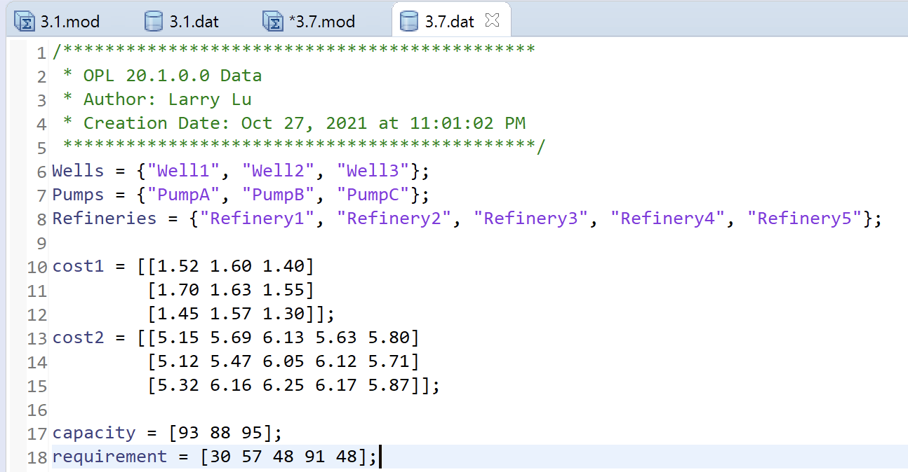

Modeling:

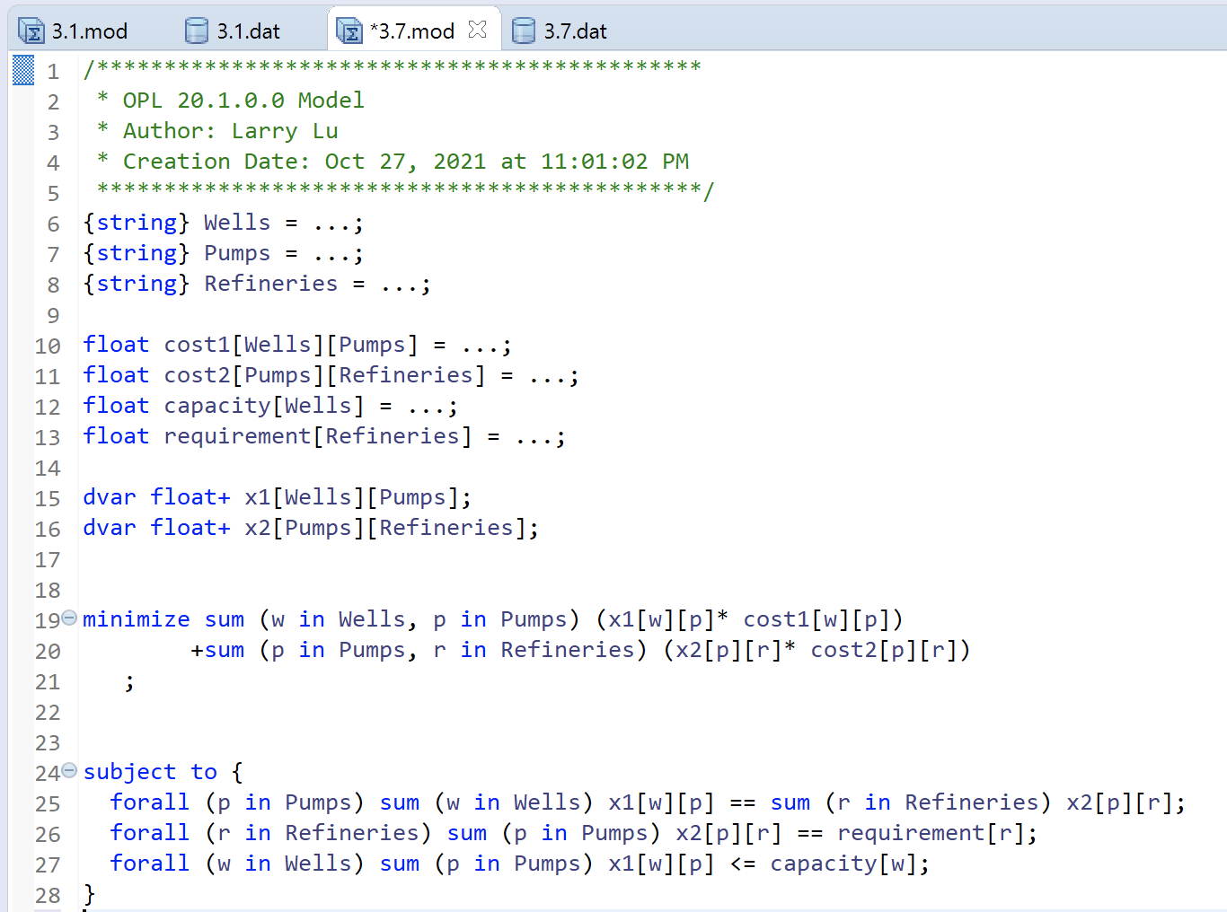

Optimal Solution:

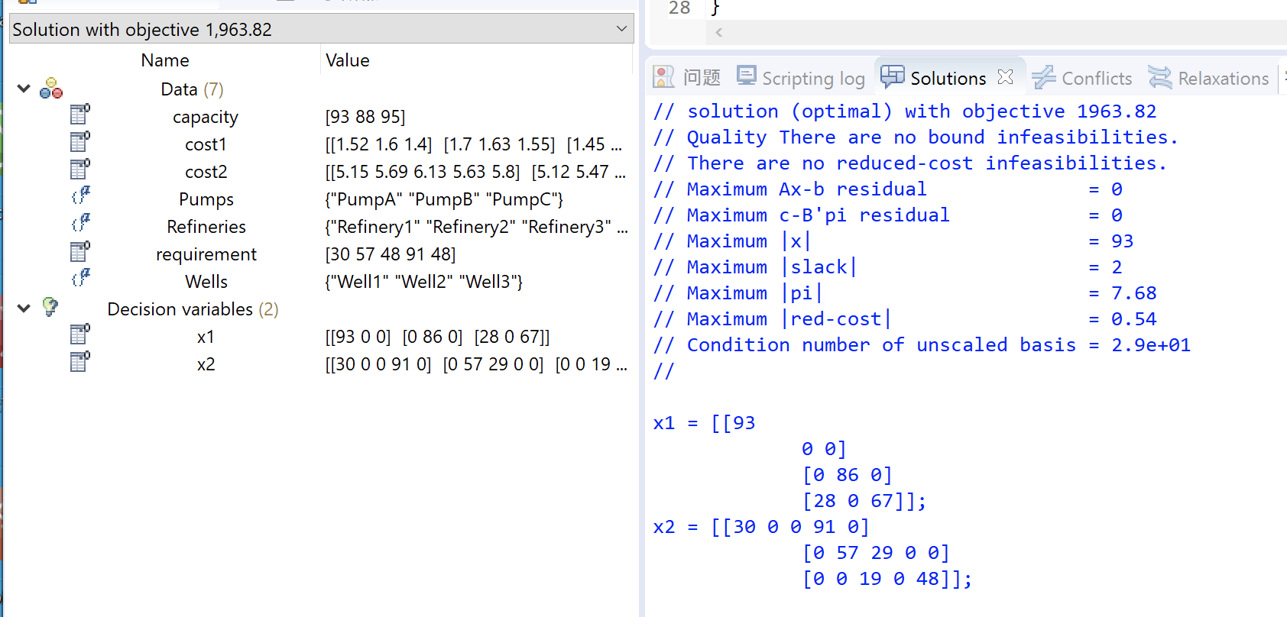

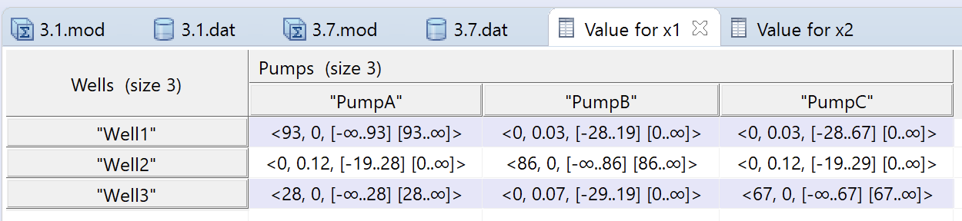

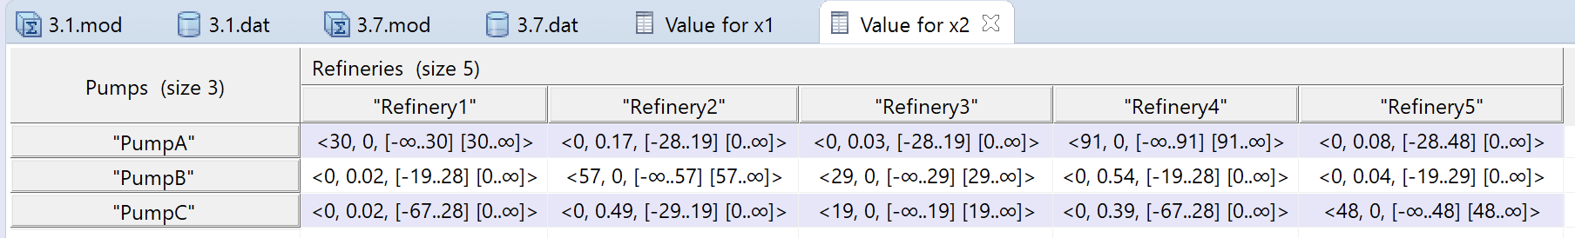

From the result table, we can see that CPLEX outputs the optimal solution as 1963.82, same as EXCEL’s, along with the same optimal situation.