BUDT732 – Individual Assignment 7

Since all the 3 questions are from previous IAs, and we are not required to show the formulation, network, etc., here I just put results from CPLEX, and discuss the differences with EXCEL solutions, if any.

**Question 2.2:**

Data file:

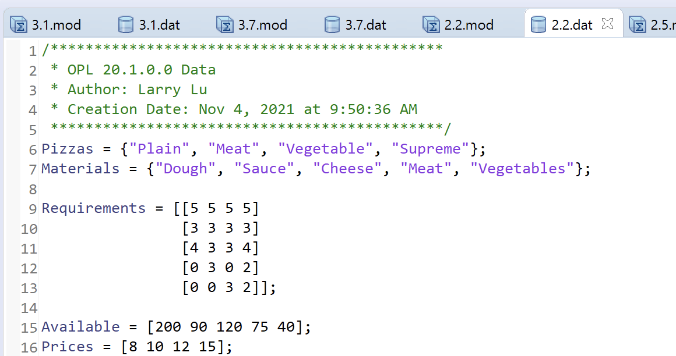

Model:

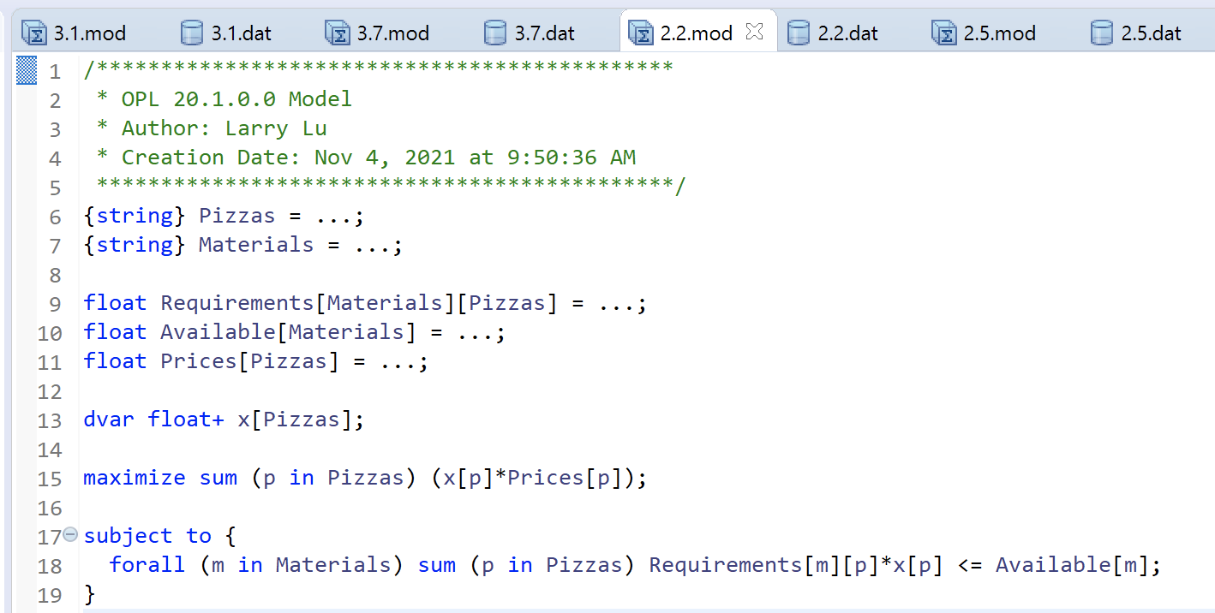

Result:

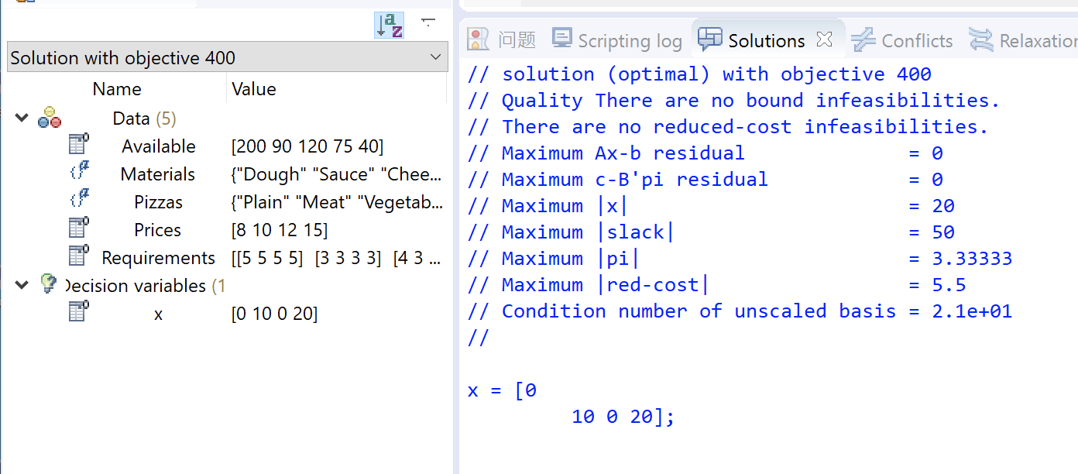

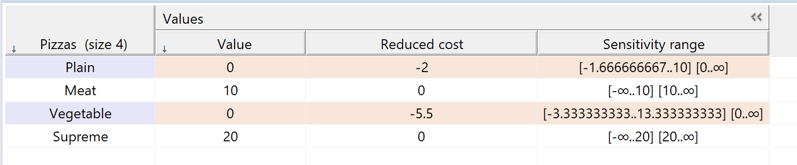

**Optimal solution and situation are same as EXCEL result.**

**Question 2.5:**

Data file:

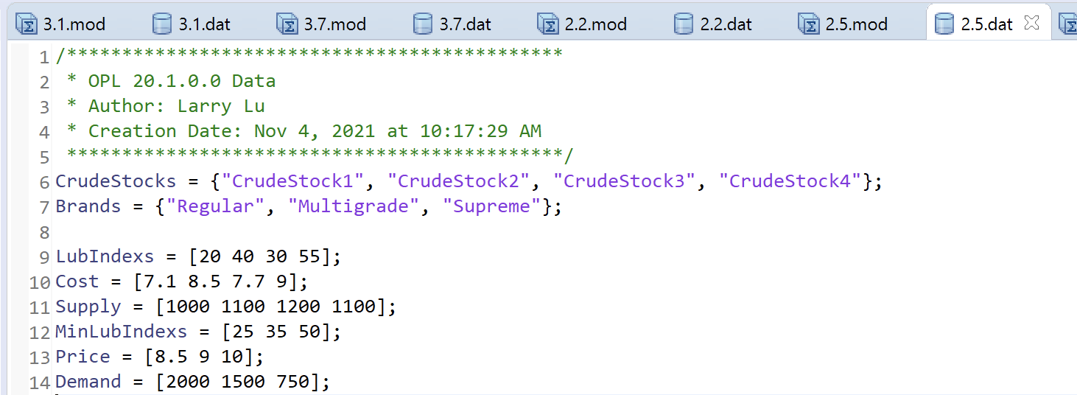

Model:

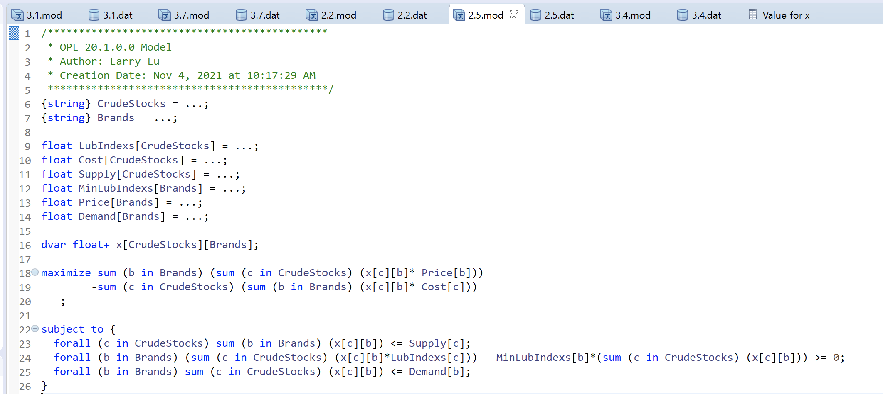

Result:

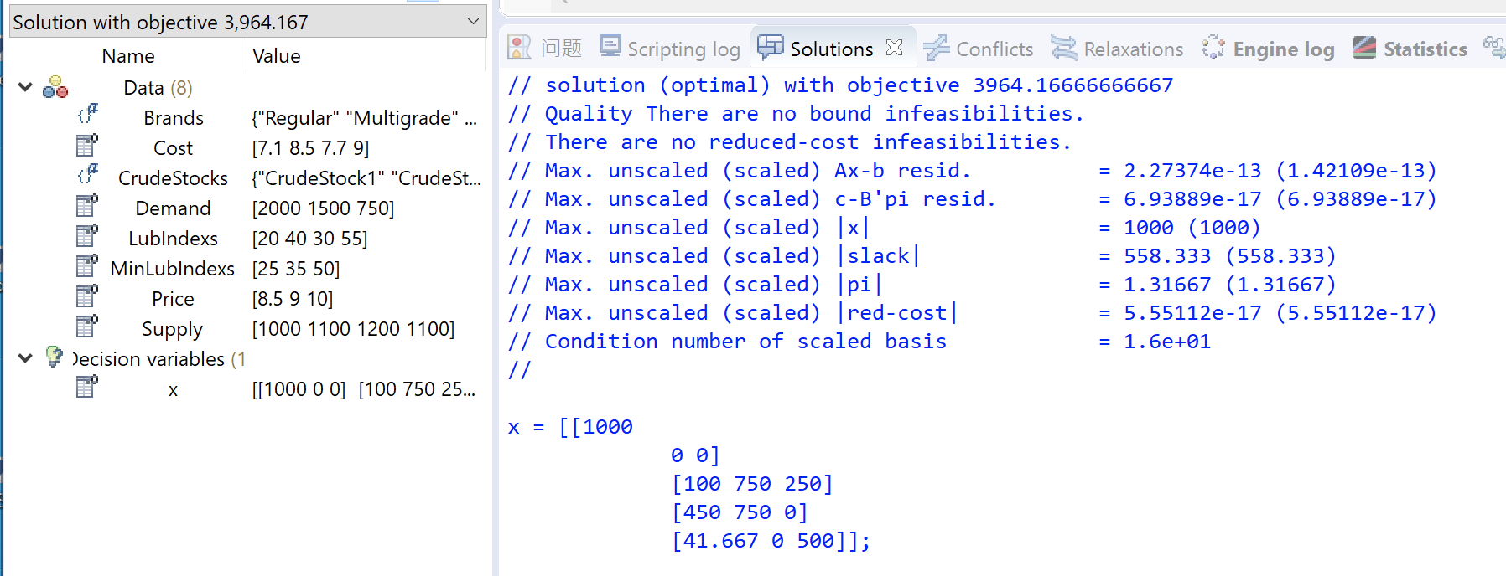

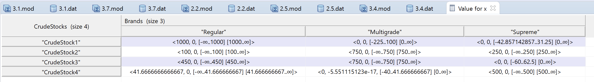

**Optimal solution is same but optimal situation is different. It’s because we can use combinations of crude stocks and get exactly the same mixture: i.e., c_1+c_3 = 2*c_2**

**Question 3.4:**

Data file:

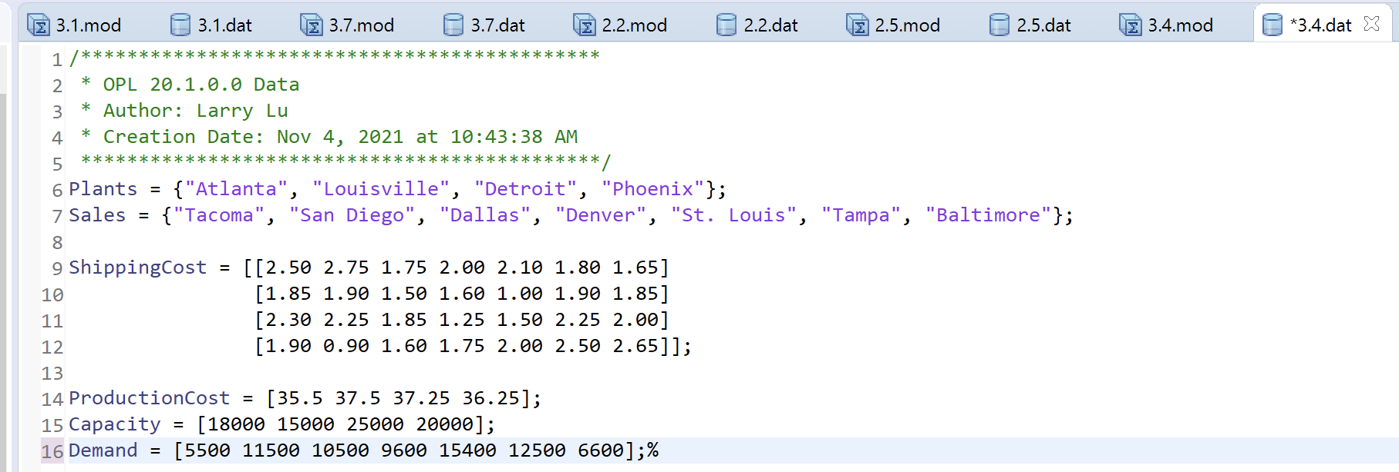

Model:

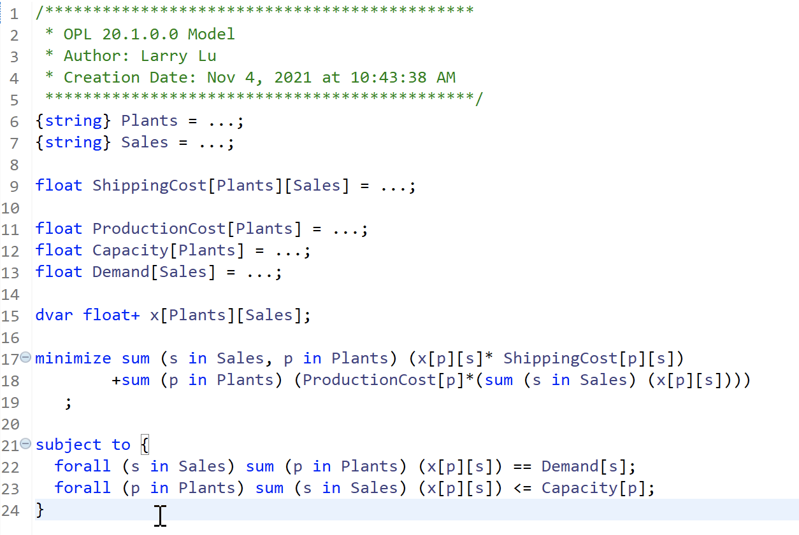

Result:

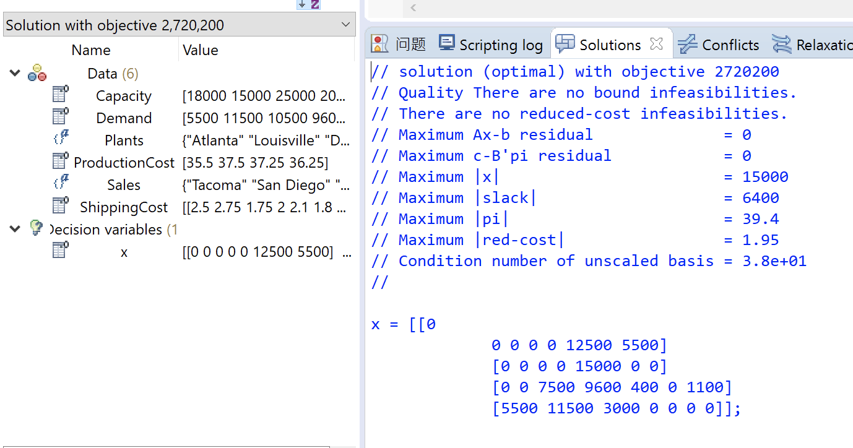

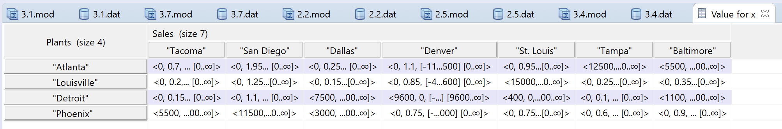

**Optimal solution and situation are same as EXCEL result.**