**BUDT 732: Decision Analytics**

Individual Assignment 8: Nonlinear Optimization

**Important Notes:**

* Prof. B. has provided additional information towards questions. But I’ve already finished this IA before that, so, here I just accept those I think are necessary. As for others, I will color it red and leave my consideration behind.

**EOQ for Multiple Products (8.6)**

* Additional information:
* For 12,000 sq. ft limitation: total (sum) average space must be less than 12,000 sq. ft where the average space for each product is calculated by multiplying average order quantity for each product (EOQ/2) times space.
* For 65 orders: total (sum) number of orders must be less than 65. Do not round the order numbers. (Why can order be a non-integer? It doesn’t make sense at all. Rather, I set number of orders as decision variables and constraint them to be int to easily solve this problem)
* For economic value of more space: resolve the problem with 1000 extra sqft (13,000 sqft) and calculate by how much did the total cost change by sqft. When resolving the problem, you might need to change the starting solution to force Solver to get out of local optimal solution.

Decision variables:

In this EOQ problem, what we need to decide is the number of orders we use in order to satisfy the demand for each item, marked as $n_{i}, i\{1, 2, 3, 4\}$.

Note:

According to **HM-GM-AM-QM inequalities**, after we decide $n_{i},$ we should equally allocate demand quantity into $n_{i}$ orders to minimize the cost, for item *i*. Then, the quantity per order, as $q_{i}=\frac{d_{i}}{n_{i}}$, where $d_{i }$ is demand for item *I*, might become a fractional number. It just represents an average and in actual situation, part of the order would have one unit more than others.

Also, we are able to use the quantities per order as Decision variables and do the opposite. Through this method, however, we cannot make sure $n_{i}$ are integers, and RoundUp function brings error to GRG solver. That’s the reason why I choose the previous method.

The objective function:

$$Fixed Cost= \sum_{i}{f_{i}n_{i}}$$

$$Holding Cost= \sum_{i}{h_{i}q_{i}}$$

$$Purchase Cost= \sum_{i}{p_{i}d_{i}}$$

$$Total Cost= Fixed Cost+Holding Cost+Purchase Cost$$

$$where q_{i}=\frac{d_{i}}{n_{i}}, i\{1, 2, 3, 4\}$$

The common constraints for all questions are:

1. Number of order non-negative integer.

**Solution for questions:**

1. We do not have space constraint here, and answer table from solve result is:

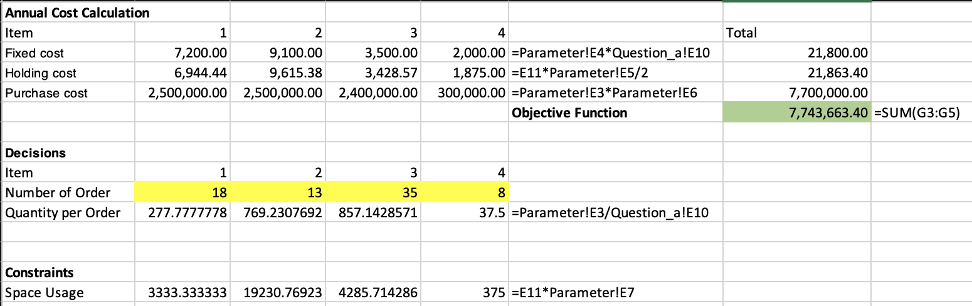

1. The extra constraint for this question is:

* $2*Average Space Usage= \sum_{i}{s_{i}q_{i}≤12000*2=24000}$, for space usage constraint.

And answer table from solve result is:

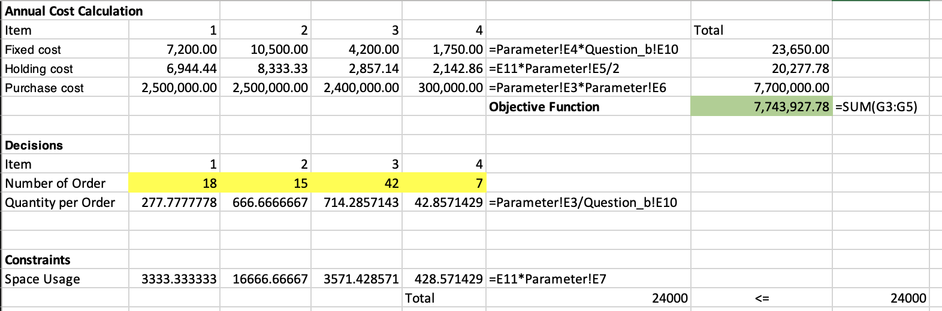

1. The extra constraints for this question are:

* $2*Average Space Usage= \sum_{i}{s_{i}q_{i}≤12000*2=24000}$, for space usage constraint
* $\sum_{i}{d_{i}≤65}$, for total number of orders constraint.

And answer table from solve result is:

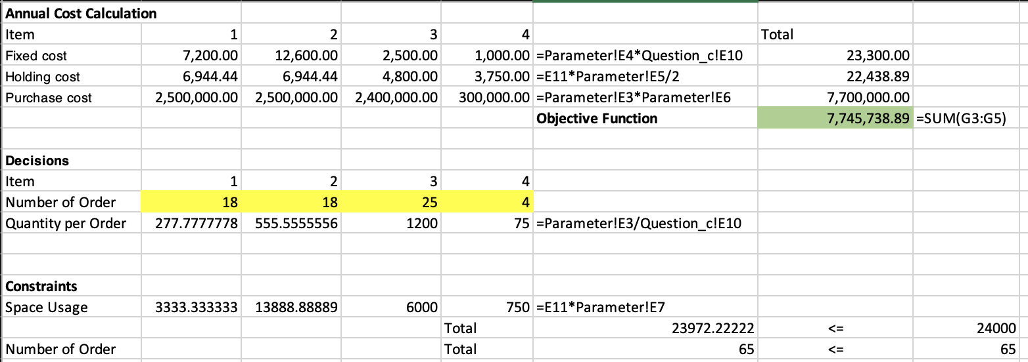

1. The extra constraint for this question is:

* $2*Average Space Usage= \sum_{i}{s_{i}q_{i}≤13000*2=26000}$, for space usage constraint.

And answer table from solve result is:

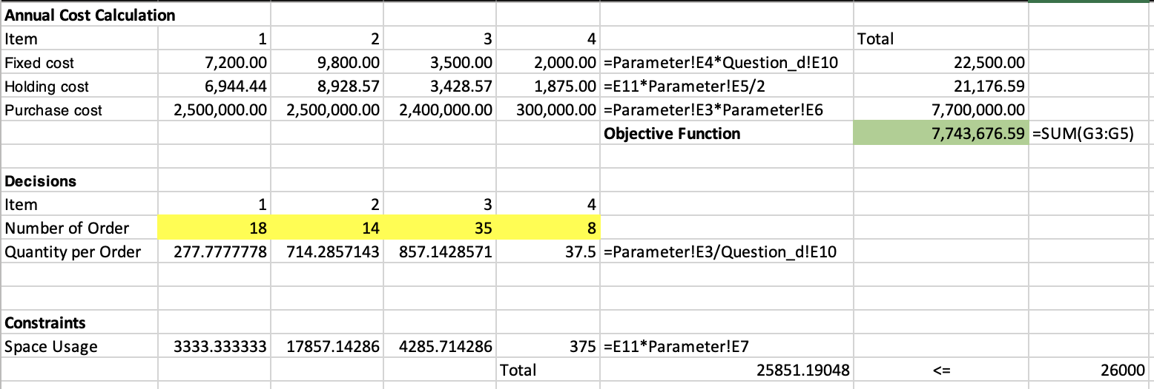

1. The extra constraints for this question are:

* $2*Average Space Usage= \sum_{i}{s_{i}q_{i}≤13000*2=26000}$, for space usage constraint.
* $\sum_{i}{d_{i}≤65}$, for total number of orders constraint.

And answer table from solve result is:

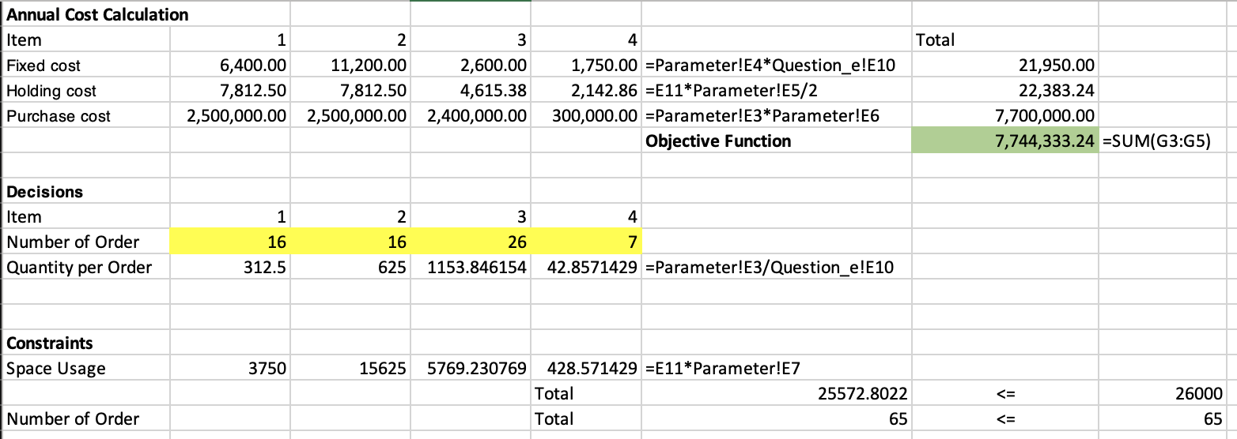

**Pricing with Dependent Demands (8.7)**

* Additional information:
  + Do not round demand quantities. (It’s no need if we start from considering the number of car production)
  + For marginal value of prep labor: you can use the Lagrange multiplier, change the available hours to 321, resolve the model and record the change in the objective function, or use SolverTable.

Decision variables:

Unlike the common thought that considers price directly as decision variables, I choose to the number of productions for SUV, as $n_{s}$, and Wagon, as $n_{w}$, as decision variables.

Once we start from productions and make decisions, we are able to calculate the upper bound of prices through demand curves, as we should have demand no smaller than produced number, and we want to minimize the demand to get the highest possible price:

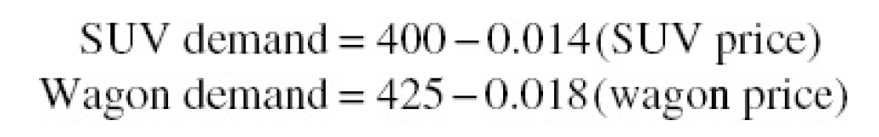

$$p_{s}= \frac{400-n_{s}}{0.014}$$

$$p_{w}= \frac{425-n_{w}}{0.018}$$

It’s robust to say that the above is the highest possible prizes for decision ( $n_{s}, n_{w})$ and we can use it for further calculation without using extra constraint to consider demand curves.

The objective function:

$$Cost= 17000*n_{s}+14000*n_{w}$$

$$Revenue= p_{s}n_{s}+p_{w}n_{w}$$

$$Profit= Revenue-Cost$$

The common constraints for all questions are:

1. Number of productions non-negative integer.
2. $Labor Cost= 2*n_{s}+3*n_{w}≤320$, for labor supply constraint.

**Solution for questions:**

1. The profit-maximizing prices for SUVs and Wagons is **23785.71** (SUVs) and **20166.66** (Wagons)
2. Demand levels result from the prices in a) is **67**(SUVs) and **62**(Wagons), which are also the exact number of productions for SUVs and Wagons.
3. Through resolving the problem, we get the marginal value of dealer prep labor at the given condition as: **936.507937.**

**Optimal solution from GRG Solver:**

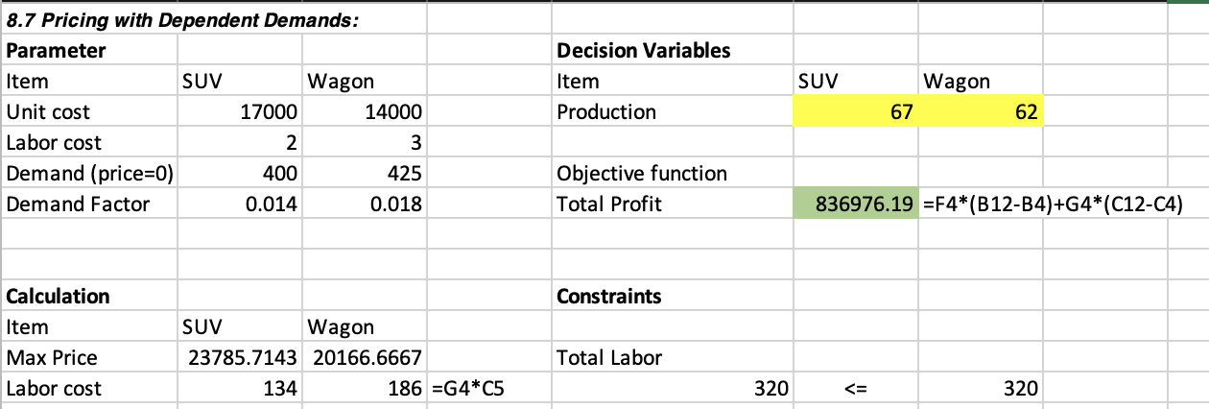

**Allocating an Advertising Budget (8.9)**

* Additional Information:
  + Do not consider the advertising cost in the objective function.

Decision variables:

In this allocating problem, what we need to decide is the allocation of dollars, in (k$), towards each market, marked as $n_{i}, i\{1, 2, 3, 4\}$, 1 for Domestic, 2 for Premium, 3 for Light, 4 for Microbrew.

The objective function:

$$c=[66, 77, 88, 99]$$

$$e=[0.55, 0.44, 0.33, 0.22]$$

$$Total Profit= \sum_{i}{{c_{i}*n}_{i}^{e_{i}}}$$

$$where i\{1, 2, 3, 4\}$$

The common constraints for all questions are:

1. Allocation of dollars non-negative.
2. $\sum_{i}{n_{i}}≤125$, for available fund constraint.

**Solution for questions:**

1. The funds be allocated among the four markets should be (**76.56** for Domestic, **28.86** for Premium, **13.22** for Light, **6.36** for Microbrew, in (k$)) so that the revenue to the company as a whole will be maximized.
2. Through resolving the problem, we get that available fund for advertising per unit worth as: **5.14**, in k$**.**

**Optimal solution from GRG Solver:**

