**BUDT 732: Decision Analytics**

Individual Assignment 9: Heuristics

**Planning a Tour (9.3)**

Decision variables:

In this tour planning problem, what we need to decide is the visit order of our tour. As we are required to visit each of the 12 sites exactly once, we can use $f_{i}, i \left[1, 12\right], i:int$ to represent a “from” list that is our $i^{th}$ visiting site.

Note:

Here the sites are numbered as:



After that, we are able to generate a “to” list to trace the route. The “to” list can be generated through: ${t_{i}=f}_{i}, i \left[1, 11\right]$, and, as the professor required, our tour should get back and end in the start point, that is: ${t_{12}=f}_{1}.$

The objective function:

$$Total Distance= \sum_{i}{d_{f_{i}, { t}_{i}}}$$

$$where d_{f_{i}, { t}_{i}} is the distance from f_{i} to { t}_{i}, i \left[1, 12\right]$$

Constraint:

1. $f_{i}$ all different in Solver. (All-different constraint in solver requires:

* Allocation function F: $f→\{1, 2, …, 12\}$ is a bijection for $f_{i}$.

**Solution for questions:**

The optimal visit order is **1, 4, 9, 11, 8, 6, 7, 10, 12, 2, 3, 5, 1.**

(please be careful here: as long as our tour start from one site and finally come back to it, the tour forms as a circle. Therefore, the start point doesn’t matter, as each site has an in and an out state.)

Minimum tour length is: **8822.00.**

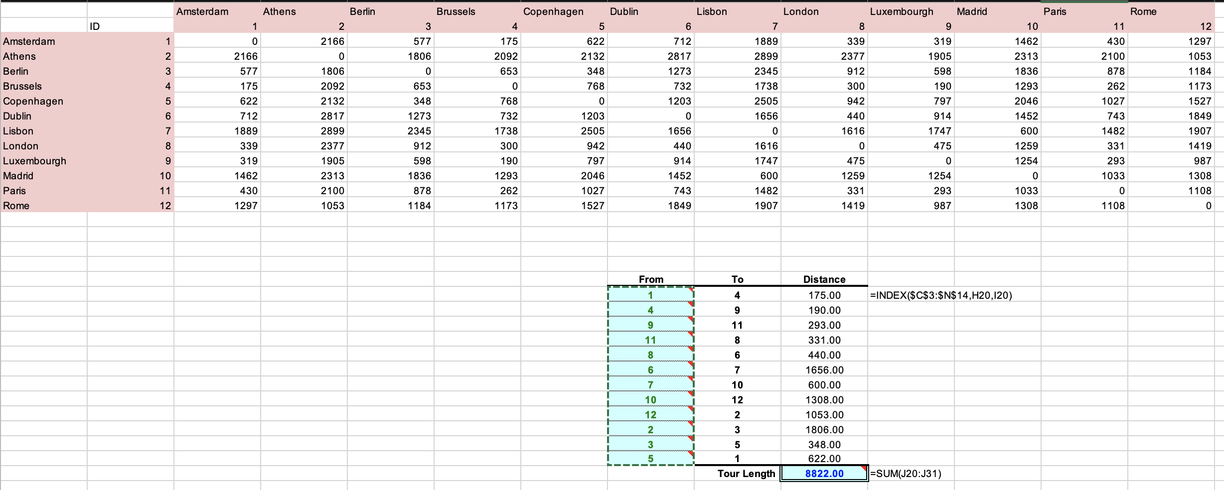

**Locating Warehouses (9.5)**

Decision variables:

In this warehouses locating problem, what we need to decide is whether or not to build warehouse at each of the 7 sites that can support warehouses, as $x_{i}, i \left\{1, 2, 3, 6, 9, 11\right\}$, 1 for selected to build and 0 for not.

Note:

Here the centers are numbered as:



In this problem we do not have capacity restrictions on warehouse. Thus, we’re able to decide the minimum cost of shipping in these procedures:

1. For selected warehouse centers, copy the cost information, shipping from that center to all centers. (self-shipping is no need, so the cost is 0
2. For un-selected warehouse centers, centers cannot get shipped from that site, but we can set the cost information to a large-enough value (I choose 2, which is larger than any of the unit cost in the cost table) so that this value can be filtered in the next step.
3. Calculate the optimal shipping plan, as minimizing unit shipping cost in each center:

$c_{i}=MIN\left(c_{i, j}\right), i \left\{1, 2, …, 11\right\}, j \left\{1, 2, 3, 6, 9, 11\right\}$

The objective function:

$$Fixed cost= 3600*\sum_{j}{x_{j}}$$

$$Shipping cost= \sum_{i}{{d_{i}c}_{i}}$$

$$Total cost=Fixed cost+Shipping cost$$

$$where d_{i} is the demand in center i, i \left\{1, 2, …, 11\right\}, j \left\{1, 2, 3, 6, 9, 11\right\}$$

Constraint:

1. Decision variables binary.

**Solution for questions:**

1. The optimal total cost is **17678.**
2. We should use: **center 2, Birmingham; center 11, Orlando.**

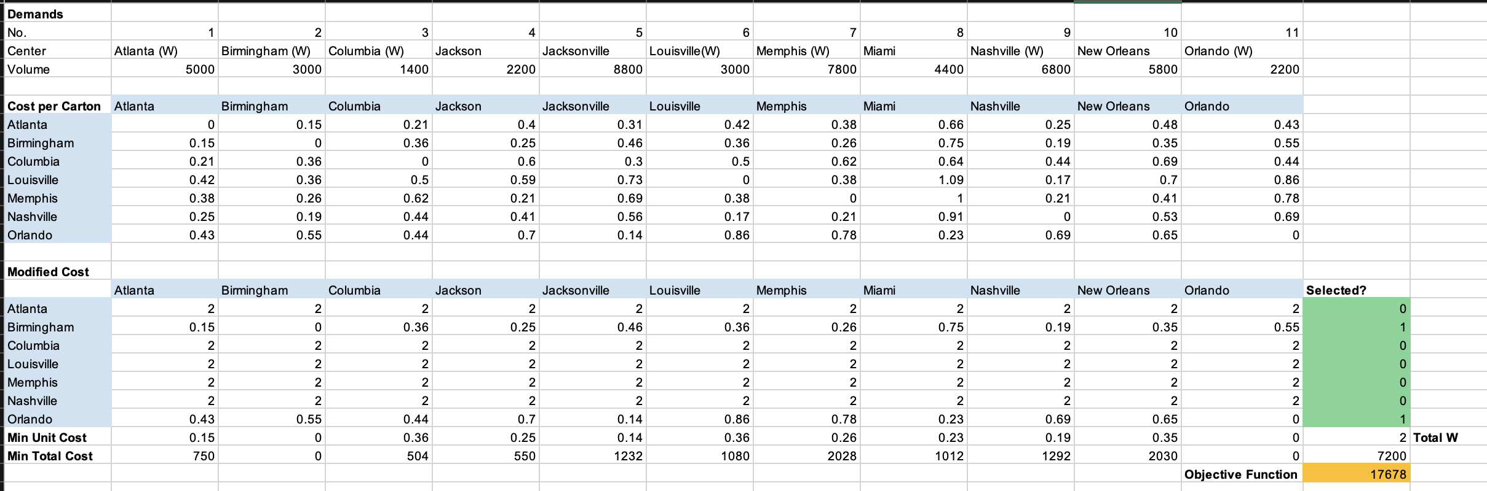

**Assigning Teams (9.9)**

Decision variables:

In this team assigning problem, what we need to decide is the team for each student, as $x_{i}, i \left[1, 15\right], i:int$.

The objective function is the total deviation, given in the problem as:

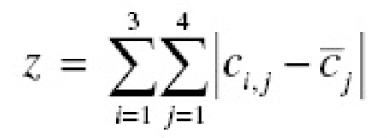

Implemented in Excel as table:



Constraint:

1. Count for the number of students in the 3 team should all be 5.
2. ${1≤x}_{i}≤3, i \left[1, 15\right], i, x_{i}:int$.

**Solution for questions:**

The optimal team assignment is:

* **Team 1: Student 1, 5, 7, 9, 11**
* **Team 2: Student 4, 6, 8, 14, 15**
* **Team 3: Student 2, 3, 10, 12, 13**
* **(the id of three team can be switched)**

