Project Address: https://github.com/ajayrandhawa/User-Management-PHP-MYSQL
After downloading, the following files are available: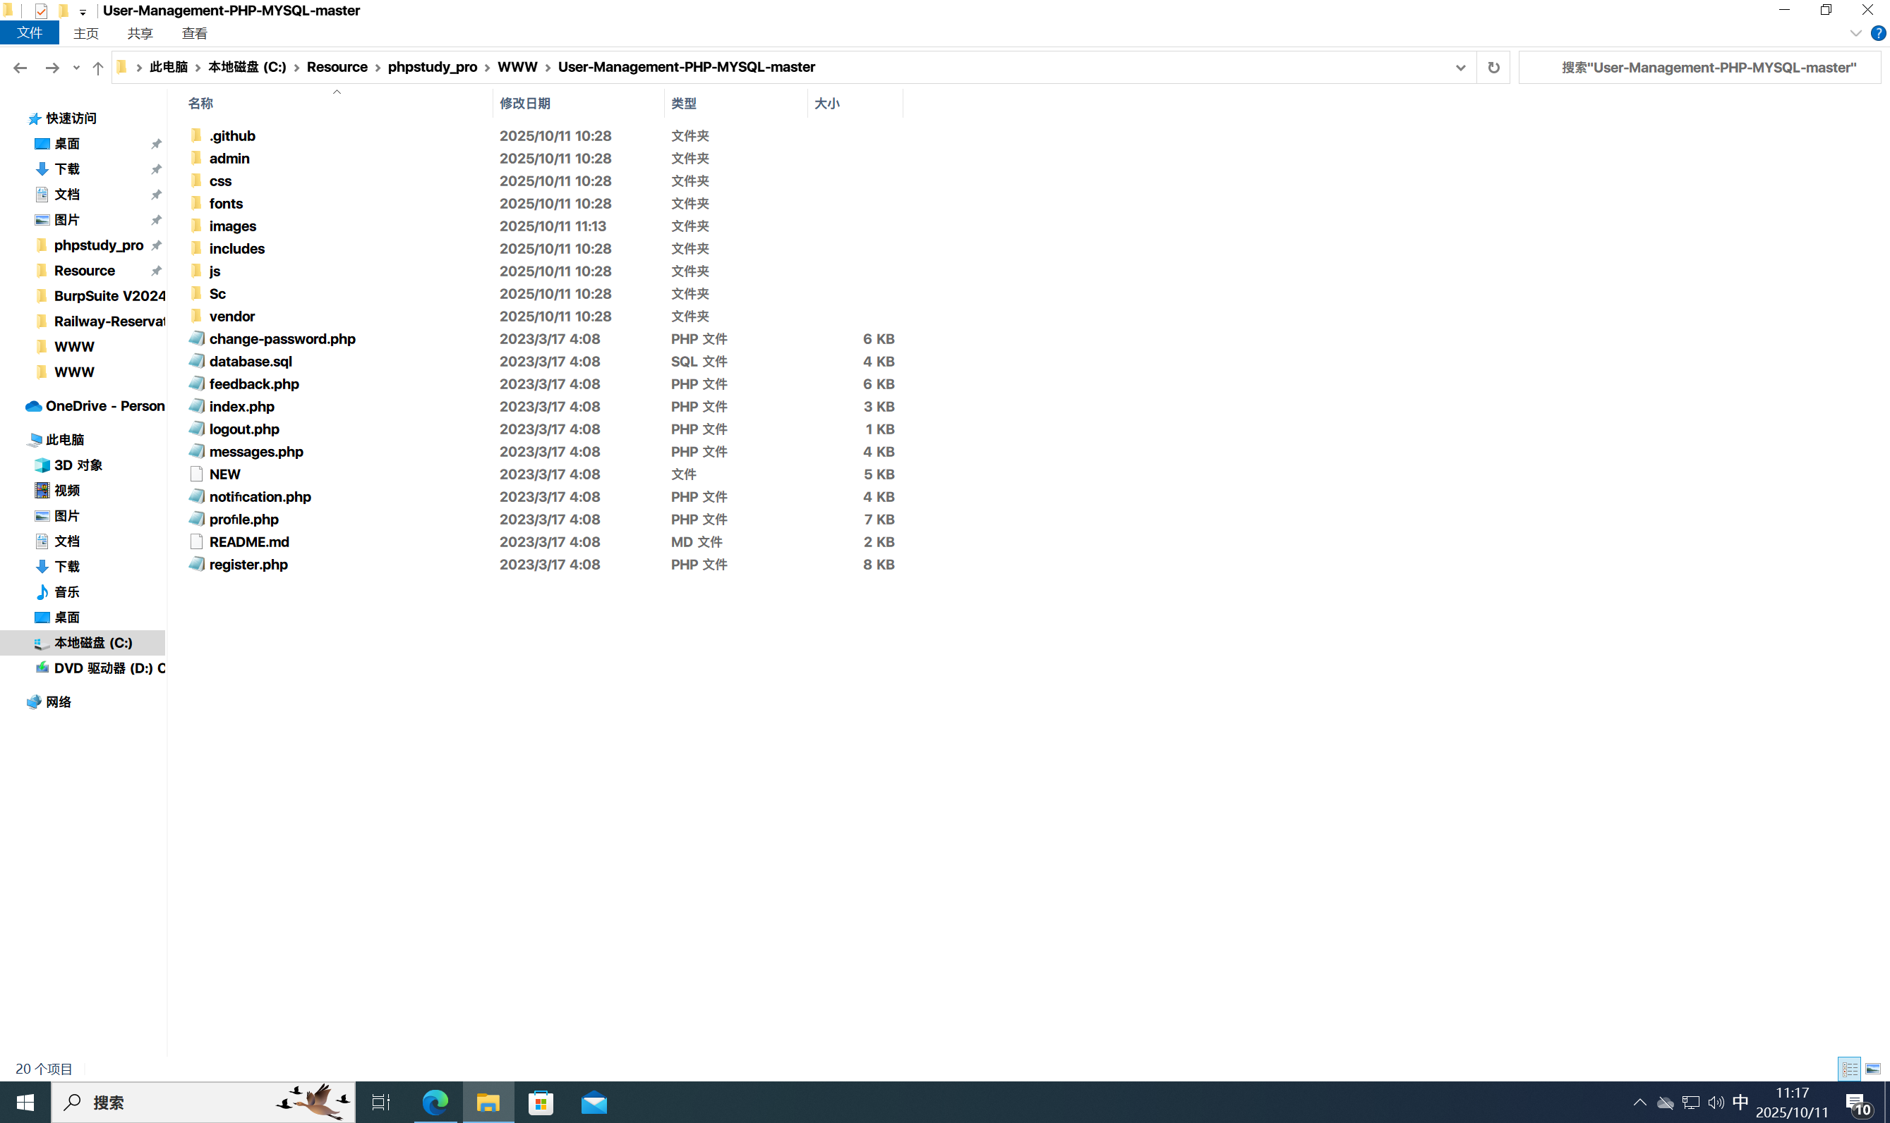
To set up the project locally, you need to modify two configuration files:
- includes\config.php
- admin\includes\config.php
The content of these two files is identical, so only the content of the first one (includes\config.php) is shown here.
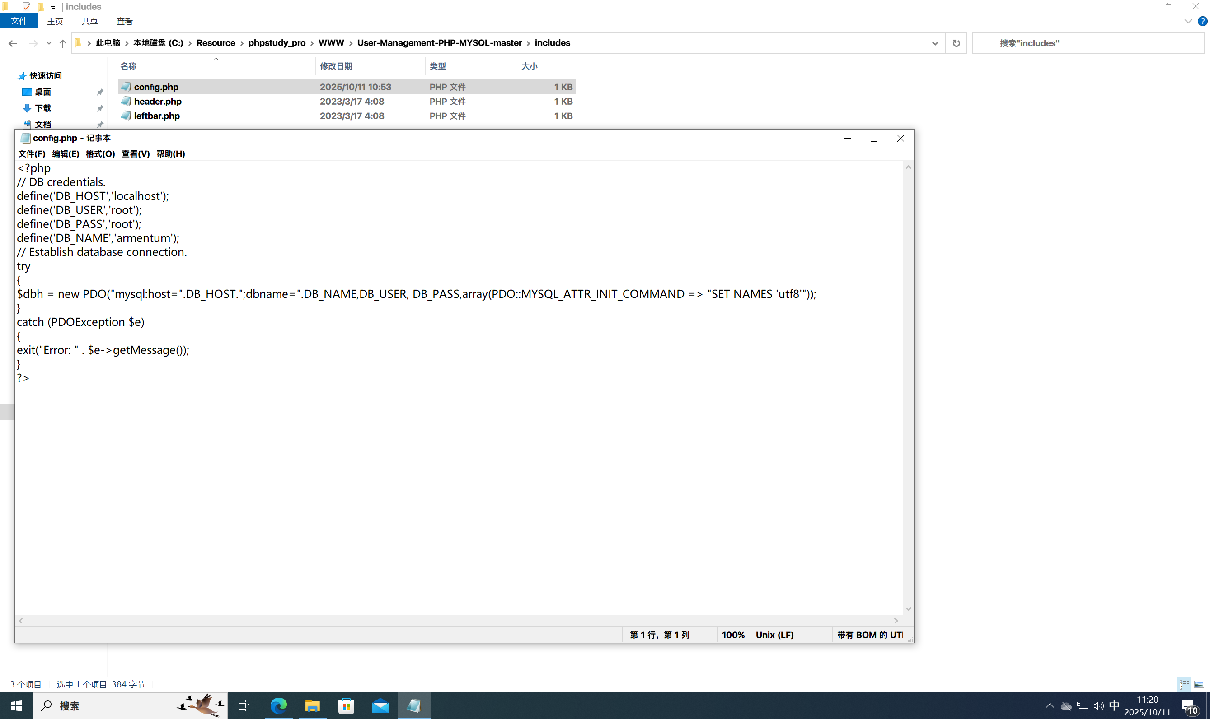
After modifying the above two files, create a database named armentum and import the database.sql file.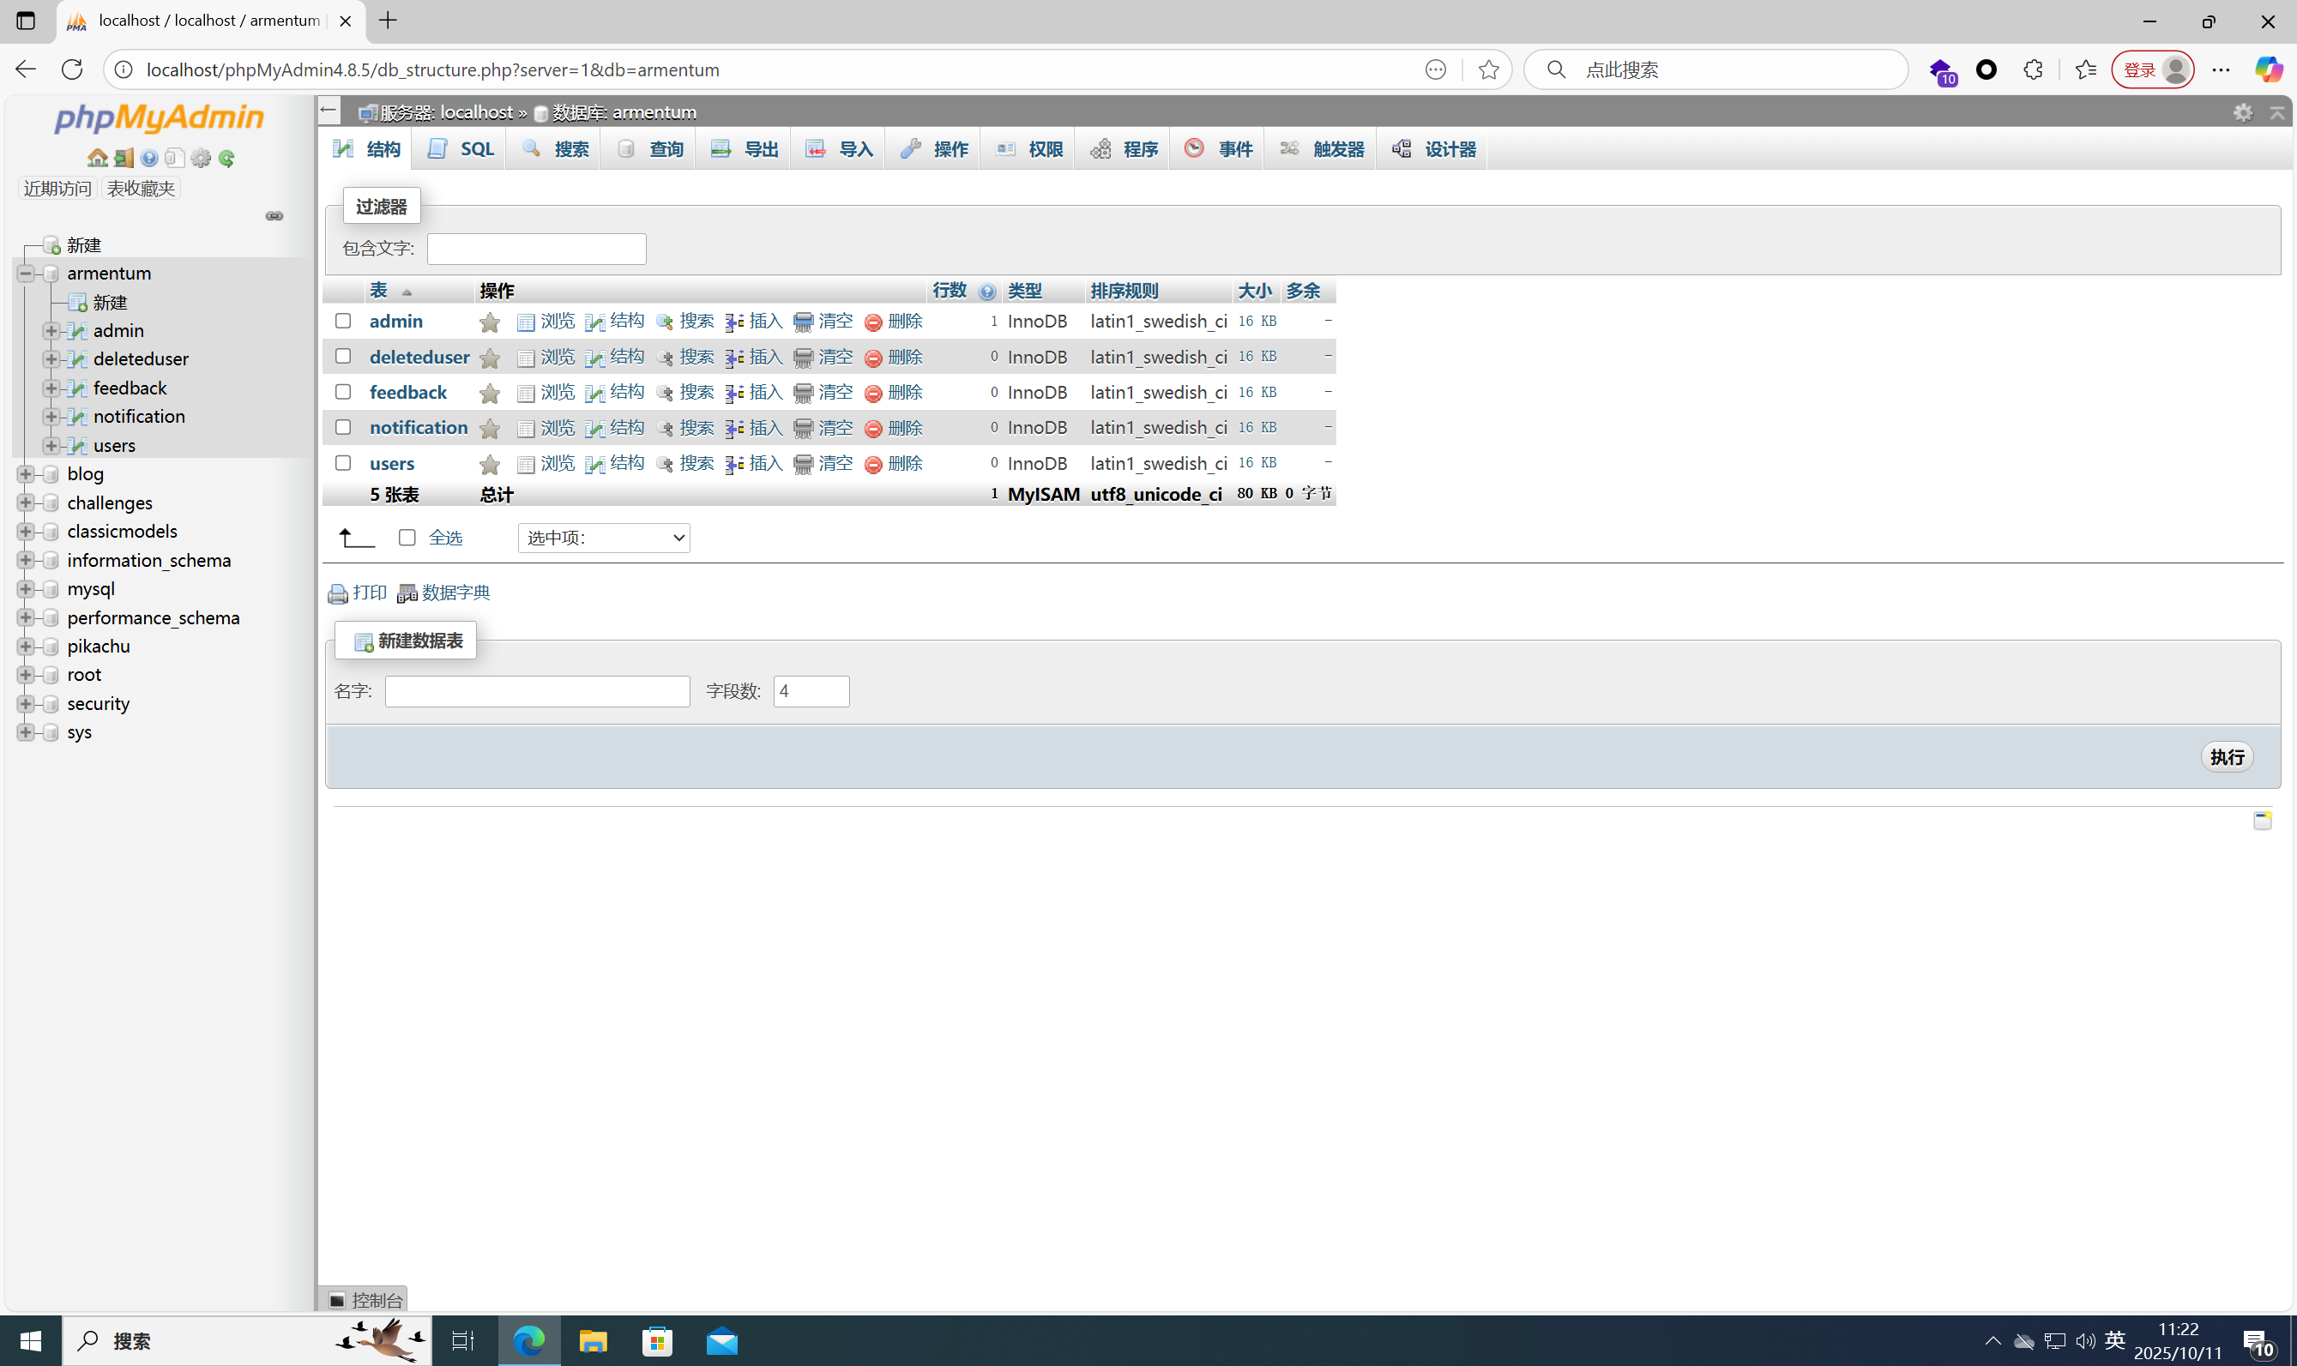
At this point, the project setup is complete.
Access the admin login interface:
http://yourIP/User-Management-PHP-MYSQL-master/admin/
The initial account and password are as follows:
Account: admin
Password: 963852741
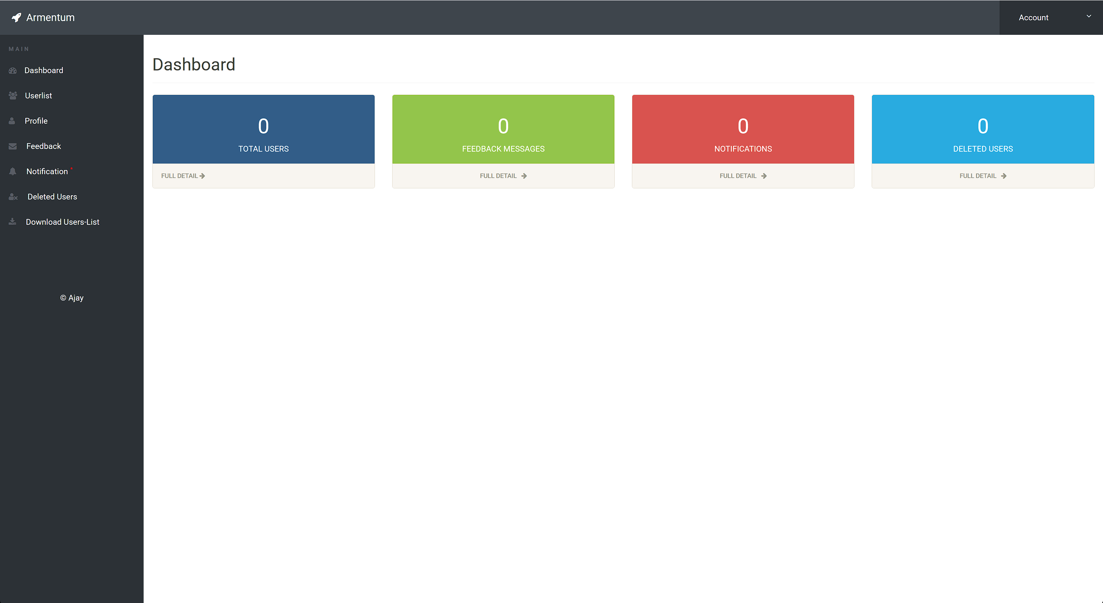
This image shows the interface after successful login.
Next, access the Edit User interface:
http://yourIP/User-Management-PHP-MYSQL-master/admin/edit-user.php
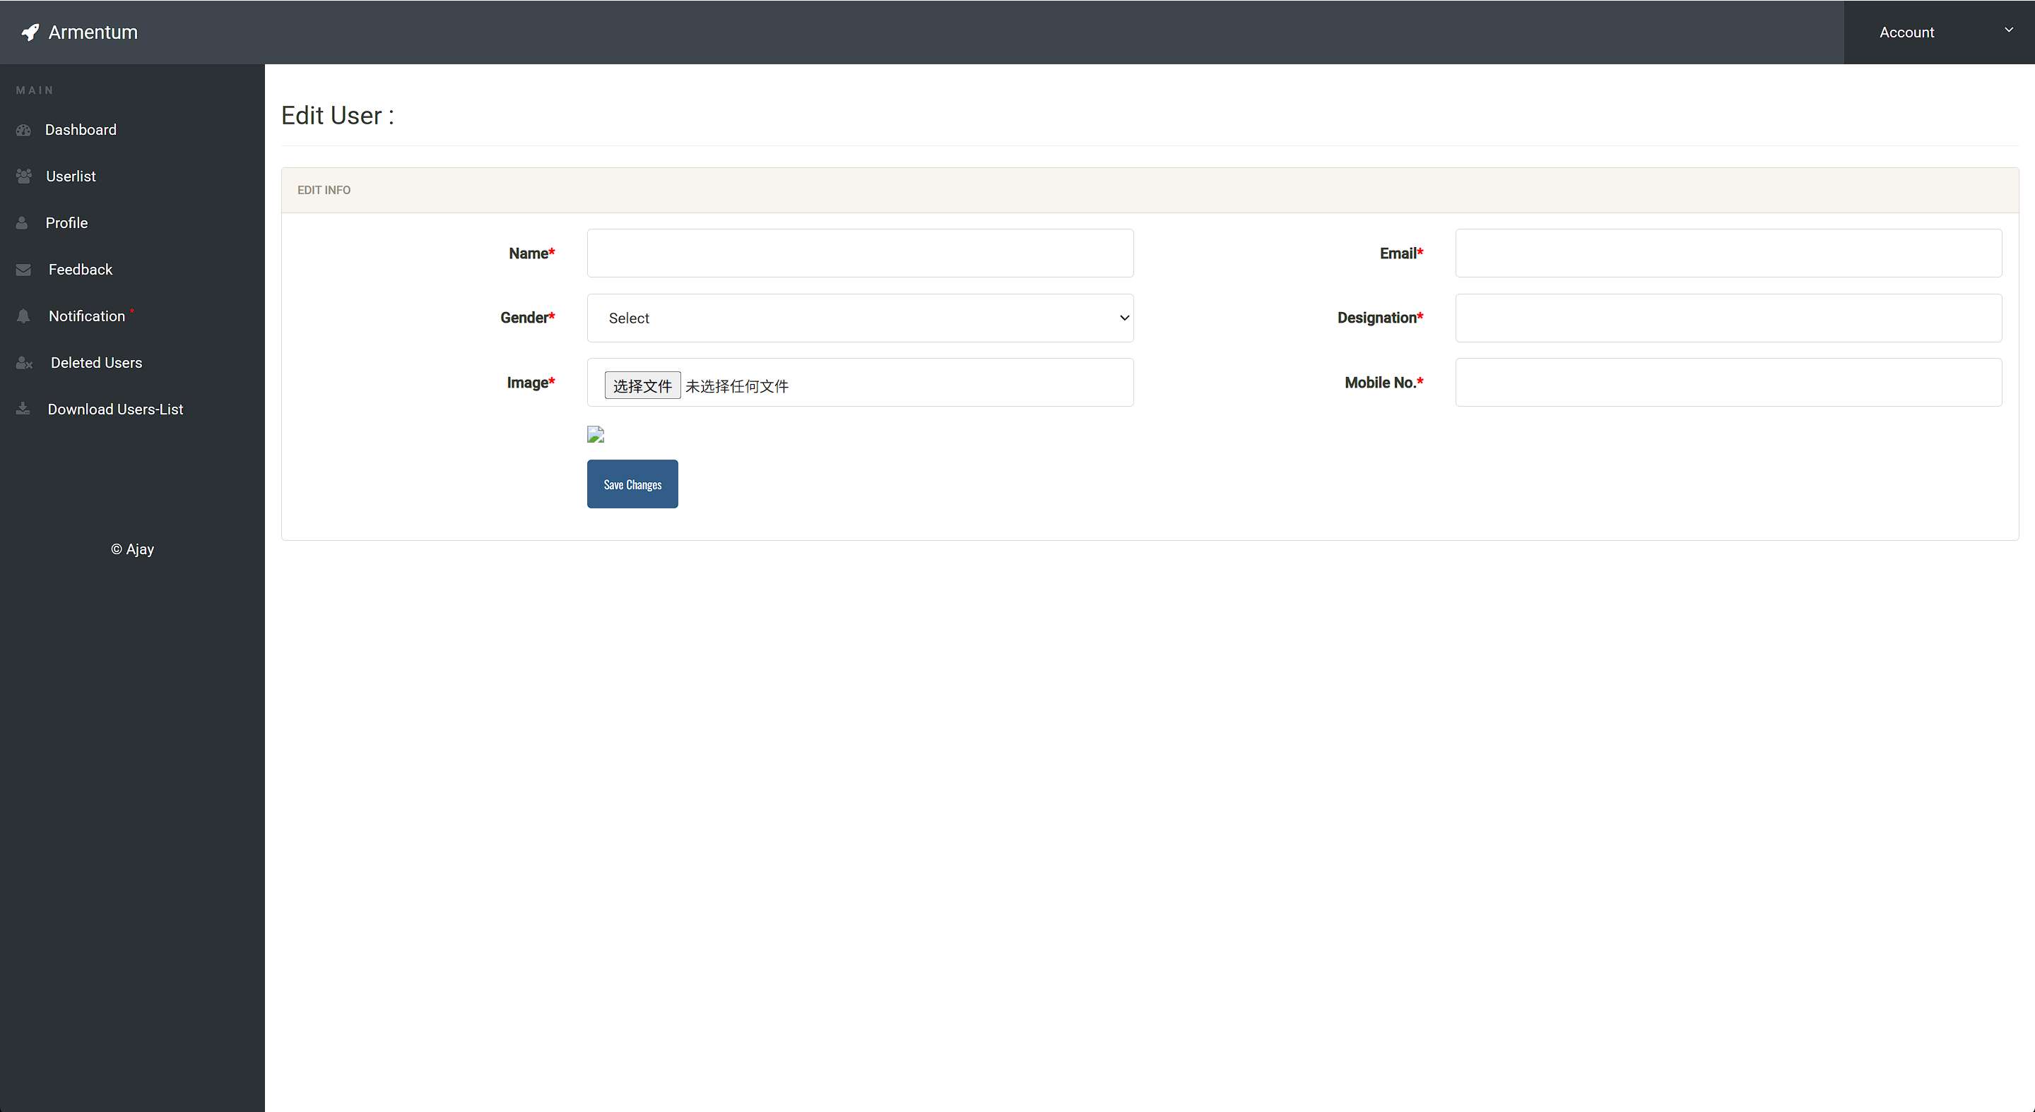
This interface has a file upload vulnerability.
Next, I will reproduce this vulnerability. The tools used are: Burp Suite; AntSword
Step 1: Create an upload file named 1.php.jpg, whose content is a one-sentence backdoor (webshell).
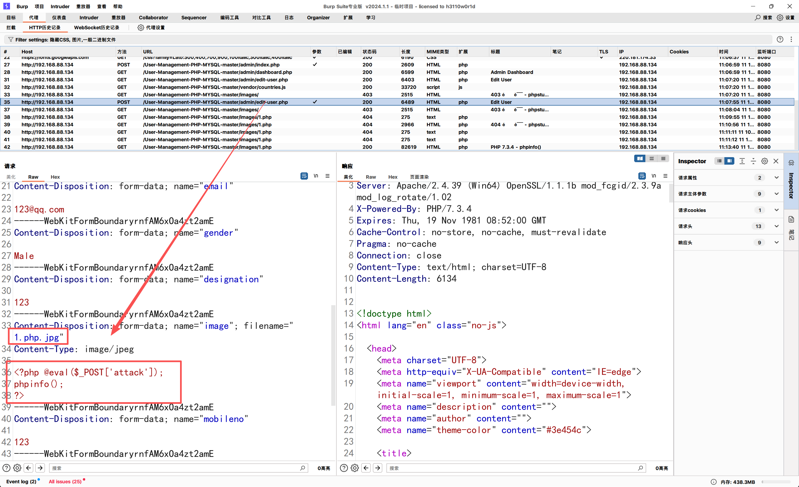
Step 2: Modify the file name to 1.php and upload it directly.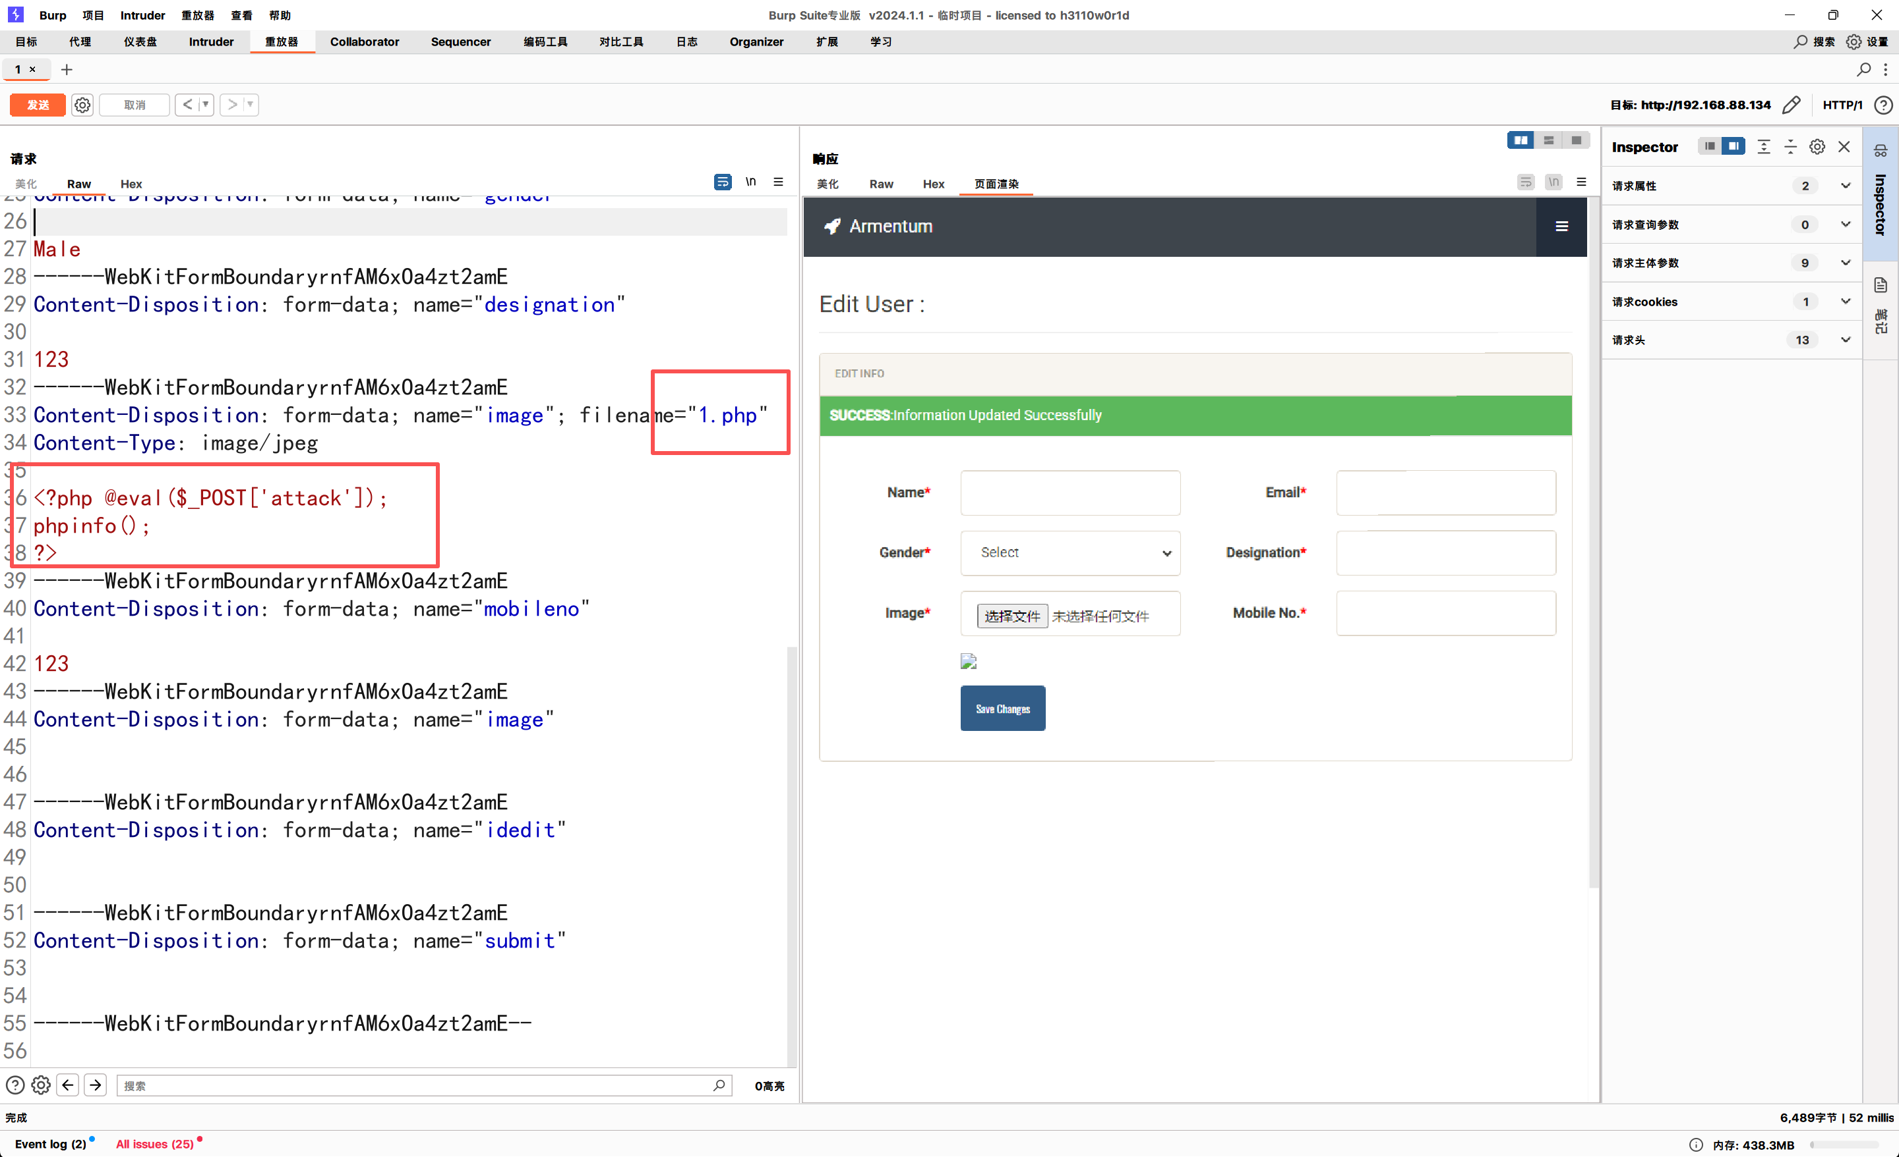
Step 3: Access the uploaded file via the following URL:
http://yourIP/User-Management-PHP-MYSQL-master/images/1.php
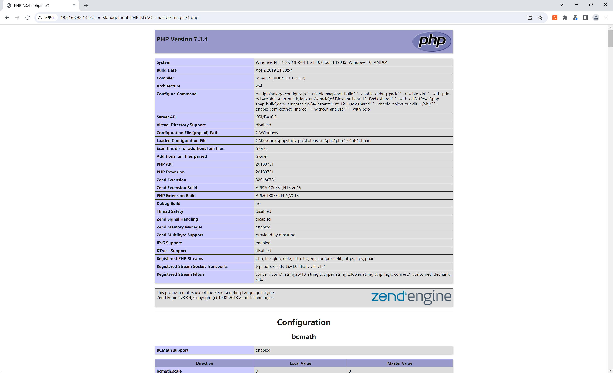
Step 4: Connect to the target host using AntSword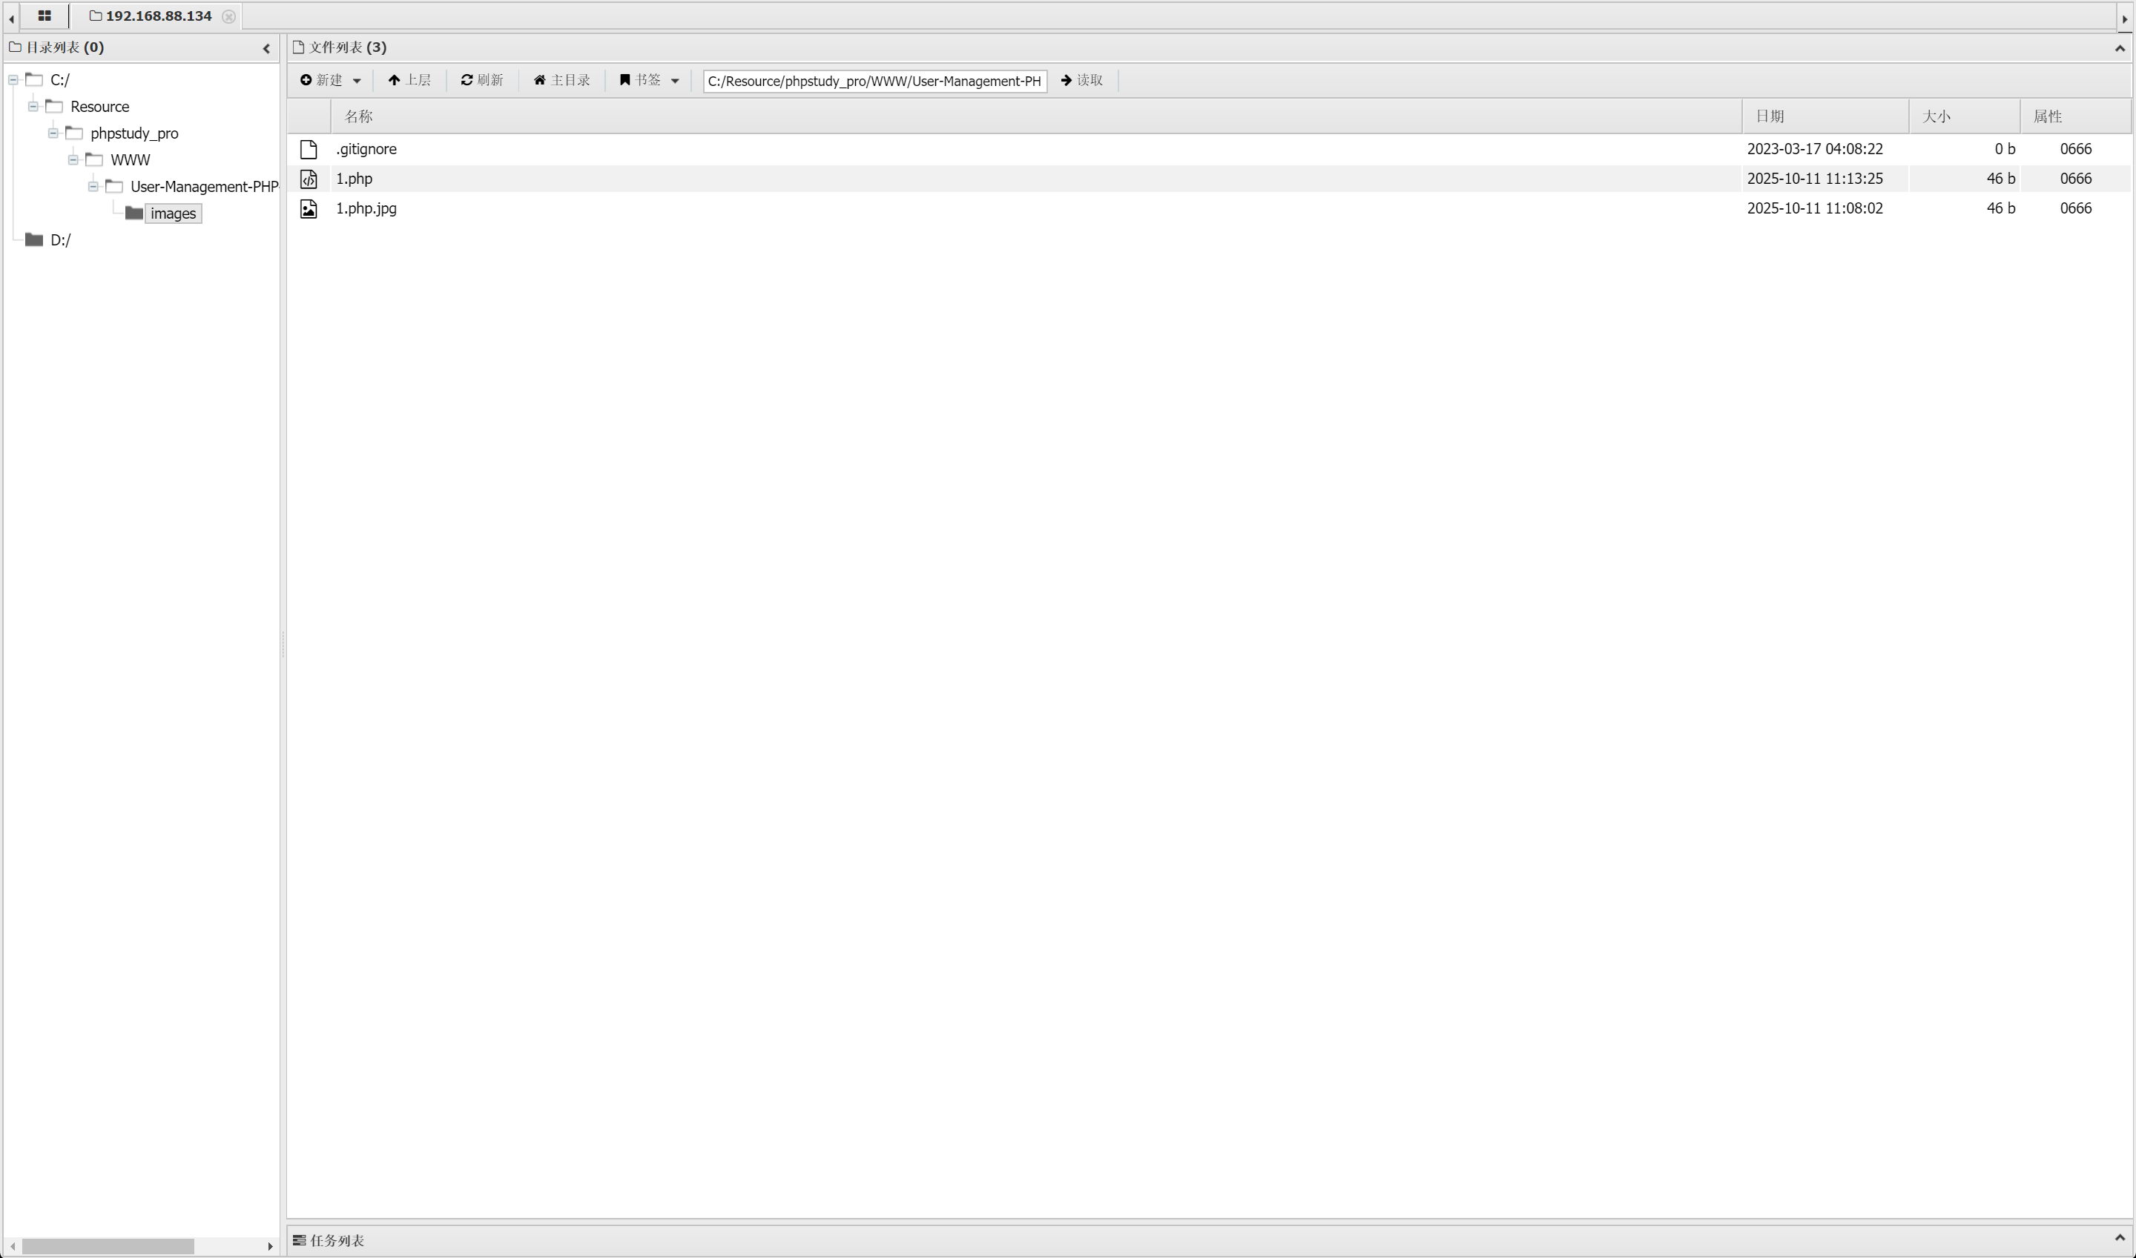 So far, the reproduction of this file upload vulnerability is completed.

In addition to admin/edit-user.php, the file register.php also has the same vulnerability.

