# QAP-4-Files-LC

Python Program(s) to be submitted for

QAP 4 SD S1

Name: OneStopInsuranceCo.py

Description: The One Stop Insurance Company, A program to enter and calculate new insurance policy information for its customers.

How-To-Run: Open File using Visual Studio Code and Run in the Terminal.

Author: Lianne Campbell

Date of Creation: 11/19/2023

How-To:

Once you run the program, you will be asked to input your information,

Note: Your inputs do not require case sensitivity.

Starting with your First and Last name:



Your Home Address Number and Street Name:



Input the name of your current City:



You will be asked to input your Province from a list provided:

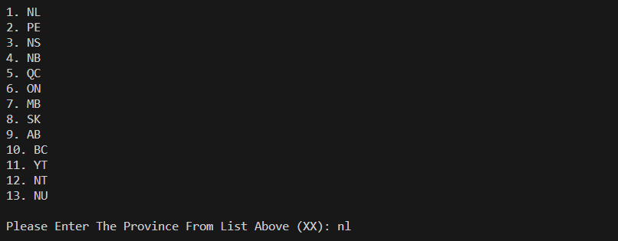

If you enter an incorrect option besides which is not on the list you will incur errors such as: 

Enter your Postal Code in the following format: 

Enter your Telephone Number in the following format: 

You will need to enter the number of cars that you wish to insure:



Next you can decide which extra options you would like to add on.

If you would like to add Extra Liability up to 1,000,000 for $130.00

Please enter Y or N:



If you would like to add Glass Coverage for $86.00 enter Y or N:



If you would like to add a Loaner Car for $58.00 enter Y or N:



With Y or N questions you can incur errors such as:



You can now choose which payment option you would like to select.

You must input an option from Full or Monthly or Down Pay:



Input an option that is not presented error occurs:



If you selected Down Pay, you will be required to enter the amount:



Next an option which allows you to add as many previous claims as needed:

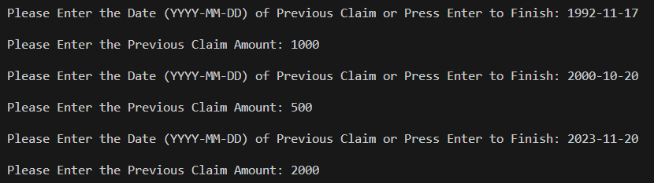

Once you are finished inputting, Press the Enter key to Continue:



You will be presented with a printed out copy of your Recipt:

