Task A: Data Exploration and Auditing

A1. Dataset size:

There are 5792 data instances and 5 variables in the data set.

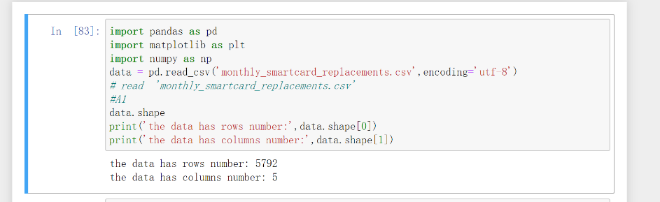

A2. Missing values in the dataset:

No, there are no null values in the data set

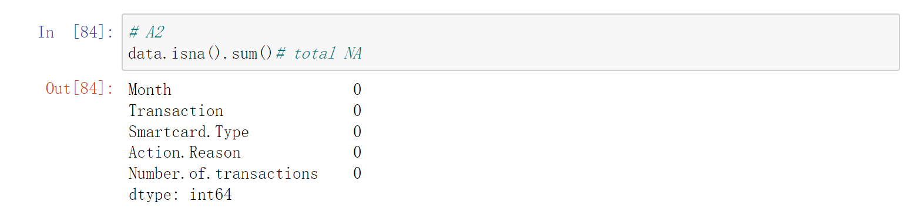

A3. Data Types:

The first four columns are of type object, and the fifth column is of type number.of. transactions int.

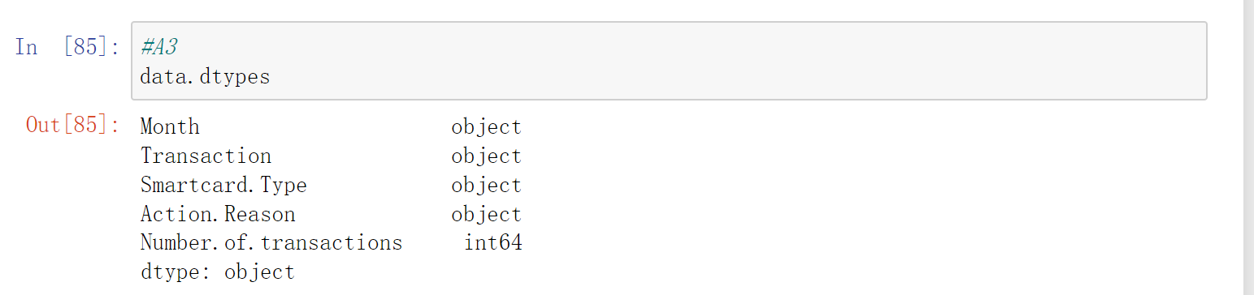

A4. Convert Data Type:

Data type of column ‘Month’ is datetime format

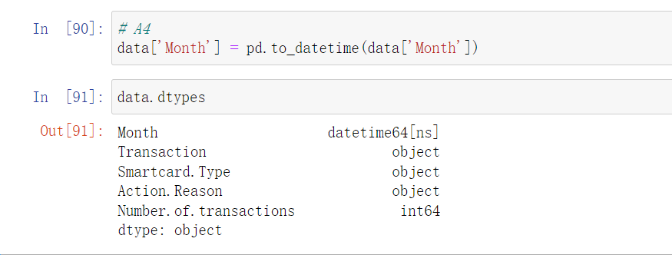

A5. Descriptive Statistics:

In the data, there was at least one transaction per day, with 9,097 transactions on the most traded day. That's an average of 303 transactions per day.

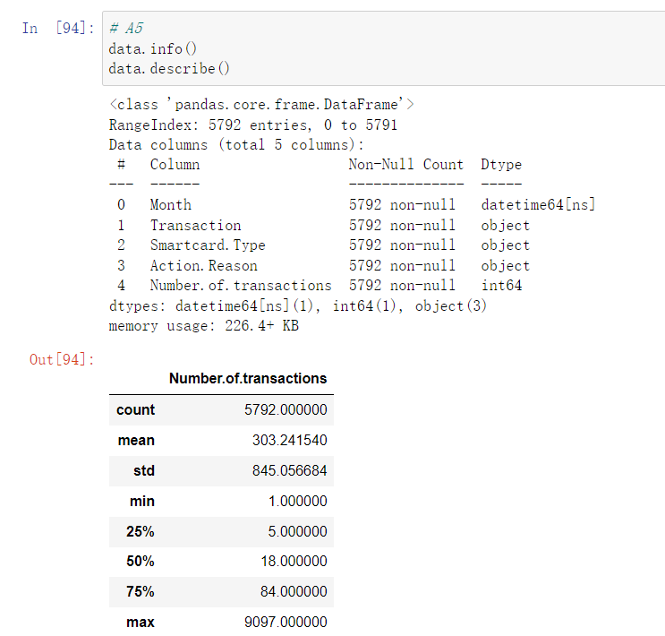

A6. Exploring Smartcard Types:

1. There are 4 different types, which are Driver Licence Card(1896 instances recorded), Industry Authority Card(1218 instances recorded), Marine Licence Ind Card(1047 instances recorded), Photo Identification Card(1631 instances recorded).

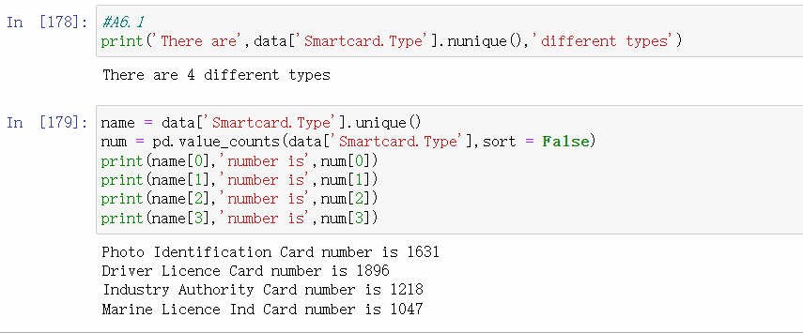

2.

The percentage of Driver Licence Card records as one of the smartcard types in ‘Smartcard.Type’ is 32.734806629834257%

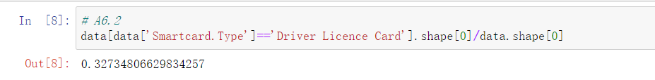

A7. Exploring Reasons for Smartcard Replacement:

1. The left is the different causes, and the right is the number of times each cause occurs

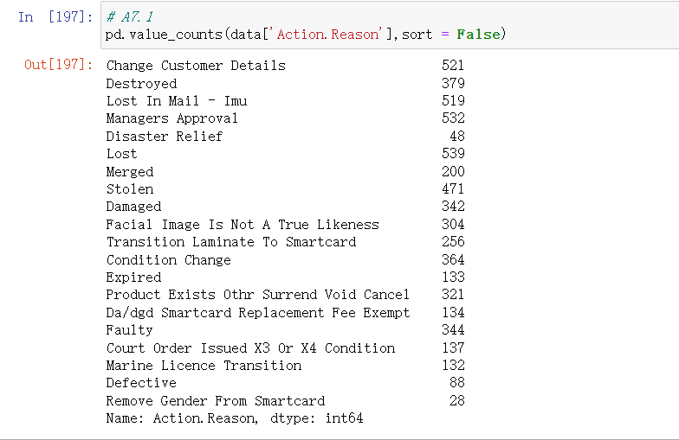

2.

Task B: Group Level Analysis and Visualisation

B1. Investigating Annual Smartcard Replacements:

1.

2.

3.

B2. Investigating Reasons for Smartcard Replacement:

1.

2.

3.

B3. Investigating Reasons over Annual Smartcard Replacement:

1.

2.

3.

4.

5.