適應控制(HW3)

0056C203 廖育賢

# objective-the problem and the purpose

此次報告我們要模擬Indirect Self-Tuning Regulator，設計一個控制器去控制我們的線性模型。

# procedure

## method

首先我們先以RLS的方法估測受控體A(q)、B(q)的係數，帶入MDPP中以Diophantine equaion找出控制器R(q)、S(q)、T(q)之係數，並算出Control Law後，再重複以上動作，直到RLS收斂。

## program flow chart

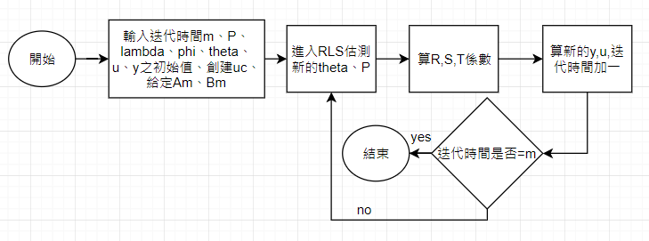

## equation

### RLS (exponential forgetting):

$$θ\left(t\right)=θ\left(t-1\right)+k\left(t\right)\left(y\left(t\right)-φ^{⊤}\left(t\right)θ\left(t-1\right)\right)$$

$$k\left(t\right)=P\left(t-1\right)φ\left(t\right){\left(λI+φ^{T}\left(t\right)P\left(t-1\right)φ\left(t\right)\right)}^{-1}$$

$P\left(t\right)=\left(I-k\left(t\right)φ^{T}\left(t\right)\right)P\left(t-1\right)$/ $λ$

### MDPP (Minimum-degree pole placement):

#### all zeros are canceled:

Diophantine Equation : AR’+b0*S=Ac’ = A0*Am

T=Am(1)*qd0 / b0

#### no zeros are canceled:

Diophantine Equation : AR+BS=Ac= A0*Am

T=(Am(1) /B(1) ) *A0

### control law

R*u=T*uc-S*y

# simulation results

## program codes

%%

%Model-following with zero cancellation

clear ;

clc ;

format long;

m=100;%time(sec) ,sampling time=0.5(sec)

n=4;

theta(1,1)=0;%a1

theta(2,1)=0;%a2

theta(3,1)=0.01;%b0

theta(4,1)=0.2;%b1

phi(1,1)=0;

phi(1,2)=0;

phi(1,3)=0;

phi(1,4)=0;

w(1:50)=1;

w(51:100)=-1;

uc=[w w w w w];

uc=[uc uc];

p=[100 0 0 0 ;0 100 0 0; 0 0 1 0; 0 0 0 1];

lambda=0.999;

%desired system:Am ,Bm

am1=-1.3205;

am2=0.4966;

bm0=0.1761;

i=1;

y(1)=0;

u(1)=0;

for k=0:0.5:(m-0.5)

[p ,theta(:,i+1)]=rls_forgetting(p,theta(:,i),phi(i,:),y(i),lambda) ;

%RLS:A,B

a1=theta(1,i+1);

a2=theta(2,i+1);

b0=theta(3,i+1);

b1=theta(4,i+1);

%Controller:R,S,T

r1=b1/b0;

s0=(am1-a1)/b0;

s1=(am2-a2)/b0;

t0=bm0/b0;

if i==1

u(i+1)=-r1*u(i)+t0*uc(i)-s0*y(i)-s1*0;

y(i+1)=1.6065*y(i)-0.6065*0+0.1065*u(i)+0.0902*0; %measured y

phi(i+1,1)=-y(i);

phi(i+1,2)=0;

phi(i+1,3)=u(i);

phi(i+1,4)=0;

end

if i==2

u(i+1)=-r1*u(i)+t0*uc(i)-s0*y(i)-s1*y(i-1);

y(i+1)=1.6065*y(i)-0.6065*y(i-1)+0.1065*u(i)+0.0902*u(i-1);

phi(i+1,1)=-y(i);

phi(i+1,2)=-y(i-1);

phi(i+1,3)=u(i);

phi(i+1,4)=u(i-1);

end

if i>=3

u(i+1)=-r1*u(i)+t0*uc(i)-s0*y(i)-s1*y(i-1);

y(i+1)=1.6065*y(i)-0.6065*y(i-1)+0.1065*u(i)+0.0902*u(i-1);

phi(i+1,1)=-y(i);

phi(i+1,2)=-y(i-1);

phi(i+1,3)=u(i);

phi(i+1,4)=u(i-1);

end

i=i+1;

end

figure(1)

subplot(211)

plot(0:0.5:m,y);

title('Model-following with zero cancellation')

xlabel('Time')

text(51, -0.08197,' y')

hold on

plot(0:0.5:m,uc(1:2*m+1));

text(21, -1,'uc')

axis([-inf, inf, -1.5, 1.5])

subplot(212)

plot(0:0.5:m,u);

xlabel('Time')

text(65, 1,' u')

axis([-inf, inf, -4.5, 4.5])

figure(2)

subplot(211)

plot(0:0.5:20,theta(1,1:41))

title('Model-following with zero cancellation')

xlabel('Time')

hold on

plot(0:0.5:20,theta(2,1:41))

hold on

plot([0,20],[-1.6065,-1.6065],'--')

hold on

plot([0,20],[0.6065,0.6065],'--')

text(3, -1.125,' a1')

text(3, -0.663,' a2')

subplot(212)

plot(0:0.5:20,theta(3,1:41))

xlabel('Time')

hold on

plot(0:0.5:20,theta(4,1:41))

hold on

plot([0,20],[0.1065,0.1065],'--')

hold on

plot([0,20],[0.0902,0.0902],'--')

text(2.5, 0.221,'b1')

text(1, 0.01,' b0')

%%

%Model-following without zero cancellation

clear ;

clc ;

format long;

m=100;%time(sec) ,sampling time=0.5(sec)

n=4;

theta(1,1)=0;%a1

theta(2,1)=0;%a2

theta(3,1)=0.01;%b0

theta(4,1)=0.2;%b1

phi(1,1)=0;

phi(1,2)=0;

phi(1,3)=0;

phi(1,4)=0;

w(1:50)=1;

w(51:100)=-1;

uc=[w w w w w];

uc=[uc uc];

p=[100 0 0 0 ;0 100 0 0; 0 0 1 0; 0 0 0 1];

lambda=0.999;

%desired system:Am ,Bm

am1=-1.3205;

am2=0.4966;

bm0=0.1761;

i=1;

y(1)=0;

u(1)=1;

a0=0;

for k=0:0.5:(m-0.5)

[p ,theta(:,i+1)]=rls_forgetting(p,theta(:,i),phi(i,:),y(i),lambda) ;

%RLS: A,B

a1=theta(1,i+1);

a2=theta(2,i+1);

b0=theta(3,i+1);

b1=theta(4,i+1);

%Controller:R,S,T

r1=(a0*am2*b0*b0+(a2-am2-a0*am1)*b0*b1+(a0+am1-a1)*b1*b1)/(b1*b1-a1*b0*b1+a2*b0*b0);

s0=(b1*(a0*am1-a2-am1*a1+a1*a1+am2-a1*a0)+b0*(am1*a2-a1*a2-a0*am2+a0*a2))/(b1*b1-a1*b0*b1+a2*b0*b0);

s1=(b1*(a1*a2-am1*a2+a0*am2-a0*a2)+b0*(a2*am2-a2*a2-a0*am2*a1+a0*a2*am1))/(b1*b1-a1*b0*b1+a2*b0*b0);

t0=(1+am1+am2)/(b0+b1);

a0=(a2*r1+b1*s1)/am2;

t1=t0*a0;

if i==1

u(i+1)=-r1*u(i)+t0*uc(i)+t1*0-s0*y(i)-s1*0;

y(i+1)=1.6065*y(i)-0.6065*0+0.1065*u(i)+0.0902*0; %measured y

phi(i+1,1)=-y(i);

phi(i+1,2)=0;

phi(i+1,3)=u(i);

phi(i+1,4)=0;

end

if i==2

u(i+1)=-r1*u(i)+t0*uc(i)+t1*uc(i-1)-s0*y(i)-s1*y(i-1);

y(i+1)=1.6065*y(i)-0.6065*y(i-1)+0.1065*u(i)+0.0902*u(i-1);

phi(i+1,1)=-y(i);

phi(i+1,2)=-y(i-1);

phi(i+1,3)=u(i);

phi(i+1,4)=u(i-1);

end

if i>=3

u(i+1)=-r1*u(i)+t0*uc(i)+t1*uc(i-1)-s0*y(i)-s1*y(i-1);

y(i+1)=1.6065*y(i)-0.6065*y(i-1)+0.1065*u(i)+0.0902*u(i-1);

phi(i+1,1)=-y(i);

phi(i+1,2)=-y(i-1);

phi(i+1,3)=u(i);

phi(i+1,4)=u(i-1);

end

i=i+1;

end

figure(3)

subplot(211)

plot(0:0.5:m,y);

title('Model-following without zero cancellation')

xlabel('Time')

text(51, -0.08197,' y')

hold on

plot(0:0.5:m,uc(1:2*m+1));

text(22, -1,'uc')

axis([-inf, inf, -1.5, 1.5])

subplot(212)

plot(0:0.5:m,u);

xlabel('Time')

text(30, 1,' u')

axis([-inf, inf, -4.5, 4.5])

figure(4)

subplot(211)

plot(0:0.5:20,theta(1,1:41))

title('Model-following without zero cancellation')

xlabel('Time')

hold on

plot(0:0.5:20,theta(2,1:41))

hold on

plot([0,20],[-1.6065,-1.6065],'--')

hold on

plot([0,20],[0.6065,0.6065],'--')

text(3, -1.125,' a1')

text(3, 0,' a2')

subplot(212)

plot(0:0.5:20,theta(3,1:41))

xlabel('Time')

hold on

plot(0:0.5:20,theta(4,1:41))

hold on

plot([0,20],[0.1065,0.1065],'--')

hold on

plot([0,20],[0.0902,0.0902],'--')

text(2.5, 0.221,'b1')

text(1, 0.01,' b0')

function [ p,theta ] = rls_forgetting( p,theta,phi,y ,lambda)

k = p *phi'./(lambda*1+phi*p*phi');

p=p-k*phi*p/lambda;

theta=theta+k*(y-phi*theta);

end

## graph

### Model-following with zero cancellation

λ=0.999:

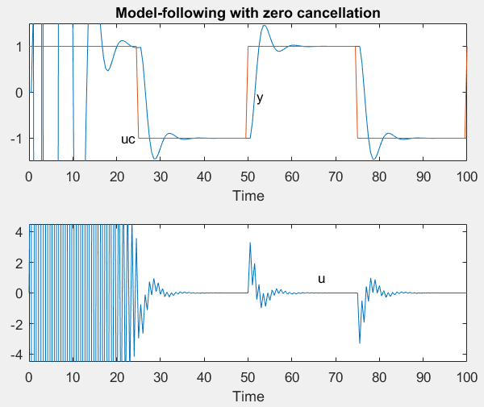 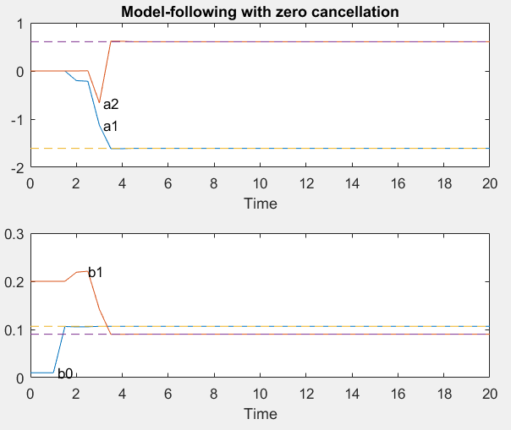

圖一

λ=0.8:

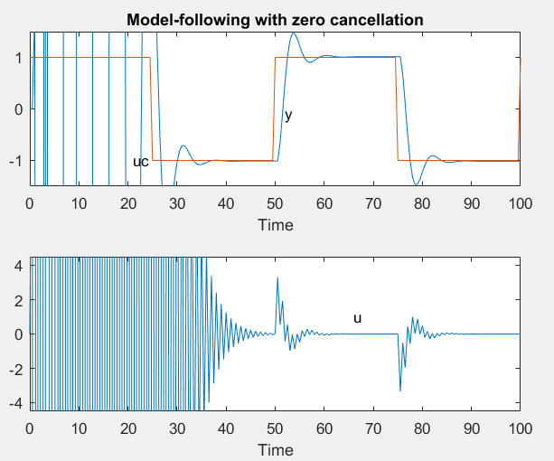 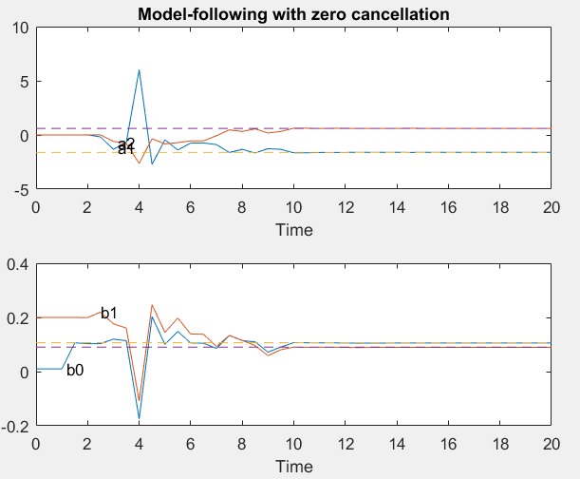

圖二

### Model-following without zero cancellation

λ=0.999:

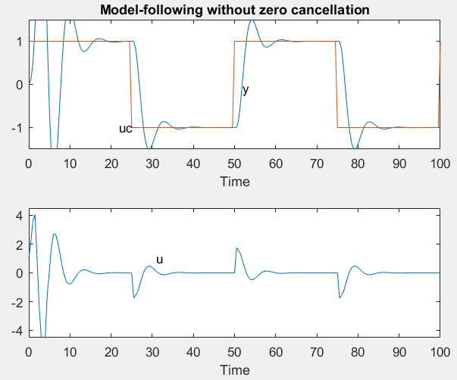 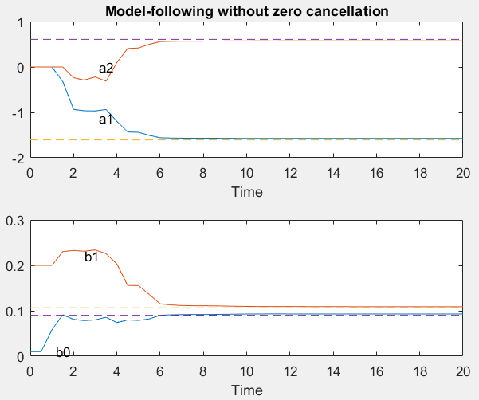

圖三

λ=0.8:

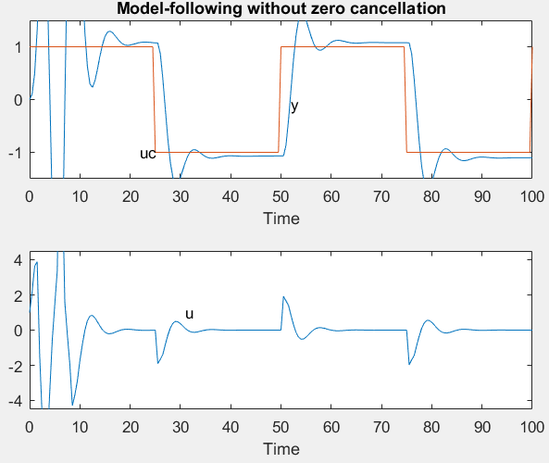 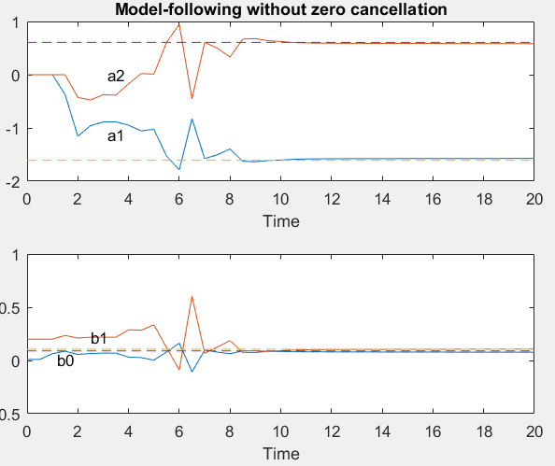

圖四

## table



表一

# conclusion-analysis

由圖一，我們可以看到Control Signal (u)有”Ring”的現象產生，原因是我們消去了-0.84這個零點的關係，Ring現象會使STR的能量消耗增加，而如圖三，我們保留零點得到的Control Signal (u) 較為穩定，耗能較小；由於消除零點方法較為精簡，製造成本會比保留零點的方法低，而保留零點成本高，但耗能較少，所以我們需要衡量這兩者的關係來設計STR。

由圖一圖二來比較RLS之Forgetting Factor(λ)的不同所造成之結果，我們可以看到當λ較高時，我們的估測值收斂時間短，λ低時，收斂時間較長，原因是因為當λ低時，會將我們的 K(t)變小，造成Δθ變小，收斂速度變慢。