BPNN

0056C203 廖育賢

# objective-the problem and the purpose

以倒傳遞神經網路學習函數z=5*sin(pi*x^2)*sin(2*pi*y)+1。

## method

首先隨機取樣400筆資料，分為300筆訓練資料及100筆測試資料，以倒傳遞演算法更新權重，訓練完後，比較Sequential Learning 及Batch Learning 的差異，及神經元個數、學習速率、慣量等參數對於訓練結果的影響。

## program flow chart

### Sequential Mode:

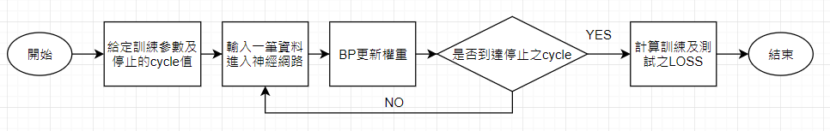

### batch mode:

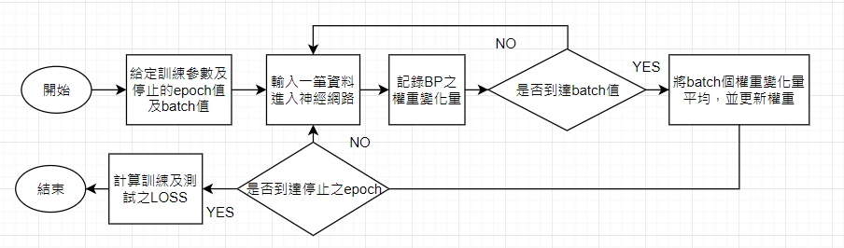

## equation

### back propagation

wji (n+1)=wji (n)+Δwji , Δwji (n)= η*δj (n)* yi (n) ,δj (n)= - $\frac{∂E(n)}{∂y_{j}(n)}* {\dot{φ}}_{j}(v_{j}(n))$

for j is output unit : - $\frac{∂E(n)}{∂y_{j}(n)}$ = $e_{j}(n)$

for j is hidden unit : - $\frac{∂E(n)}{∂y_{j}(n)}= \sum_{k}{δ_{k}\left(n\right) w_{kj}(n)}$, k is output uint

### generalized delta rule

Δwji (n)=η*δj*yi (n)+α*Δwji (n-1)

### batch mode

$$∆w_{ji}=\frac{1}{N}\sum_{n=1}^{N}{∆w_{j}(n)}$$

# simulation results

## program codes

function [ z ] = f( x,y )

z=5*sin(pi*x^2)*sin(2*pi*y)+1;

end

function [ y] = normolized_data(x,a,b)

% enter a matrix x ,size(x) is m by 1

% b:after normolized max value

% a:after normolized min value

y=(x-min(x))*(b-a)/(max(x)-min(x))+a;

end

function [ y ] = sigmoid( x )

y=1/(1+exp(-x));

end

%========================BPNN.m======================================

format long;

load('data.mat')

d=normolized_data(data(:,3),0.2,0.8);% map data -->range 0.2~0.8

% Input Data-->1(bias_input),x,y,z(normolized)

x=zeros(400,4);

x(:,1)=1;

x(:,2:3)=data(1:400,1:2);

x(:,4)=d(1:400);

%======================= Parameters ==============================

iter=200000; %iteration(cycle)

learning_rate=0.1;

alpha=0.8; %momentum

input_cell=3; % 1(bias_input),x,y

hidden_cell=20;

output_cell=1; % z=f(x,y)

%hidden layer to input layer:w_h2i

w_h2i=rand(hidden_cell,input_cell)-0.5; %-0.5~0.5

%output layer to hidden layer :w_o2h

w_o2h=rand(output_cell,hidden_cell)-0.5; %-0.5~0.5

%========================= Loss ================================

error=zeros(1,300);

E=zeros(1,300);

E_ave=zeros(1,iter);

%=========================Temp array=================================

yout=zeros(output_cell);

dw_o2h=zeros(output_cell,hidden_cell);

w_o2h_new=zeros(output_cell,hidden_cell);

dw_h2i=zeros(hidden_cell,input_cell );

w_h2i_new=zeros(hidden_cell,input_cell);

%=========================Training=============================

for cycle=1:iter

for num=1:300 % #1~#300 data

%=======================Forward===========================

% the value of x0*w0+x1*w1+...

v_hidden=zeros(hidden_cell,1); %hidden layer

v_output=zeros(output_cell,1); %output layer

% input layer to hidden layer

for j=1:hidden_cell

for i=1:input_cell

v_hidden(j,1)=v_hidden(j,1)+x(num,i)*w_h2i(j,i);

end

end

% hidden layer to output layer

for j=1:output_cell

for i=1:hidden_cell

v_output(j,1)=v_output(j,1)+sigmoid(v_hidden(i,1))*w_o2h(j,i);

end

yout(j)=sigmoid(v_output(j,1));

end

error(1,num)=d(num,1)-yout(j);

E(num)=1/2*(error(1,num))^2;

%===================== Back Propagation ==============================

for j=1:output_cell

delta_o2h=error(j,num)*(yout(j)*(1-yout(j)));

for i=1:hidden_cell

dw_o2h(j,i)=alpha*dw_o2h(j,i)+learning_rate*delta_o2h*sigmoid(v_hidden(i,1));

w_o2h_new(j,i)=w_o2h(j,i)+dw_o2h(j,i);

end

end

for j=1:hidden_cell

delta_h2i=sigmoid(v_hidden(j,1))*(1-sigmoid(v_hidden(j,1)))*delta_o2h*w_o2h(1,j);

for i=1:input_cell

dw_h2i(j,i)=alpha*dw_h2i(j,i)+learning_rate*delta_h2i*sigmoid(x(num,i));

w_h2i_new(j,i)=w_h2i(j,i)+dw_h2i(j,i);

end

end

w_o2h=w_o2h_new;

w_h2i=w_h2i_new;

end

E_ave(cycle)=mean(E);

end

%%

%======================== Predict data ==========================

% output cell data=1; % z=f(x,y)

predict_data=zeros(100,1);

for num=301:400

% the value of x0*w0+x1*w1+...

v_hidden=zeros(hidden_cell,1); %hidden layer

v_output=zeros(output_cell,1); %output layer

% input layer to hidden layer

for j=1:hidden_cell

for i=1:input_cell

v_hidden(j,1)=v_hidden(j,1)+x(num,i)*w_h2i(j,i);

end

end

% hidden layer to output layer

for j=1:output_cell

for i=1:hidden_cell

v_output(j,1)=v_output(j,1)+sigmoid(v_hidden(i,1))*w_o2h(j,i);

end

yout(j)=sigmoid(v_output(j,1));

predict_data(num-300,1)=yout(j);

end

error(1,num)=d(num,1)-yout(j);

E(num)=1/2*(error(1,num))^2;

end

%%

figure(1)

subplot(211),plot(1:cycle,E_ave),

title(['Training Loss:',num2str(E_ave(cycle)) ,' Hidden cell :',num2str(hidden_cell),' \eta:',num2str(learning_rate),' \alpha:',num2str(alpha)]);

xlabel('cycle'),ylabel('E ave')

subplot(212),stem(301:400,E(301:400),'.'),

title(['Predict Loss :',num2str(mean(E(301:400)))]);

xlabel('number of data'),ylabel('E')

suptitle(['E predict - E train = ',num2str(mean(E(301:400))-E_ave(cycle))]);

figure(2)

subplot(121)

a=data(301:400,1);

b=data(301:400,2);

c=normolized_data(predict_data(1:100,1),min(data(:,3)),max(data(:,3)));% z--> map to original range

scatter3(a,b,c,'.','r');

xlabel('x'),ylabel('y'),zlabel('z'),title('100 predict data');

subplot(122)

a=data(1:300,1);

b=data(1:300,2);

c=data(1:300,3);

scatter3(a,b,c,'.','b')

xlabel('x'),ylabel('y'),zlabel('z'),title('300 training data')

figure(3)

a=data(301:400,1);

b=data(301:400,2);

c=data(301:400,3);

scatter3(a,b,c,'.','r');

xlabel('x'),ylabel('y'),zlabel('z');

title('100 testing true data')

%========================BPNN_epoch.m======================================

format long;

load('data.mat')

d=normolized_data(data(:,3),0.2,0.8);% map data -->range 0.2~0.8

% Input Data-->1(bias_input),x,y,z(normolized)

x=zeros(400,4);

x(:,1)=1;

x(:,2:3)=data(1:400,1:2);

x(:,4)=d(1:400);

%======================= Parameters ==============================

batch=300;

iter=300000; %iteration(epoch)

learning_rate=0.2;

alpha=0.9; % momentum

input_cell=3; % 1(bias_input),x,y

hidden_cell=15;

output_cell=1; % z=f(x,y)

%hidden layer to input layer:w_h2i

w_h2i=rand(hidden_cell,input_cell)-0.5; %-0.5~0.5

%output layer to hidden layer :w_o2h

w_o2h=rand(output_cell,hidden_cell)-0.5; %-0.5~0.5

%========================= Loss ================================

error=zeros(1,300);

E=zeros(1,300);

E_ave=zeros(1,iter);

%=========================Temp array=================================

yout=zeros(output_cell);

dw_o2h=zeros(output_cell,hidden_cell);

dw_o2h_epoch=zeros(output_cell,hidden_cell);

dw_h2i=zeros(hidden_cell,input_cell );

dw_h2i_epoch=zeros(hidden_cell,input_cell);

%=========================Training=============================

for epoch=1:iter

for num=1:batch % #1~#batch data

%=======================Forward===========================

% the value of x0*w0+x1*w1+...

v_hidden=zeros(hidden_cell,1); %hidden layer

v_output=zeros(output_cell,1); %output layer

% input layer to hidden layer

for j=1:hidden_cell

for i=1:input_cell

v_hidden(j,1)=v_hidden(j,1)+x(num,i)*w_h2i(j,i);

end

end

% hidden layer to output layer

for j=1:output_cell

for i=1:hidden_cell

v_output(j,1)=v_output(j,1)+sigmoid(v_hidden(i,1))*w_o2h(j,i);

end

yout(j)=sigmoid(v_output(j,1));

end

error(1,num)=d(num,1)-yout(j);

E(num)=1/2*(error(1,num))^2;

%===================== Back Propagation ==============================

for j=1:output_cell

delta_o2h=error(j,num)*(yout(j)*(1-yout(j)));

for i=1:hidden_cell

dw_o2h(j,i)=alpha*dw_o2h(j,i)+learning_rate*delta_o2h*sigmoid(v_hidden(i,1));

%w_o2h_new(j,i)=w_o2h(j,i)+dw_o2h(j,i);

end

end

for j=1:hidden_cell

delta_h2i=sigmoid(v_hidden(j,1))*(1-sigmoid(v_hidden(j,1)))*delta_o2h*w_o2h(1,j);

for i=1:input_cell

dw_h2i(j,i)=alpha*dw_h2i(j,i)+learning_rate*delta_h2i*sigmoid(x(num,i));

%w_h2i_new(j,i)=w_h2i(j,i)+dw_h2i(j,i);

end

end

dw_o2h_epoch = dw_o2h_epoch + dw_o2h;

dw_h2i_epoch = dw_h2i_epoch + dw_h2i;

end

dw_o2h_epoch = dw_o2h_epoch / batch;

dw_h2i_epoch = dw_h2i_epoch / batch;

w_o2h = w_o2h + dw_o2h_epoch;

w_h2i = w_h2i + dw_h2i_epoch;

E_ave(epoch)=mean(E);

end

%%

%======================== Predict data ==========================

% output cell data=1; % z=f(x,y)

predict_data=zeros(100,1);

for num=301:400

% the value of x0*w0+x1*w1+...

v_hidden=zeros(hidden_cell,1); %hidden layer

v_output=zeros(output_cell,1); %output layer

% input layer to hidden layer

for j=1:hidden_cell

for i=1:input_cell

v_hidden(j,1)=v_hidden(j,1)+x(num,i)*w_h2i(j,i);

end

end

% hidden layer to output layer

for j=1:output_cell

for i=1:hidden_cell

v_output(j,1)=v_output(j,1)+sigmoid(v_hidden(i,1))*w_o2h(j,i);

end

yout(j)=sigmoid(v_output(j,1));

predict_data(num-300,1)=yout(j);

end

error(1,num)=d(num,1)-yout(j);

E(num)=1/2*(error(1,num))^2;

end

%%

figure(1)

subplot(211),plot(1:epoch,E_ave),

title(['Training Loss:',num2str(E_ave(epoch)) ,' Hidden cell :',num2str(hidden_cell),' \eta:',num2str(learning_rate),' \alpha:',num2str(alpha)]);

xlabel('epoch'),ylabel('E ave')

subplot(212),stem(301:400,E(301:400),'.'),

title(['Predict Loss :',num2str(mean(E(301:400)))]);

xlabel('number of data'),ylabel('E')

suptitle(['E predict - E train = ',num2str(mean(E(301:400))-E_ave(epoch))]);

figure(2)

subplot(121)

a=data(301:400,1);

b=data(301:400,2);

c=normolized_data(predict_data(1:100,1),min(data(:,3)),max(data(:,3)));% z--> map to original range

scatter3(a,b,c,'.','r');

xlabel('x'),ylabel('y'),zlabel('z'),title('100 predict data');

subplot(122)

a=data(1:300,1);

b=data(1:300,2);

c=data(1:300,3);

scatter3(a,b,c,'.','b')

xlabel('x'),ylabel('y'),zlabel('z'),title('300 training data')

figure(3)

a=data(301:400,1);

b=data(301:400,2);

c=data(301:400,3);

scatter3(a,b,c,'.','r');

xlabel('x'),ylabel('y'),zlabel('z');

title('100 testing true data')

## graph

### 400 data (300 training & 100 testing):

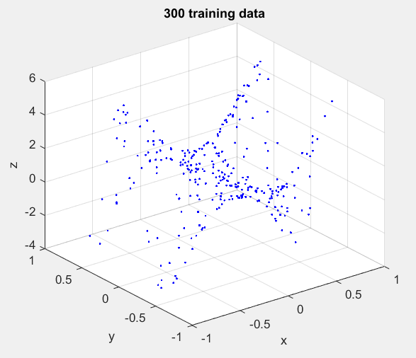 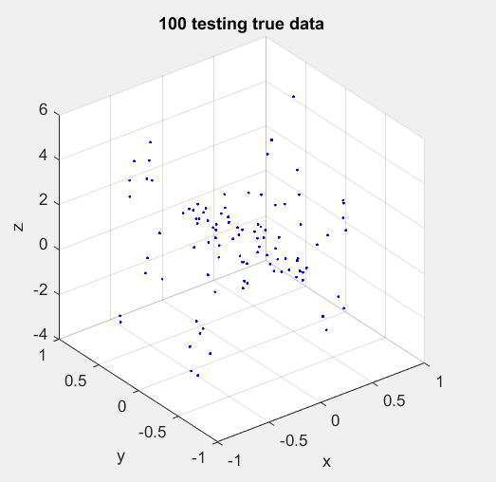

圖一

### Sequential learning:

#### ( hidden cell , learning rate , momentum )= ( 20 ,0.01 , 0 )

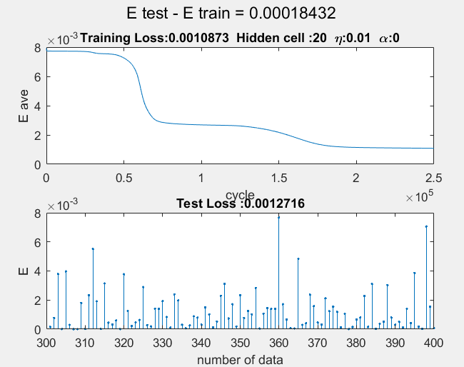 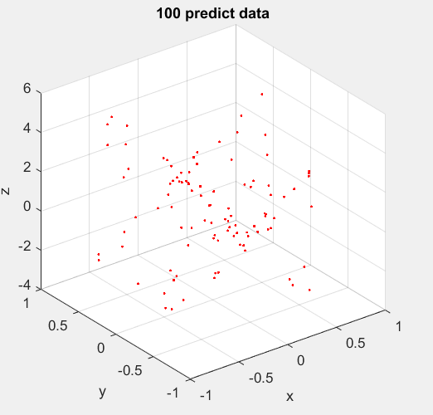

圖二

#### ( hidden cell , learning rate, momentum )=( 5 ,0.1 , 0.8 )

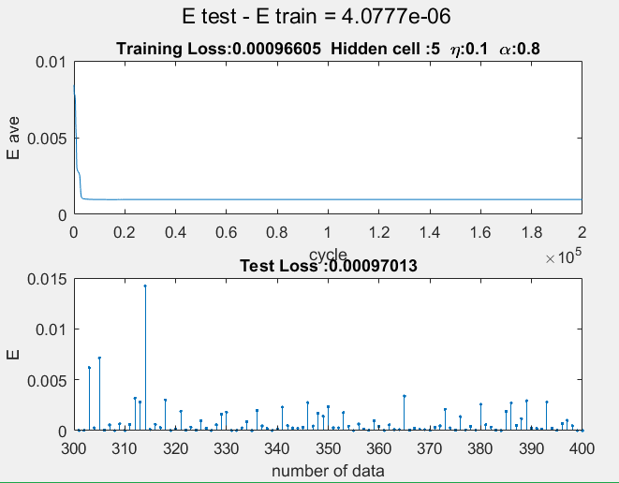 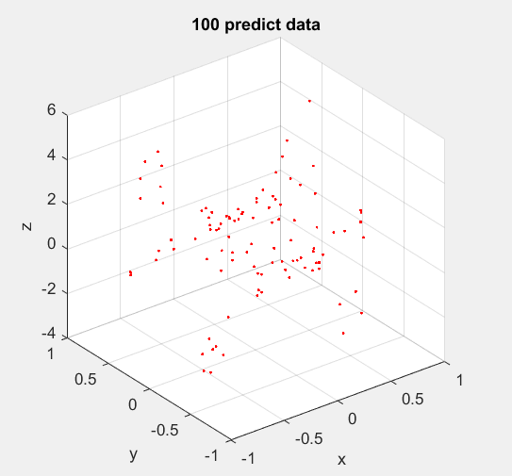

圖三

#### ( hidden cell , learning rate , momentum )=( 10 ,0.1 , 0.8 )

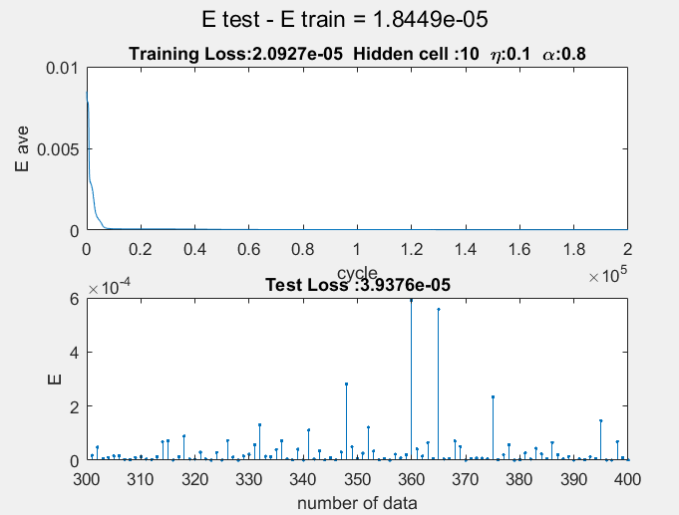 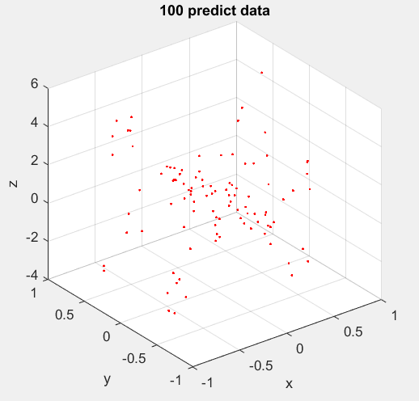

圖四

#### ( hidden cell , learning rate , momentum )=( 15 ,0.1 , 0.8 )

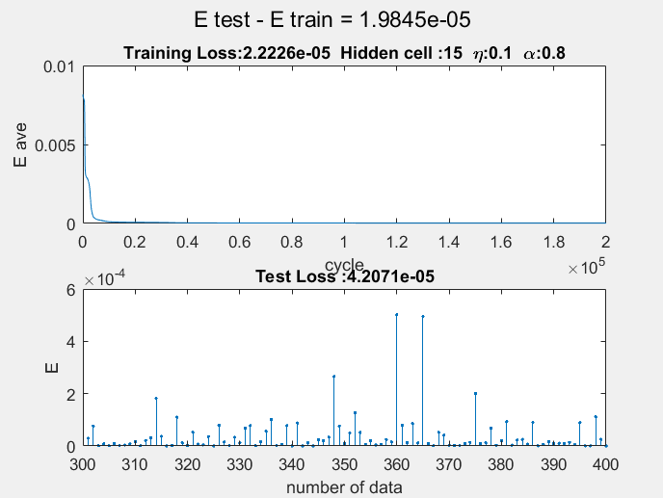 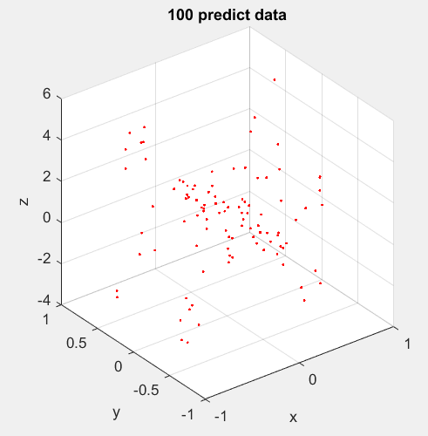

圖五

#### ( hidden cell , learning rate , momentum )= ( 15 ,0.1 , 0.9 )

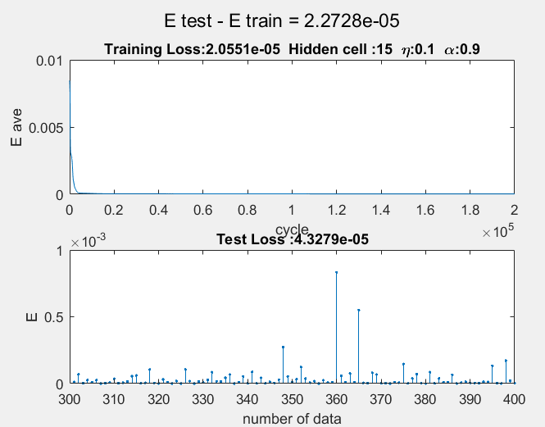 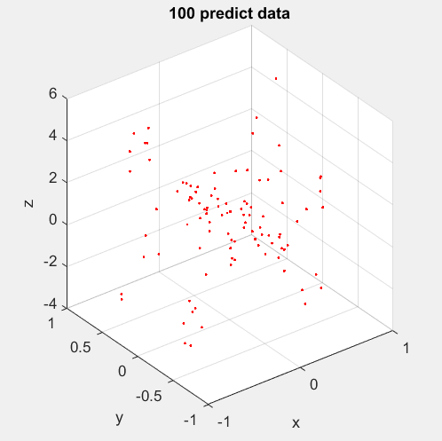

圖六

#### ( hidden cell , learning rate , momentum )= ( 20 ,0.1 , 0.8 )

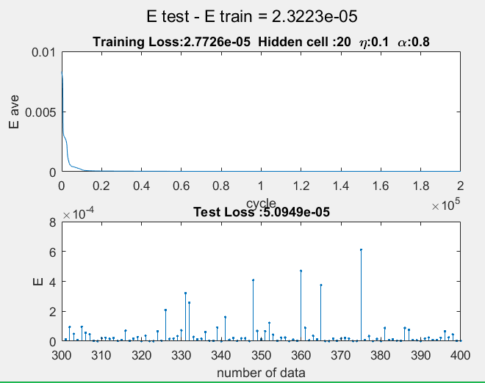 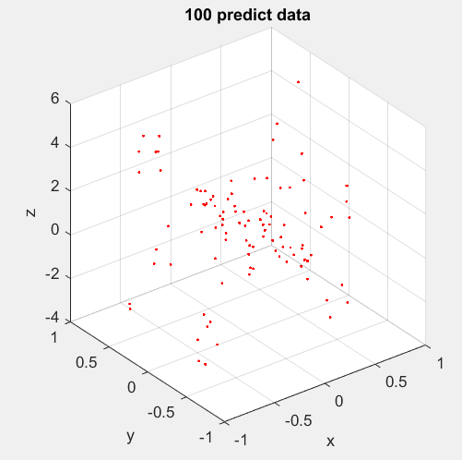

圖七

#### ( hidden cell , learning rate , momentum )= ( 20 ,0.01 , 0.8 )

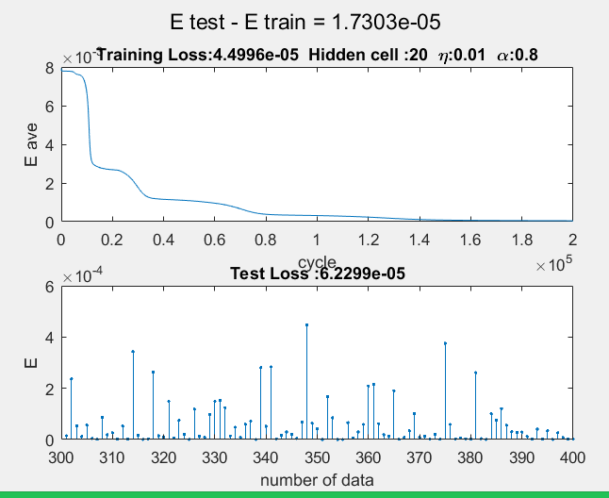 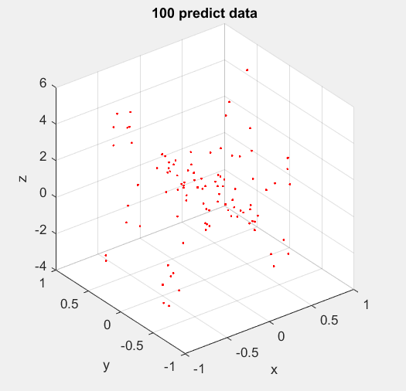

圖八

### batch learning:

#### ( hidden cell , learning rate , momentum )= ( 10 ,0.5 , 0.8 )

#### 

圖九

#### ( hidden cell , learning rate , momentum )= ( 10 ,1 , 0.8 )

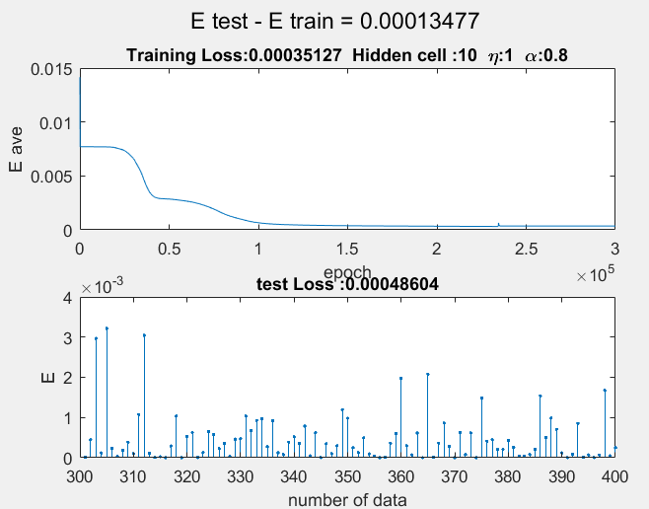 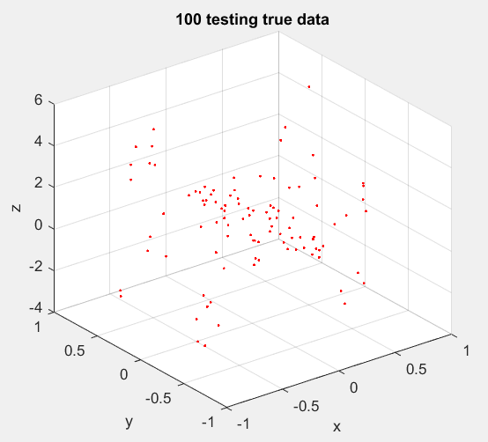

圖十

#### ( hidden cell , learning rate , momentum )= ( 10 ,0.2, 0.9 )

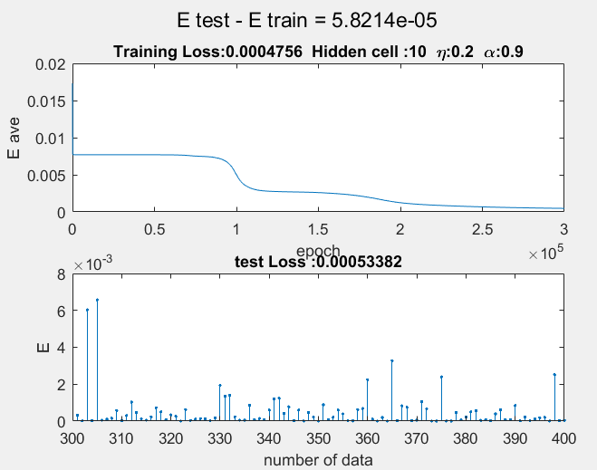 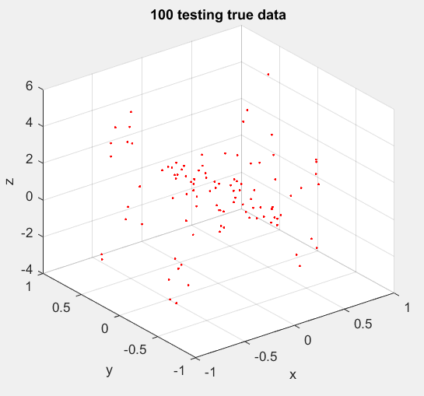

圖十一

#### ( hidden cell , learning rate , momentum )= ( 15 ,0.2, 0.9 )

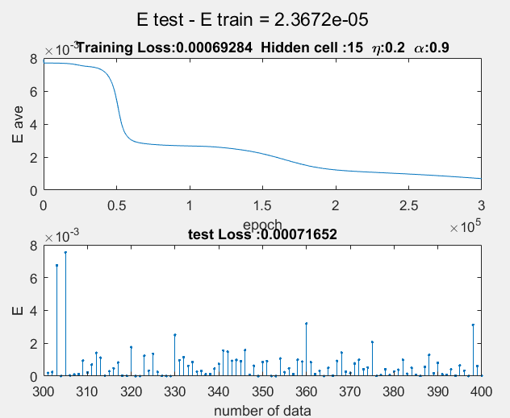 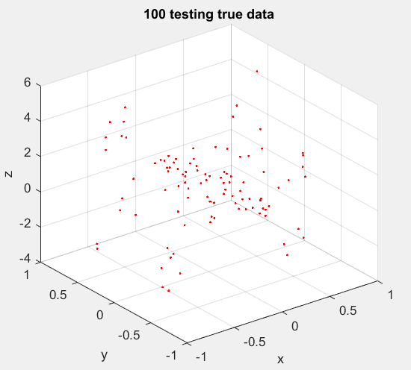

圖十二

## table

### sequential learning:

|  |  |  |  |  |  |
| --- | --- | --- | --- | --- | --- |
| Hidden cell | η | α | Training Loss | Test Loss | E_train-E_test |
| 20 | 0.01 | 0 | 0.0010873 | 0.0012716 | 0.00018432 |
| 5 | 0.1 | 0.8 | 0.0009660 | 0.000970 | 0.0000040 |
| 10 | 0.1 | 0.8 | 0.000020 | 0.000039 | 0.0000184 |
| 15 | 0.1 | 0.8 | 0.000022 | 0.000042 | 0.0000198 |
| 15 | 0.1 | 0.9 | 0.000020 | 0.000043 | 0.0000227 |
| 20 | 0.1 | 0.8 | 0.000027 | 0.000050 | 0.0000232 |
| 20 | 0.01 | 0.8 | 0.000044 | 0.000062 | 0.0000173 |

表一

### batch learning:

|  |  |  |  |  |  |
| --- | --- | --- | --- | --- | --- |
| Hidden cell | η | α | Training Loss | Testing Loss | E_train-E_test |
| 10 | 0.5 | 0.8 | 0.000368 | 0.000460 | 0.0009130 |
| 10 | 1 | 0.8 | 0.000351 | 0.000486 | 0.0001340 |
| 10 | 0.2 | 0.9 | 0.000475 | 0.000533 | 0.0000582 |
| 15 | 0.2 | 0.9 | 0.000692 | 0.000716 | 0.0000236 |

表二

# conclusion-analysis

以Learning Mode 來看，Batch learning 因為將一批的權重更新量做平均，所以可使學習效果穩定、平滑，適用於處理細緻複雜的問題，缺點是收斂速度緩慢，耗費運算空間；Sequential learning 優點是可以做real-time學習，但因為每一筆資料皆會影響權重，如果資料選得不好，造成陷入局部最佳值，為了解決此情況發生，我們可以加入Momentum將上一次的更新量保留一個比例，加入此次的權重更新量，由圖二Training Loss 0.00108，加入Momentum 0.8後，得到Training Loss 0.00002 ，明顯提升學習效果，也可以發現加入慣量後，收斂速度提高了。

從learning rate的角度來看，理論上learing rate越小，學習之Loss也會變小，而圖七之Training Loss 0.000044 ，將learning rate提高後，得到圖八 Training Loss 0.00002，Loss反而降低了0.00002，此情況也可由圖九圖十觀察到，推測原因可能是此次的訓練目標函數，對於learning rate精度要求不高，故0.1或0.01對函數來說影響不大；從Hidden Layer 神經元個數來看，由表一，固定learning rate 0.1、Momentum 0.8，改變神經元數5,10,15，觀察到10顆的traning loss 最好 ，故神經元太多並不會提高學習表現，我們要選擇最合適的神經元個數。

由表一，此次學習效果最好的是10顆神經元、learning rate 0.1 、M0mentum 0.8，testing loss為0.000039，如何調整參數至最佳結果是我們需要進一步學習的課題。