Университет ИТМО
Факультет ФПИ и КТ
P33131

Отчет
по лабраторной работе №1

«Распределенные системы хранения данных»

Студент:
Ляо Ихун
Гр.P33131
Предподаватель:
Шешуков Дмитрий Михайлович

Задание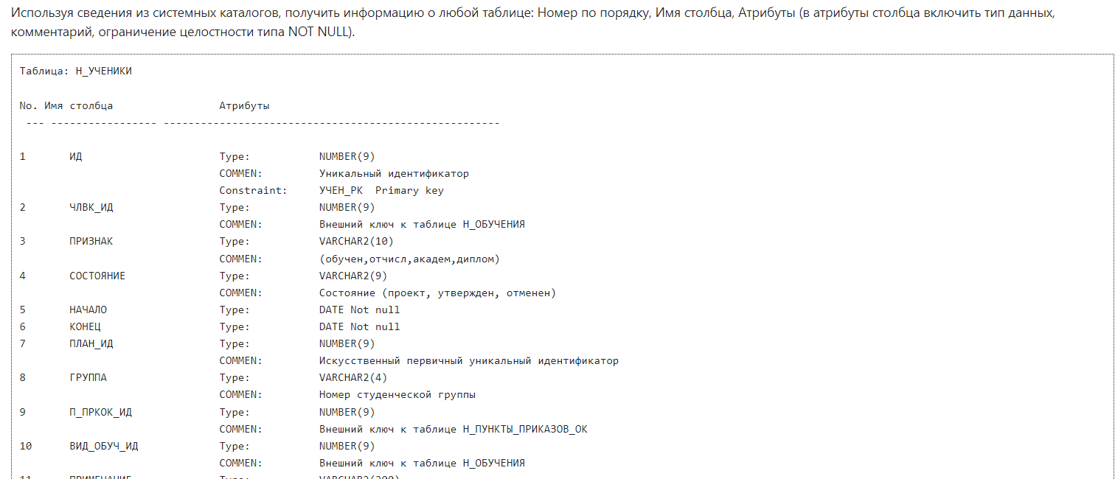

Решение

create or replace procedure Read_Tables_By_Name(rel text) as
$$
DECLARE
alloid int [] := ARRAY(select C.oid from pg_description D, pg_attribute A,pg_class C,pg_type T where
C.relname='account' and
A.attrelid = C.oid and
A.atttypid = T.oid AND
A.attnum = D.objsubid and
t.typname NOT LIKE '%id' and
A.attnum > 0 order by C.oid);
types text []:=ARRAY(select T.typname from pg_description D, pg_attribute A,pg_class C,pg_type T where
C.relname='account' and
A.attrelid = C.oid and
A.atttypid = T.oid AND
A.attnum = D.objsubid and
t.typname NOT LIKE '%id' and
A.attnum > 0 order by C.oid);
coloums_name text [] := ARRAY(select A.attname from pg_description D, pg_attribute A,pg_class C,pg_type T where
C.relname='account' and
A.attrelid = C.oid and
A.atttypid = T.oid AND
A.attnum = D.objsubid and
t.typname NOT LIKE '%id' and
A.attnum > 0 order by C.oid);
descriptions text [] := ARRAY(select D.description from pg_description D, pg_attribute A,pg_class C,pg_type T where
C.relname='account' and
A.attrelid = C.oid and
A.atttypid = T.oid AND
A.attnum = D.objsubid and
t.typname NOT LIKE '%id' and
A.attnum > 0 order by C.oid);
attnotnull bool [] := ARRAY(select A.attnotnull from pg_description D, pg_attribute A,pg_class C,pg_type T where
C.relname='account' and
A.attrelid = C.oid and
A.atttypid = T.oid AND
A.attnum = D.objsubid and
t.typname NOT LIKE '%id' and
A.attnum > 0 order by C.oid);
result text := format(E'Таблица:%s\noid:%s\n\n%5s%15s%40s\n%s',rel,alloid[1],'No.','Имя столбца','Атрибуты','---- ----------------- ------------------------------------------------------------');
i int := 1;
num int := 1;
o int;
last int := alloid[1];
BEGIN
foreach o in array alloid loop
if o != last then
num := 1;
last := o;
result := result|| format(E'\n\noid:%s\n%5s%15s%40s\n%s',o,'No.','Имя столбца','Атрибуты','---- ----------------- ------------------------------------------------------------');
result := result || E'\n';
result := E'\n%'||result;
end if;
if attnotnull[i] then
result:=result|| E'\n'||format('%-5s',num)||format('%15s',coloums_name[i])||format('%15s','Type:')||format('%25s',types[i]||' not null');
elsif not attnotnull[i] then
result:=result|| E'\n'||format('%-5s',num)||format('%15s',coloums_name[i])||format('%15s','Type:')||format('%25s',types[i]);
end if;
result:=result||E'\n'||format('%15s','COMMEN:')||format('%-50s',descriptions[i])||E'\n'||E'\n';
num := num + 1;
i := i + 1;
end loop;
raise info '%',result;
end;
$$ language plpgsql;
call Read_Tables_By_Name('account');
Скрипт:
psql -h pg -d studs -c"
call Read_Tables_By_Name('$1');
"

Пример
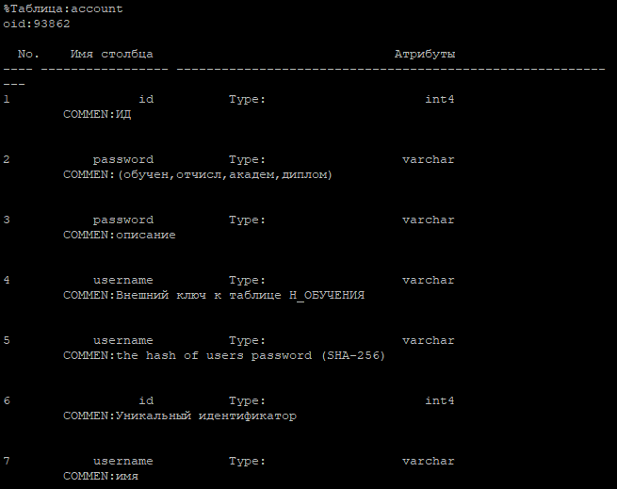

Вывод
В ходе выполнения работы изучал как использовать системный каталог чтобы читать информацию таблиц в БД.

