Problem1:

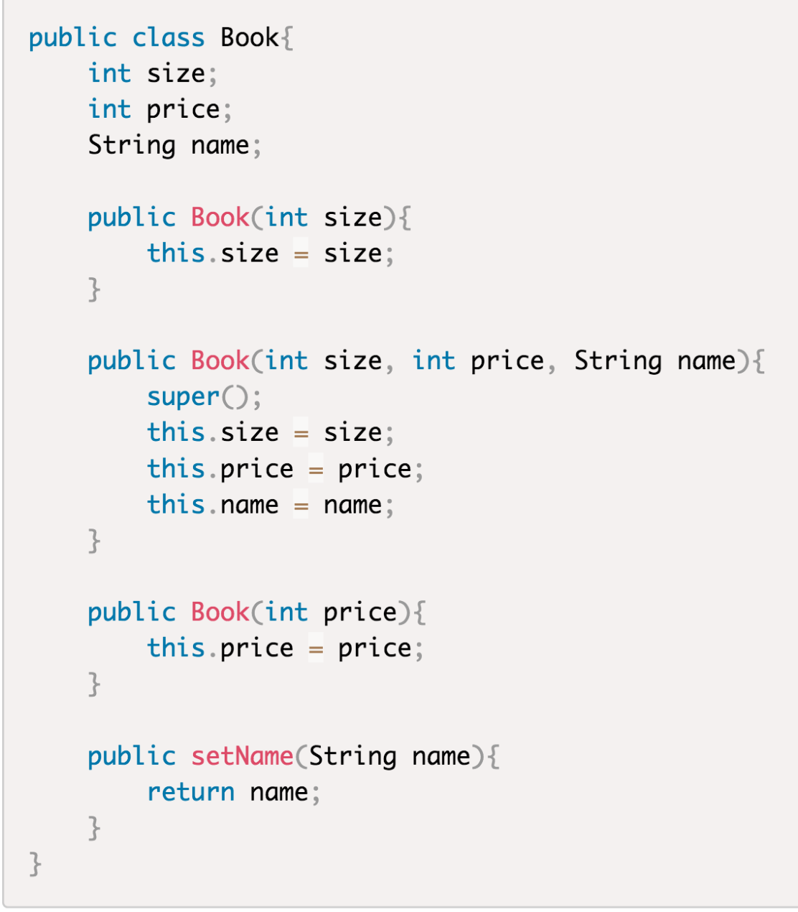

the line of

**public setName(String name)**

is wrong,because the function have a save the Name

so it should be changed to

**public void setName(String name)**

the next line change to **this.name = name**

Problem2:

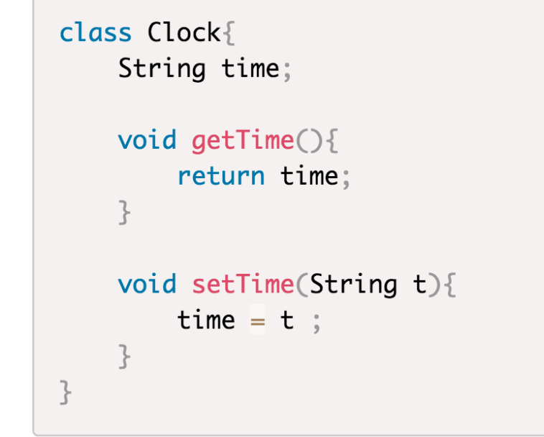

the line of

**void getTime(){}**

is wrong,because it needs a return type and change to

**String getTime(){}**