Week 1

Then read study material 1, follow instructions and install Python to your PC!
Give a short report about the process. Did you manage to install it?

1. Using this command to install Python on my Ubuntu Linux system.
sudo apt-get install python
2. Using text editor coding and save as .py
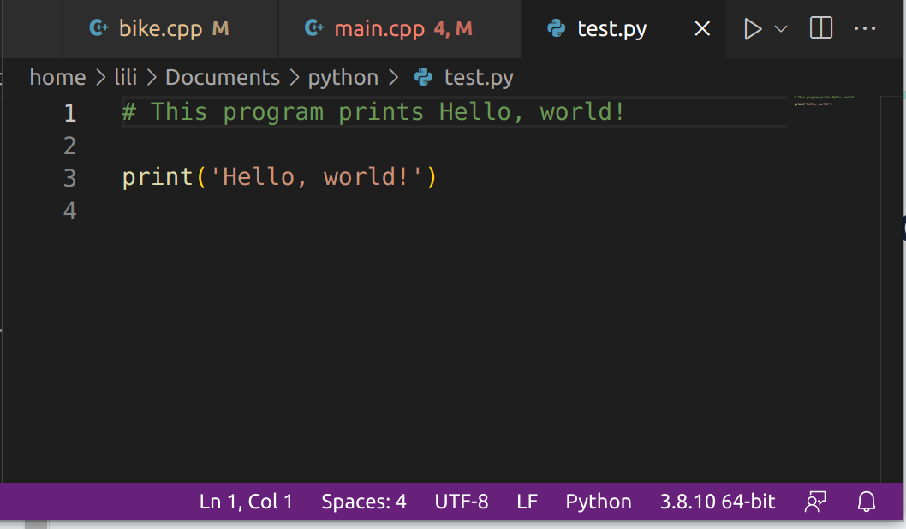
3. Compile and run in terminal using this command
python test.py

