## Week 3

1  
User gives a value and our program tells if the value is > 100 or not.

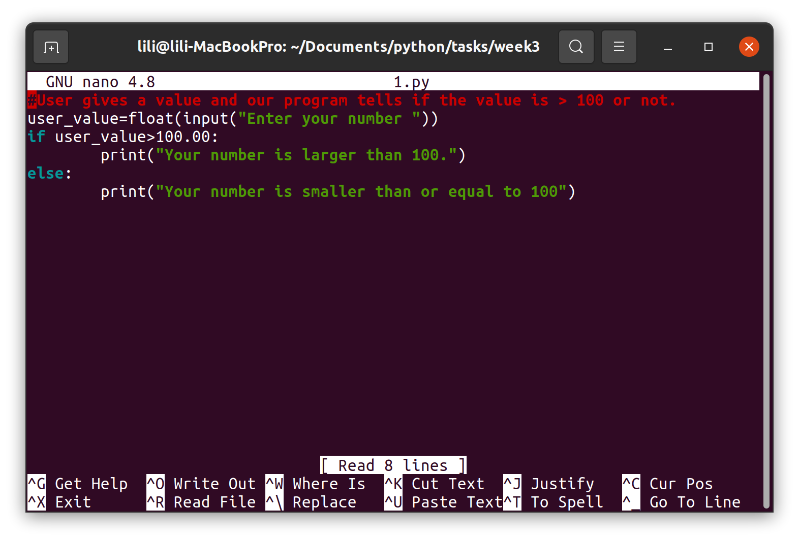  
2 User enters a weekday number and the program tells the name of the day.  
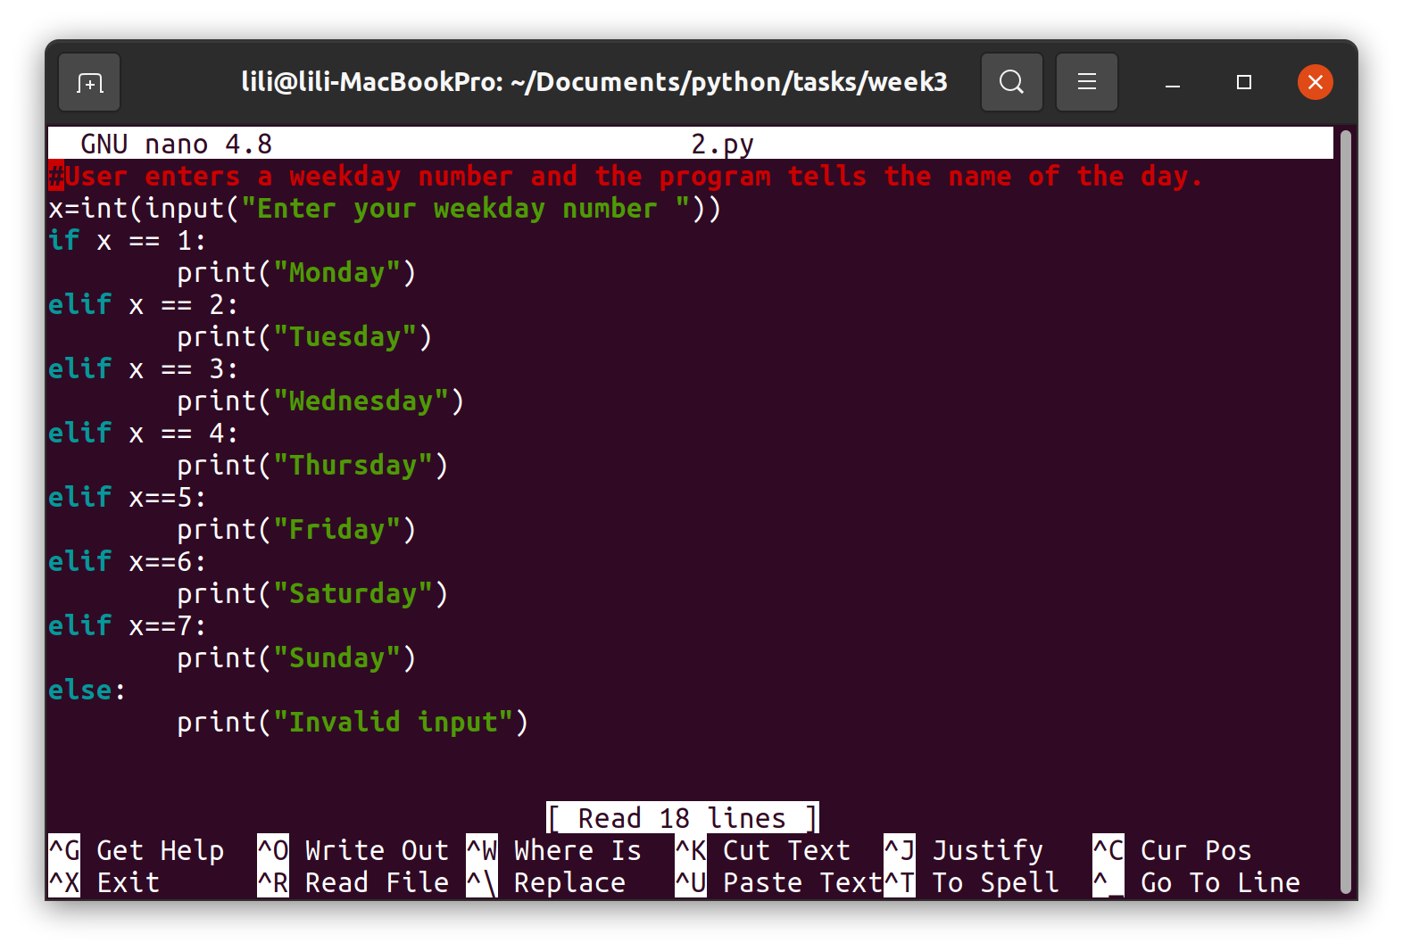  
3Program calculates BMI and gives also a textual description.

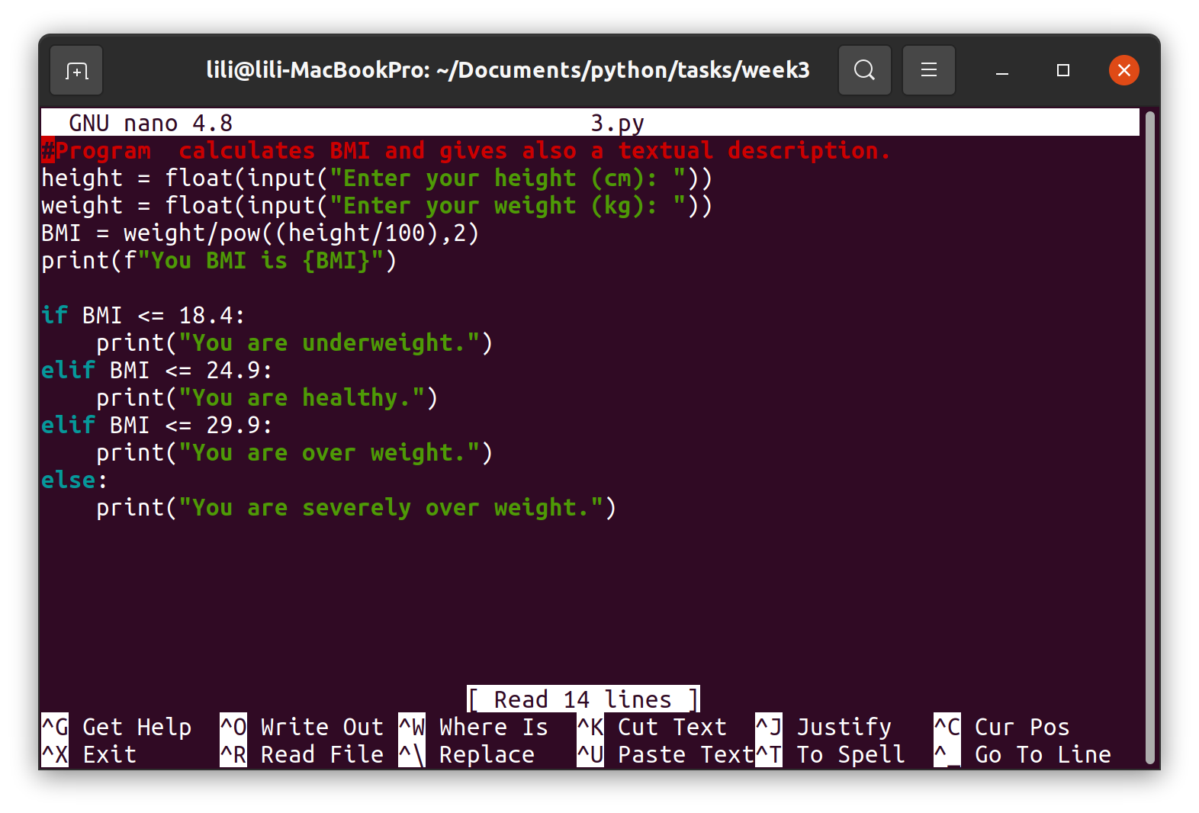4User gives a month number and our program tells the number of days in that month.  
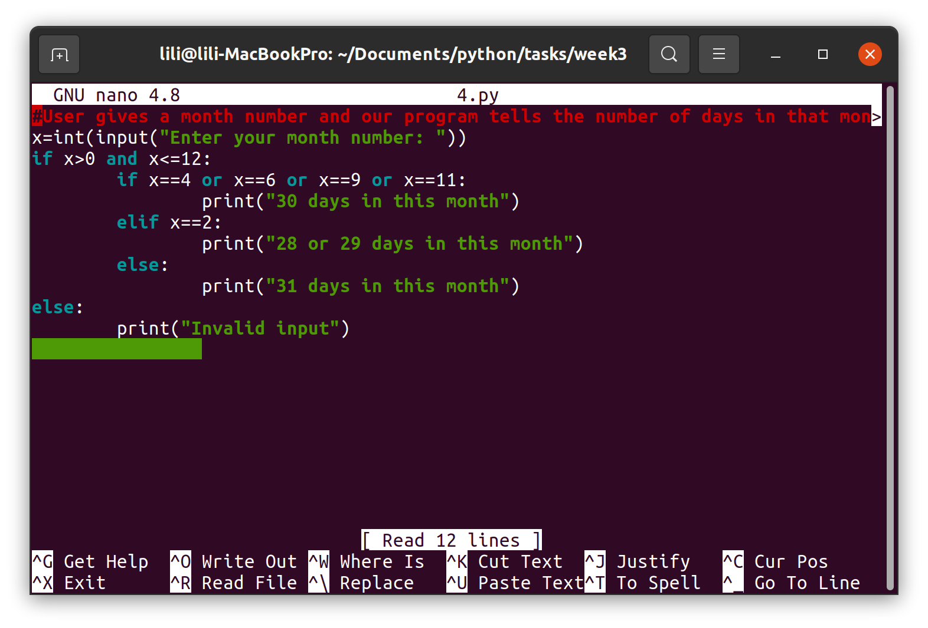  
5User gives the lengths of the triangle's sides. Program tells what is the triangle like (e.g. is it right angled, isosceles…)

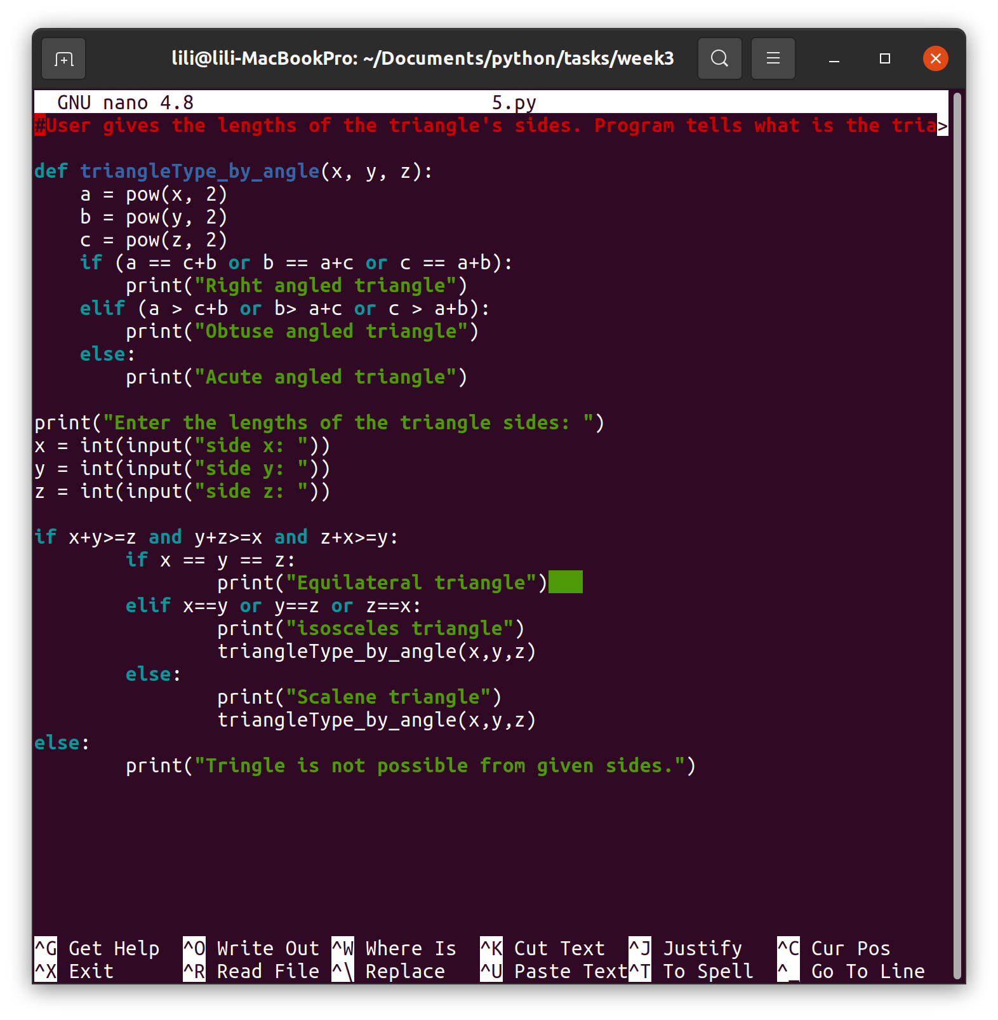6Variables a, b and c have different values. Create a program that finds the biggest one.   
Show 3 different ways to solve the problem.

