## Week 4

1. Program calculates the sum of values 1 - 5.  
Use: for and while

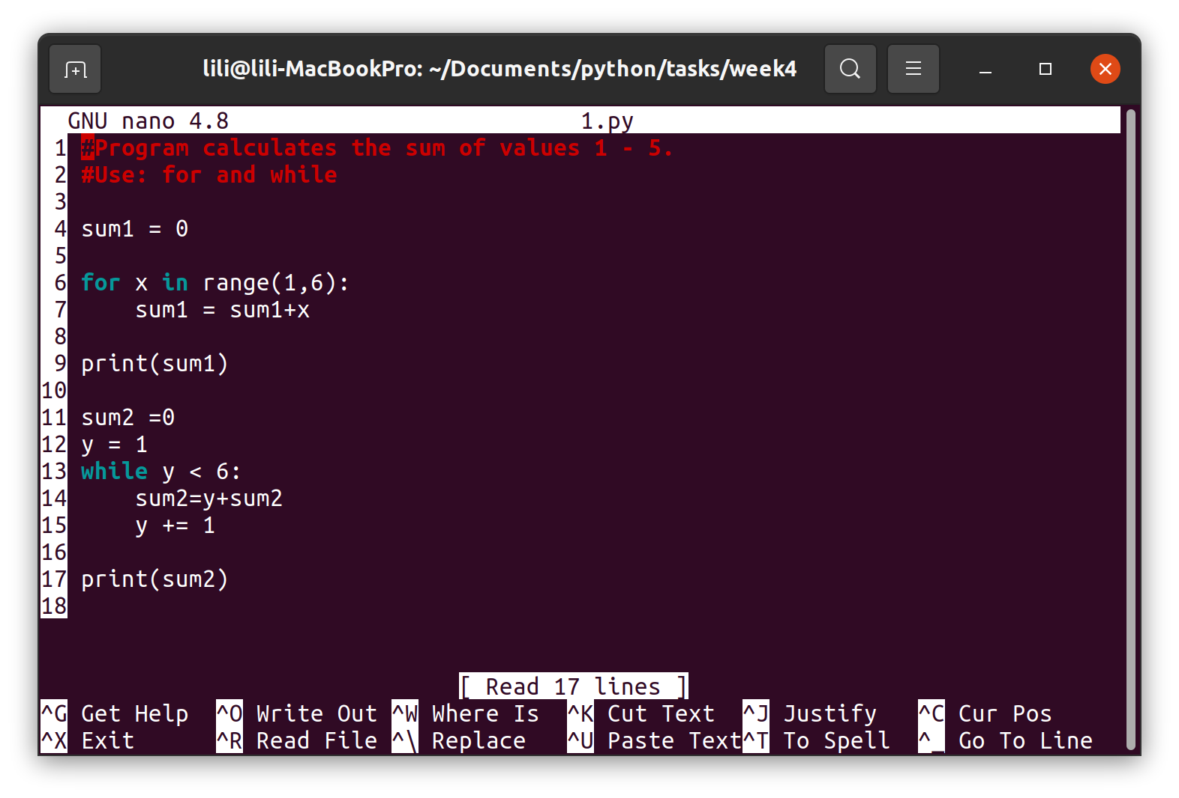2. Program calculates the sum of **even** numbers between 2 - 40.  
Use: for and while

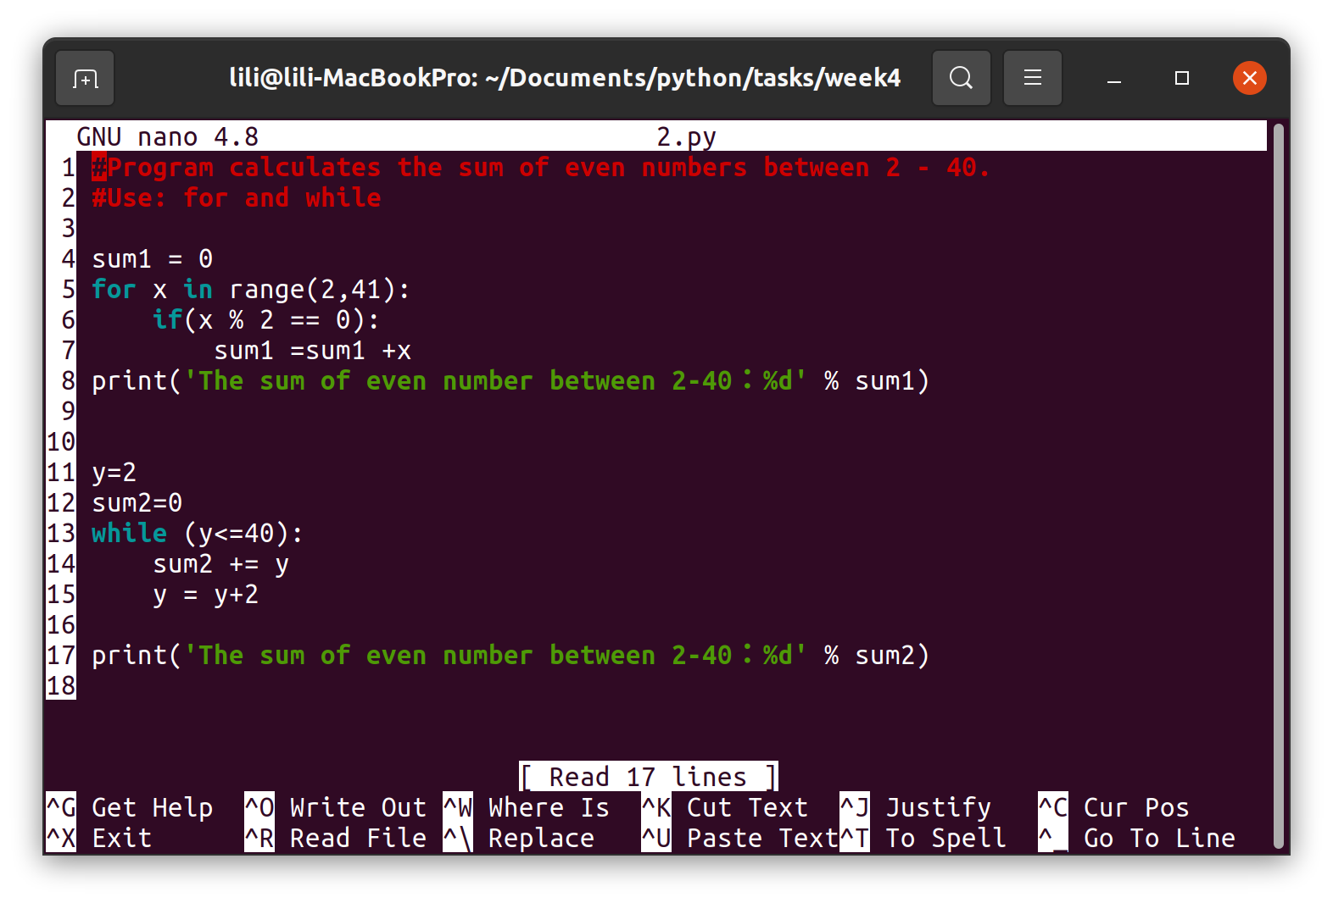3. Program calculates sum: 5, 10, 15, .. 100.  
Use: for and while

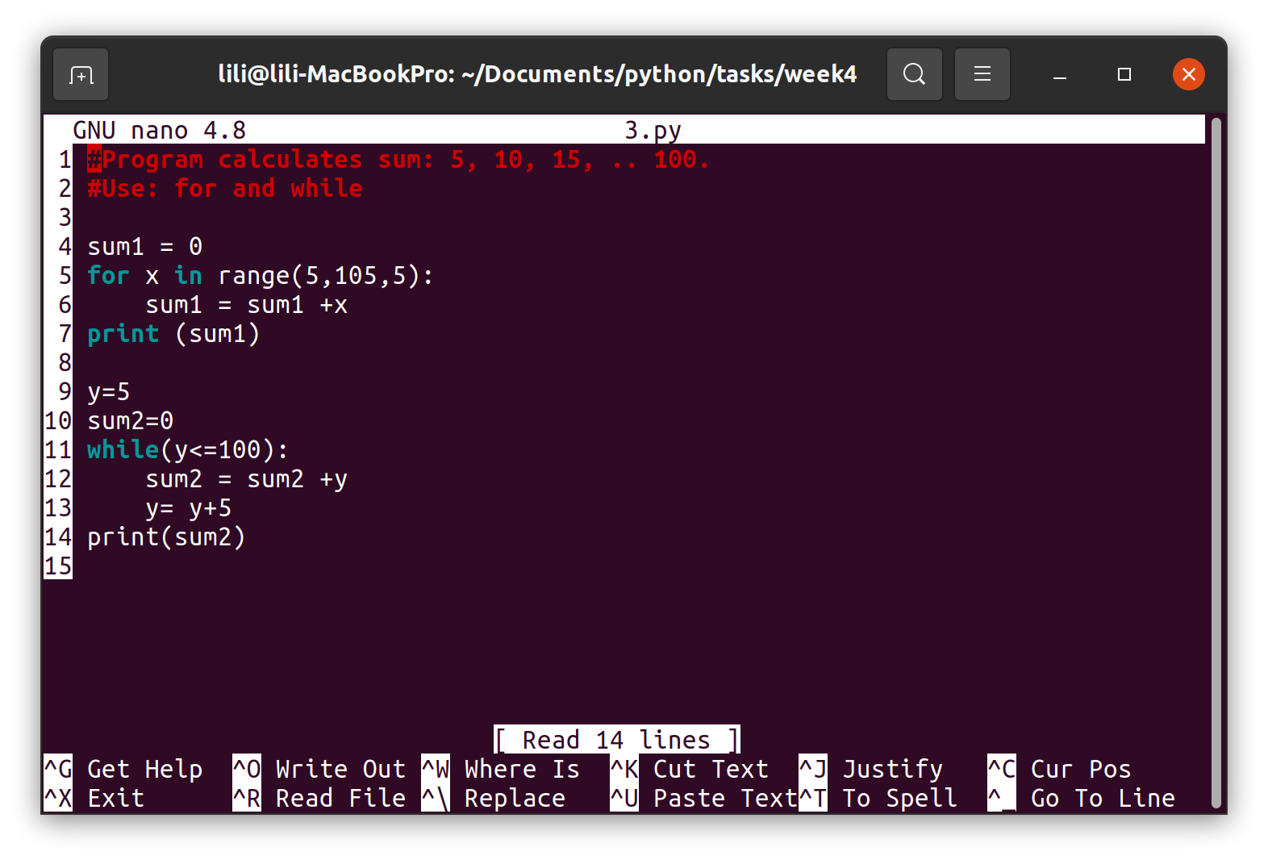4. Program throws dice 100 times and tells amounts of different values (1, 2, 3, 4, 5, and 6).  
Hints:  
from random import randint  
# scaling example [0,10]  
value = randint(0, 10)

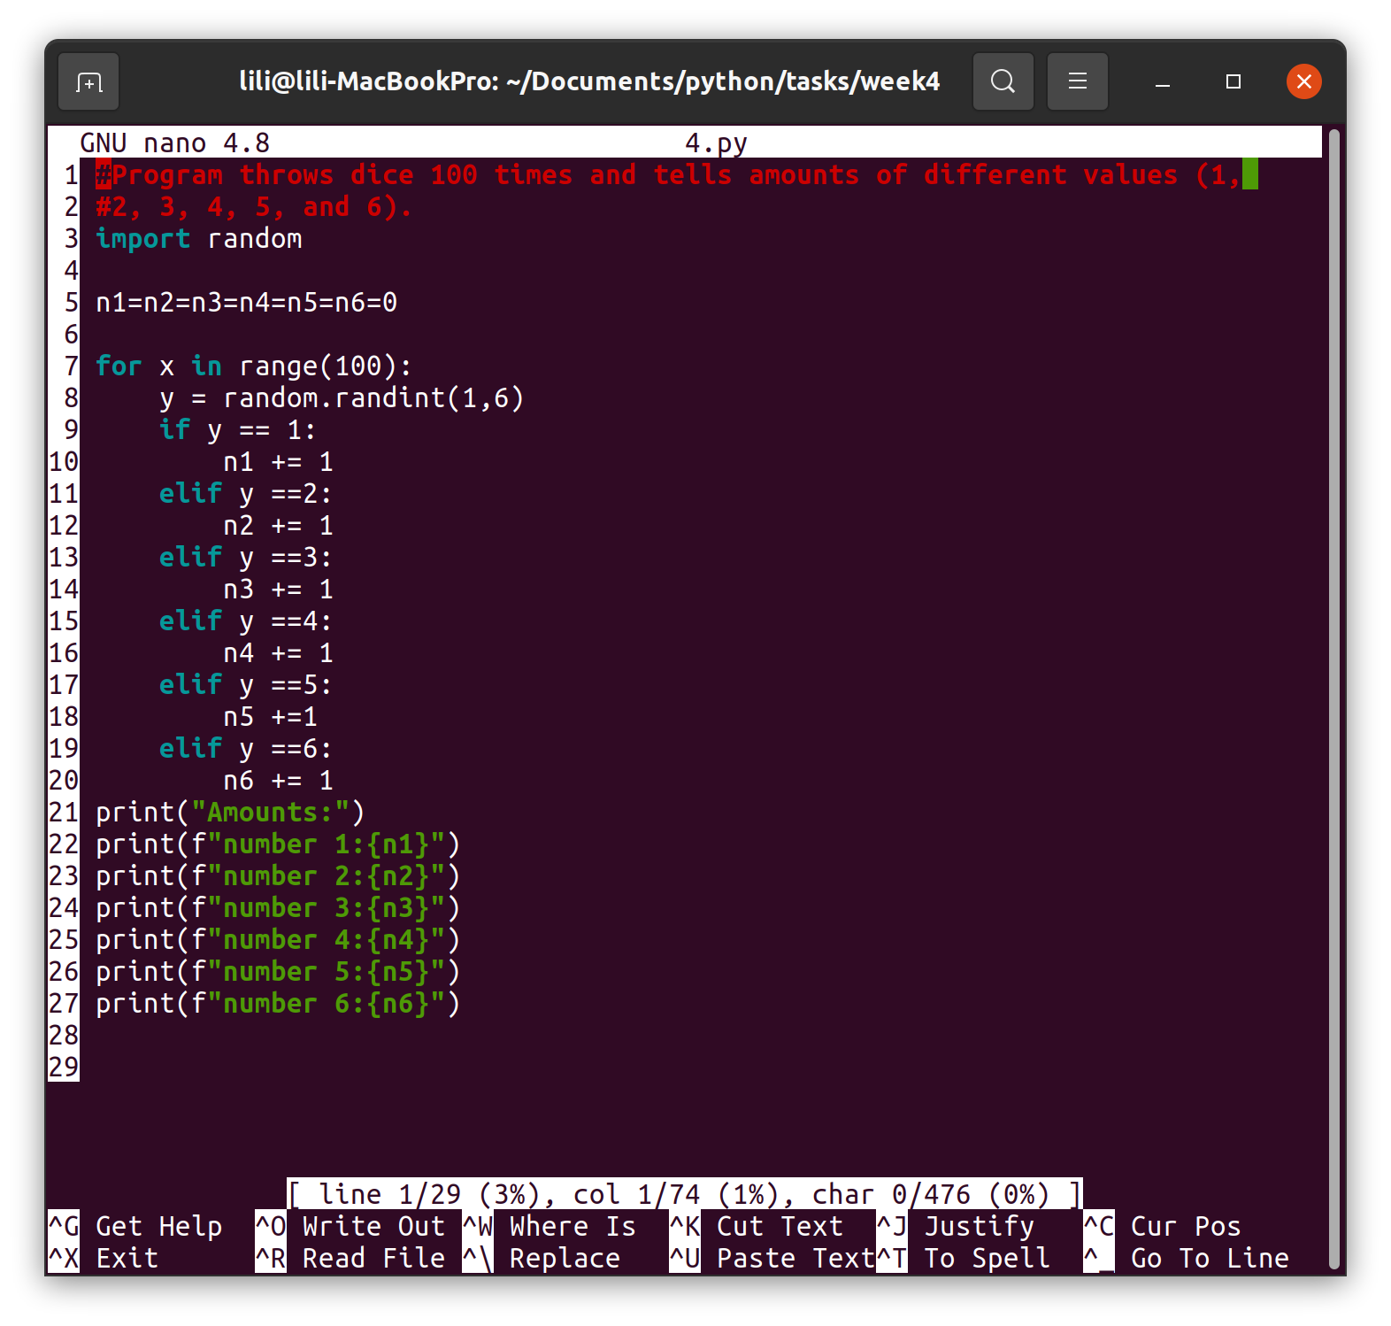  
  
5  
Account manager with menu:  
User can make deposits  
Do withdrawal  
Check the balance

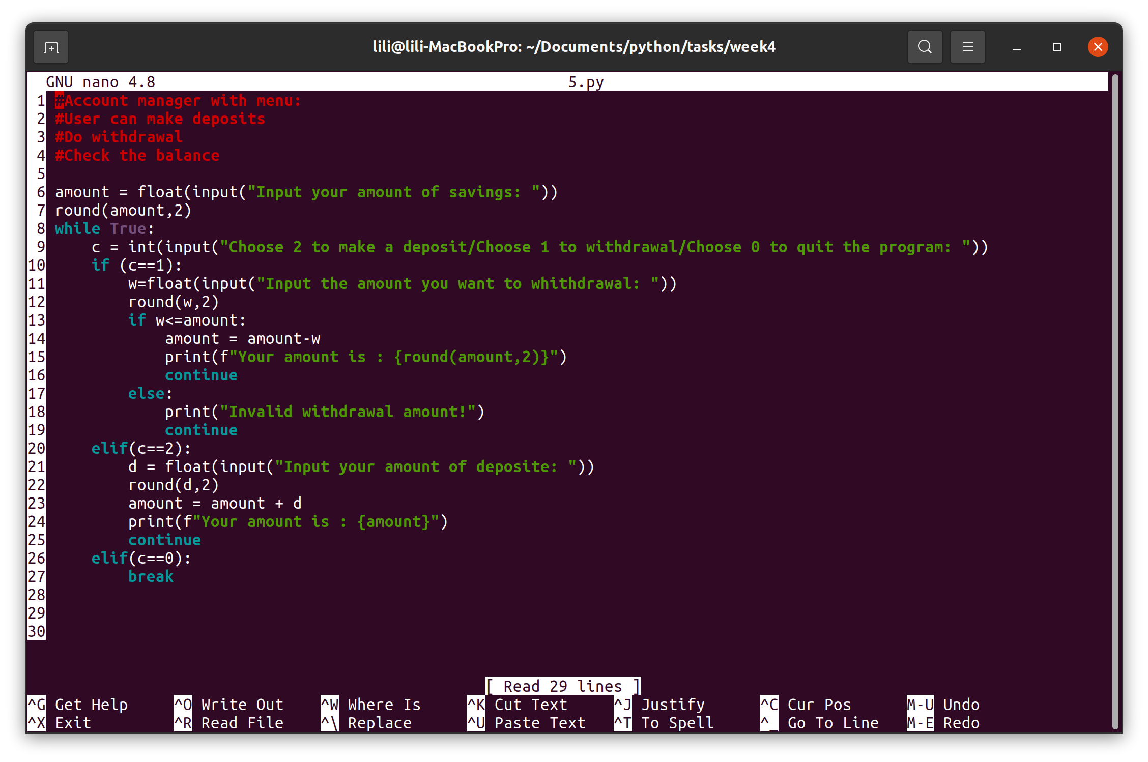the run

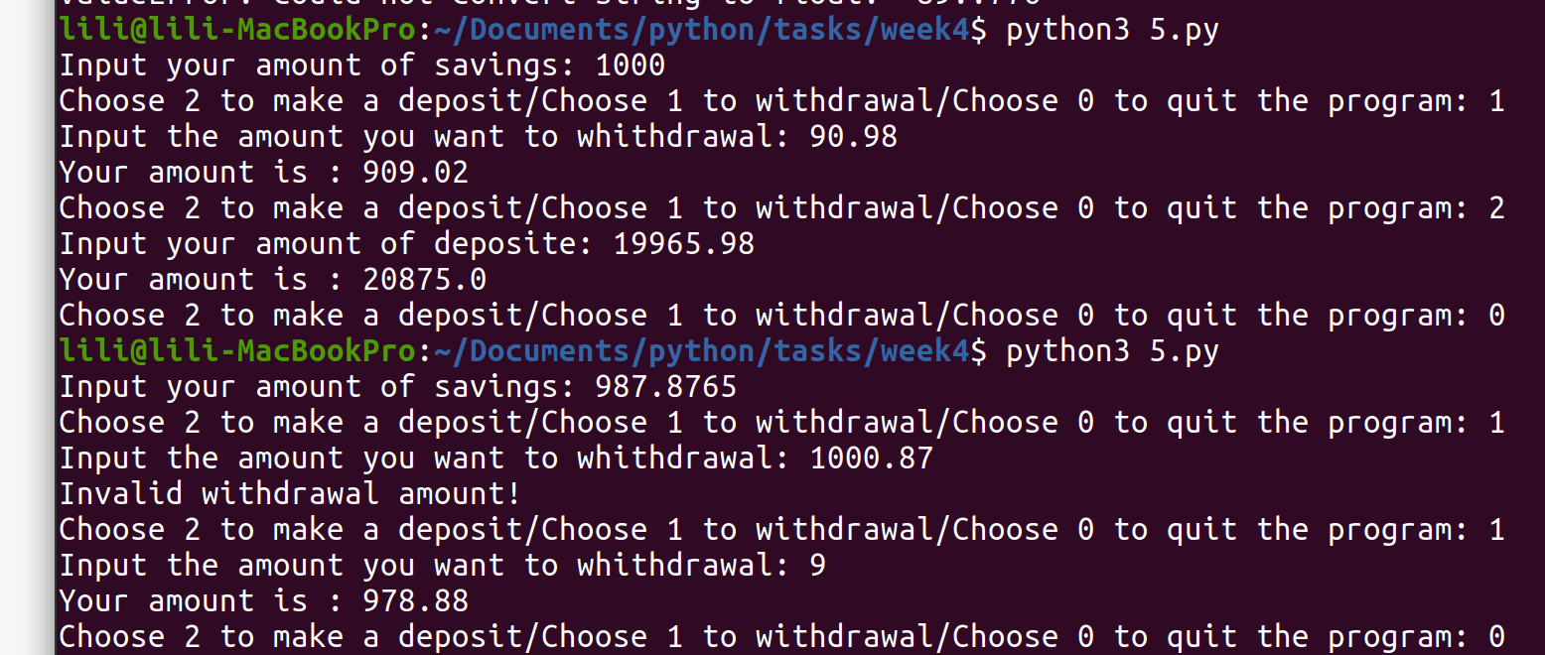  
6  
Try to solve this equation (try find 1 of roots)  
3x^3 - 4x^2 + 9x +5 = 0  
Here ^ means exponent



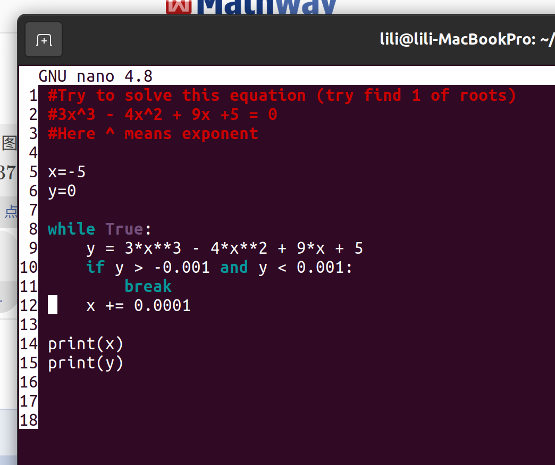

7  
Print this kind of semipyramid (character amount of rows is given in a variable):

m  
mm  
mmm  
mmmm  
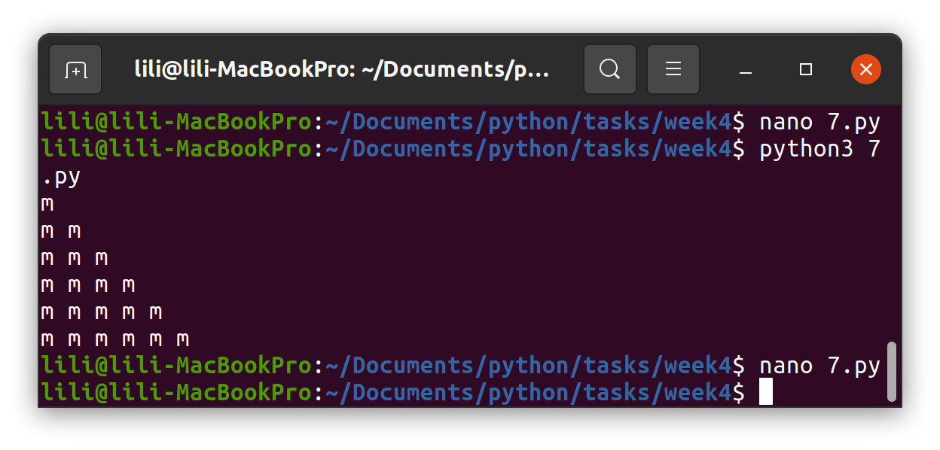mmmmm

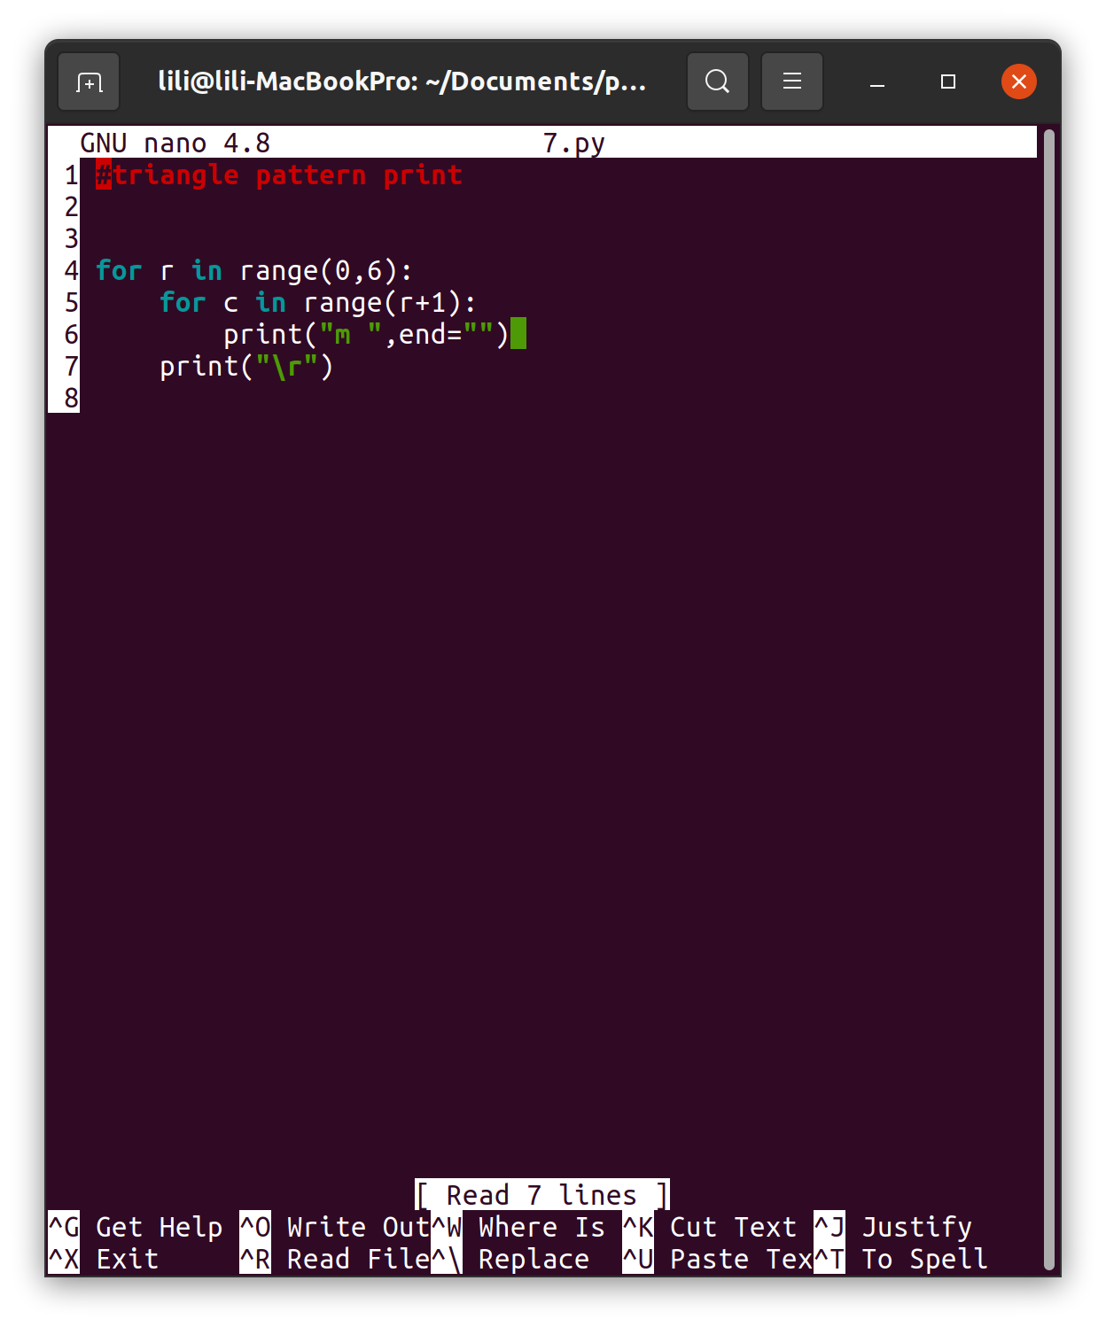

8.  
Program calculates the factorial of n (given in a variable)

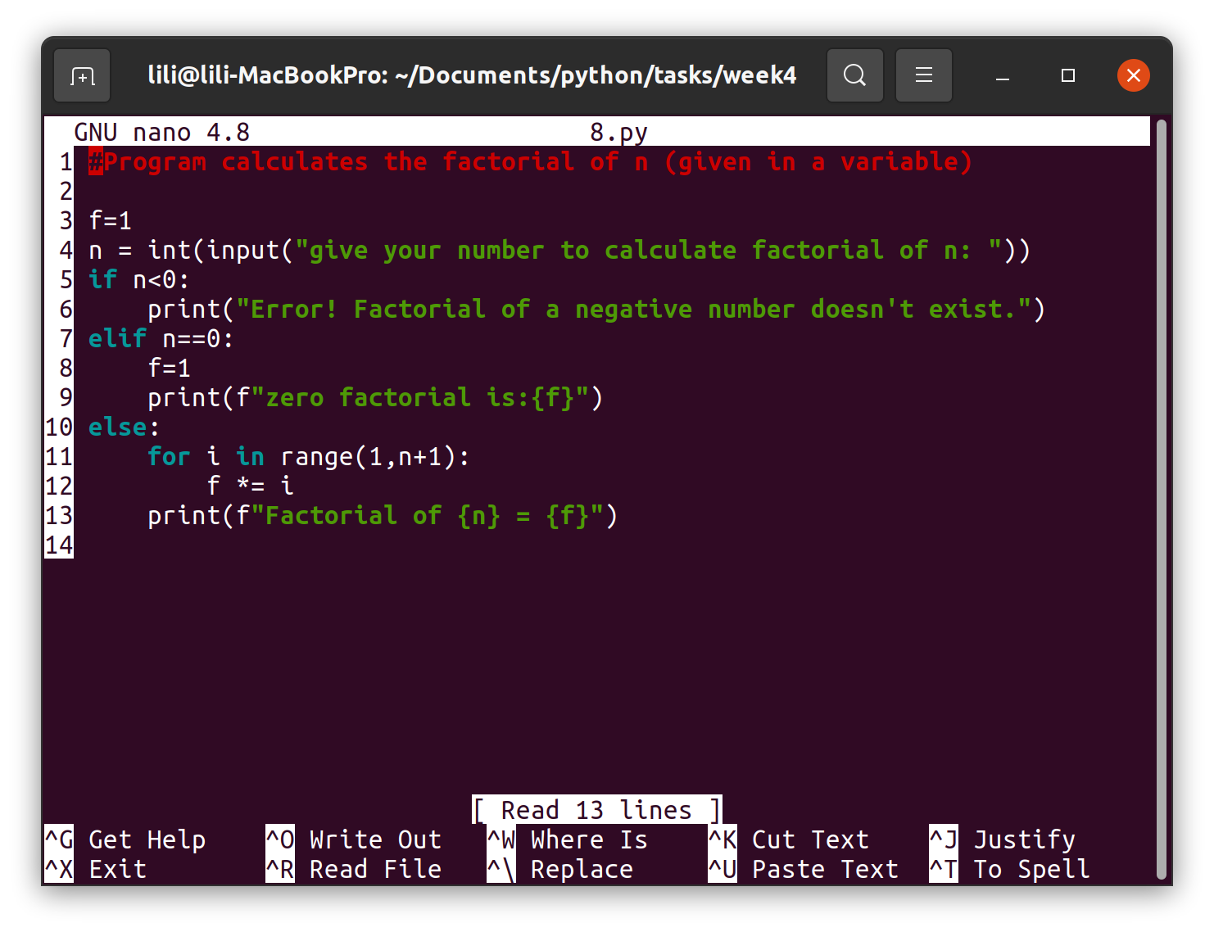

9.  
Program calculates the exponential value (base and exponent are given invariable). Base can be a real number, exponent is a whole number. Use a loop.

