## Week 5

1. Array contains 30 random values. Calculate the sum and average.

2. Find the maximun of an array.

3. Search a value from an array.

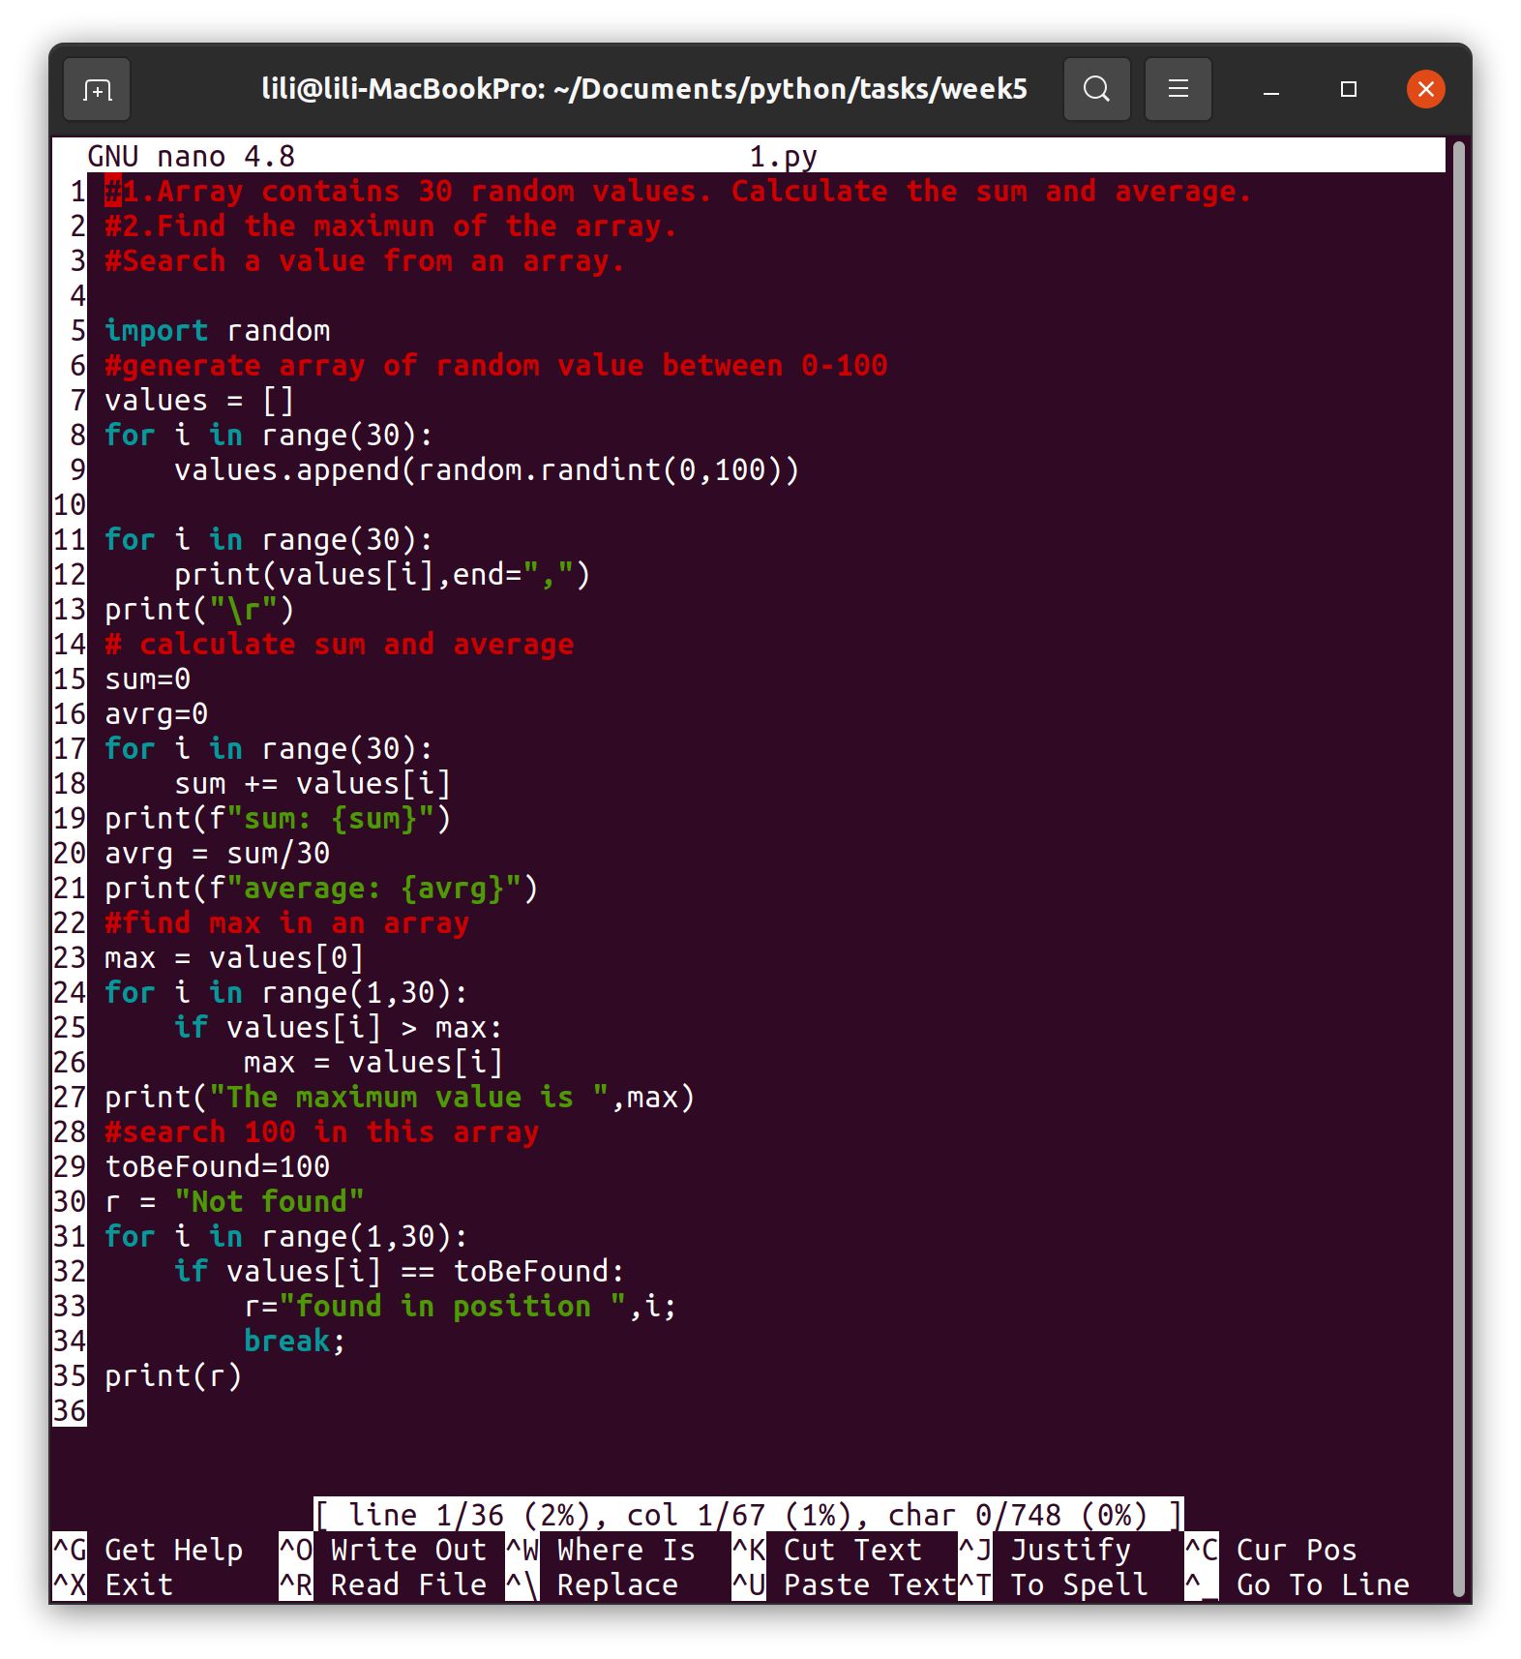

4. Fill 2 arrays with some values and calculate the sum array.

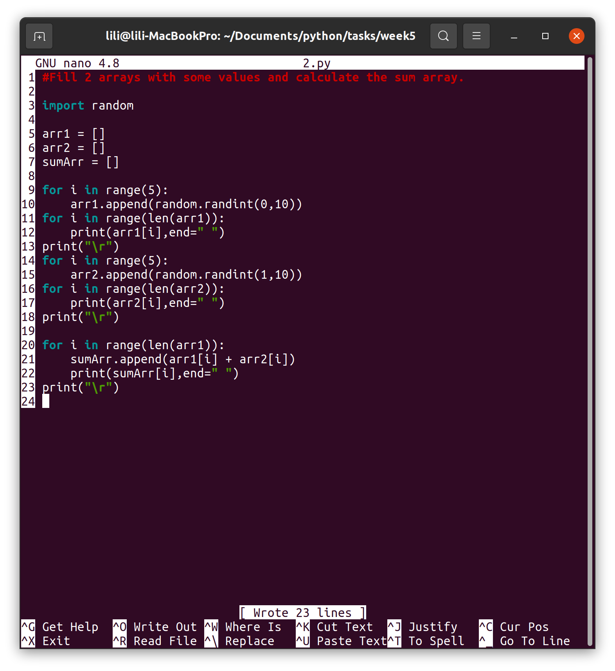

5. Generate a lottorow (try to use an array here).

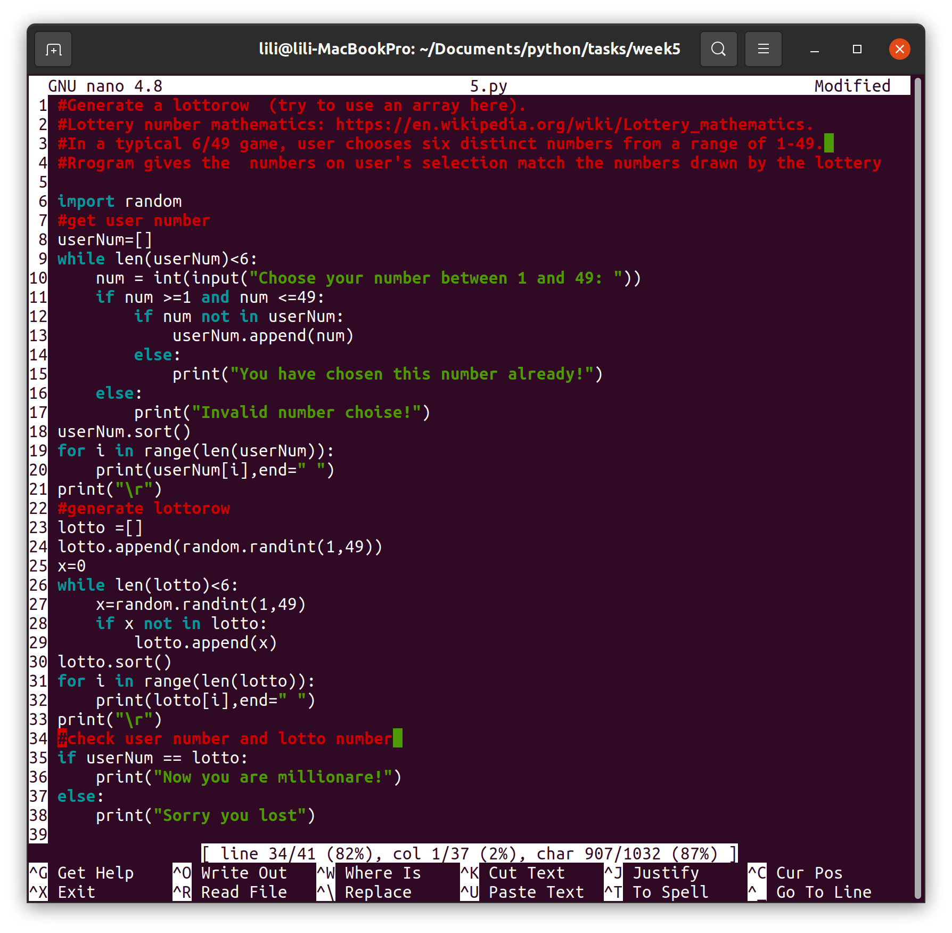

6. Take a look at python.org site.   
Array methods are presented here:  
<https://docs.python.org/3/tutorial/datastructures.html>

Give your own examples of using those metods.

See Appendix

7. Create a short dictionary: e.g Finnish to English.  
Add some wordpairs to a list.  
Or as example, here are some English – Italian words:

treaty patto

truck camion

trust trust

value valore

volunteer volontario

wage paga

wages ricompensa

wholesale ingrosso

work lavoro

work opera

work force manodopera

worker operaio

workman operaio

workplace posto di lavoro

worth valore

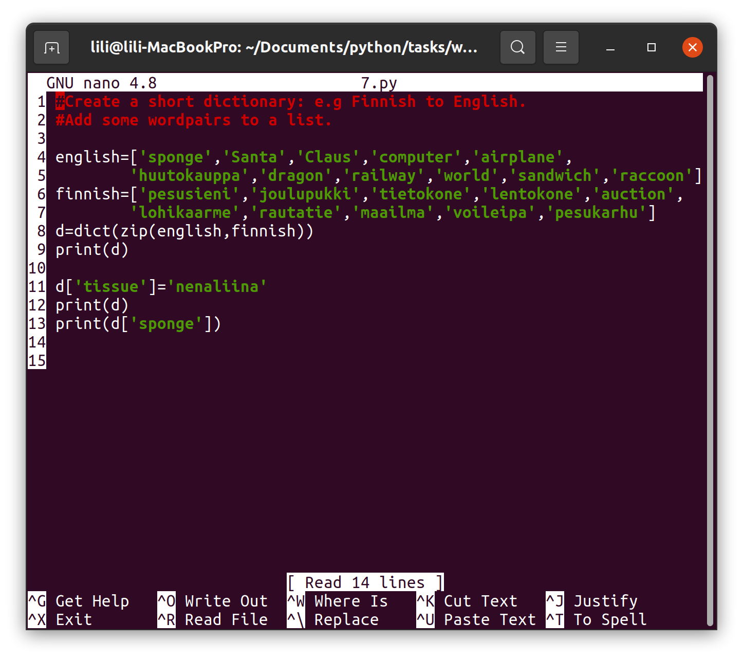

Bonus tasks (1 points/task)  
There are 20 values in an array:  
calculate the standard deviation

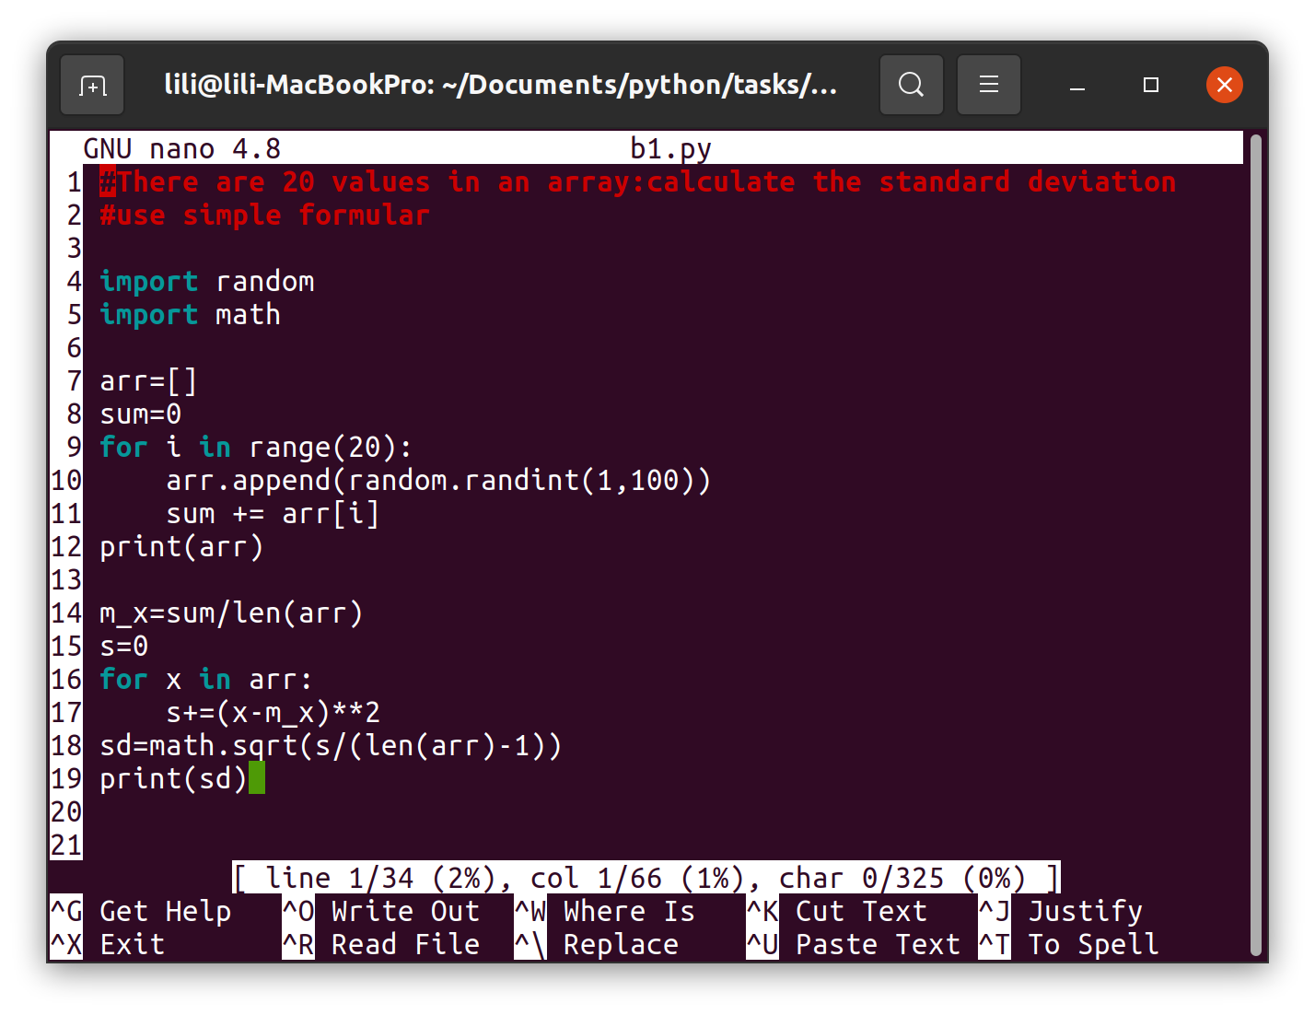  
2 arrays contain students grades in math and in English language.  
There are 10 students. Try to calculate the correlation.

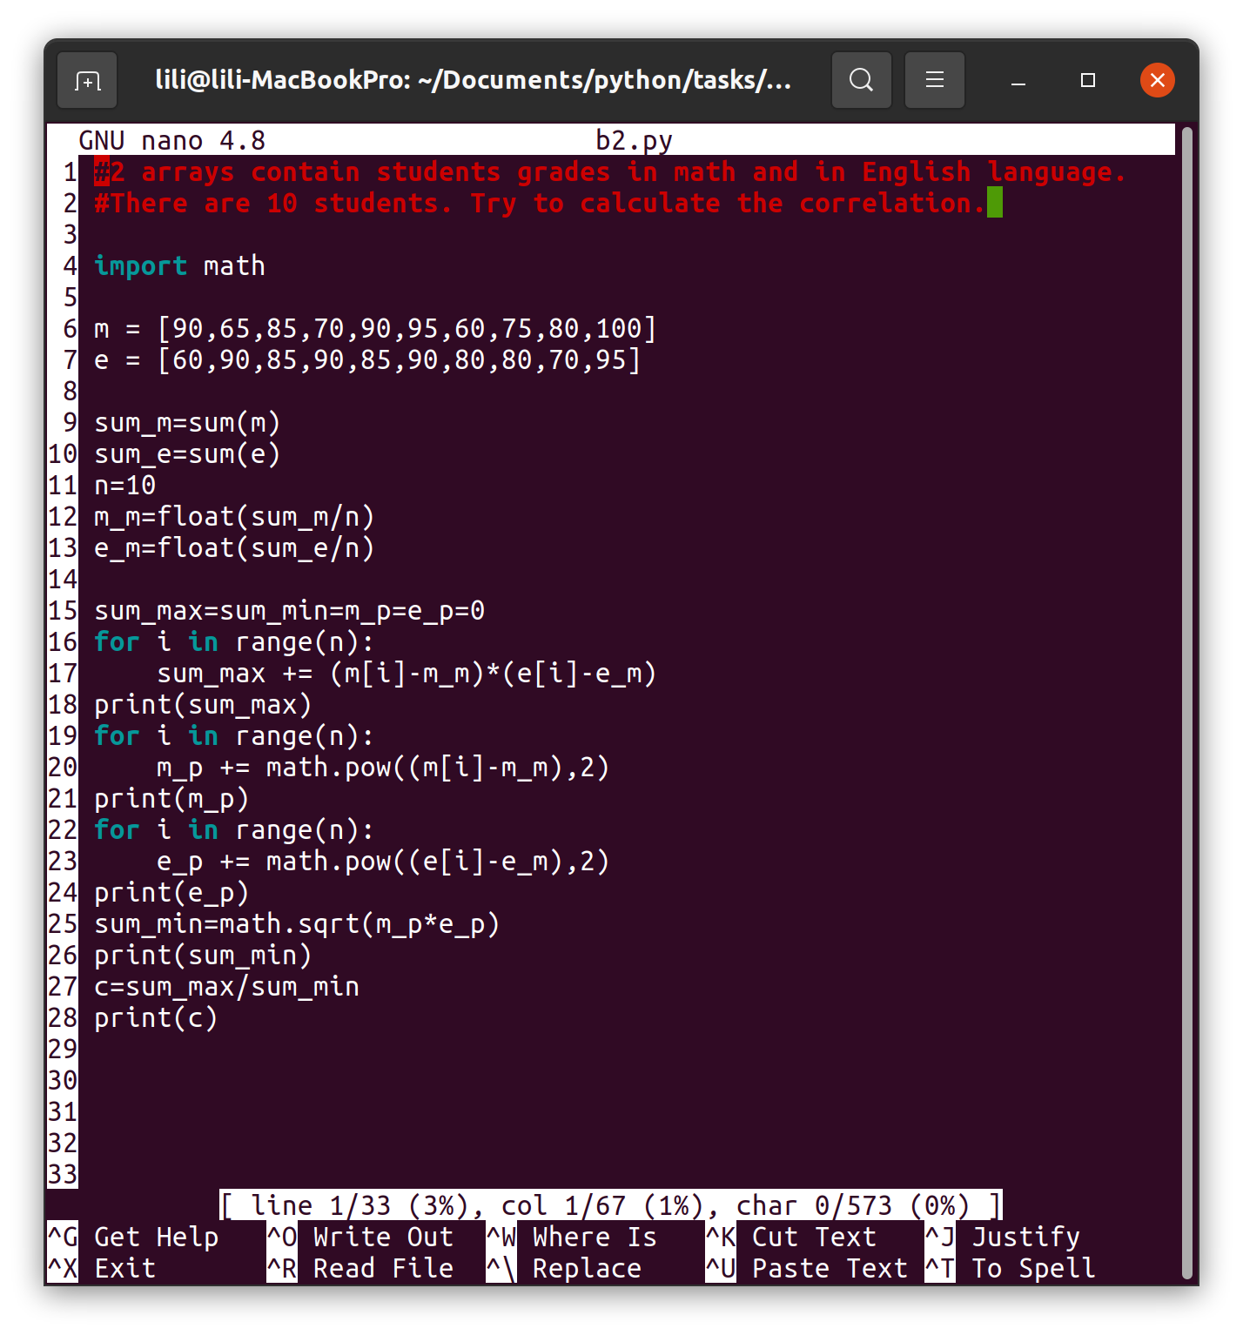

Appendix:

from collections import deque

a = [1,2,3,4,5,6,7,8]

print(a)

a.insert(2, 9)

print("Array after inserting 9 is", a)

a.append(10)

print (a)

a.remove(1)

print(a)

a.pop(a[0])

print(a)

print(a.index(4))

print(a.count(9))

a.sort()

print(a)

a.reverse()

print(a)

a.append(10)

a.pop()

print(a)

del a[0]

print(a)

del a[2:4]

print(a)

b=deque(a)

b.append(6)

b.append(7)

print(b.popleft())

print(b.popleft())

#del b

#print(b)

triple=[]

for x in range(5):

triple.append(x**3)

print(triple)

triple = list(map(lambda x: x**3,range(5)))

print(triple)

triple = [x**3 for x in range(5)]

print(triple)

print([(x, y) for x in [6,7,8] for y in [5,6,7] if x != y])

c =[-9,-6,-3,0,3,6,9]

print([x**2 for x in c])

print([x for x in c if x>0])

print([abs(x) for x in c if x<0])

d=[(x,x*10) for x in range(2,9)]

print(d)

e=[[1,3],[2,4],[5,7],[6,8]]

print([num for elem in e for num in elem])

m=[

[1,3,5,7,9],

[2,4,6,8,10],

[0,0,0,0,0],

]

t1=[[row[i] for row in m] for i in range(len(m[0]))]

print(m)

print(t1)

t2=[]

for i in range(len(m[0])):

t2.append([row[i] for row in m])

print(t2)

t3=[]

for i in range(5):

t3_row=[]

for row in m:

t3_row.append(row[i])

t3.append(t3_row)

print(t3)

t=1357,2468,'test'

print(t[2])

print(t)

tu=t,t,('works')

print(tu)

s1={1,1,2,2,3,4,5,6,7,8,9}

print(s1)

print(2 in s1)

print(10 in s1)

s2=set('a1b2c3d4')

s3=set('abcd')

print(s2)

print(s3)

print(s2-s3)

print(s2|s3)

print(s2&s3)

print(s2^s3)