## Week 6

Create these functions and run tests.

Function:

1. Returns the average of 2 integers

2. Returns the average of 4 floating point values.

3. Returns the sum of an array.

4. Returns the factorial.

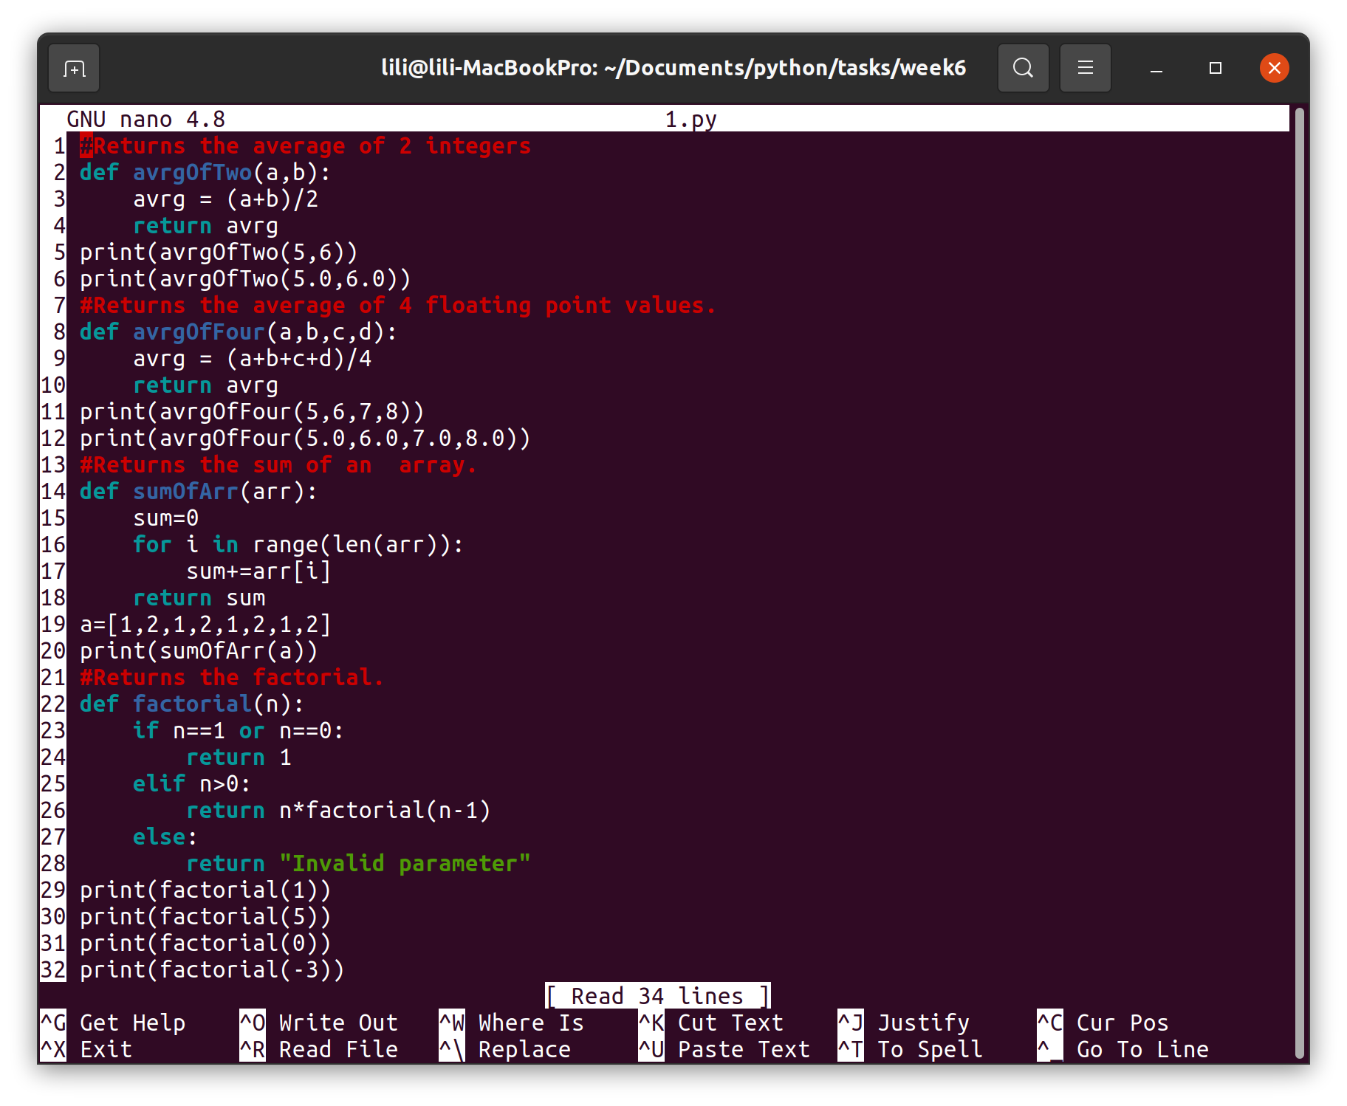

5. Returns the biggest of 3 integers.

6. Returns the BMI.

7. Function returns the biggest of 5 integers.

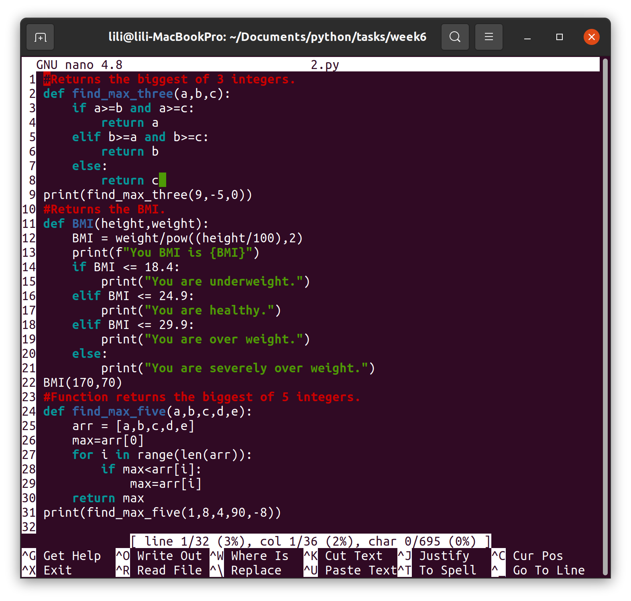8. Calculates amount of combinations (try to use also an own factorial function here).

9. Calculates the standard deviation.

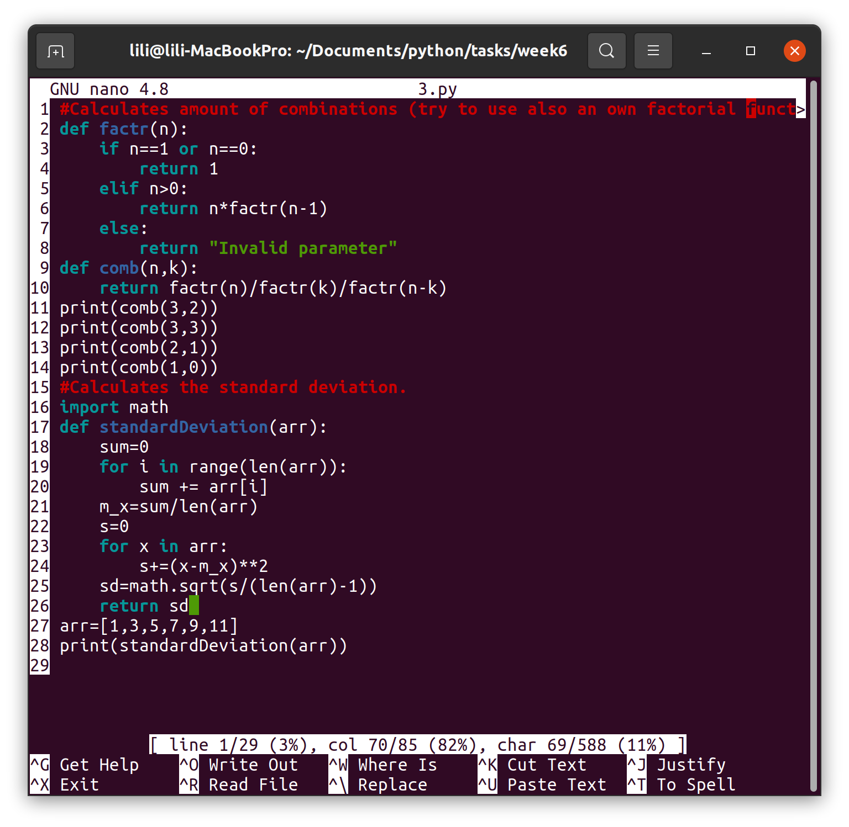

10. Searches for a value from an array.

11. Calculates the square root of value 2 (create your own function).

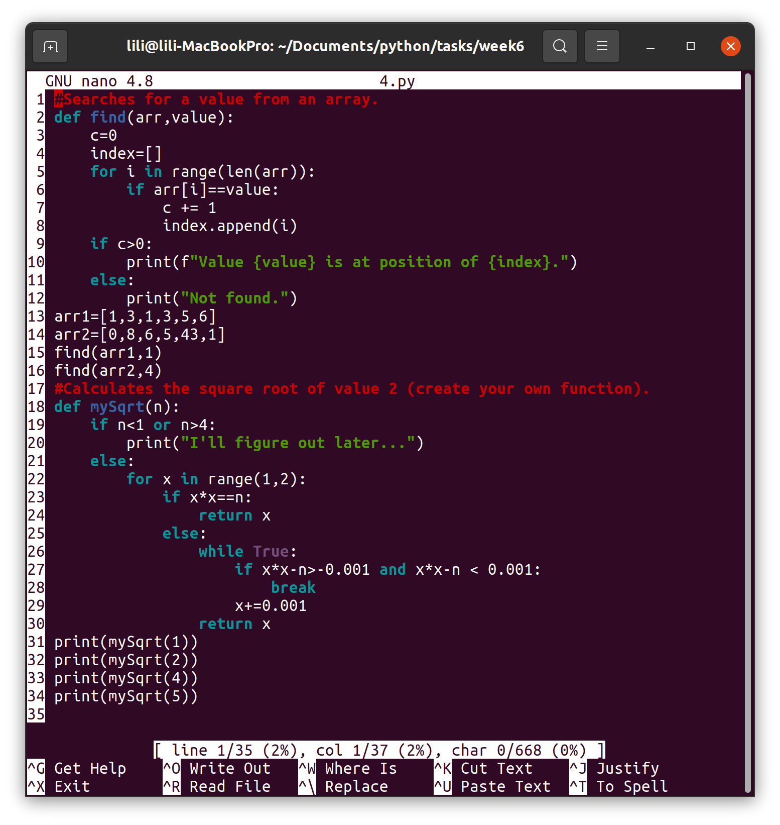

12. Calculates an approximation of Neper's value (e).

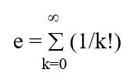

13 . Calculates approximations of sin(x) and cos(x)

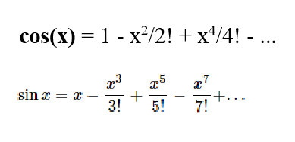

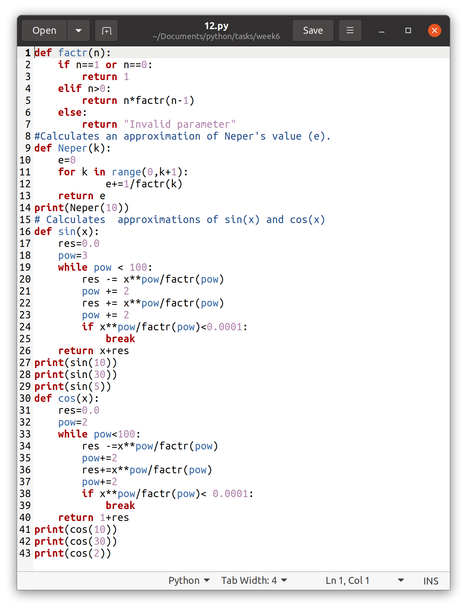Bonus (max 1 point/task)

B1

Create a function that sorts an array by using selection sort.

B2

Create a function that multiplies two arrays.

