Week8

1.student and course class

UML:

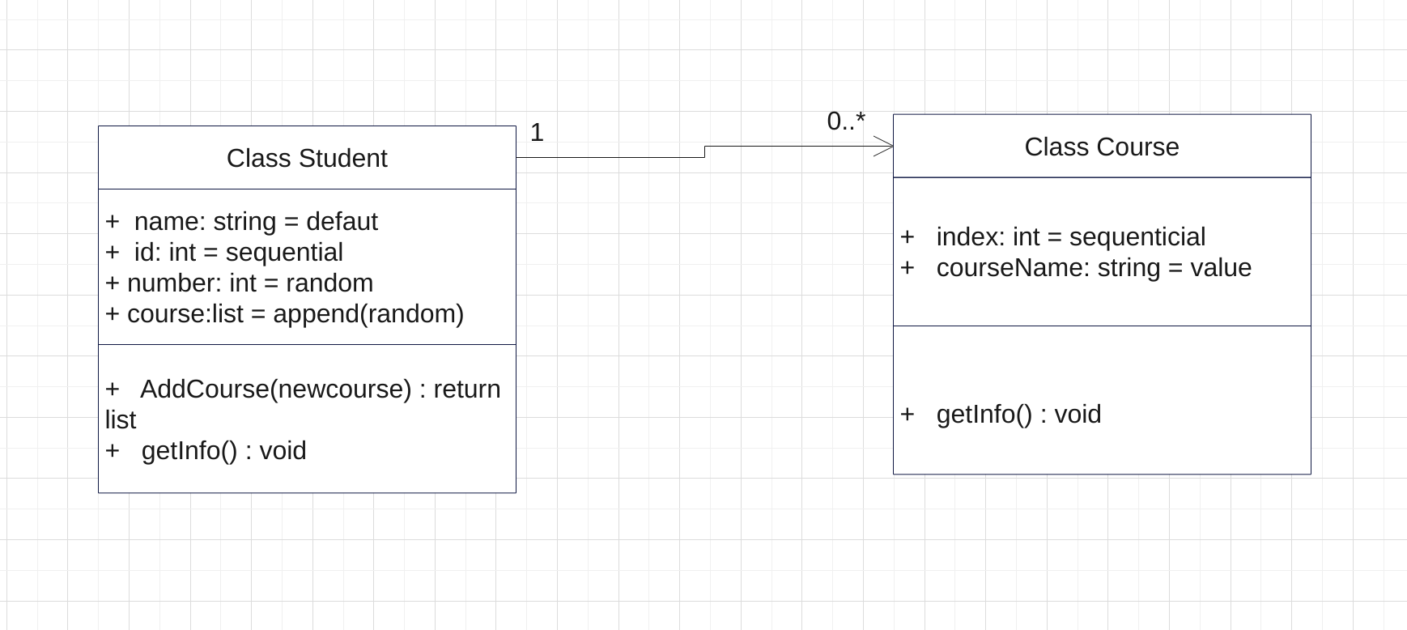

CODE:

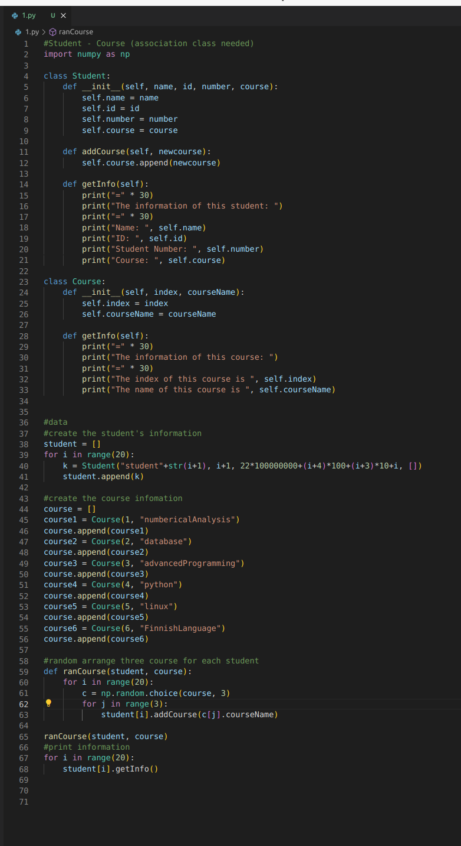

2. Group has 3 members (note: aggregation)

Uml:

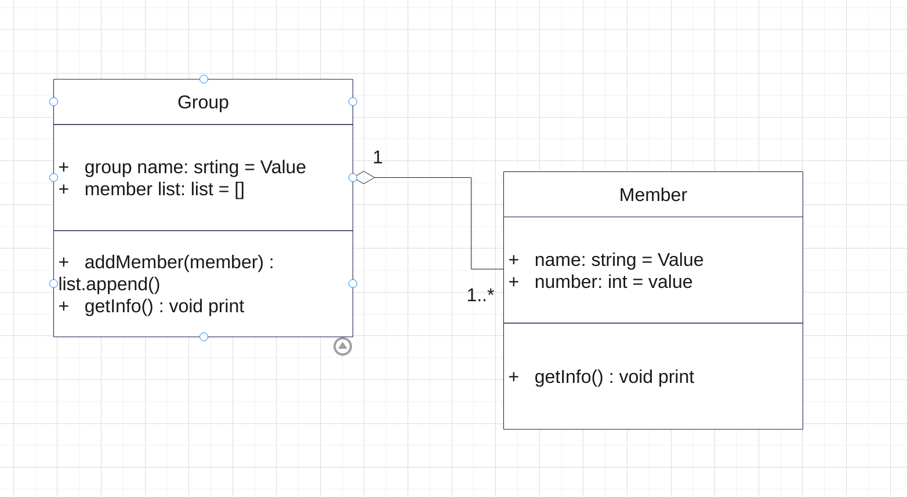

Code:

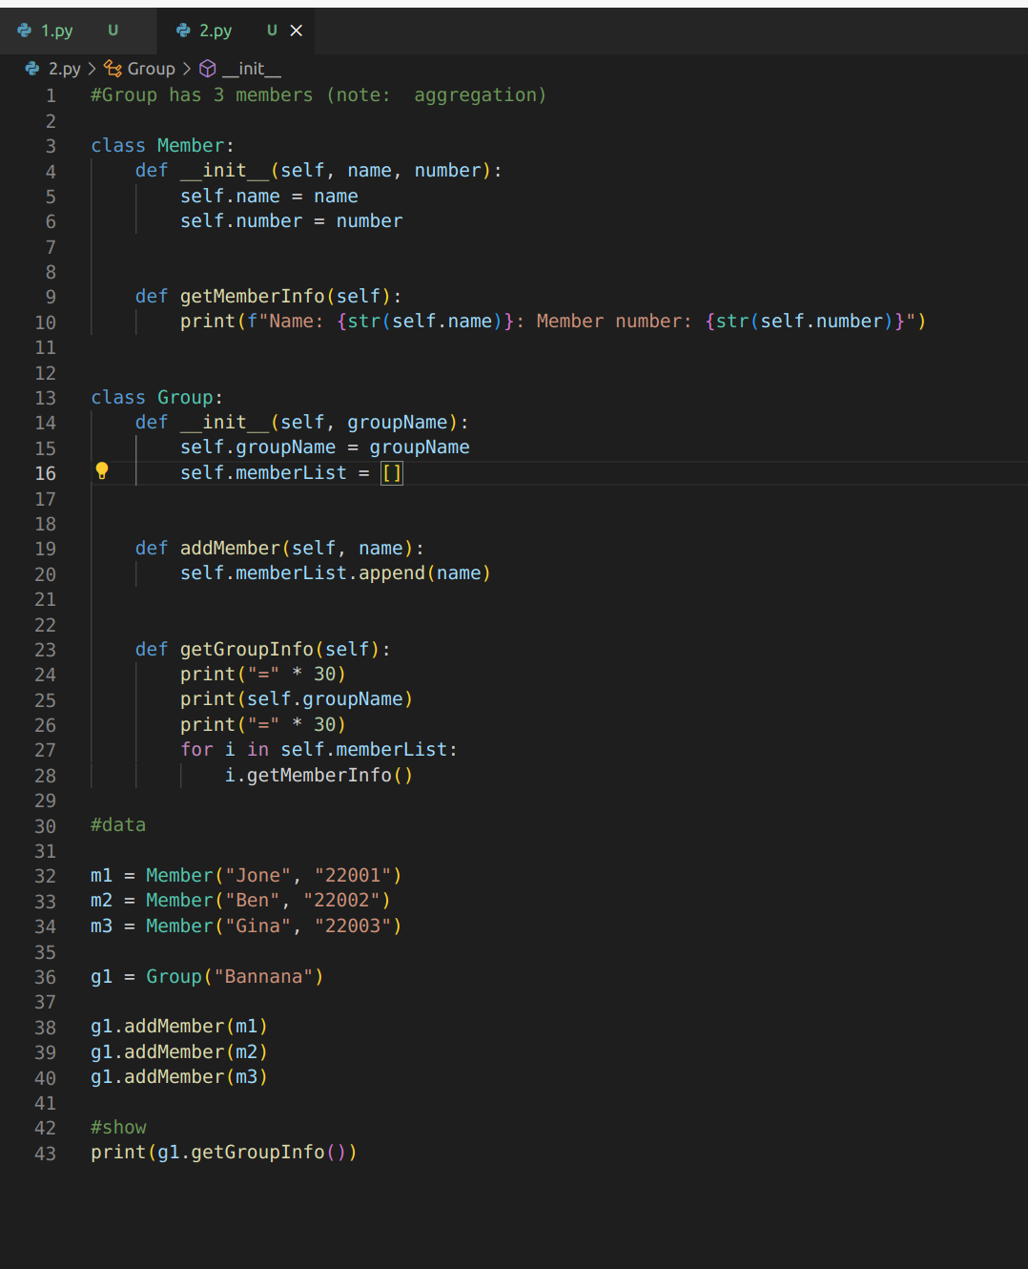

3. House with 3 Rooms (note: composition)

Uml:

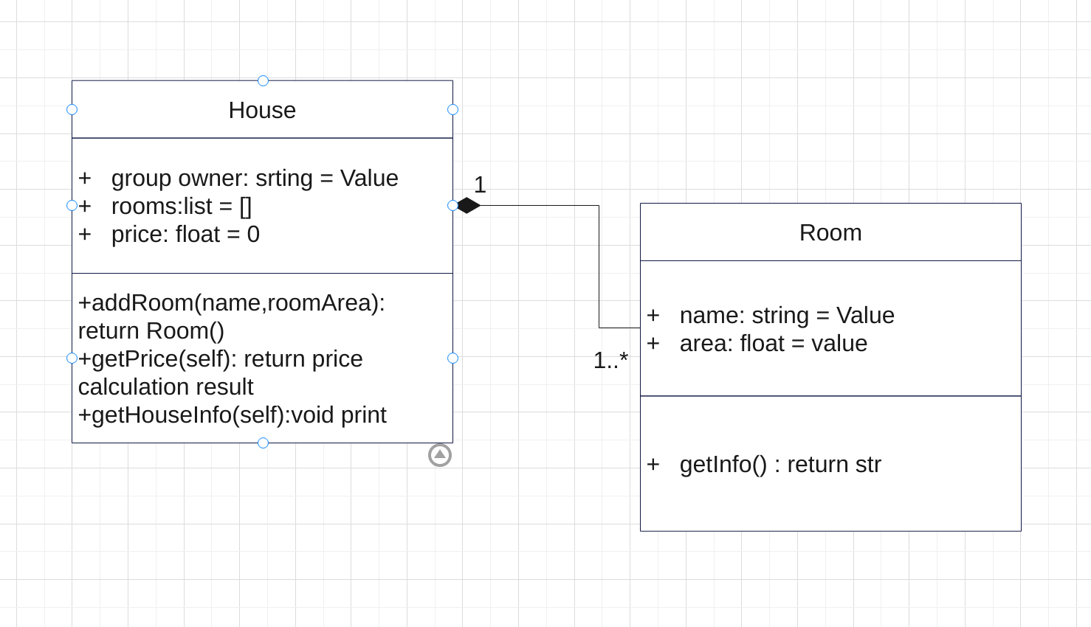

Code:

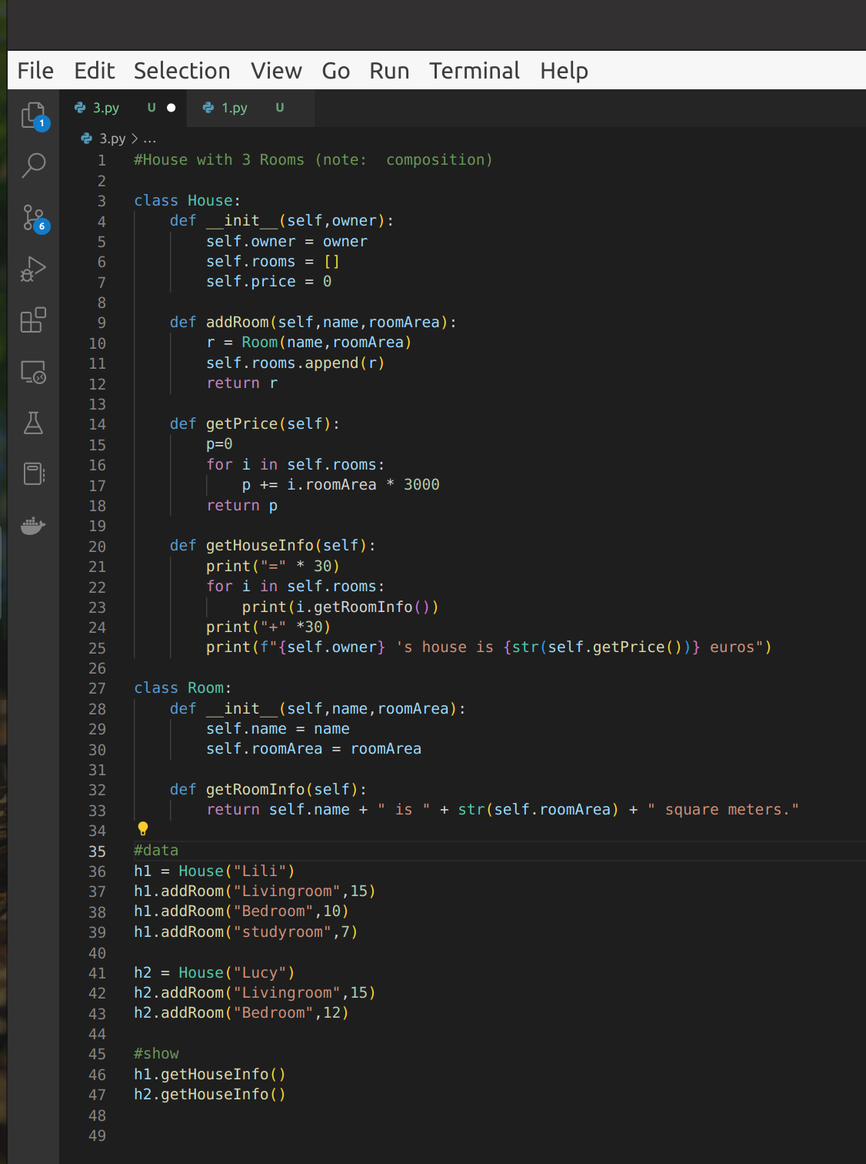4.

Uml:

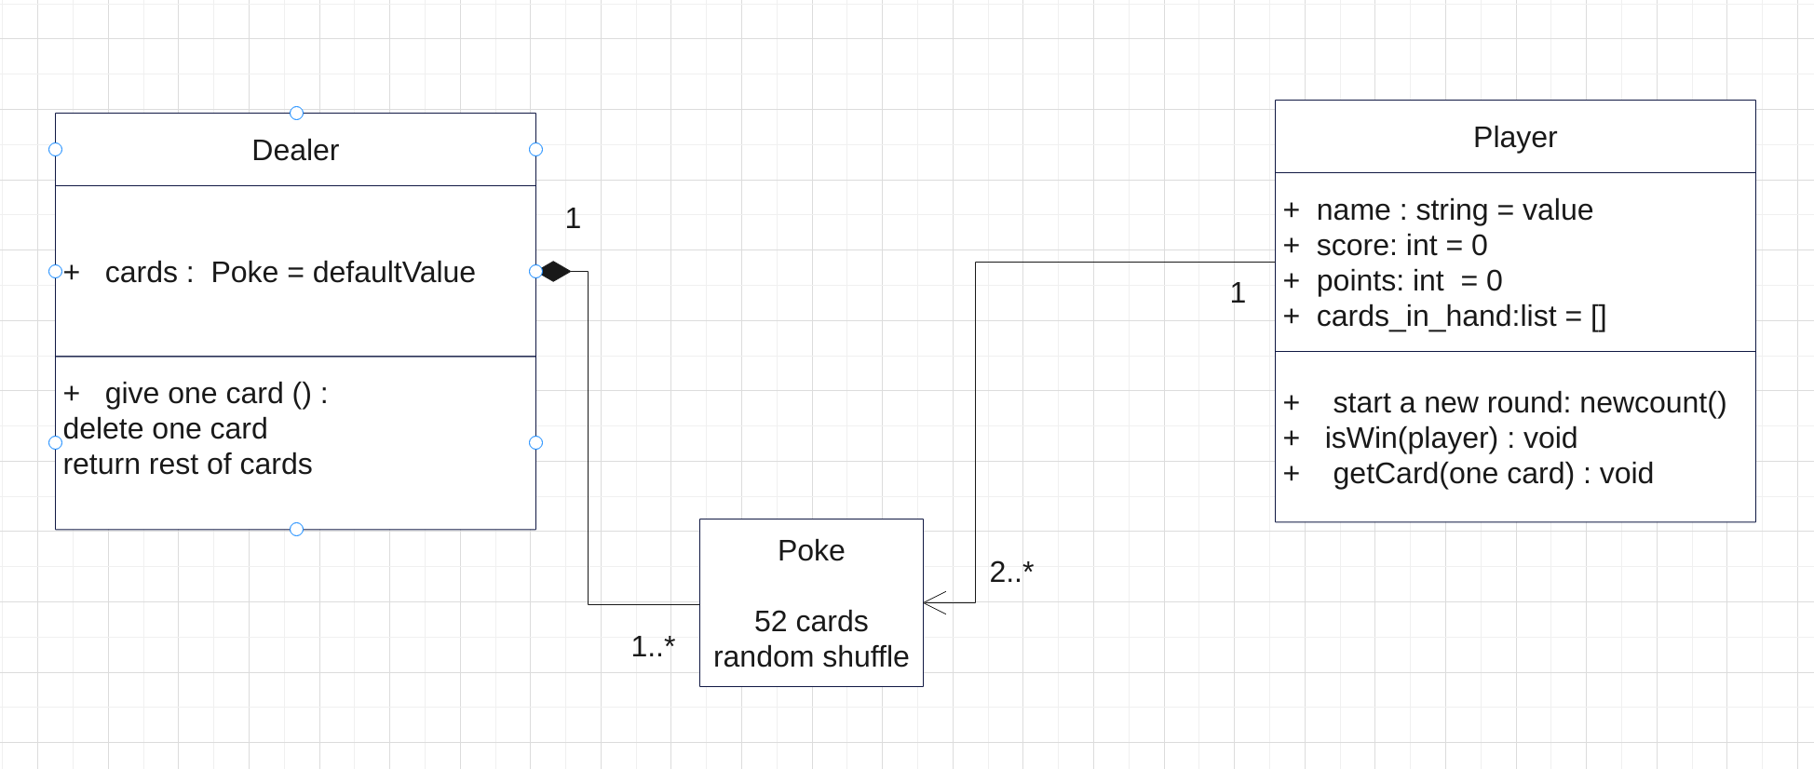

Code:

#BlackJack cardgame (Note: part ok => 3 classes ok)

import random

from sys import exit

class Poke:

def __init__(self):

self.cards = [[face, suite] for face in "♠♥♦♣" for suite in [1,2,3,4,5,6,7,8,9,10,'J','Q','K']]

random.shuffle(self.cards)

class Dealer:

def __init__(self):

self.cards = Poke().cards

def give_one_card(self):

if not self.cards:

self.cards.extend(Poke().cards)

return self.cards.pop()

class Player:

def __init__(self, name):

self.name = name

self.score = 0

self.points = 0

self.cards_in_hand = []

def init(self):

self.cards_in_hand = []

self.points = 0

def now_count(self):

point = 0

for face, suite in self.cards_in_hand:

if suite in ['J', 'Q', 'K']:

suite = 10

point += suite

self.points = point

def is_win(self, player):

s1 = self.points

s2 = player.points

if s1 > s2:

print(f"Player {self.name} has {s1} points, Computer {player.name} has {s2} points, Player {self.name} wins!")

self.score += 1

elif s1 == s2:

print(f"Player {self.name} has {s1} points, Computer {player.name} has {s2} points, draw!")

else:

print(f"Player {self.name} has {s1} points, Computer {player.name} has {s2} points, Computer {player.name} wins!")

player.score += 1

def get(self, *cards):

for card in cards:

self.cards_in_hand.append(card)

self.now_count() # reset points

# game playing main function

def main(dealer: Dealer, computer: Player, human: Player):

# round counts

count = 0

while True:

count += 1

print(f"Round {count}：")

#set for gameover in advance

flag = False

human.init()

computer.init()

# two cards each

human.get(dealer.give_one_card(), dealer.give_one_card())

computer.get(dealer.give_one_card(), dealer.give_one_card())

print(f"Player {human.name}'s hand: {human.cards_in_hand[-2]}, {human.cards_in_hand[-1]}")

print(f"Computer {computer.name}'s hand: {computer.cards_in_hand[-2]}, ?")

# judging whether it's blackjack

if human.points == 21 == computer.points:

print("Player {human.name} and Computer {computer.name} both get 21 points, draw!")

elif human.points == 21:

print("Player {human.name} has 21 points, congratulation {human.name} wins!")

human.score += 1

else:

# Player ask more card

while True:

if_next_card = input("Continue getting card: (Y/N)")

if if_next_card in ['N', 'n']:

break

elif if_next_card in ['Y', 'y']:

human.get(dealer.give_one_card())

print(f"Player {human.name} gets {human.cards_in_hand[-1]}, Player {human.name}'s hand: '{human.cards_in_hand}")

# judging if player over 21，if it is, gave over in advance, set true

if human.points > 21:

print(f"Player {human.name} has {human.points} points, over 21 points, Player {human.name} lost!")

computer.score += 1

flag = True

break

# Computer ask card

if not flag:

# if points smaller than human player, ask more

while computer.points < human.points:

computer.get(dealer.give_one_card())

print(f"Computer {computer.name} gets: {computer.cards_in_hand[-1]}, Computer {computer.name}'s hand: {computer.cards_in_hand}")

# judging if computer over 21，if it is, gave over in advance

if computer.points > 21:

print(f"Computer {computer.name} has {computer.points} points, over 21, Congratulation {human.name} wins!")

human.score += 1

else:

# If there is no early end, that is, if both are less than 21 points, judge whether to win or lose

human.is_win(computer)

print("-" * 30)

# if next round

if_play_again = input("One more try?:(Y/N)")

if if_play_again in ['Y', 'y']:

print(f"Player {human.name}, Computer {computer.name} total scores is {human.score}:{computer.score}")

# if fully stop，print result

elif if_play_again in ['N', 'n']:

print(f"PLAYER {human.name},COMPUTER {computer.name} final score : {human.score}:{computer.score}")

if human.score > computer.score:

print(f"{human.name}win!")

elif human.score < computer.score:

print(f"{computer.name}win! ")

else:

print("The battle is fierce, you are even!")

print("GAME OVER")

exit(0)

else:

print("Invalid input, input again: ")

# game starts

computer = Player('Robo')

human = Player('Lili')

dealer = Dealer()

main(dealer, computer, human)